Extended Wifi Network Design Model for Ubiquitous Emergency Events
Zayan Elkhaled  University of Quebec at Chicoutimi  555 Boul. University, Chicoutimi (QC) G7H 2B1 Canada  Zayan.elkhaled1@uqac.ca | Hamid Mcheick  University of Quebec at Chicoutimi  555 Boul. University, Chicoutimi (QC) G7H 2B1 Canada  Hamid_mcheick@uqac.ca | Hicham Ajami  University of Quebec at Chicoutimi  555 Boul. University, Chicoutimi (QC) G7H 2B1 Canada  Hicham.ajami1@uqac.ca

ABSTRACT
SummerSim-SCSC, 2016 July 24–27, Montreal, Quebec, Canada
© 2016 Society for Modeling & Simulation International (SCS), Cooperatin with ACM. ACM Digital Library.

Telecommunication is the exchange of information and data over significant distance by electronic means. During extreme events such as natural disasters and urgent events it becomes more and more important to preserve the communication devices and infrastructure to exchange information between rescue teams and persons in damaged zone based on their area. When extreme event happens, many communication scenarios can be considered. We focus on a the case of destruction of traditional communication networks during an emergency event such as natural disasters in which it is important to find an alternative network architecture to prevent the death and injury of thousands of people. The rescue teams are unable to locate and communicate with victims on right time. This work presents network architectural design model to extend the range of WIFI networks and help people access to Internet or get rescue when the damage affects the most existing telecommunication networks. This model is validated by analyzing two communication scenarios.

Author Keywords
Emergency network; pervasive and ubiquitous computing; WIFI; WIFI peer-to-peer (P2P); formal model;

ACM Classification Keywords
I.6.1 SIMULATION AND MODELING (e.g. Model Development). See: http://www.acm.org/about/class/1998/ for more information and the full list of ACM classifiers and descriptors.

INTRODUCTION
During emergency events such as natural disasters and huge events in smart city, essential communications are exposed to partial or complete breakdown causing delays and errors in emergency response and disaster relief effort. This can lead to lose the life of thousands of people and damage to properties. For example, communications failures in New York City on September 11 led directly to the loss of at least 300 firefighters [1]. In the Asian deadly waves in 2004, the failure to communicate warnings and the poor quality of telecommunication infrastructures prevented citizens from receiving timely information [2]. In these kind of extreme events, it is important to propose easy to install and deploy solutions to solve robustness issue of the communication and monitoring systems.
Due to growing dependence upon telecommunications networks in emergency operations, many approaches have been proposed such as architecture [14] and to determine a violent action by monitoring people actions [15]. However, these approaches do not propose complete solutions dealing with large urban disasters that can reduce the network capacity to help people inside and near damaged areas. This paper proposes and analyses an extended WIFI network model to deal with extreme event using formal model.
This paper is organized as follows, the section 2 defines why telecommunication infrastructure fails during disasters, the section 3 gives an overview on the different communications technologies used in mobile phones and the pros and cons of using WIFI service compared to other technologies. Section 4 describes in detail WIFI peer-to-peer (P2P) and its capacity to create an ad hoc network on smart phones. The section 5 describes and analyses our formal network model to help P2P network communicates to external zone by extending the range of WIFI coverage. A theoretical study is made and a result is exposed. Finally, a conclusion is given in section 6.

TELECOMMUNICATIONS STATUS DURING DISASTERS
Network failures occur for many different reasons and in many different forms. Many researches are made on failure prediction standards and network failures causes. Kyas [16] and Hudyma&Fels [17] have identified many categories of events that can lead to general system failure. These are:
- Operator Error
- Mass Storage Problems
- Computer Hardware Problems
- Software Problems
- Network Problems
- Denial of Service Attack
- Disaster Scenarios
These events can be classified into three primary categories of causes in network failure [3]:
- The physical destruction
- Disruption in supporting network
- Network congestion
Previous classifications show the need to build an easy communication network requiring fewer components and compatible with any kind of mobile device. As during disasters, rescue teams and damaged people should react efficiently and quickly and mostly concentrated on helping operations, the proposed system would be easy to configure by using every day tools, and everyone can employ it easily. In addition as affected zone can vary on surface and distance from big centers, the network has to be easy to extend, support wide range operations, the coverage can be adapted to any geography or environment. Moreover, transport and power supplying should be taken into account, as during disaster electricity and transport network are severely damaged. In addition to the high reliability and resiliency, the network has to be easy to repair and equipments are easy to replace. Also, the network has to deal with heavy call traffic that exceeds the evaluation of accessing network during busy hour. Accordingly, it seems clear that we urgently need to build a wireless network that does not require a big amount of additional infrastructure and means of energy.

COMMUNICATION TECHNOLOGIES IN MOBILE PHONES
In addition to reduce the cable restrictions with respect to cabled devices, Wireless networks benefits include the dynamic network formation, low cost, and easy deployment. For those important advantages, wireless technologies knew a huge development and appear to be a really exciting analysis space for the researchers, in the last decades. Wireless technique is actually controlled by four protocols: Bluetooth (IEEE 802.15.1), UWB (IEEE 802.15.3), ZigBee (IEEE 802.15.4), and WIFI (IEEE 802.11). Current section introduces those standards and compares their performance to choose which technology fits the needs to develop wide range emergency network.

Bluetooth (IEEE 802.15.1)
Bluetooth, also known as the IEEE 802.15.1 standard is intended for low complexity and low power applications. This radio system is designed to be integrated in devices to replace cabled link by a wireless one. Two network topologies are defined in Bluetooth: The piconet and scatternet [10]. A piconet is formed by a Bluetooth device serving as a master who synchronize the clock and the frequency channel, and one or more Bluetooth devices serving as slaves. Slaves can transmit only with their master if they are in an active mode. Also, parked or standby modes are made to reduce power consumptions when slaves are not transmitting. A scatternet is a collection of piconets. As Bluetooth device may participate in several piconets at the same time, the area of the network can be extended and the information could flow beyond the coverage of a single piconet.

UWB (IEEE 802.15.3)
Ultra Wideband Impulse (UWB) Radio is a novel and robust to frequency dependent propagation effects wireless technology. Pulsed nature of the signal means that the short duration of pulses leads most multipath components to be isolated, which give it more robustness to multipath fading, high-speed communication rate and ultra-low power levels [18]. One of the most exciting characteristics of UWB is that its bandwidth is up to 480 Mbps which can satisfy most of height speed multimedia applications such as audio and video streaming in home networking.

ZigBee (IEEE 802.15.4)
ZigBee is new low power and low range standard. It provides self-organized, multi-hop, and reliable mesh star or cluster-tree networking with long battery lifetime [10]. The devices in the ZigBee network are divided into full function devices (FFD) that can act as network coordinators or routers and reduced function devices (RFD) that can only act as end-devices. RFD can be implemented using minimal resources and memory capacity, as it is intended for simple applications without need to send large amounts of data and may only associate with a single FFD at a time. The ZigBee provides self-configuring network that is very flexible and easy to set up.

WIFI (IEEE 802.11)
Wireless fidelity (WIFI) includes IEEE 802.11 a/b/g/n standards for wireless local area networks (WLAN). The WIFI is primary a single-hop network using IP stack. It allows users to surf the Internet at broadband speeds when they are connected to an access point (AP). As it is a multiple-access network, all nodes within the range of AP can hear each other without worry about any network topology or station mobility [9]. The current solution to extend network range is to use repeaters or a wired LAN to interconnect group of WIFI access points. New methods are designed to widen the range of the network by allowing stations to communicate directly without any AP [19]. Because this type WLAN is often formed without pre-planning, it is often referred to as an ad hoc network [10].

Performance Analysis
In this section we will present a small comparison between the four wireless standards, critical requirements to build such network are given as follows:
- Coverage is very interesting subject because the greater the scope of coverage the concerned population disserved zone are increased. A major advantage of WIFI network is its signal coverage range [9] which is typically 100m.
- The number of nodes is essential to connect the largest number of people. In this context Lee et al. [10] confirms that the maximum number of nodes using WIFI ad hoc network could be unlimited.
- Data rate identifies the amount of information that network can support. The higher the data rate the greater amount of information can be transmitted and the more the network is reliable.
- When electrical energy becomes more and more rare, communication with less power becomes an essential subject too. Even if you want victims to be saved as quickly as possible, but also that the network remains online for as long as possible, to give more time to emergency services to find infected people.
- In general, technology is absolutely the most effective to support the communication, but when it is not available on smart phones, then it becomes useless for emergency cases where no network available. The network technology has to be available on smart phone to disserve the maximum people to respect the need of mobility and to facilitate network deployment. According to information provided by Nokia [12] and Sony [13], Bluetooth and WIFI are the only technologies available on current smart phones [11].
- Due to its characteristics, WIFI seems to be the best suitable choice for emergency needs. Its wide range and big amount of nodes allow rescue team to cover a large geographic zone and a maximum damaged people. In addition, its high data rate maximizes information transfer and prevent network breakdown due to capacity saturation. This technology is also easy to deploy due to its availability on most Smart phones.

Standard | Bluetouth | UWB | Zigbee | WIFI
Frequency band | 2.4 GHz | 3.1 – 10.6 GHz | 868/915 MHz; 2.4 GHz | 2.4 GHz; 5 GHz
Max signal rate | 1 Mb/s | 110 Mb/s | 250 Kb/s | 54 Mb/s (802.1 1a/b/g)
Nominal range | 10m | 10 m | 10 - 100 m | 100 m
Nominal TX power | 0 - 10 dBm | -41.3 dBm/MHz | (-25) - 0 dBm | 15 - 20 dBm
Channel bandwidth | 1 MHz | 500 MHz - 7.5 GHz | 0.3/0.6 MHz; 2 MHz | 22 MHz
Max number of cell nodes | 8 | 8 | > 65000 | 2007
Table 1: Comparison of wireless standards networks [10].

MOBILE AD-HOC NETWORKS

MANET
Mobile ad hoc network (MANET) is a set of wireless mobile devices communicating together without the need of centralized administration [4].The network topology is dynamic and unpredictable; its structure can change at any time, so that the disconnection of any node is very common. MANETs can use many wireless technologies such as WIFI, cellular or satellite transmission to connect to various networks [4].

WIFI Direct
WIFI Direct is a WIFI Alliance technical specification called WIFI Peer-to-Peer (P2P) [6]. It allows users to have Peer-to-Peer connectivity without access point (AP) which is replaced by the group owner (GO). In 2013 Camps-Mur et al. [8] described in detail the “WIFI Direct devices, formally known as P2P Devices, communicate by establishing P2P Groups, which are functionally equivalent to traditional WIFI infrastructure networks."

Operation mode
Mobile device detects existing P2P groups by performing regular WIFI scan. The GO announces itself through beacon, as traditional access point, Then devices start scanning by alternate between the states of listen and search on each channel, once they find the owner the communication process starts. P2P connection requires three main steps or three-way handshake, namely GO negotiation. Request / Response / Confirmation.
The device that receives a probe response sends a negotiation request GO with a number called GO Intent value while the answer comes with a GO negotiation response and of course with the same intended value. The device that has the highest value of intent becomes P2P GO. At the end of the algorithm, the elected GO serves as a beacon for others and assigns IP address to other group members using DHCP.

NETWORK ARCHITECTURE MODEL

Wide Range Network Model
Our model is based on the model proposed in Ajami and Mcheick [19], where a WIFI P2P network technology is created in the area which is out of coverage. The network coverage is extended from 100 meters to several kilometers by passing information from one network to another as we can see in figure 1.
The major problem is that devices are not compatible with each other and a solution that supports IOS devices has to be proposed. Another weakness of this model is the necessity of WIFI direct devices to be present on all the damaged area to insure continuity of the coverage to reach victims. Sometimes, the last condition is difficult to satisfy due to geographic issue simply because we do not have any device in certain zone to insure continuity.
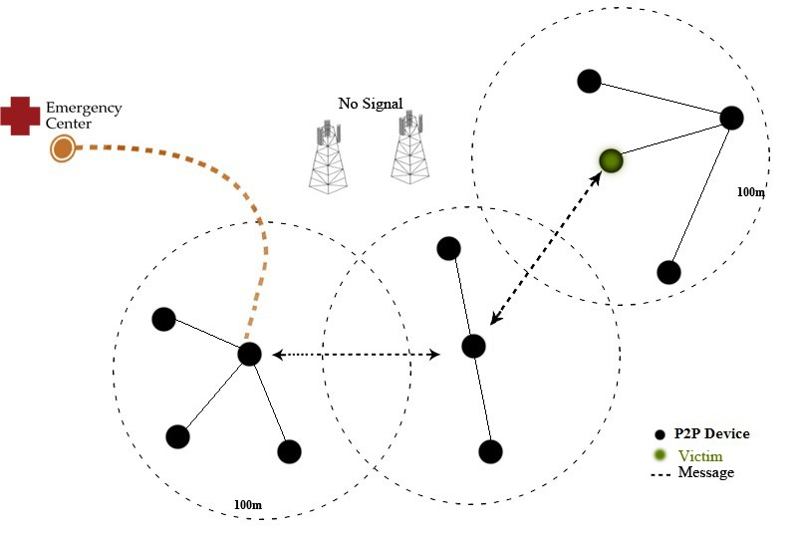
Figure 1: Communication network model for emergency case study [19].

The example of uncovered area is given in the figure 2. As we see, the major reason of this weakness is due to short range of actual WIFI direct solution, limited to 100 M of distance. Unfortunately we cannot extend its range because it depends on mobile phone devices constructors and normalization organisms. The solution is finding a WIFI network that can expand coverage by its wide range capability.
The proposed solution is a combination of WIFI P2P network and wide range WIFI network as illustrated in figure 3. The model is composed of WIFI P2P network devices, and WIFI access point (AP). Routing or switching device to make firewalling, other network operations and to insure link between AP and Backbone which is used to insure link between network and emergency center or Internet.

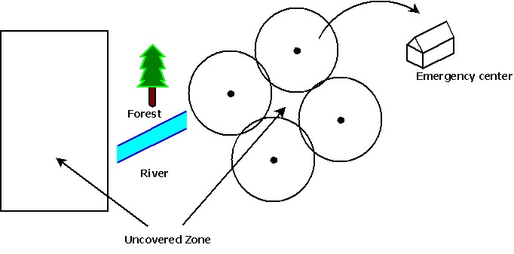
Figure 2: Illustration of uncovered zone examples.

In this model, WIFI P2P and AP collaborate together to cover the whole damaged area. AP insures link directly without intermediate devices like WIFI P2P networks. With its wide range capacity, AP can fulfill difficult zones like bridges or simply the discontinuity of P2P devices. Though, WIFI P2P [19] can adjust coverage to cover small area that is not reached by AP. The advantage of having direct connectivity to Internet is the high data rate; contrarily to WIFI P2P where the network capability is decreased when traffic goes through an intermediate device. To insure the widest range, it is recommended to install AP in a high place as in the top of a mountain and building or even in a balloon. High antennas installation provides reliable backbone link and high data rate. The proposed network model is easy to configure, for less complexity we can prepare in advance antennas and switching devices.

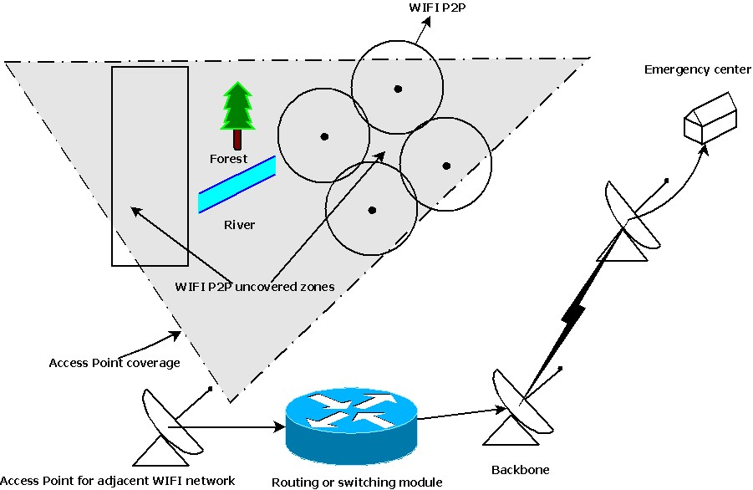
Figure 3: Proposed wide range network model.

AP antenna is chosen dependently to covered zone, in the market we can find omnidirectional antennas if victims are distributed uniformly around antenna. If we need to cover a specific zone we can optimize our choice for sector antennas, which have many radiation angles like 120, 90 or 60 degrees. As antenna gain decreases each time radiation angle increases it is recommended to choose lowest radiation angle to widen the radiation distance as we will see in the next section. Backbone links most have directional antennas with very high gain to insure longer range link with emergency center and reliable service.
The most used frequencies for WIFI are 2.4 and 5.8 GHz, which are available for most WIFI devices. It is possible to use other frequencies like 900 MHz and 3.65 GHz but the network requires frequency conversion devices. It is recommended to use 900 MHz and 2.4 GHz for AP due to their high penetration rate. Licensed 3 GHz is recommended to use for backbone link in high interference area. For ease line of site backbone link the 5 GHz is recommended for its high capacity and data rate.
In all day life electricity is very important to activate most electronic devices. But during disaster electricity becomes a big concern to power on rescue equipment to facilitate operation, mostly if electricity stations are defective or destroyed. By using batteries, solar panel and Aeolian devices we still able to bring sufficient power to our low consumption WIFI network. Batteries can store unused supplement energy, that can be used when no other power source available.

Theoretical Range
As radio waves propagate in free space, power falls off as the square of range. This effect is due to the spreading of the radio waves as they propagate, and it can be calculated by the following formula [20]:
$L_{FS}(dB)=20\log{\frac{4πD}{λ}}$ (1)
Where D is the distance between transmitting and receiving antenna and λ is the free space wave length. Equation (1) describes line-of-sight link, where no obstacles that obstruct visibility. To handle the range of our AP we need to calculate link budget, it is given by this equation [20]:
$P_{RX}=P_{TX}+G_{TX}+G_{RX}-L_{FS}$ (2)
Where PRX and PTX are received and transmitter power respectively (dBm), GRX and GTX are receiver and transmitter antenna gain respectively (dBi), LFS is free path loss (dB) where other losses are neglected,
As the range of a receiver is the maximum distance at which the received signal strength is sufficiently strong that receiver still able to handle it to extract useful information. The value of this signal is the receiver sensitivity (PSENS) and it is generally given by manufacture. Thus the only unknown value in two equations above is the distance D which is the maximum range if we replace PRX by receiver sensitivity PSENS. The receiver range is given by this equation if parameters are:
$D=\frac{λ×{10}^{\frac{P_{TX}+G_{TX}+G_{RX}-P_{SENS}}{20}}}{4π}$ (3)

If parameters are given in linear form, the range is given by the next expression:
$D=\frac{λ}{4π}×\sqrt[2]{\frac{P_{TX}×G_{TX}×G_{RX}}{P_{SENS}}}$ (4)
It is important to mention that calculation parameter will be changed according to the direction of communication. For example, when Smartphone is transmitting to AP (uplink) TX parameters belong to it and RX one belong to AP. In the other side when AP is transmitting to smart phone (downlink) TX and RX parameters are inverted.

Theoretical range improvement calculation
In the network design we have only the choice of AP transmitting antenna and its radio, because smart phones have generally same RF specifications which are completely dependent of manufacturers. To extend the WIFI coverage we have to increase Access point performances. Below we will express AP range improvement by raising AP parameters respectively: Gain (G), Transmitting power Ptx, sensitivity (Psens), Smartphone still the same. Initial AP parameters are indexed by 1, after improvement the index is 2. The ration between Downlink communication range before and after AP gain improvement is given by the expression below, other parameters are not changed:
$\frac{D_{2}}{D_{1}}=\frac{\frac{λ}{4π}×\sqrt[2]{\frac{P_{TX}×G_{TX2}×G_{RX}}{P_{SENS}}}}{\frac{λ}{4π}×\sqrt[2]{\frac{P_{TX}×G_{TX1}×G_{RX}}{P_{SENS}}}}=\sqrt[2]{\frac{G_{TX2}}{G_{TX1}}}$ (5)
With the same manner range improvement due to transmit power is given by:
$\frac{D_{2}}{D_{1}}=\sqrt[2]{\frac{P_{TX2}}{P_{TX1}}}$ (6)
As the AP sensitivity affects its reception, the uplink will be increased and downlink still intact. The range expansion due to Sensitivity is given in the next expression with the same manner as equations (5) and (6):
$\frac{D_{2}}{D_{1}}=\sqrt[2]{\frac{P_{SENS1}}{P_{SENS2}}}$ (7)
By upgrading all AP performances the range improvement for downlink is given by:
$\frac{D_{2}}{D_{1}}=\sqrt[2]{\frac{G_{TX2}×P_{TX2}}{G_{TX1}×P_{TX1}}}$ (8)
For uplink the range improvement is given by:
$\frac{D_{2}}{D_{1}}=\sqrt[2]{\frac{G_{RX2}×P_{SENS1}}{G_{RX1}×P_{SENS2}}}$ (9)

P2P and AP-Smartphone communication comparison
To prove our concept two scenarios are analyzed. We compare communication improvement between smart phones in the context of P2P, where two phones are communicating together, and AP-Smart phone, where smart phone is communicating with AP, in the context of range expansion. During the first scenario, as smart phones are the same, radio frequency parameters (RF) will still the same whatever the direction of communication is. This scenario will serves as reference to compare the range of our concept with P2P communication. The second scenario considers the case where a smart phone is communicating with AP. The range expansion is proved by calculating the rate of range D between two scenarios by improving RF parameters.
 |  | AP | Smart phone
Gain (dBi) |  | 16 | 2
PTX(dBm) | Lowest rate (11 Mbs) | 28 | 16
 | Highest rate (300 Mbs) | 22 | 11
Psens(dBm) | Lowest rate (11 Mbs) | -97 | -89
 | Highest rate (300 Mbs) | -75 | -70
Table 2: AP and smart phone characteristics in the market for 2.4 GHz [21], [22], [23].

By using table 2 that summarize AP and Smart phones characteristics and equations (8) and (9), The total range improvement in downlink and uplink is 16.5, 8.5 respectively.

CASE STUDY AND RESULT
Our test includes following devices:
- A smart phone: Samsung Galaxy S5
- AP antenna: Ubiquity Airmax AM-2G16-90 [24]
- Radio module for AP: Rocket M2 [23]
- Power supply

The AP antenna is installed in a way to give a direct line of site to the position of test. The maximum distance we get before disconnection is 550 M which correspond toD1/D2 = 5.5 if we consider that the wireless maximum range is 100 M [9]. Measured value is not so fare of calculated uplink range, and the difference is due to fading and multipath phenomenon. In addition as during communication we need to exchange information in both directions, we need to consider the worst case to insure that the two ends of our system still able to handle received signal. For this reason we consider the uplink improvement as reference which is 8.5. Even if we can go so far in downlink (16.5), we have to keep in the smart phone uplink range for both directions. If not, even if the smart phone will receive AP signal, it will not be able to respond or give any information beyond it emission limit. Thus the AP will consider it as out of range and it will disconnect.

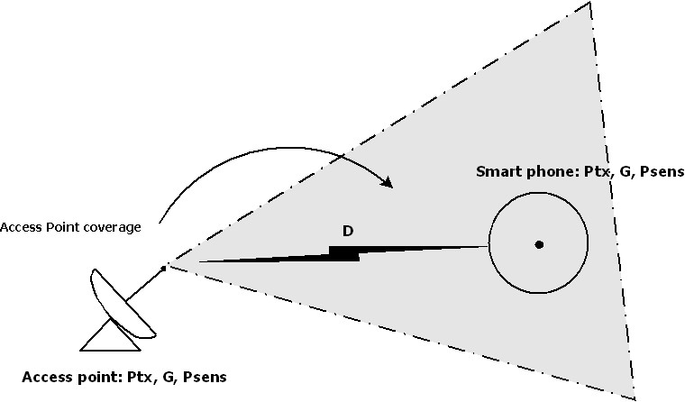
Figure 4: Proposed diagram to test range extension.

CONCLUSION
This paper proposes a hybrid network communication model over P2P and WIFI technologies. It combines benefits of those two technologies via android WIFI direct and WIFI low cost easy to install access points to solve problems related to the collapse of the communication and robustness of ubiquitous and distributed systems. This architecture model resolves device compatibility problem of WIFI direct by connecting non WIFI-direct devices, like apple Smart phones, to a WIFI standard network which is available on all mobile devices. Therefore, investments to develop new compatible technologies on other devices are saved. Also, a solution for the small coverage of P2P networks and the necessity to have continuity of P2P devices to reach all needed zone is proposed. The extended range of WIFI AP can expand coverage to uncovered zone like buildings, rivers, trees, and uncovered zones by WIFI AP can be reached by neighbors P2P devices. This AP is easy to install and to power up; it can be integrated with other equipments of emergency team in a future work. The coverage can be optimized by adequate choice of frequency, installation site and antenna. A complete implementation and testing of this model will be done in the future research. Finally, we have to argue that this kind of research is needful because it has a humanist side which could mitigate the damage caused by disasters.

ACKNOWLEDGMENTS
This work is supported by the Department of Computer Science and Mathematics at the University of Quebec at Chicoutimi, Quebec Canada.

REFERENCES
- National Commission on Terrorist Attacks Upon the United States. 2004. The 9/11 Commission Report: final Report of the National Commission on Terrorist Attacks Upon the United States (Authorized Edition). (W.W Norton & Co.: New York)
- Kayal M and Wald M L. “Asia’s Deadly Waves: At Warning Center, Alert for the Quake, None for Tsunami.” New York Times December 28, 2004.
- Anthony M. Townsend and Mitchell L. Moss."telecommunication during disatsres " Center for Catastrophe Preparedness and Response, New York 2005.
- Nabil Ammar Tabbane. "Modèles Stochastiques pour la Prévision de la Qualité de Service dans les Réseaux Ad Hoc Multimédia". THÈSE 2006.
- Brent Ishibashi, and RaoufBoutaba "Topology and mobility considerations in mobile ad hoc networks",Elsevier. 2004.
- Derek Ferro, and Bill Rink, “Understanding Technology Options for Deploying WIFI". Technical paper 2014.
- Lee, B. G. & Choi, S. (2008) ‘Broadband wireless access and local networks: mobile WiMAX and WIFI’. London: Artech House."
- Camps-Mur, D., Garcia-Saavedra, A. & Serrano, P. (2013) ‘Device-to-device communications with WIFI Direct: overview and experimentation’. WirelessCommunications, IEEE, 20(3), pp. 96-104.
- OndreyHyncica et al, 2005, Wireless Standards for Mobile Platform, WSEAS, Stevens Point, Wisconsin, USA.
- Jin-Shyan Lee et al., 33rth Annual Conference of IECON, A Comparative Study of Wireless Protocols: Bluetooth, UWB, ZigBee and WIFI, November, 2007.
- Apple Inc., http://www.apple.com/iphone/specs.html, May 2012
- Nokia, http://www.developer.nokia.com/Devices/ Device_ specifications/N97/, May 2012.
- Sony, http://www.sonymobile.com/globalen/ products/phones/xperia-p/specifications/, May 2012.
- Mohamad Dbouk, Hamid Mcheick, and Ihab Sbeity. CityPro; An integrated City Protection Collaborative Platform, The 5th International Conference on Emerging Ubiquitous Systems and Pervasive Networks (EUSPN-2014), Proceeding published by Elsevier, September 22-25, Halifax, Canada, 2014.
- G. P. Hancke, B. de Carvalho e Silva, and G. P. H. Jr., "The Role of Advanced Sensing in Smart Cities," Sensors, vol. 13, pp. 393-425, 2013.
- Kyas, O.: "Network Troubleshooting, .Palo Alto California, Agilent Technologies", 2001.
- Hudyma R., Fels, D.I.: "Causes of failure in IT telecommunications networks". Proceedings of SCI 2004. Florida. pp.35-38.
- Jérôme ROUSSELOT: "Ultra Low Power Communication Protocols for UWB Impulse Radio Wireless Sensor Networks", These 2010.
- HichamAjami and Hamid Mcheick, Emergency network Prototype, Proceeding of the 5Th Annual DIVA Workshop, NSERC-DIVA Network, DIVA research strategy network, Eds. A Boukerche& R. De Grande, pp. 52-56, February 16-18, 2016, Ottawa, Canada.
- Bernard Slar: Digital Communications: Fundamentals & Applications, Second Edition, December 2005.
- X. L. Sun, S. W. Cheung andT. I. Yuk: A compact monopole antenna for WLAN applications, Microwave and Optical Technology Letters Volume 56, Issue 2, pages 469–475, February 2014
- BroadcomBCM4334 radio chip datasheet, April 2016 : http://www.embeddedworks.net/wlan490.html
- Ubiquit manufacturer used as an example to show access point radio performance: https://dl.ubnt.com/datasheets/rocketm/RocketM_DS.pdf
- Ubiquity manufacturer, airmax access points https://dl.ubnt.com/datasheets/airmaxsector/airMAX_Sector_Antennas_DS.pdf

