**CHARACTERIZATION OF PETROLEUM COKE AND BUTTS USED IN ANODE MANUFACTURING IN ALUMINUM INDUSTRY**

Arunima Sarkar1, Duygu Kocaefe1, Yasar Kocaefe1, Dipankar Bhattacharyay1, Brigitte Morais2, Martin Pouliot2

1University of Quebec at Chicoutimi, Dept. of Applied Sciences, 555, boul. De l’Université, Chicoutimi, Québec, Canada G7H 2B1

2Aluminerie Alouette Inc., 400, Chemin de la Pointe-Noire, C.P. 1650, Sept-Îles, Quebec, Canada, G4R 5M9

**Abstract**

Prebaked anodes are produced from aggregates (calcined coke, recycled butts and anodes) and binder pitch. Good binding between aggregates and pitch results in dense anodes and has a direct impact on the electrical resistivity. The quality of coke and butts has a strong influence on anode properties. A comprehensive study of the physical and chemical interactions taking place during mixing allows a better understanding of the important factors and helps determine conditions that will lead to improved anode properties.

The objective of this research is to characterize the surface properties of a calcined petroleum coke and butt particles and then relate them to their wettability by pitch. The wetting tests were carried out using the sessile drop method. Further investigations were carried out using SEM, FTIR, and XPS. In the article, the results of this study is presented and discussed.

Keywords: Petroleum coke, carbon anodes, surface characterization, wetting, SEM, FTIR, XPS.

**Introduction**

In Hall-Héroult cells, carbon anodes are used to reduce alumina for the production of aluminium. The unused part of carbon anode is known as anode butts. Prebaked anodes consist of about 65-68% petroleum coke, 15-25% anode butts, and 13-15% coal tar pitch. [[1](#_ENREF_1), [2](#_ENREF_2)]. Binder pitch should provide satisfactory bond between dry aggregates (coke and anode buts). Wettability of coke and anode butt particles by pitch determines the quality of bonding between these two components, and thereby greatly affects the final anode properties. The interaction between dry aggregates and pitch depends on the pitch characteristics such as softening point, chemical composition, surface tension, viscosity, and the dry aggregate characteristics such as particle size, texture, chemical functional groups at the surface, and porosity [[3](#_ENREF_3)]. The butt surface chemistry may differ significantly from that of petroleum coke because it is already mixed with pitch and has undergone physical and chemical modifications during baking and electrolysis. The surface chemistry of the butt may be changed as the bottom part is exposed to cryolite in the cell and subjected to CO2 reactivity. In addition, the top portion is affected because of the oxidation due to air reactivity [[2](#_ENREF_2)]. It is cited in different references that the wettability and the penetration characteristics of pitch with coke is different than those with anode butt. Prouix [[4](#_ENREF_4)] observed that the optimal binder demand increases about 1% due to the absence of recycled anode butts. The average pitch film thickness on the butt surface is found to be smaller than that found on coke surface [[5](#_ENREF_5), [6](#_ENREF_6)]. These show that liquid pitch penetrates more easily through accessible porosity due to lower surface energy which results in a thinner film thickness on the surface of the butt [[6](#_ENREF_6)]. The characterization of the surface properties of the raw materials can help explain this behavior. Adams [[7](#_ENREF_7)] found that the carboxyl, lactonic, and phenolic functional groups are present in higher amounts on anode recycled butt surface than on petroleum coke surface by performing a selective neutralization technique using different bases. Different authors studied the chemical structures of green petroleum cokes by different analytical methods which include SEM, optical microscope, FT-IR, and XPS [[8-14](#_ENREF_8)]. However, there isn’t any published work on the utilisation of these techniques on recycled anode butts.

The aim of this project is to identify the wetting behaviour of recycled anode butts and petroleum coke. The work involves the characterization of the butt surface properties by FTIR, SEM, optical microscope, and XPS, their correlation with the wetting results, and the comparison of the results with those of petroleum coke.

**Methodology**

Sessile Drop System

Several investigations were reported in the literature on the determination of wetting between pitch and coke using the sessile-drop analysis method. The sessile-drop technique involves placing a drop of liquid pitch on a coke bed or positioning a solid pitch sample on a coke bed and heating the furnace to the desired temperature under inert gas atmosphere. The change of contact angle with time is recorded with a video camera for further analysis [[3](#_ENREF_3), [15-19](#_ENREF_15)].

Pitch/coke wetting is important because it provides information on their interactions during the mixing stage of anode manufacturing. The degree of wettability can be described in terms of the contact angle formed between solid and liquid surfaces. The contact angle is a measure of the ability of a liquid to spread and penetrate on a surface. Wetting can be physical due to intermolecular interactions known as adhesive and cohesive forces or can be chemical due to a reaction at the interface. Wetting coke by pitch is a function of temperature and time. With increasing time and temperature, wetting is improved [[3](#_ENREF_3), [6](#_ENREF_6), [15-19](#_ENREF_15)] .

In this study, the wettability of butt and petroleum coke by a coal tar pitch was studied using the sessile drop method as shown in Figure 1. The solid particle size was 125 μm. The experiments were carried out under high purity argon atmosphere. After the experiments, the drop and the solid were cut vertically and studied with different techniques as explained below.

Optical Microscope

The optical microscope allows the examination of a larger surface area compared to the SEM technique. The solidified pitch drop on calcined petroleum coke or recycled anode butt after the sessile-drop tests were sectioned vertically and polished for image analysis of larger surface area at the pitch-coke or pitch-butt interface using the optical microscope. This allows the visualisation of pitch penetration through the particles. The calcined petroleum coke and recycled anode butt structures as well as the interface of the drop samples were studied by Nikon Eclipse ME600P optical microscope and analysed by Clemex Vision 4.0 image analysis software.

  
Figure 1 Schematic Diagram of the Sessile-Drop Experimental Set-up at UQAC

Scanning Electron Microscope (SEM)

The scanning electron microscopy (SEM) is a highly useful technique to study the detail and inherent structural analysis of coke [[13](#_ENREF_13), [14](#_ENREF_14)] and butt samples on a smaller scale. It illustrates the chemical composition of the calcined petroleum coke and recycled anode butt by EDS analysis. The SEM analysis was carried out using JEOL-JSM-6480LV with secondary electron scattering and with a voltage of 20 kV and WD is 12mm.

FT-IR Analysis

The chemical structure of calcined petroleum coke and recycled anode butt samples were examined by FT-IR spectroscopy at room temperature. FT-IR is powerful tool to detect different functional groups based on bond energies. FT-IR can also detect different hybridization of carbon present in CH bonds and can also identify aromatic and aliphatic hydrocarbons which are difficult to analyze in XPS. IR spectra were collected in the wave number range of 500–4000 cm−1 and all the spectra were recorded at 4 cm−1 resolution. Each time, 20 scans were carried out prior to the Fourier transformation. All spectra were collected using the DRIFTS (Diffuse Reflectance Infrared Fourier Transform Spectroscopy) technique (Perkin Elmer Instument, Spectrum one), and all the results were averaged over four experiments. DRIFTS technique was used with an aperture mask of 2 mm diameter and a reflector angle of 16°. All spectra were analyzed using the Spectrum version 5.0.1 software. The effective depth of the surface scanning was 0.5-5 microns.

XPS Analysis

Recycled anode butt and calcined petroleum coke samples were studied by AXIS Ultra XPS spectrometer (Kratos Analytical) using Mono-chromate Al K[α] (h [upsilon] = 1486.6 eV) source at a power of 210 W at the Alberta Centre for Surface Engineering and Science (ACSES), University of Alberta. The XP-spectra fitting was performed using the CASAXPS software. The analysed surface depth of the sample was 2-5nm. XPS analysis provides information about the distribution of different atoms on the surface based on their binding energy [[20](#_ENREF_20)]. High-resolution spectra give an idea about the nature of bonds and component analysis. It can give quantitative information about different functional groups such as COOH, C=O, C-OH, C-C, and C=C[[21](#_ENREF_21)].

**Results and Discussions**

Wettability

The contact angle measurements of coal tar pitch on the dry aggregate (petroleum coke and recycled anode butt) are essential for understanding the idea about the mixing time required for each aggregate to be wetted as much as possible for given system. Figure 2 compares the petroleum coke and recycled anode butt dynamic contact angles with a coal tar pitch. The initial contact angle of calcined petroleum coke and recycled anode butt differs by 9º. The wettability increases (contact angle decreases) with time for both coke and butt. Recycled anode butt has a lower contact angle compared to petroleum coke at all times, showing that the butt is wetted better than the coke by pitch. It is observed that the contact angle for recycled anode butt decreases very rapidly and pitch completely penetrates through the butt surface within 133 s (0º contact angle). On the other hand, the final contact angle was found to be 18º for petroleum coke even after 1500 s.

**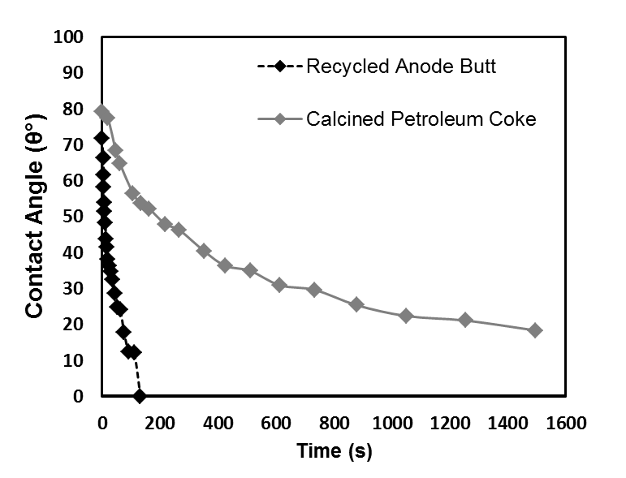**

Figure 2 Comparison of the wettability of butt and calcined petroleum coke by coal tar pitch

The wettability tests give information not only on the penetration of the liquid into the solid substrate but also on the spreading of the liquid on the substrate. The spreading of pitch on the recycled anode butt was found to be faster than the spreading on the petroleum coke. In order to investigate the penetration characteristic of coal tar pitch, the images of the pitch drop as well as the sections of the anode butt and petroleum coke samples were taken using an optical microscope after the wettability tests. Figures 3(a) and (b) show that the penetration into both petroleum coke and recycled anode butt is good, and there is good adhesion between the particle and the pitch for both. Contact angle vs. time data might also indicate the mixing time required for the coke to be wetted as much as possible for a given system.

Assessment of Interface with Optical Microscope

The optical microscopy of the sessile drop sections provides useful information on the distribution of the coal tar pitch within the butt and the petroleum coke since it is possible to observe relatively large areas at low magnification. This makes the comparison of coke-pitch and anode butt-pitch interfaces possible from the samples obtained after the wettability tests carried out at 170ºC. Optical microscopy images show good adhesion for both cases, and pitch penetrates completely through the recycled anode butt particles (see Figure 3).

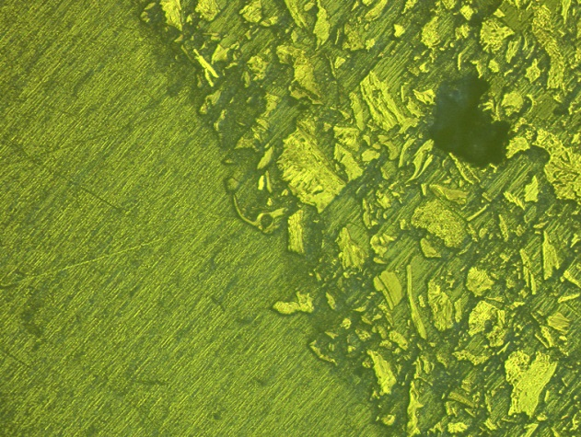Z:\PC\PC_old\publications\CARBON\COM2013\arunima\12C.tif

**(b)**

**(a)**

**Butt**

**Pitch**

**Pitch**

**Coke**

Figure 3 Optical microscopy analysis of the sessile drop interface: (a) coke-pitch (b) butt-pitch

Scanning Electron Microscope (SEM) Analysis of Structure of Coke and Anode Butt

Figures 4(a) and (b) show the SEM images of the calcined petroleum coke and recycled anode butt samples, respectively. Coke surface contains pores and cracks, and the presence of well aligned basal layers of carbon is evident. The dimensions of some pores are very small although there are also larger pores. The presence of very small pores prevent the penetration of pitch into coke particles [[22](#_ENREF_22)] and reduces the wetting of coke by pitch. Recycled anode butt surface also contains different size pores. Tran and Bhatia [[23](#_ENREF_23)] stated that the micro-pore area decreases with heat treatment at higher temperature as a result of increase in the graphitization level of coke. Also, the butt particles already contain pitch carbonized previously during baking in some of its pores. Therefore, anode butt might contain less micro-pores and different surface characteristics which might lead to higher wetting compared to coke.

SEM/EDS analysis was performed to study the surface chemistry of the coke and the butt. The presence of sodium on butt surface confirmed the sodium penetration into the anode during electrolysis. It is also possible that the presence of different impurities and greater amount of oxygen on butt surface might enhance the chemical wetting and lower the contact angle compared to that of coke. Presence of Cu and Au in petroleum coke sample comes from gold coating used during the sample preparation for SEM analysis. The results of EDS analysis of anode butt and petroleum coke are given in Table 1.

D:\Carbon_image\COKE 1CM\7.tif D:\Carbon_image\butt\6.tif

(a)

(b)

Figure 4. SEM image analysis of (a) petroleum coke and (b) recycled anode butt

Table 1. Chemical composition of recycled anode butt and petroleum coke by EDS analysis

|  |  |  |  |  |
| --- | --- | --- | --- | --- |
| Element | Recycled Anode Butt | | Calcined Petroleum Coke | |
| Weight% | Atomic% | Weight% | Atomic% |
| C | 87.21 | 91.51 | 89.95 | 95.01 |
| O | 8.76 | 6.90 | 4.61 | 3.65 |
| Na | 0.28 | 0.15 | - | - |
| S | 3.14 | 1.24 | 2.71 | 1.07 |
| K | 0.60 | 0.19 | - | - |
| Cu | - | - | 0.62 | 0.12 |
| Au | - | - | 2.11 | 0.14 |
| Total | 100.00 | 100.00 | 100.00 | 100.00 |

FT-IR Analysis

FT-IR analysis of recycled anode butt was carried out to identify different surface functional groups and also to compare with those of calcined petroleum coke. The assignments of the bands were performed based on the literature of FT-IR data for green coke [[8](#_ENREF_8), [12](#_ENREF_12)] and pitch [[24](#_ENREF_24), [25](#_ENREF_25)]. FTIR analysis of calcined petroleum coke and anode butt is not well documented. The calcined petroleum coke has very low transmission characteristics to baseline levels [[8](#_ENREF_8)]. Figure 5 shows the FTIR analysis of the anode butt and coke samples. It is evident from Figure 5 that FTIR spectra of calcined petroleum coke and recycled anode butt are distinctly different from each other.

K:\COM 2013\articles\butt.tif

Figure 5 FTIR spectra of calcined petroleum coke and recycled anode butt by DRIFT technique

FTIR analysis shows the presence of aliphatic (2850-3000 cm-1) and aromatic (3000-3100 cm-1) hydro carbons, C-N/C-O (1200-1300 cm-1), C-O stretch for ester/ ether/alcohol (950-1150 cm-1), substituted aromatic C-H (700-900 cm-1), CN (2100-2160) in both coke and anode butt.

Anode butt and petroleum coke, both contain COOH functional group as evident from the transmittance bands around 3530 cm-1and 1126 cm-1. At around 3040 cm-1 transmittance band, petroleum coke shows the presence of aromatic CH in sp2 hybridized state whereas this bond is missing in recycled anode butt. Peak around 2100-2160 cm-1 for anode butts appears to be mainly due to presence of nitrile groups. There is also a possibility of a small peak for C≡C (2130-2150 cm-1) in this region. This peak is not significant in the case of calcined petroleum coke. Peak at 2349 cm-1 transmittance band is due to CO2 which was not considered for analysis.

Since the petroleum coke, anode butt, and coal tar pitch contain complimentary functional groups, there is a possibility that the functional groups on the coke and butt surfaces might interact with those present in pitch. Polycyclic aromatic hydrocarbons (PAH) are predominant in pitch. Also, alkylated PAH, PAH with cyclopenteno moieties, partially hydrogenated PAH, oligo-aryl methanes, hetero-substituted PAH: NH2, OH, carbonyl derivatives of PAH, polycyclic hetero-aromatic compounds are found in pitch [[7](#_ENREF_7), [12](#_ENREF_12), [24](#_ENREF_24)]. This shows that there is a possibility of the formation of electrostatic as well as hydrogen bonds between coke or butt and pitch during wetting.

XPS Analysis

FT-IR analysis is used to identify the chemical functionality of the calcined petroleum coke and the recycled anode butt. Data acquired from FT-IR analysis are used to perform the de-convolution of C1s peak. The de-convoluted C1s spectrum for anode butt is very different than that for petroleum coke. XPS spectra of anode butt comprises of a separate large peak for C-C at 285.5 eV. Atomic percentages of different components of calcined petroleum coke and recycled anode are presented in Table 3 for the survey spectra and de-convoluted C1s spectrum. The de-convoluted C1s spectra of calcined petroleum coke and recycled anode butt are illustrated in Figure 6. From this figure it can be observed that butts have a significant amount of C-C which makes it different from coke. However, butts contain less amount of C=C compared to that of calcined coke. Usually C=C in aromatic compounds help wetting through electrostatic bond. Thus, C=C bonds in aromatic compounds need compounds with positive centres (such as NH4+) to establish an interaction. However, these kinds of electron-deficient functional groups are not present in notable quantity in anode materials. Thus, the low amount of C=C in butts do not significantly affect the wettability. It is evident from the XPS results that recycled anode butts contain higher amounts of heteroatoms (O, N) and sodium (Na) compared to those in calcined petroleum coke (see Table 2). The functional groups with heteroatoms may form covalent/ hydrogen bonds with conjugate functional groups and assist wetting. Thus, the difference in the amount of heteroatoms in coke/butts might explain the difference in their wettability by pitch.

**Table 2.** Atomic percentages of different components of calcined petroleum coke and recycled anode butt

|  |  |  |  |  |  |  |  |  |  |  |  |  |
| --- | --- | --- | --- | --- | --- | --- | --- | --- | --- | --- | --- | --- |
| **Sample** | **C(%)** | | **Carbon components** | | | | | **O(%)** | | **N(%)** | **S(%)** | **Na%** |
|  |  | | **C=C** | **C-C** | **CN/CO/CS** | **C=O** | **COO** | |  |  |  |  |
| **Coke** | | 95.4 | 87.22 | 9.73 | 2.23 | 0.75 | 0.43 | | 2.95 | 0.95 | 0.68 | - |
| **Butt** | | 90 | 50.69 | 29.57 | 5.60 | 8.34 | 4.60 | | 7.46 | 1.15 | 0.40 | 0.99 |

The greater the oxygen percentage is, the higher is the possibility of forming bonds between recycled anode butt and pitch functional groups; consequently, the wettability increases with increasing oxygen percentage. As it is well-known, bonds containing oxygen and nitrogen are more reactive. Also, the presence of greater amount of COOH plays a significant role in the initiation of chemical reactions. Therefore, it is possible that calcined petroleum coke forms fewer chemical bonds with pitch compared to recycled anode butt at 170°C due to the differences in the functional groups present on their surfaces. The lower nitrogen concentration in coke can be attributed to the presence of lower concentration of amine groups, which results in lower wetting.

**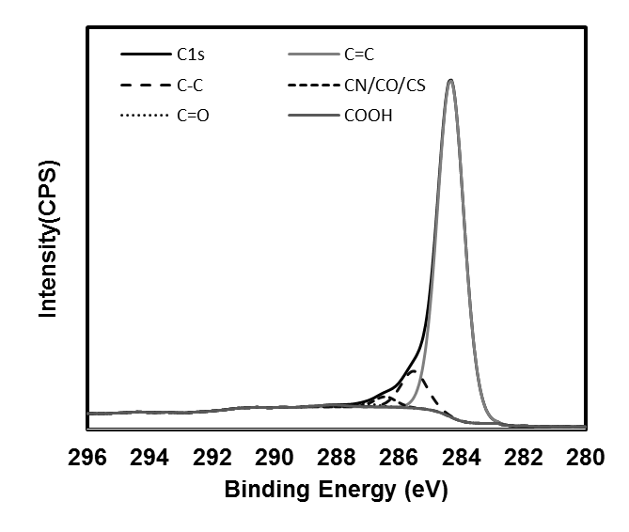**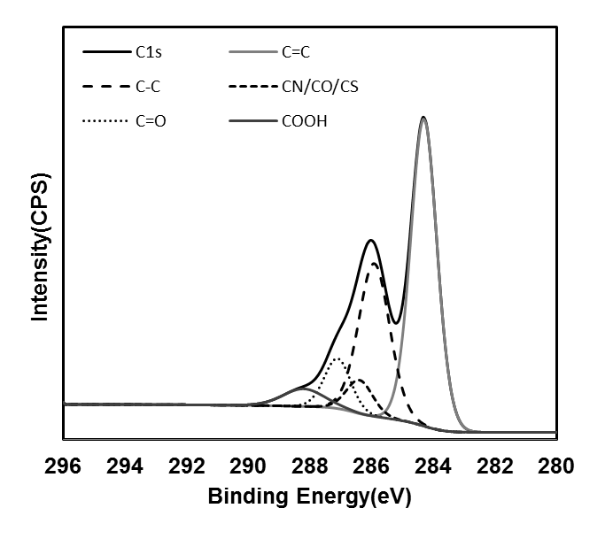

(a)

(b)

Figure 6De-convoluted C1s peaks of (a) Coke and (b) Recycled anode butt

**Conclusions**

The results showed that the butt particles have a lower contact angle; consequently, they are better wetted by pitch than the coke particles for the samples studied. Optical microscopy revealed the higher penetration of pitch through the butt particles compared to that of petroleum coke. This behavior may be the result of the presence of more oxygen containing functional groups in the anode butt compared to the coke. FT-IR analysis indicated the presence of surface functional groups in both coke and anode butt which can provide chemical bonding with coal tar pitch leading to wetting. SEM and XPS results show in butt samples the presence of Na and K due to anode’s exposure to cryolite as well as higher concentration of oxygen containing functional groups resulting from air and CO2 reactivities[[7](#_ENREF_7)].

**Acknowledgements**

The technical and financial support of Aluminerie Alouette Inc. as well as the financial support of the National Science and Engineering Research Council of Canada (NSERC), Développement économique Sept-Îles, the University of Québec at Chicoutimi (UQAC), and the Foundation of the University of Québec at Chicoutimi (FUQAC) are greatly appreciated.

**Reference**

1. Belitskus, D., *Effect of carbon recycle materials on properties of bench scale prebaked anodes for aluminum smelting.* Metallurgical Transactions B, 1981. **12**(1): p. 135-139.

2. Suriyapraphasilok, U., et al. *Physical, chemical and X-ray Computed Tomography characterization of anode butt cores*. 2005.

3. Rocha, V.G., Blanco, C., Santamaría, R., Diestre, E. I., Menéndez, R., Granda, M., *Pitch/coke wetting behaviour.* Fuel., 2005. **84**(12-13): p. 1550-1556.

4. Prouix, A.L., *Optimum binder content for prebaked anodes.* Light Metals., 1993: p. 657-661.

5. Adams, A.N., Mathews, J. P., Schobert, H. H., *The use of image analysis for the optimization of pre-baked anode formulation.* Light Metals., 2002: p. 547-552.

6. Adams, A.N., *Characterization of the pitch wetting and penetration behavior of petroleum coke and recycled butts in pre-baked carbon anode*, in *The Department of Energy and Geo-Environmental Engineering*. 2004, Pennsylvania State University: Pennsylvania. p. 1-220.

7. Adams, A.N., Schobert, H. H., *Characterization of the surface properties of anode raw materials.* Light Metals., 2004: p. 495-498.

8. Menéndez, J.A., Pis, J. J., Alvarez, R., Barriocanal, C., Fuente, E., Díez, M. A., *Characterization of petroleum coke as an additive in metallurgical cokemaking. Modification of thermoplastic properties of coal.* Energy and Fuels,, 1996. **10**(6): p. 1262-1268.

9. Tran, K.N., Berkovich, A. J., Tomsett, A., Bhatia, S. K., *Influence of sulfur and metal microconstituents on the reactivity of carbon anodes.* Energy and Fuels., 2009. **23**(4): p. 1909-1924.

10. Blyth, R.I.R., Buqa, H., Netzer, F. P., Ramsey, M. G., Besenhard, J. O., Winter, M., *X-ray photoemission studies of surface pre-treated graphite electrodes.* Journal of Power Sources., 2001. **97-98**: p. 171-173.

11. Blyth, R.I.R., Buqa, H., Netzer, F. P., Ramsey, M. G., Besenhard, J. O., Golob, P., Winter, M., *XPS studies of graphite electrode materials for lithium ion batteries.* Applied Surface Science., 2000. **167**(1): p. 99-106.

12. Lee, S.H., Choi, C. S., *Chemical activation of high sulfur petroleum cokes by alkali metal compounds.* Fuel processing technology., 2000. **64**(1): p. 141-153.

13. Hays, D., J.W. Patrick, and A. Walker, *SEM characterization of cokes and carbons.* Fuel, 1983. **62**(9): p. 1079-1083.

14. Hays, D., J.W. Patrick, and A. Walker, *SEM study of binder coke in electrode carbon.* Fuel, 1983. **62**(8): p. 946-952.

15. Mirchi, A.A., Savard, G., Tremblay, J. P., Simard, M., *Alcan characterisation of pitch performance for pitch binder evaluation and process changes in an aluminium smelter.* Light Metals., 2002: p. 525-533.

16. Couderc, P., Hyvernat, P.,Lemarchand, J. L., *Correlations between ability of pitch to penetrate coke and the physical characteristics of prebaked anodes for the aluminium industry.* Fuel., 1986. **65**(2): p. 281-287.

17. Lahaye, J., Ehrburger, P., *Pitch-coke interactions.* Fuel., 1985. **64**(9): p. 1187-1191.

18. Rocha, V.G., Blanco, C., Santamaría, R., Diestre, E. I., Menéndez, R., Granda, M., *An insight into pitch/substrate wetting behaviour. The effect of the substrate processing temperature on pitch wetting capacity.* Fuel., 2007. **86**(7-8): p. 1046-1052.

19. Rocha, V.G., Blanco, C., Santamaría, R., Diestre, E. I., Menéndez, R., Granda, M., *The effect of the substrate on pitch wetting behaviour.* Fuel Processing Technology., 2010. **91**(11): p. 1373-1377.

20. Estrade-Szwarckopf, H., *XPS photoemission in carbonaceous materials: A "defect" peak beside the graphitic asymmetric peak.* Carbon, 2004. **42**(8-9): p. 1713-1721.

21. Metzinger, T. and K.J. Hüttinger, *Investigations on the cross-linking of binder pitch matrix of carbon bodies with molecular oxygen - Part I. Chemistry of reactions between pitch and oxygen.* Carbon, 1997. **35**(7): p. 885-892.

22. Belitskus, D., Danka, D. J., *Comprehensive determination of effects of calcined petroleum coke properties on aluminum reduction cell anode properties.* Light Metals., 1989: p. 429-442.

23. Tran, K.N., Bhatia, S. K., Tomsett, A., *Air reactivity of petroleum cokes: Role of inaccessible porosity.* Industrial and Engineering Chemistry Research., 2007. **46**(10): p. 3265-3274.

24. Alcañiz-Monge, J., Cazorla-Amorós, D., Linares-Solano, A., *Characterization of coal tar pitches by thermal analysis, infrared spectroscopy and solvent fractionation.* Fuel., 2001. **80**(1): p. 41-48.

25. Guillén, M.D., Iglesias, M. J., Domínguez, A., Blanco, C. G., *Semiquantitative FTIR analysis of a coal tar pitch and its extracts and residues in several organic solvents.* Energy & Fuels., 1992. **6**(4): p. 518-525.