A DYNAMIC PROCESS MODEL FOR SIMULATING HORIZONTAL ANODE BAKING FURNACES
Noura Oumarou¹, Duygu Kocaefe¹, Yasar Kocaefe¹,
Brigitte Morais², Jérôme Chabot²

¹University of Quebec at Chicoutimi, Dept. of Applied Sciences, 555, boul. de l’Université, Chicoutimi, Québec, Canada G7H 2B1

²Aluminerie Alouette Inc., 400, Chemin de la Pointe-Noire, C.P. 1650, Sept-Îles, Québec, Canada, G4R 5M9

Abstract
Anode manufacturing is an important step during the production of primary aluminum, and baking is the costliest stage of the anode manufacturing process. The industrial challenge resides in obtaining a good anode quality while keeping the energy consumption, environmental emissions, and cost to minimum.

A dynamic process model of a horizontal anode baking furnace has been developed. It covers all important parameters such as fuel combustion, generation and combustion of volatiles (tar, methane, and hydrogen), air infiltration, and heat losses to the atmosphere and the foundation. The model was built using two coupled sub-models of the flue and the pit and was validated using plant data. It simulates the dynamic behavior of the furnace and gives a prediction of its operation and performance. In this article, the modelling approach will be described, and the results showing some of the industrial applications will be presented.

Keywords: horizontal anode baking furnace, carbon anodes, dynamic model, process model, anode manufacturing

Introduction
The anode manufacturing is one of the important components of the aluminum production cost. A green anode is typically composed of a mixture of about 65% petroleum coke with variable particle sizes, 15% liquid pitch for binding, and 20% crushed anode butts [1]. After the mixing and compacting operations, the green anodes are cooled and stored until they are baked in large furnaces. The anode baking stage is the most costly step of the anode manufacturing process and affects the final anode quality significantly. This quality depends also on the raw material properties as well as all the process parameters. The baking process should be carried out appropriately.

The green anodes are baked in large furnaces, usually called ring furnaces referring to their original structure. There are generally two different types of baking furnace designs used in the aluminum industry: the open top furnace (horizontal flue) and the closed top furnace (vertical flue). These furnaces act as high temperature heat exchangers involving indirect heating by the combustion of natural gas or oil. One furnace can contain 34 (two fires groups) to 70 (four fires groups) sections arranged in two parallel rows connected at each end by a crossover (Figure 1). Each section (chamber) contains four to eight parallel pits enclosed between two flues. Anode blocks are placed in the pits and are surrounded by filler coke to protect them against oxidation by the flue gas or air and to provide heat transfer from the flue wall to the anodes blocks. After each fire cycle, the ramps of burners, exhaust, and cooling manifolds are shifted together to the next section in the flue gas flow direction. During the baking process, the temperature within anodes rises and reaches its highest value (1000 to 1200°C) as the burners approach. The anode baking furnace design and operation must be optimised to obtain appropriate anodes properties required for the reduction of alumina by electrolysis.

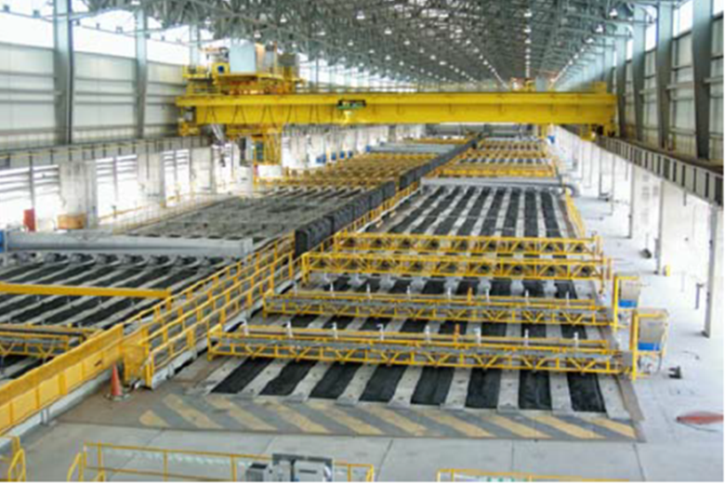
Figure 1 : A horizontal anode baking furnace in operation [2]
The mathematical modeling has become an important tool to study the behavior of ring furnaces for any parameter optimization or design changes. In general, it is difficult to make detailed measurements around the furnace due to limited accessibility and high cost and duration involved. A reliable model helps avoid this limitation by giving detailed information on various parameters such as the distributions of solid and gas temperatures. A comprehensive review of various modelling approaches is given in reference [3].

The active work on the mathematical modelling of anode baking furnaces started at the beginning of the 1980’s with relatively simple approaches [4-6]. The developments in numerical modelling and computing capacity (memory and speed) became increasingly important. This allowed the apparition of more sophisticated models in the literature [7-10]. A full 3D transient model was reported in mid-1990’s [11]. Later on, many models of varying complexity, but similar in nature to these early works have been published [12-15]. Mathematical modelling has become a key tool in the improvement of furnace operation and design.

In the current article, the development of a dynamic process model will be presented. In all previous process models reported, the flue gas flow is considered as unidirectional along the furnace length. The difference appears only in the treatment of solid parts (pit containing anodes and filler coke plus the refractory wall separating the pit from the flue). The heat transfer trough the solid part is solved on a line in the horizontal direction [9], on a vertical plane [6 16] or on a horizontal plane [15] along the furnace. However, in the real furnace, due to the presence of baffles, the gas flow is mainly vertical as seen in Figure 2.

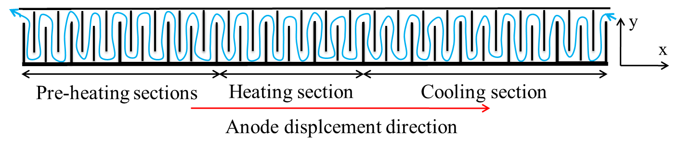
Figure 2 : A schematic view of the gas flow in a horizontal anode baking furnace
In this paper, to have a more realistic representation of the phenomena taking place in the flue, the gas flow is considered vertical all along the furnace length as shown on Figure 3. The advantage of this configuration is that the temperature distribution in the flue (gas and brick wall surface) is represented in 2D (variation in the vertical and horizontal directions).

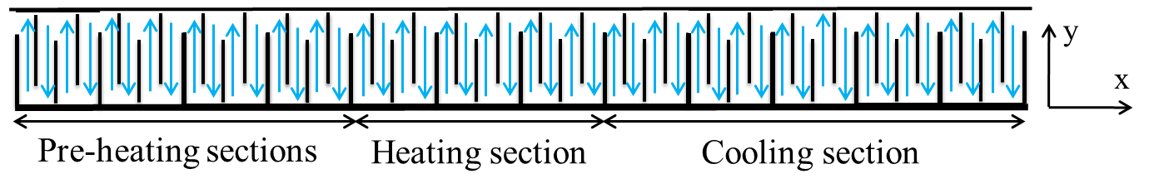
Figure 3 : A schematic of the flow representation considered in the model
Mathematical Model
The dynamic process model presented in this article is built into two steps. First, the pit sub-model and the flue sub-model were developed separately; and then, the two models were coupled via an interface at the brick surface on the flue side. The control volume representing half of pit and half of a flue is shown in Figure 4. One important point is that the layers of packing coke on the pit top and bottom are considered in the current model. These packing coke layers, neglected in some published works, play an important role in calculating heat losses.

The pit sub-model solves for the problem of heat transfer (conduction) through the solids (refractory brick, packing coke, and anode block). This sub-model takes into account also other phenomena occurring during the baking process: volatile evolution (tar, methane, and hydrogen); heat losses from the top to ambient air and surroundings as well as from the bottom to the foundation [17].

In the flue sub-model, a reacting flow (combusting medium) combined with heat transfer involving conduction, convection, and radiation, has been solved. In the equations, the energy input due to the combustion of fuel and volatiles matters as well as the heat loss from the top (to the ambient atmosphere) and the bottom (to the foundation) were considered. Each flue consists of four parts (due to the presence of baffles), and each part is divided vertically into many cells. On each cell, overall mass, chemical species, and energy balances are carried out assuming pseudo steady-state condition. This is updated at each time step accounting for the transient nature of the process.

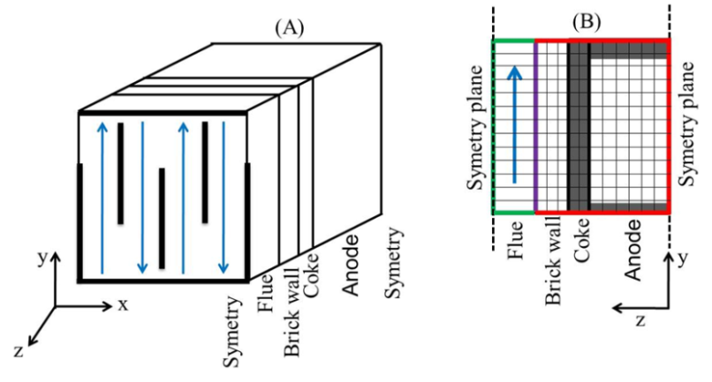
Figure 4 : A schematic view of the model control volume of the baking furnace
The two sub-models (pit sub-model and flue sub-model) are coupled via an interface located on the brick wall surface of the flue. During simulation, the calculations on the flue side are carried out for all sections within the entire cycle using the brick wall temperatures as the boundary condition. Then, using the heat fluxes as the boundary condition, pit side equations are solved on a number of selected vertical planes. This could be four planes per section corresponding to the four parts of the flue sub-model due to baffles.

For both flue and pit sub-models, the equations are solved using an explicit Euler finite-difference method on a FORTRAN platform.

Results and discussion
The advantage of developing separately the pit and the flue sub-models allows the use of either one to analyze a specific problem for a horizontal anode baking furnace. First, some investigations were done only with the pit sub-model using constant and variable properties of the solids (refractory wall, filler coke, and anode blocks). A temperature profile obtained experimentally was applied on the brick surface. The solid properties at 400°C were considered as the values for constant properties of the solids. The temperature profiles through the solids during the baking process are presented in Figure 5 as a function of baking time. As the profiles indicate, the heat is transferred from the brick surface to the solids (refractory wall, filler coke, and anodes blocks).

The temperature profiles through the solids for both the constants and variables properties are presented in Figure 6 for comparison. In the model, if the material properties are considered constant, some information could be lost. Compared to the case with the constant properties, the temperatures within the solids are higher at a given baking time and the gradients are smaller for the variable properties (Figure 6). This sub-model can be used to investigate other operational parameters as well.

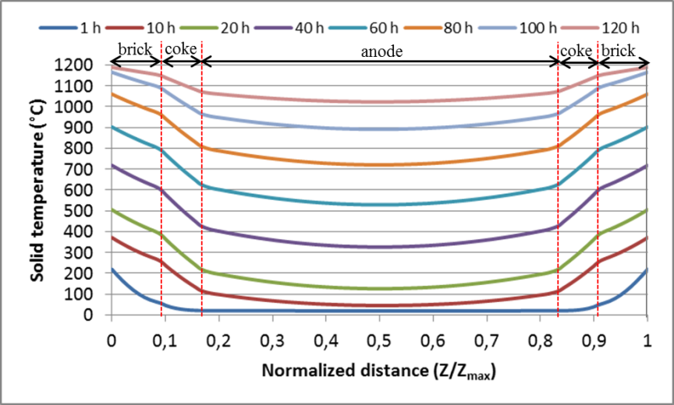
Figure 5 : Calculated temperature gradients through the solids at various baking times using constant properties.

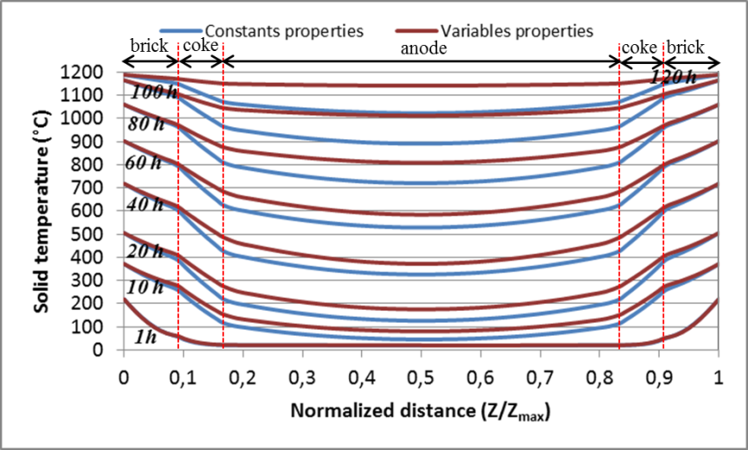
Figure 6 : Calculated temperature gradients through the solids at various baking times using variable properties.

After the development of the two sub-models (pit and flue) separately, they were coupled via an interface located at the brick wall surface on the flue side. The coupling is described schematically in Figure 7. This constitutes the global model for the horizontal anode baking furnace.

The calculated anode and gas temperature profiles predicted by the global model are presented in Figure 8. The model is able to give the temperature profiles of solids and gas and can be used to evaluate the furnace performance. Various cases are being considered to determine and reduce the energy consumption.
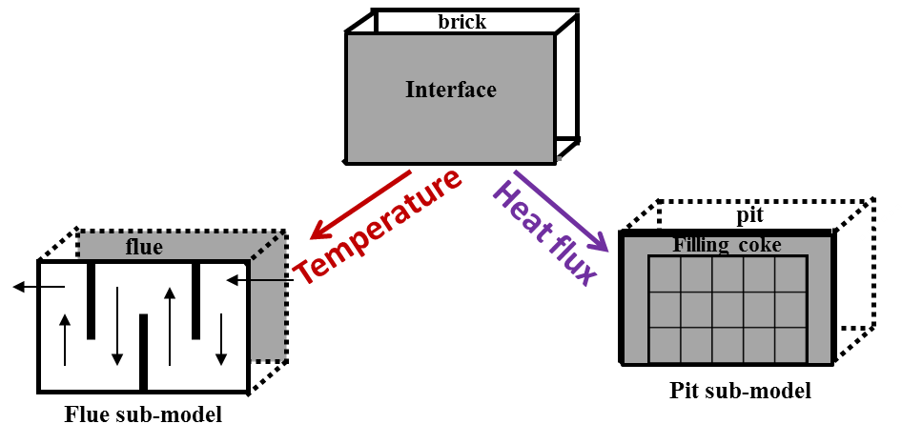
Figure 7 : Coupling of the two sub-models
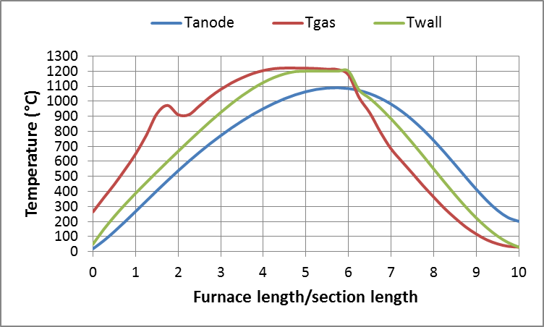
Figure 8: Calculated temperature evolution of the anode and the gas along the furnace.
Conclusions
Mathematical modelling is an important tool for understanding, testing, and optimizing the anode baking process in a horizontal anode baking furnace. A dynamic process model was built by coupling two sub-models (pit and flue) developed separately. It is shown that each sub-model can be used individually to study a specific parameter of the anode baking furnace. The model is used for various industrial applications.

Acknowledgements
The technical and financial support of Aluminerie Alouette Inc. as well as the financial support of the National Science and Engineering Research Council of Canada (NSERC), Développement économique Sept-Îles, the University of Québec at Chicoutimi (UQAC), and the Foundation of the UQAC (FUQAC) are greatly appreciated.

References
- Fisher, W.K., U. Mannweiler, F. Keller, R.C. Perruchoud, and U. Bûhler, 1995. Anodes for the aluminium industry, Sierre, Switzerland, R&D Carbon Ltd., 394 p.
- Raja Javed Akhtar, Markus W. Meier, Peter O. Sulger, Werner K. Fischer, Ralph Friedrich, Thomas Janousch, 2012. Anode quality and bake furnace performance of email, light metals 2012 (TMS); 1175-1179.
- Charette, A., Kocaefe, Y, Kocaefe, D., “Le carbone dans l’industrie d’aluminium”, La Presses de l’aluminium (PRAL), Chicoutimi, Quebec, Canada, 2012
- Furman A., Martirena, H., “A Mathematical Model Simulating an Anode Baking Furnace”, Light Metals (AIME), 1980, 545-552.
- Thibault, M.A., Bui, R.T., Charette, A., Dernedde, E., “Simulating the dynamics of the anode baking furnace”, Light Metal, 1985, 1141-1151.
- Bui R.T., Charette A. and Bourgeois T., “Performance analysis of the ring furnace used for baking industrial carbon electrodes”, The Canadian Journal of Chemical Engineering, 1987, 65, 96-101.
- Bourgeois T., Bui R.T., Charette A., Sadler B.A. and Thomsett A.D., “Computer Simulation of a vertical ring furnace”, Light Metals, 1990, 547-552.
- Jacobsen M., Melaaen M. Chr., “Heat and Mass Transfer in Anode Materials During Baking”, Light Metals, 1995, 681-690.
- Ouellet R., Jiao Q., Chin E., Celik C., Lancaster D., Wilburn D., “Anode baking furnace modeling for process optimization”, Light Metals, 1995, 653-662.
- Bui, R.T., Peter S., Charette A., Tomsett A.D., Potocnik V., “Modelling of heat transfer and gas flow in the vertical flue anode baking furnace”, Light Metals, 1995, 663-671.
- Kocaefe Y., Dernedde E., Kocaefe D., Ouellet R., Jiao Q., Crowell W.F., “A 3D mathematical model for the horizontal anode baking furnaces”, Light Metals,1996, 529-534.
- Zhang L., Zheng C., Xu M., “Simulating the heat transfer process of horizontal anode baking furnace”, Dev. Chem. Eng. Mineral Process., 2004, 12(3/4), 427-440.
- Severo D. S., Gusberti V., Pinto E. C. V., “Advanced 3D modelling for anode baking furnaces”, Light Metals, 2005, 697-702.
- Keller F., Mannweiler, U., Severo D. S., “Computational Modeling in Anode Baking”, R&D Carbon Ltd., Sierre, Switzerland, August 2006, 1-12.
- Severo D. S., Gusberti V., Sulger P., Keller F., Meier M.W., “Recent developments in anode baking furnace design”, Light Metals, 2011, 853-858.
- Zhang L., Zheng C., Xu M., Simulating the heat transfer process of horizontal anode baking furnace, Dev. Chem. Eng. Mineral Process., 2004, 12(3/4), 427-440.
- Kocaefe, Y., Oumarou, N., Baiteche, M., Kocaefe, D., Morais, B. and Gagnon, M. (2013) Use of Mathematical Modelling to Study the Behavior of a Horizontal Anode Baking Furnace, in Light Metals 2013 (ed B. A. Sadler), John Wiley & Sons, Inc., Hoboken, NJ, USA.

