MEASUREMENT OF ANODE ELECTRICAL RESISTIVITY FOR QUALITY CONTROL IN ALUMINIUM INDUSTRY

*D. Kocaefe, Y. Kocaefe, D. Bhattacharyay

University of Quebec at Chicoutimi (UQAC) Department of Applied Sciences
555, boul. de l’Université
Chicoutimi, Quebec, Canada G7H 2B11 (*Corresponding author: dkocaefe@uqac.ca)

ABSTRACT

The carbon anodes used in the electrolytic production of aluminum are made of petroleum coke, recycled anodes and butts, and coal tar pitch. Due to technological advances in the aluminum production technology, aimed at increasing production and decreasing energy consumption and greenhouse gas emissions, better quality anodes are required. Presently, the anode quality is evaluated by visual inspection and the analysis of a small core taken from 1.5-2% of the anodes produced. The visual inspection is susceptible to human error and limited to surface imperfections. The analysis of cores takes time, and therefore, it is difficult to determine the existence of a problem and intervene at the right time. In addition, the core does not represent the whole anode due to the non-homogeneity of anodes. A validated online anode quality control system can highly improve the situation. In this article, an electrical resistivity measurement method developed for this purpose is presented.

KEYWORDS

Carbon anodes, anode quality control, non-intrusive electrical resistivity measurement,
anode electrical resistivity, aluminum production
INTRODUCTION

Electrolytic aluminum production process requires the consumption of carbon anodes which must be replaced after 20-25 days. The anodes are made of dry aggregates (petroleum coke, recycled butts and green/baked anodes) and coal tar pitch which acts as the binder. The dry aggregate and pitch are mixed in a mixer or a kneader to make anode paste. Then, the anode paste is compacted using either a press or a vibro-compactor to form green anodes. Afterwards, the green anodes are baked in vast anode baking furnaces. After rodding, the baked anodes are ready for use in the electrolysis of alumina to produce aluminum.

The quality of anodes affects not only the stability of cell operation during alumina electrolysis, but also the greenhouse gas (GHG) emissions, the energy consumption, and the production cost. Currently, the anode quality is determined in industry by visual inspection (manual or automated) of the anode surface and by the analysis of a core sample taken from the upper part of 1.5-2% of the anodes produced. These approaches do not necessarily show the overall quality of the anodes.

The anodes are usually produced on site at the smelter. There are a number of problems the smelters commonly face during anode production which affect the cell performance. The presence of cracks in an anode causes an increase in anode electrical resistivity, and consequently in energy consumption during electrolysis. Inhomogeneity of pitch in a green anode leads to non-uniform baking of that anode, creating regions of high porosity which reduces the density and increases the electrical resistivity. High pitch levels in a green anode may give rise to problems such as anodes sticking together (which requires non-standard procedures to separate them), fire hazard, etc. in the baking furnace. In addition, large pieces of an anode may break and fall to the bottom of the bath (called an "anode accident") in the cell due to presence of large cracks. Such problems result in greater security risk and/or the temporary interruption of production, and hence significant productivity losses, higher production costs, and increased GHG emissions.

There are not many publications on this specific topic. A number of researchers have been working on the detection of anode defects and its application in industry as described below.

First work in the literature was published by Seger (1973, 1978) who developed a multiprobe electrode resistance measurement system which is nondestructive. At that time, the anodes had fewer stub holes (mostly one). He suggested applying a current (less than 250A) at the bottom of the stub hole with the intention of creating a current distribution within the anode, to some extent similar to the one in the cell in a smelter. Usually, the current passes from the sides of the stub hole during the actual operation due to the contraction and expansion of thimbles (almost no current passes through the bottom of a stub hole). A set of current probes were placed at the bottom and current passing from each probe was measured. Another set of voltage probes were similarly distributed. Only an average voltage drop was measured by means of a resistor network. The average anode resistance was determined by dividing the average voltage drop by the total current flow. He also tried to correlate the anode resistance (or voltage drop) measured at ambient temperature to that measured at actual operating temperature. The anode quality was essentially judged by the average resistance. Also, it is not possible to locate exactly the position of the defect increasing the anode resistance.

Chollier-Brym et al. (2012) applied the idea of Seger to the anodes with three stub holes, a commonly used configuration in many smelters today, to measure the anode electrical resistivity. The device is called MIREA (the French acronym for “Instantaneous measurement of electrical anode resistance”). Authors tried to recreate the current distribution during the operation of a cell in their measurements, in a manner more or less similar to Seger’s work (1973, 1978). In this version of MIREA, a current (200A) is applied to the walls of the stub holes by inflatable metallic bags, and the current passed through metallic brushes placed at the bottom of the anode. The voltage measurements are carried out between the reference probe and the probes located on the sides of the anode at different heights, which give an indication of the resistivities, consequently, the presence of defects. They found a good correlation between the measurement with MIREA and the resistivities measured from anode cores. It was possible to measure the resistivities of six anodes per hour with this system due to anode handling required. Therefore, it was not possible to measure every anode on-line. This system is designed only for baked anodes. Due to the positions of the probes, it is not possible to determine the defect location in the zone outside the region covered by the probes.

In 2014, Léonard et al. (2014) published the description of a second generation of MIREA. The measurement principle is similar to that of the previous version. However, the inflatable metallic bags were replaced by metallic brushes to decrease the anode cycling time, and the number of voltage measurement points was increased. The voltage measurements were converted to resistivity measurements by using a numerical model calculating the electrical resistivity distribution within the anode based on certain assumptions. This has to be adapted to the conditions of each plant by carrying out a calibration. According to the authors, this version can be used for on-line measurements. A measurement campaign carried out with 600 anodes was successful in identifying the defects of baked anodes along the current lines created by applying a current to the side surfaces of the stub holes. Neither of the two generations of MIREA can measure the resistivities of green anodes. Again, the probe positions do not allow the determination of the defect locations in some areas directly.

As explained above, a group of devices was developed for the anodes with an attempt to recreate a current distribution that is similar to the one observed during electrolysis. In this approach, defects in some sections of the anode cannot be detected, and this was deemed unimportant. Another approach was to develop a measurement system which can determine the resistivity of the anode only in a layer of limited thickness. This was also a nondestructive method and an improvement over the measurements on a core taken from the top of the anode, a practice currently in use.

Haldemann and Fawzi (1995) proposed an apparatus which can determine the quality of an anode from measured eddy current and electrical resistivity. First, the eddy current losses induced by a coil were measured. Then, the electrical resistivity was determined using a four-point probe applied on the surface. The anode quality was determined from these two measurements. The four points were placed on the top anode surface, and it was assumed that the resistance measured is representative of the entire block. This is acceptable for small samples, but not for large carbon blocks. The penetration depth of magnetic field is also limited which in turn limits the evaluation to the external part of the anode. The cylindrical coil shape should closely match the anode shape; but this is also difficult to realize since anodes have stub holes of different geometry and the top layer of the anode have a chamfer which would cause the distortion of the field. The idea was tested only with small carbon samples which were probably baked. The text makes a reference to carbon anodes without indicating whether they are green or baked. Industrial size anodes were never tested.

Audet and Parent (2009, 2013) determined the electrical conductivity (the reciprocal of resistivity) of anodes within the top layer of about 11-cm thickness. The anodes pass through the center of a coil which creates a magnetic field. This field was captured by a sensing coil. The presence of an anode in the field changes its impedance. Signals obtained from the anode to be evaluated were compared with those of a reference anode which must be relatively defect-free. The penetration depth of magnetic field was around 11 cm. Therefore, the measurement was limited to this top layer. The green anodes were targeted; however, in the two references, no testing on green anodes has been reported. The equipment requires the availability of a homogeneous reference anode which is difficult to obtain. The anode also has to be perfectly centered in the coil during the measurement.

The descriptions above show that the last two apparatuses cannot give a resistivity distribution. They can only give an average value per anode. Also, their application for on-line evaluation of anodes in the plant is difficult. As this literature review shows, although the existing techniques are satisfactory, there is room for development.

This article gives the description of an equipment which can measure the electrical resistivity distribution rapidly and accurately in an entire anode using a low current source, and thereby giving a map of the defects present. A provisional patent application has already been filed (Kocaefe, Bhattacharyay, and Kocaefe, 2014) for this equipment. The aim is to use the method for the detection of defective green anodes and thereby decrease: a) the anode accidents, b) the average resistivity of the anodes, c) the unnecessary fuel consumption by avoiding the baking of defective anodes, and d) the GHG emissions taking place due to the baking of inferior quality green anodes and anode accidents. In addition, the utilization of the equipment is easy and the capital cost is relatively low.

METHODOLOGY

The equipment described in this section can measure the green or baked anode electrical resistivity. However, the aim is to measure on-line the green anode electrical resistivity and, therefore, to prevent further processing of defective green anodes as well as to identify rapidly possible problems in the paste plant and to take corrective action without any delay. This technique is not based on reproducing the conditions in the electrolytic cell, but rather determining the electrical resistivity distribution in the anode. Thus, the current is not fed only through the stub holes of the anode.

The measurement of electrical resistivity allows the determination of the presence of defects, and consequently, the evaluation of anode quality. The technology is based on the passage of a low electric current through the anode from the top to the bottom surface. The current passing through the anode can be as low as five amperes. Therefore, the heat generation by Joule effect is negligible which prevents the modification of pitch distribution within the green anode and preserves the integrity of the anode during the measurement.

There are two plates: one at the top and one at the bottom. Each plate contains a number of flexible contact points. For each current probe there exists a voltage probe nearby. The current is applied through the current probes distributed over the top plate. The bottom plate contains the same number of current and voltage probes at the positions corresponding exactly to those of the top plate. During the measurement, the top and bottom plates come in contact with the top and bottom surfaces of the anode, respectively, leading to a closed circuit. This creates a vertical current field and vertical voltage paths. The voltage drop is measured at all points spread over the anode surface by a computerized data acquisition system; and the electrical resistivities are then calculated across the anode for all voltage paths instantaneously. The method is simple, rapid (estimated time <1 minute/anode), non-destructive, and non-intrusive.

The technique permits the determination of two-dimensional resistivity mapping across two opposites faces of the anode if the measurements are carried out between the top and bottom plates as well as between the smaller side faces of the anode (perpendicular to the slots). The measurement covers the whole anode volume and virtually eliminates the possibility of missing any defects that are important for cell operation. During electrolysis, the defects which are on the path of current affect the energy consumption, and the defects present in other regions can be important since they can cause part of the anode block to break and fall into the cell resulting in anode accidents or an increase in the anode reactivity.

The equipment can be installed on an anode production line, more specifically, on a portion of a conveyor which allows the inspection of all anodes on this line. The measurement sequence is presented in Figure 1. First, the anode is positioned at the measurement site (Figures 1a and 1b). Then, the plates are placed in contact with the anode (Figure 1c). The current is applied and voltage drops are measured at each voltage probe position. Then, the plates are moved away from the anode surfaces and the anode leaves the measurement site (Figures 1d and 1e) clearing the way for the next anode to be evaluated.
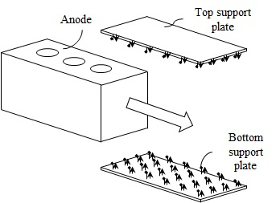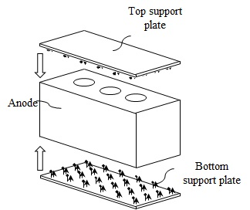
(b)
(a)
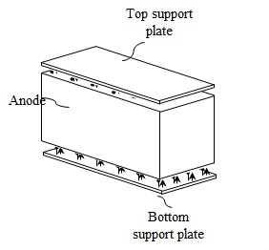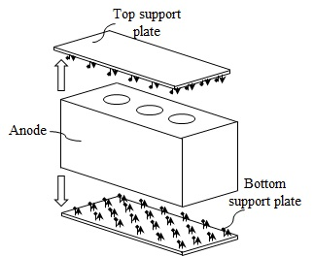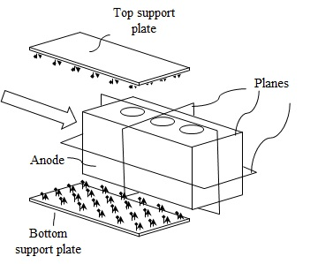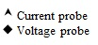
(e)
(d)
(c)
Figure 1: Schematic view of the anode electrical resistivity measurement: (a) anode entering the measurement location, (b) anode aligning with the top and bottom plates and plates approaching the anode, (c) measurement, (d) movement of plates away from the anode after the measurement, (e ) anode leaving the measurement location
RESULTS AND DISCUSSION
A first preliminary, static, and low cost version of the equipment has been built to verify the concept and its applicability to quality control of industrial anodes. This equipment was used to measure the electrical resistivity distribution in more than thirty industrial green anodes, and the average resistivity for each anode was also calculated.

To validate the measurements carried out with the equipment, the anodes were separated into two groups. The first group (approximately 25% of those tested with the equipment) was cored at different positions as green anodes, and the electrical resistivities of these cores were measured using the conventional 4-point method. Their averages were also calculated for each green anode. Figure 2 compares the average normalized electrical resistivities of the green anodes determined with the equipment with those calculated from the measurements on the cores of the same anodes. The results are normalized for the confidentiality reasons. A good correlation (correlation coefficient of 0.91) was found showing that the equipment measures the resistivities correctly.

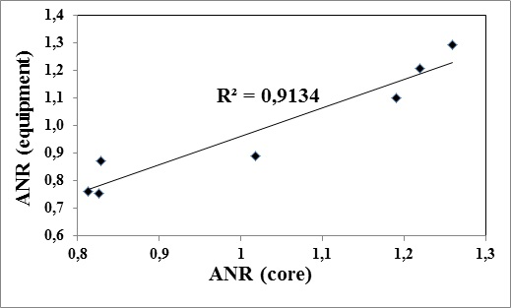

Figure 2- Comparison of average normalized resistivity values (ANR) measured by the equipment with those determined from the cores taken from different positions in the green anode

The remaining 75% of the original anodes (second group) were baked in an industrial anode baking furnace. Then, the distribution of electrical resistivity in each baked anode was measured with the same equipment, and its average electrical resistivity was also calculated. Afterwards, they were also cored at the same positions as the first group. Then, the electrical resistivities of cores were also measured using the 4-point method. The average resistivities were also calculated using the results from the cores.

The electrical resistivities measured by the equipment and those measured from the cores were compared at the same positions within the anodes for both green and baked anodes. Figure 3 shows the comparison for a number of positions of an anode. Again, a reasonably good correlation was found between the measurements obtained with the equipment and those of the cores at corresponding positions of the same anode. The correlation coefficient (R²) for the normalized resistivities were found to be within the range of 0.70 to 0.95 (average 0.81 ± 0.07) for the baked anodes and from 0.54 to 0.95 (average 0.74 ± 0.08) for the green anodes.

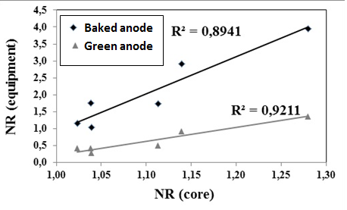

Figure 3- Comparison of normalized resistivity (NR) values measured by the equipment with those determined from the cores at the same positions within the anode

The concept proposed uses a low current which does not cause local overheating in anodes during measurements. If overheating occurs, pitch can soften, and this can result in the redistribution of pitch within the anode. Therefore, the quality of the anode might change during the measurement; consequently, the quality control measurements will not reflect the true anode quality.

According to literature, there is no equipment in the market which can determine on-line the electrical resistivity of green anodes. The detection of the defects in green anodes will prevent the unnecessary baking of these anodes, and consequently, will reduce the fuel consumption, the smelter operating cost, and GES emissions. Also, the mapping of the electrical resistivity of the anodes will identify those that are susceptible to cause anode accidents in the cells. As a result of the elimination of such anodes, the greenhouse gas emissions will be reduced. It will also help pinpoint any existing problems in the paste plant and will allow rapid correction of this problem before it affects the operation for prolonged periods. Evidently, if the green anode quality is not good, even the best anode baking practices can’t remedy this problem.

The first equipment was completely manual and was constructed to demonstrate the concept. The next step is the development of an automatized static prototype which will also be tested in the plant. This will be followed by the development of an on-line system.

CONCLUSIONS
Presently, the quality control of anodes is carried out only for baked anodes either visually and/or with the analysis of a core obtained from the upper part of 1.5-2% of the anodes produced. This inspection does not reflect the overall quality of the anodes. The availability of an on-line system would increase the dependability of anodes quality inspection in the smelters. In addition, the analysis of baked anodes induces long delays in the identification and the correction of operational problems in the paste plant by at least 20 days.

The on-line inspection of the green anode quality, made possible with the new technology, can rapidly identify the problems in the paste plant before the anode quality is affected to a great extent, decrease the fuel consumption by eliminating the baking of defective green anodes, and decrease the anode accidents in the electrolytic cells by identifying the anodes at risk of creating such an event from their electrical resistivity distribution. As a result, the greenhouse gas emissions occurring due to these unwanted events will also be reduced. This will contribute to the sustainable development in aluminum production and to the protection of environment.
The equipment developed showed the validity of the concept. Effort to develop an automated on-line equipment for the measurement of green anode quality is continuing.

REFERENCES

Audet, D., & Parent, L. (2009, 2013) Système et procédé de prévision de la conductivité électrique d’anodes de production d’aluminium avant leur cuisson. US Patent US7576534, International patent IPC, CA 2590482.
Chollier-Brym M.J., Laroche, D., Alexandre, A., Landry, M., Simard, C., Simard, L., & Ringuette,D. (2012). New method for representative measurement of anode electrical resistance. Light Metals, 1299-1302.
Haldemann, P.R. & Fawzi, E.P. (1995). Methods and Apparatus for Non-destructively Detecting Flaws in a Carbon Anode”, US Patent US5473248.
Kocaefe, D., Bhattacharyay, D., & Kocaefe, Y. (2014). Method for analyzing an anode and device thereof , Provisional patent application US 61/939768.
Léonard, G., Guérard, S., Laroche, D., Arnaud, J.C., Gourmaud, S., Gagnon, M., Marie-Chollier, M.J., & Yvon Perron (2014). Anode Electrical Resistance Measurements: Learning and Industrial On-line Measurement Equipment Development. Light Metals, 1269-1274.
Seger, E.J. (1973). Method and means for measuring electrode resistance. US patent US3735253.
Seger, E.J. (1978). New method of measuring electric resistance for quality control. Light Metals, 283-290.

