HEFAT2012
9th International Conference on Heat Transfer, Fluid Mechanics and Thermodynamics
16 – 18 July 2012
Malta

Study OF WEATHERING BEHAVIOR OF JACK PINE HEAT-TREATED UNDER DIFFERENT CONDITIONS

Kocaefe D.*, Huang X., Kocaefe Y., Boluk Y.
*Author for correspondence
Université du Québec à Chicoutimi, Canada
555, boul. de l’Université, Chicoutimi Québec Canada G7H 2B1
E-mail: dkocaefe@uqac.ca

Abstract
It is of considerable importance to investigate the influence of weathering on the degradation processes of heat-treated wood. Kiln-dried (untreated) jack pine (Pinus banksiana) and jack pine heat-treated at three different temperatures (190°C, 200°C, and 210°C) were exposed to artificial weathering for different periods in order to understand the degradation processes due to weathering. Before and after exposure, their color and wettability by water were determined. Structural changes and chemical modifications at exposed surfaces were also investigated using SEM, FTIR spectroscopy, and XPS. The results revealed that the photo-degradation of lignin and the presence of extractives play important roles in color change and wetting behavior of heat-treated wood surfaces during weathering. The structural changes also influence the wettability. The effects of weathering for woods heat-treated under different conditions were similar, but different from those for untreated wood.

introduction

Wood is commonly used as engineering and structural material because of its versatile and attractive properties such as mechanical strength, low density, low thermal expansion, and aesthetic appeal . Wood is heat treated at high temperatures in the range of 180 and 240°C for its preservation without using any additional chemicals. Heat treatment modifies wood both chemically and physically. Amorphous polysaccharide content (hemicelluloses) decreases, condensation and demethoxylation of lignin take place and certain extractives are removed . Consequently, heat-treated wood possesses new physical properties such as reduced hygroscopy, improved dimensional stability, better resistance to degradation by insects and micro-organisms, and attractive darker color. These new versatile and attractive properties make heat-treated wood popular for outdoor applications.
However, wood, similar to other biological materials, is susceptible to environmental degradation. Untreated wood undergoes degradation induced by weathering factors such as solar radiation (ultraviolet (UV), visible, and infrared light), moisture (dew, rain, snow, and humidity), temperature, and oxygen . The color of untreated wood exposed to outdoor conditions changes very rapidly because of the photo-degradation of lignin and wood extractives . Absorption of UV light results in breakage of weak chemical bonds and leads to cracking and damage of untreated wood surface .
One of the advantages of the heat treatment of wood at high temperatures is the appearance of products. However, similar to untreated wood, heat-treated wood is also susceptible to environmental degradation. Studies have also shown that weathering results in poor aesthetics for heat-treated wood because of the discoloration and surface checking when exposed to UV radiation . Most of the previous studies on weathering of heat-treated wood were limited to description of discoloration. A complete understanding of the mechanisms involved in weathering process would allow the development of new treatments and finishes that would greatly enhance the durability of heat-treated wood and provide greater protection against degradation due to weathering. However, many aspects of the weathering of heat-treated wood are not completely understood. Investigations on the wettability changes, chemical changes, and microscopic changes of heat-treated wood after exposure to artificial weathering are very limited, and there is no publication available in the literature on the degradation taking place due to the weathering of the heat-treated North American jack pine.
The purpose of this work is to study the mechanisms of degradation of the North American jack pine wood heat-treated under three different conditions, and to understand chemical and physical changes taking place, and to compare these changes with those of untreated controlled samples when they are exposed to artificial weathering for various periods.
In order to attain this research goal, several techniques and tools for the study of heat-treated jack pine surfaces were used: color measurement, contact angle test for wettability analysis, Fourier transforms infrared spectroscopy (FTIR) and X-ray photoelectron spectroscopy (XPS) for chemical analysis, and scanning electron spectroscopy (SEM) for microscopic structural analysis. These techniques provide a great deal of insight into the degradation process for both heat-treated and untreated wood exposed to artificial weathering and, consequently, allow in-depth study of heat treatment and modification of wood surface by weathering.
Material and methods

- Materials
The jack pine (Pinus banksiana), which is commonly used for outdoor applications in North America, was studied. Wood boards of approximately 6500 × 200 × 30 mm were heat-treated in a prototype furnace of the University of Quebec at Chicoutimi (UQAC), Quebec, Canada. Table 1 shows the conditions used during the heat treatment. Untreated wood boards, kiln-dried to the final moisture content of about 12%, were chosen for comparison purposes. Specimens of 70 × 65 mm cross-section on longitudinal tangential (LT) surfaces and 20 mm in length were cut from sapwood of heat-treated and untreated wood and then planed to have smooth surfaces. All samples were arbitrarily selected for complete statistical randomization. They were stored in an environment-controlled chamber at 20°C and 40% relative humidity (RH) until they were exposed to the artificial weathering, and the characterization tests were carried out as described below.
Table 1 Conditions of heat treatment
N. | Surface | Temp.  (°C) | Heating rate  (°C/h) | Holding time  (h) | Humidity  control
1 | LT | - | - | - | -
2 | LT | 190 | 15 | 1 | Yes
3 | LT | 200 | 15 | 1 | Yes
4 | LT | 210 | 15 | 1 | Yes

- Artificial weathering tests
Artificial weathering tests were conducted at the Laval University in collaboration with FPInnovation. The prepared samples were exposed to artificial weathering using a commercial chamber, Atlas Material Testing Technology LLC (USA) Ci65/Ci65A Xenon Weather-Ometer. A controlled irradiance water-cooled xenon arc with a CIRA inner filter and a Soda outer filter was used as the source of radiation to simulate sunlight. Tests were performed according to Cycle 1 of Standard ASTM G155: 102 min Xenon light, 18 min light and water spray (air temperature is not controlled) without dark cycle to simulate rain in natural weathering. The black panel temperature was set to 63±3˚C and the irradiance level was 0.35W/m² at 340 nm. The irradiation was interrupted after 72, 168, 336, 672, 1008, and 1512 h of exposure and two samples for each set of experimental conditions were taken out for evaluation of their properties.
- Color determination
The surface color of specimens exposed to artificial weathering for different periods was measured using a reflectance spectrophotometer (Datacolor, CHECK TM) with a measuring head which has a diameter of 10 mm. Equipment calibration was carried out with standards provided by the supplier. The color system L*a*b* 1976 according to the CIELab (Commission Internationale d'Eclairage) standard was used to determinate color modifications. The system is characterized by three parameters, L*, a*, and b* co-ordinates that represent the color pairs red/green and yellow/ blue, respectively. The total color difference (ΔE) was calculated as a function of the artificial sunlight exposure time according to the equation given below.
$ΔE={\left[(L_{t^{}}−L_{0^{}})^{2}+(a_{t^{}}−a_{0^{}})^{2}+(b_{t^{}}−b_{0^{}})^{2})\right]}^{\frac{1}{2}}$
where the subscript “0” represents the values before artificial sunlight irradiation, and “t” denotes those exposed to “t” h of weathering.
- SEM analysis
Small wood blocks measuring 20 ×20 mm on the weathered tangential face were cut from heat-treated and untreated boards after artificial sunlight irradiation of different times. For subsurface cell degradation analysis, same blocks measuring 20 ×10 mm on the transverse face was used. The specimens were immerged in water for 30 minutes and then cut with a razor blade mounted onto a microtome by carefully cutting one of end-grain surfaces. A new razor blade was used for each final cut. All blocks were sputter-coated with a palladium/gold layer (20 nm) and then mounted onto standard aluminum stubs using electrically conducting paste. The samples were scanned using a Jeol scanning electron microscope (JSM 6480LV) with magnification up to 300000× at 10kV of accelerating voltage. The distance between sample and electron microscope head was 20-25 mm with a spot size of 35. The specimen temperature was approximately 20˚C and the column vacuum was 6.66×10⁴Pa.
- Contact angle tests
The contact angles between water and specimen surfaces were determined using a sessile-drop system, First Ten Angstroms FTA200, equipped with CCD camera and image analysis software. The initial period after trigger was 0.033s and the post-trigger period multiplier was set up to 1.1. A drop of test liquid with a volume of 15µl was dosed automatically by an auto-syringe and dropped on the specimen (20 × 20 × 70 mm) placed on a movable sample table. Measurements of contact angle were carried out by sessile drop profile method with a view across to the grain. The wetting process parallel to the grain was investigated. Six to twelve tests were performed for each set of experimental conditions. The contact angles between each droplet and specimen surface were measured both on the left side and the right side of the droplet and the mean contact angles were automatically calculated. The dynamic contact angle data were used to assess wood surface wettability.
- FTIR spectroscopy analysis
The air-dried specimens (10×20×20 mm) were studied using Jasco FT/IR 4200 equipped with a diamond micro-ATR crystal. IR spectra were recorded in the wave number range of 550–4000cm⁻¹at 4 cm⁻¹ resolutions for 20 scans prior to the Fourier transformation. The incident angle of the micro-ATR crystal was 47˚ corresponding to a sampling depth of infrared radiation of 0.2–5µm, depending on the wave number. The aperture diameter was 7.1mm. The IR spectra for each set experimental condition were transformed and analyzed into absorbance spectra using the Jasco spectra manager software. The IR spectra were corrected by the FTIR software package which includes an ATR correction algorithm. All relative intensity ratios were normalized relative to the peak of the band at 2900 cm⁻¹ which corresponds to C-H stretching in methyl and methylene groups.
- XPS spectroscopy analysis
Small wood chips (approximately 10×10 mm on exposed surface and 1mm width) were cut with a cutter blade from heat-treated and untreated jack pine surfaces before and after artificial weathering. The XPS measurements were performed on AXIS Ultra XPS spectrometer (Kratos Analytical) at the Alberta Centre for Surface Engineering and Science (ACSES), University of Alberta. The base pressure in the analytical chamber was lower than 2 x 10⁻⁸ Pa. Monochromated Al Kα (hν = 1486.6 eV) source was used at a power of 210 W. The resolution function of the instrument for the source in hybrid lens mode was 0.55 eV for Ag 3d and 0.70 eV for Au 4f peaks. The photoelectron exit was along the normal of the sample surface. The analysis spot was 400×700 µm. Charge neutralizer was used to compensate for sample charging during the analysis. The survey scans spanned from 1100 to 0 eV binding energy, they were collected with analyzer pass energy (PE) of 160 eV and a step of 0.35 eV. For the high-resolution spectra, the pass-energy of 20 eV with a step of 0.1 eV was used. CASA software was utilized in the data processing. A linear background was subtracted from each peak, than the peak area was evaluated and scaled to the instrument sensitivity factors. The composition was calculated from the survey spectra taking the sum of all peaks after scaling equal to 100 %. The spectra fitting and component analysis were performed using the high-resolution spectra. The number of components and their binding-energy positions were taken from the paper of Inari et al .
Results and discussion

The curves of Figure 1(a) were generated in order to verify the existence of a relationship between chromatic variation occurring during heat treatment at different temperatures and color changes for jack pine wood using the CIE L*a*b* system.
As shown by the modifications of L* values, lightening and darkening of wood surface can be observed. L* is the most sensitive and visualized parameter for the wood surface quality during heat treatment. L*values decreased due to heat treatment under the three investigated temperatures, which means that the samples lost lightness. During the heat treatment at lower temperatures (190°C), a slow decrease in the lightness indicates that the wood becomes darker slightly. The variation becomes more significant when the heat treatment temperature was increased. A previous study also reported darkening of wood surface due to heat treatment as a function of heat treatment temperatures and the type of wood species . Hemicelluloses of heat-treated wood degraded and consequently lignin contents of heat-treated wood increased proportionally. Thus, changes in lightness of wood during heat treatment are mainly due to the hemicellulose degradation, and wood color becomes darker starting from the beginning of heat treatment. The degradation of hemicelluloses intensifies with increasing heat treatment temperature. The total color differences (ΔE) of wood after heat treatment at different temperatures are also shown in Figure 1 (a). With increasing heat treatment temperature, the ΔE increased. The final heat treatment temperature was chosen as 210°C, beyond which the physical and mechanical properties deteriorate drastically.
Erreur ! Liaison incorrecte.
(a)
Erreur ! Liaison incorrecte.
(b)
Figure 1 Color changes of heat-treated jack pine reported using CIE-L*a*b* system: (a) total color difference (ΔE) and lightness (L*) during heat-treatment, (b) ΔE during artificial weathering

Figure 1 (b) shows the ΔE of heat-treated and untreated jack pine during artificial weathering. Although the color change trends of different samples due to artificial weathering have some similar features, each sample has a uniquely different color change pattern. The rapidness and extent of the weather effects on untreated wood and woods heat-treated at different temperatures are different.
Heat-treated woods have better color stability during the early times of weathering (72 h), while the colors of heat-treated woods and untreated woods are very similar after the specimens have been subjected to long term artificial weathering. As it can be seen from Figure 1 (b), ΔE values of heat-treated jack pine change more significantly than those of untreated wood after weathering for 1512 h. This can be explained by the difference in their initial color (see Figure 1(a)). The colors of untreated wood and those heat-treated at different temperatures changed to white and gray after long term weathering; however, the original colors of heat-treated wood were darker than that of untreated wood.
Figure 2 presents the dynamic contact angle of wood/water system as a function of time for jack pine, heat-treated at 210°C during artificial weathering. As it can be seen in the figure, the weathering reduced the hydrophobic behavior of heat-treated wood; consequently, all dynamic contact angles of weathered wood were lower than those before weathering (0 h). Contact angles of heat-treated samples after weathering reduced with increasing exposure time to different extents. Water on heat-treated sample surface after weathering for 1500 h was absorbed within one second.
Figure 2 Wettability of heat-treated jack pine surface during artificial weathering

The difference in wood surface structure can cause wettability differences between wood surfaces . SEM micrographs of the tracheids on tangential surfaces of untreated and heat-treated jack pine revealed the formation of different patterns of cell wall cracks due to heat treatment and artificial weathering (see Figure 3 (a-c)). SEM analysis indicated that the anatomical structure of samples was only slightly affected during heat treatment such as the formation of small cracks in some areas on the tracheid cell wall observed after heat treatment, but the contact angle increased significantly after heat treatment (see Figure 3 (a) and (b)). This implied that the structural factors did not play an important role on the wettability, but the chemical changes of wood surfaces had greater effect on the wettability changes during heat treatment.
Weathering changed significantly heat-treated wood structural properties (see Figure 3 (c)). The degradation of lignin was seen after artificial weathering for 1512 h. It seems that the binding of cellulose microfibrils by lignin in the various cell wall layers has been degraded. Consequently, separation between two adjacent cells occurred and the tracheids loosened, collapsed, and became detached from the substrate of wood. SEM analysis suggested that the changes occurring due to weathering in the wettability of heat-treated wood tested in this study might be attributed to the surface structural changes. The wettability of wood surface by water was related to the water flow into wood cell lumena and diffusion within the cell wall . Cracks present on heat-treated sample surfaces after artificial weathering (shown in Figure 3 (c)) allowed easier entrance of water into cell lumena and cell wall, which consequently decreased contact angles and increased wettability (see Figure 2 and image of initial contact angle in Figure 3 (c)). The weather degradation occurs preferentially in the middle lamella because the lignin concentration was the highest in this area. The degradation of the middle lamella resulted in the separation of adjoined cells (Figure 3 (c)), which allowed easier entrance of water into wood.
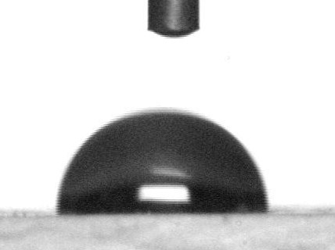
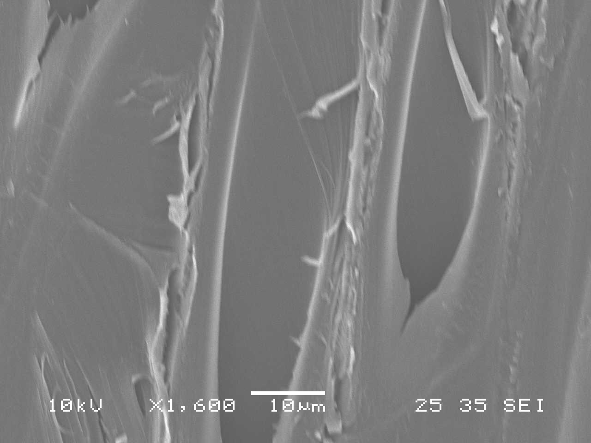
(a)
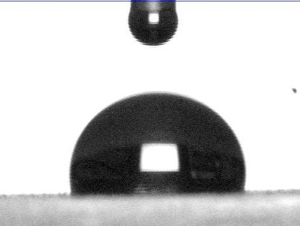
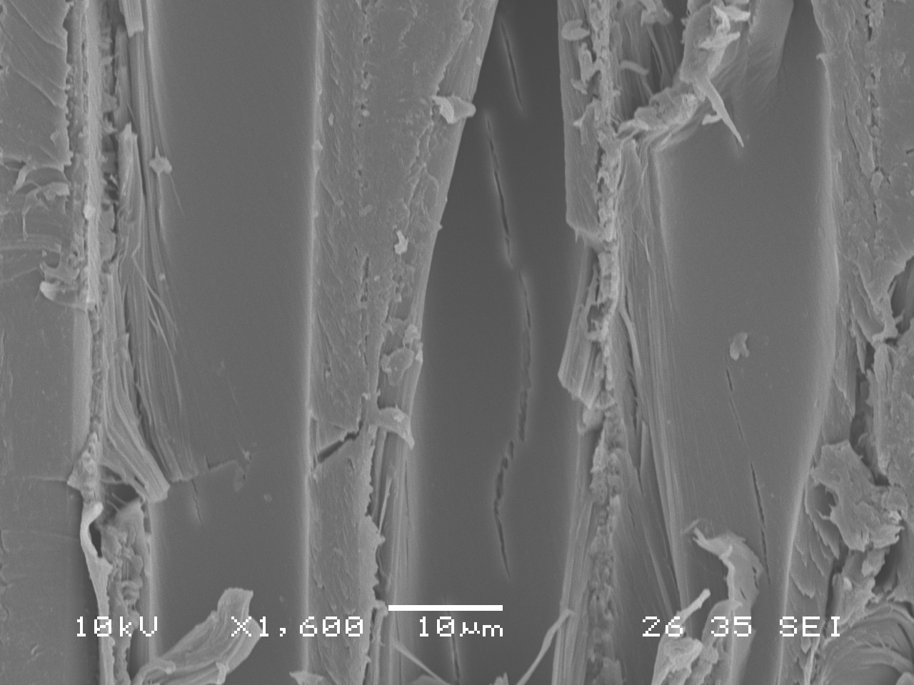
(b)
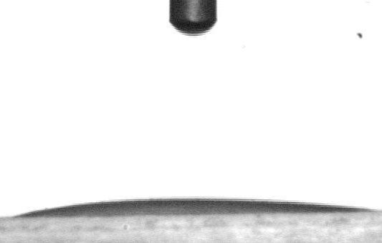
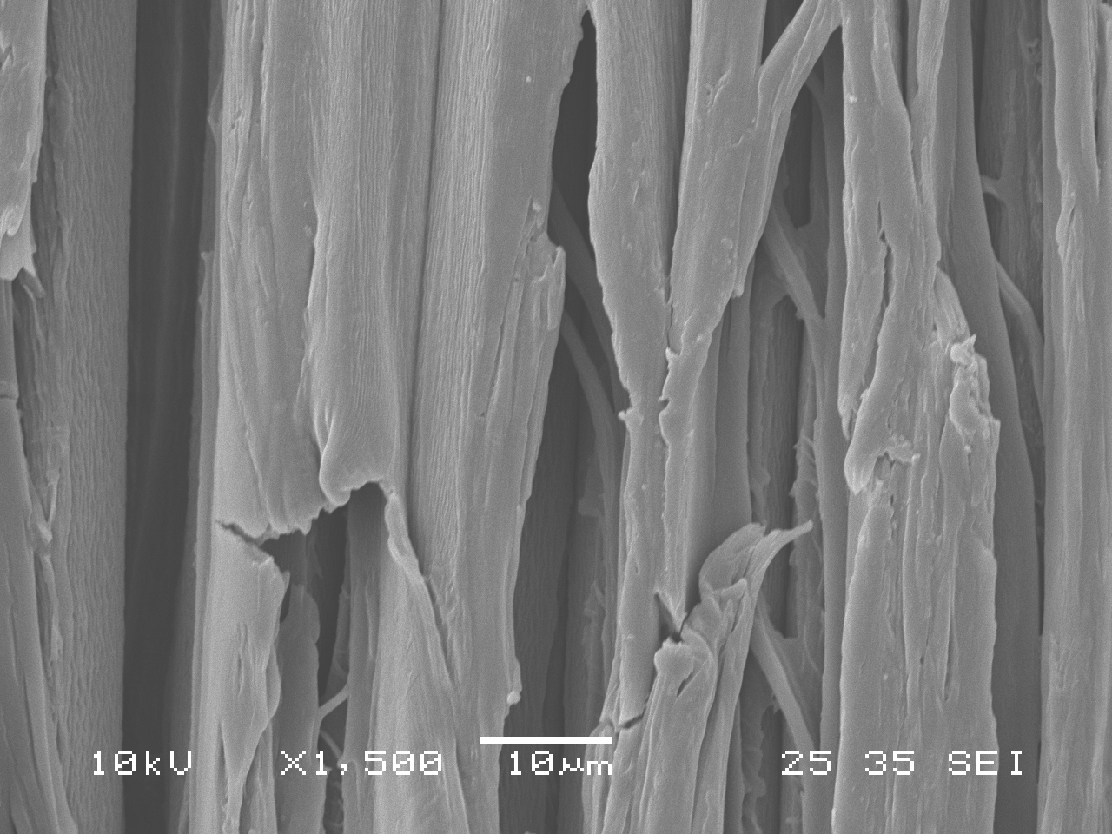
(c)
Figure 3 SEM image and initial contact angle of heat-treated jack pine surface: (a) untreated before weathering, (b) heat-treated at 210°C before weathering, (c) heat-treated at 210°C after weathering of 1512 h

Heat treatment can cause chemical changes such as degradation of hemicelluloses and extractives, leading to increase in crystallinity and percentage of lignin and consequent decrease in wettability . Weathering induces changes not only in physical properties of a wood surface but also in its chemical properties . The color change and increase in wettability during weathering can also be related to chemical changes of wood surface .
Figure 4 shows the FTIR spectra within the spectral region of 1800-850 cm⁻¹ on untreated and heat-treated jack pine before and after artificial weathering for 1512 h. Differences due to heat treatment and weathering can be clearly seen in the infrared spectra in the band shapes.
The spectra in Figure 4 (a), (c), (e), and (g) show uniquely different infrared spectra for untreated and heat-treated samples before weathering, respectively, although their infrared spectra in the studied region had some similar features. Upon analysis of the spectra, it can be seen that the relative intensity at 1508 cm⁻¹ which was assigned to lignin was not significantly affected by heat treatment. Another peak which has to be taken into consideration is the peak at 1230 cm⁻¹ which was a characteristic of syringyl nuclei remained similar after heat treatment. This indicates that lignin was not degraded significantly by heat treatment in this study.
a
b
c
d
e
f
g
h
Figure 4 FTIR spectra of heat-treated jack pine before and after weathering for 1512 h: (a) untreated before weathering, (b) untreated after weathering, (c) heat-treated at 190°C before weathering, (d) heat-treated at 190°C after weathering, (e) heat-treated at 200°C before weathering, (f) heat-treated at 200°C after weathering, (g) heat-treated at 210°C before weathering, (h) heat-treated at 210°C before weathering

It was clearly apparent from the results of IR analysis that weathering had a significant effect on the functional groups found on the heat-treated wood surfaces. A general observation that can be made from the results was that, the effect of weathering on untreated and heat-treated samples might be very similar in the long term, 1512 h. Weathering degradation of heat-treated wood samples caused mainly changes in the absorption intensity at the peaks shown in Figure 4. All the bands at 1600 cm⁻¹, 1508 cm⁻¹ , and 1261 cm⁻¹ represented lignin characteristics . As shown in Figure 4, all these characteristic bands of lignin decreased to different extents as a result of artificial weathering depending on different heat treatment conditions. The peak at 1508 cm⁻¹ is mainly the characteristic absorption of C=C in an aromatic ring that originated from lignin in wood. It can be observed that the peak at 1508 cm⁻¹ disappeared after weathering for 1512 h for both heat-treated and untreated woods. This was in agreement with a previous study on untreated wood reported by Pandey . The loss of lignin made the surface more hydrophilic (see Figures 2 and 3). The intensities of peaks at 1316 and 896 cm⁻¹, which were mainly due to the carbohydrates (cellulose and hemicelluloses) and had no significant contribution from lignin, increased slightly by weathering. As a result of this significant photochemical degradation of lignin by irradiation, Erin et al. reported that new bands at 1730 and 1650 cm⁻¹, which may be due to the formation of unconjugated free carbonyl groups and quinines and quinine methides ( responsible yellowing of wood surface), were generated and changed during different artificial weathering conditions. However, as Figure 4 shows, the new bands at 1730 cm⁻¹and 1650 cm⁻¹ were not detected in the present study for heat-treated and untreated wood surfaces after weathering for 1512 h. These might be related to the different artificial weathering conditions. In this study, the natural rain was simulated with water spray during the artificial weathering test, which might leach out the by-products of the degradation of lignin after long term weathering such as quinines and quinine methides. These by-products are responsible for the darkening of untreated wood surface during the initial weathering process of 72 h (see Figure 1b). Consequently, as it was stated above, the color of untreated wood changes to a darker tone during initial weathering. As the weathering continues, the leaching of other polymers (such as cellulose and hemicelluloses) on wood surface occurs, and, consequently, the color returns to lighter and whiter tones. For heat-treated wood, the color change mechanism involves the degradation of lignin matrix and extractives, which lightens the heat-treated wood color.
Erreur ! Liaison incorrecte.
Figure 5 Correlation of the O/C atomic concentration ratio with the percentage of C₁ carbon for heat-treated jack pine

In the XPS analysis, the focus was on the high-resolution of C 1s and O/C ratio. C₁ peak of C 1s corresponds to carbon linked to carbon (C–C) present in lignin and hydrogen (C-H) groups of lignin and extractives . The percentage of C₁ carbon for heat-treated jack pine wood was inversely proportional to the O/C atomic concentration ratio as shown in Figure 5. Also shown were theoretical points given by Johansson et al. for wood lignin and pure cellulose according to the chemical composition of these substances . A linear correlation between the two measures can be observed with a high correlation coefficient of 0.97. This indicates that the types of lignin present, although they might be chemically modified during weathering, were sufficiently similar to allow a consistent lignin determination on heat-treated samples used in this study. In addition, as the weathering exposure time increases, the percentage of C₁ carbon vs. O/C ratio shifted towards the theoretical value of cellulose for all the three heat-treated species studied. This indicates that the lignin content of heat-treated samples declined during artificial weathering; and consequently, specimens tended to exhibit abundant cellulose content after weathering of 1512 h. The linear fit to the data of Figure 5 was nearly parallel to the line drawn through the theoretical values for lignin and cellulose. This indicates that the contamination levels on sample surfaces were constant for the data set and the relatively small variance of the plotted points can be attributed to random error.
ConclusionS

Heat-treated woods have better color stability during the early times of weathering while the colors were similar after long term artificial weathering for both heat-treated and untreated woods. The color stability of heat-treated wood o during weathering was estimated to be due to increase in lignin condensation and decrease in extractives content on wood surfaces caused by heat treatment. Discoloration during weathering of heat-treated wood was due to the combination of the degradation of lignin and extractives. The weathering increased the wettability by water and decreased lignin content for all the heat-treated samples.
References

[1] M. Nuopponen, H. Wikberg, T. Vuorinen, S.L. Maunu, S. Jämsä, P. Viitaniemi, Heat-treated softwood exposed to weathering, Journal of Applied Polymer Science, 91 (2004) 2128-2134.
[2] H. Sivonen, S.L. Maunu, F. Sundholm, S. Jämsä, P. Viitaniemi, Magnetic resonance studies of thermally modified wood, Holzforschung, 56 (2002) 648-654.
[3] R. Kotilainen, R. Alén, V. Arpiainen, Changes in the chemical composition of Norway spruce (Picea abies) at 160-260°C under nitrogen and air atmospheres, Paperi ja Puu/Paper and Timber, 81 (1999) 384-388.
[4] W.C. Feist, R.M. Rowell, R.J. Barbour, Outdoor wood weathering and protection, Archaeological Wood: Properties, Chemistry, and Preservation, (1990) 263-298.
[5] D.N.S. Hon, Photochemistry of wood, Wood and Cellulosic Chemistry, (1991) 525-555.
[6] S.Y. Lin, K.P. Kringstad, Photosensitive groups in lignin and lignin model compounds, Tappi, 53 (1970) 658-663.
[7] T. Syrjänen, E. Kangas, Heat treated timber in Finland, The International Research Group on Wood Preservation, IRG/WP 00-40158, IRG Secretariat, SE-100 (2000) 44.
[8] A. Ahajji, P.N. Diouf, F. Aloui, I. Elbakali, D. Perrin, A. Merlin, B. George, Influence of heat treatment on antioxidant properties and colour stability of beech and spruce wood and their extractives, Wood Science and Technology, 43 (2009) 69-83.
[9] M.K. Dubey, S. Pang, J. Walker, Color and dimensional stability of oil heat-treated radiata pinewood after accelerated UV weathering, Forest Products Journal, 60 (2010) 453-459.
[10] D. Mayes, O. Oksanen, Thermo Wood® Handbook, (2002) 52.
[11] R.W.G. Hunt, The Reproduction of Color, (1995).
[12] G. Nguila Inari, M. Petrissans, J. Lambert, J.J. Ehrhardt, P. Gérardin, XPS characterization of wood chemical composition after heat-treatment, Surface and Interface Analysis, 38 (2006) 1336-1342.
[13] P. Bekhta, P. Niemz, Effect of high temperature on the change in color, dimensional stability and mechanical properties of spruce wood, Holzforschung, 57 (2003) 539-546.
[14] M. Kishino, T. Nakano, Artificial weathering of tropical woods. Part 1: Changes in wettability, Holzforschung, 58 (2004) 552-557.
[15] T.C. Patton, Simplified Review of Adhesion Theory Based on Surface Energetics, Tappi, 53 (1970) 421-429.
[16] W.B. Banks, Water uptake by scots pine sapwood, and its restriction by the use of water repellents, Wood Science and Technology, 7 (1973) 271-284.
[17] D. Kocaefe, S. Poncsak, G. Dore, R. Younsi, Effect of heat treatment on the wettability of white ash and soft maple by water, Einfluss der Wa?rmebehandlung auf die Benetzbarkeit von Weißesche und Rot-Ahorn mit Wasser, 66 (2008) 355-361.
[18] Y. Kataoka, M. Kiguchi, Depth profiling of photo-induced degradation in wood by FT-IR microspectroscopy, Journal of Wood Science, 47 (2001) 325-327.
[19] B.A. Horn, J. Qiu, N.L. Owen, W.C. Feist, FT-IR studies of weathering effects in Western red cedar and Southern pine, Chemical Modification of Lignocellulosics, (1992).
[20] M.A. Kalnins, W.C. Feist, Increase in wettability of wood with weathering, Forest Products Journal, 43 (1993) 55.
[21] M. Gindl, A. Reiterer, G. Sinn, S.E. Stanzl-Tschegg, Effects of surface ageing on wettability, surface chemistry, and adhesion of wood, Holz als Roh - und Werkstoff, 62 (2004) 273-280.
[22] X. Colom, F. Carrillo, F. Nogués, P. Garriga, Structural analysis of photodegraded wood by means of FTIR spectroscopy, Polymer Degradation and Stability, 80 (2003) 543-549.
[23] K.K. Pandey, A Study of Chemical Structure of Soft and Hardwood and Wood Polymers by FTIR Spectroscopy, Journal of Applied Polymer Science, 71 (1999) 1969-1975.
[24] E.L.P. Anderson, Zenon1; Owen, Noel L.1; Feist, William C.2, Infrared Studies of Wood Weathering. Part I: Softwoods Society for Applied Spectroscopy, 45 (1991) 521-714 (May 1991) , pp. 1641-1647(1997).
[25] L.S. Johansson, J.M. Campbell, K. Koljonen, P. Stenius, Evaluation of surface lignin on cellulose fibers with XPS, Applied Surface Science, 144-145 (1999) 92-95.

