A non-destructive technique for the on-line quality control of green and baked anodes

Abderrahmane Benzaoui¹, Duygu Kocaefe², Dipankar Bhattacharyay³ and Yasar Kocaefe⁴
1. Postdoctoral fellow
2. Professor, Carbon Chair
3. Research professor
4. Research professor
University Research Centre on Aluminum (CURAL) - Aluminum Research Centre (REGAL)
University of Quebec at Chicoutimi, Chicoutimi, Quebec, Canada
Corresponding author: Duygu_Kocaefe@uqac.ca

Abstract

Carbon anodes play an important role in the electrolytic production of aluminum. They have a significant impact on economics and environment. Carbon anodes are made of dry aggregates, composed of petroleum coke, recycled rejects, and butts, bound by coal tar pitch. Due to several factors, cracks and defects appear in anodes during the fabrication process, affecting their quality. It is thus essential to control the quality of anodes before their use in the electrolysis cell. Current practice for the quality evaluation (visual inspection, core analysis) gives limited information. As an alternative to this practice, the electrical resistivity measurement, one of the key indicators for anode quality and its homogeneity, can be used. A simple and non-destructive method has been developed for the specific electrical resistivity measurement of anodes (SERMA) for on-line control of anode quality. Various tests have been carried out at both lab scale and industrial scale. In this study, the resistivity distributions in the lab scale anodes were measured and compared with those of the tomography analysis. The method is able to detect defective anodes even before the baking process.

Keywords: Carbon anodes; quality control; non-destructive method; electrical resistivity.

- Introduction

Carbon anodes are used in the electrolysis cell for the production of primary aluminum according to the Hall-Hérault process. These anodes are made of a dry aggregate composed of calcined petroleum coke, butts, and green and baked rejects. The dry aggregate particles are bound by coal tar pitch. The dry aggregate and the pitch are mixed and compacted in a vibro-compactor to produce green anodes. The green anodes are baked in a baking furnace. During the baking process the volatiles in pitch are removed from the carbon material. Cracks are created in the anode material due to the pressure of the volatiles [1-3]. These defects affect the final quality of the anode and increase the production cost and energy consumption. Thus, it is necessary to inspect the anodes before their introduction into the electrolysis cell.

In industry, the anode quality is usually inspected by two methods: visual inspection of the anode surface and analysis of a cylindrical sample (core) taken from the anode. The visual inspection gives only limited information since the inside of the anode cannot be examined. The analysis of core can provide significant information; however, it is a destructive technique and can be applied to a few anodes (about 1.5% of the anodes produced) during the anode production. Also, the sample is taken from a region near the top of the anode, which does not necessarily represent the entire anode [1].

There are some non-destructive methods which are used to evaluate anode quality in the laboratory but are not applied to the inspection of industrial anodes. Among these methods, the ultrasound inspection is used for the detection of defects, dimensional measurement and material characterization. However, its application is difficult on rough, irregular, heterogeneous porous materials [4]. Amrani et al. [5, 6] performed an ultrasound inspection on core samples from carbon anodes and was able to detect the cracks in these samples. However, it was not possible to apply this method to large carbon blocks because of the limited penetration of the ultrasonic waves into the material.

Eddy current testing is a method used for the detection of defects in a conducting material. The application of this technique has been published in the literature [[7], [8], [9]]. Haldemann and Fawzi [10] developed an eddy-current based system to detect flaws in carbon anodes. In their system, the eddy current was induced by a coil surrounding the carbon block. Then, by measuring the impedance of the coil, it was possible to detect the presence of cracks. The authors complemented this method with the electrical resistivity measurement using the four point method. The main drawback of this system is the limited penetration of the eddy current into large anodes, and the influence of external magnetic fields.

Audet and Parent [11] designed a system made of one emitting coil and two receiving coils connected to a sensing device. A carbon anode sample was moved in the emitting coil resulting in the modification of the electromagnetic field. Thus, a current was induced in the receiving coils. By comparing the measured signal to that obtained using a reference sample, the authors were able to estimate the electrical conductivity of the sample. This system was limited by the short penetration of the electromagnetic field into the sample. The large size of the coils also restricted the industrial implementation. Moreover, it required the calibration using a homogeneous reference anode which is difficult to do in practice. In addition, the systems developed by Haldemann and Fawzi [10], and Audet and Parent [11] give a bulk information about the sample but cannot locate the position of the defect.

As explained above, both the ultrasound and the eddy-current testing methods are limited to thin samples because of the short penetration of the acoustic waves or the electromagnetic field into the carbon material. To overcome this limitation, the electrical resistivity measurement can be used and is an efficient and promising non-destructive testing method. This method is widely used in mining, civil engineering and composite material characterization. Matsui et al. [12] developed a system to measure the resistivity of various rock samples. They related the measured resistivity to the physical properties of the rock. Schueler et al. [13] used electrical impedance tomography to detect damages in carbon-fiber-reinforced polymers. Karhunen et al. [14] reported a 3D imaging of concrete using impedance tomography. Lataste et al. [15] developed a four-point resistivity measurement system to detect defects in concrete. There are some publications where electrical resistivity measurement has been applied to carbon anodes. Seger [16] developed a system to measure the electrical resistivity of baked anodes. In this system, the current was injected into the anode from the top through the stub holes and left the anode through a set of probes in contact with the bottom surface. The resistivity was obtained by measuring the voltage drop between the stub and the contact probes and the current flowing through each probe. Later, Chollier-Bryn et al. [17] and Léonard et al. [18] developed similar systems where they tried to reproduce the current distribution in a baked anode in the electrolysis cell. In this system, the current entered the anode through the stub holes (initially using inflatable metallic bags which were later replaced by metallic contacts) and left it from the bottom surface through a metallic brush carpet. The voltage drop was measured between a reference point on the top surface and predefined points on the side surfaces. The resistivity was calculated by comparing the voltage drop to that obtained by a numerical simulation of the current distribution in anode. The system gave an idea of the overall quality of the anode. These systems were designed only for baked anodes and cannot handle green anodes.

A non-destructive testing method based on the electrical resistivity measurement has been developed and tested on lab scale and industrial anodes (SERMA - Specific Electrical Resistance Measurement of Anodes) [19, 20]. The principle of this system is also given in the same references. It is able to not only detect flaws in carbon anodes, but also localize these flaws and give an indication about the anode heterogeneity. The system is designed for both green and baked anodes; and this offers the advantage of rejecting defective green anodes that will help save the cost of baking. In the lab, it is possible to produce anodes under different conditions and with or without specific defects, and the study of these anodes allows the verification of SERMA for its capacity to identify those defects. In this article, the results of the tests on the laboratory anodes produced with specific defects as well as their comparison with those obtained by the x-ray tomographic analysis are presented.

- Methodology

  - Fabrication of anodes in the laboratory

The experiments were carried out on anodes fabricated in the laboratory of the University of Quebec at Chicoutimi. The granulometry and the fabrication procedure were similar to those employed in industry. Only the dimensions were different, which are, of course, were much smaller compared to the industrial anodes. Each anode weighs about 10 kg. The dimensions are not given due to confidentiality. Three anodes were used for the purpose of this study. The first one (Anode 1) was made using the standard recipe. Anode 2 was similar to Anode 1 except that only large butt particles were used. The overall granulometry was maintained the same by adjusting the recipe. The finer butt particles were replaced by fresh coke. The presence of such large particles affects the anode properties such as density, porosity, and electrical resistivity. Finally, Anode 3 was fabricated following a special preparation procedure. The mold was divided into three sections (two bottom ones side by side and one top section covering the entire area). The paste containing the dry aggregate particles was sieved and divided into three parts according to their granulometry. Paste containing the particles of the fraction identified as 4-mm was placed in one of the bottom sections of the mold. Paste containing the particles of the fraction identified as 2-mm was put in the second bottom section. The paste containing the remaining particles was added above these two sections. In this manner, an anode was fabricated with high heterogeneity (see Figure 1). All anodes were fabricated under similar forming and baking conditions.
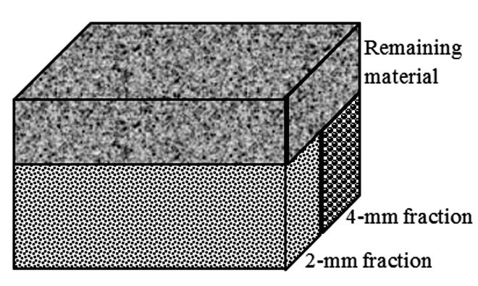
Figure 1: Schematic representation of Anode 3

  - Measurement of electrical resistivity

The method presented in this study consists of measuring the electrical resistivity of carbon anodes using a quick and simple procedure that can easily be implemented on-line to monitor anode quality during the anode production process. The technique is based on passing a known current through an anode using multiple points between two opposite faces and measuring the corresponding voltage drops at each point. Four plates were used for the measurements: two plates between the top and bottom surfaces of the anode and two plates between the side surfaces. Each pair of plates contained a certain number of contacts at exactly the same positions to feed current from one anode surface and to receive from the opposite anode surface. These contacts were connected to a power supply of 5A. The voltage contacts were installed, adjacent to the current contacts, on both plates to be able to measure the voltage drop at a given position. The current and voltage contacts are distributed over the plate covering the entire anode surface. Thirty (5×6 grid) and twenty five (5×5 grid) contacts were used for the top/bottom and side surfaces, respectively. Figure 2 describes schematically the measurement method.

The experimental procedure consists of two main steps. In the first step, the voltage measurements were carried out between the top and bottom faces of the anode. These measurements were plotted to get a map of the resistivity distribution in the horizontal plan. In the second step, the voltage measurements were carried out between the small side faces. The results were also plotted to get a map of the resistivity distribution in the vertical plan. The highly resistive regions indicated the presence of a defect. The intersection of the highly resistive sections measured by the two steps helped identify the position of the defective/cracked regions in the anode. This method was applied to the anodes before and after baking. The resistivity measurement equipment not only permits the detection of a defect in the anode, but also helps identify the problems during the fabrication process.

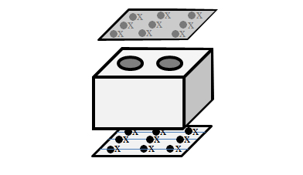  Side plate 1  Voltage contact  Current contact  Bottom plate  Top plate | 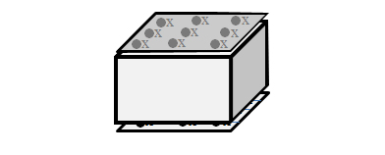
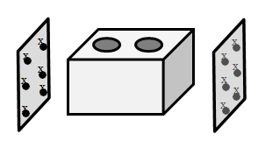
Side plate 2
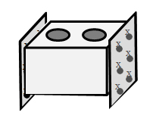
Figure 2: The sequence of operations for the electrical resistivity measurement of the anodes with SERMA [19, 20]
2.3. Analysis of tomography results

An X-ray tomography analysis was carried out on the baked anodes at the National Institute for Scientific Research (INRS, Québec, Canada). The tomography provides image files representing slices of the anode taken at consecutive positions. Each image is made of a number of voxels of a resolution of about 0.3 to 0.4 mm and a thickness of about 0.6 mm. For each voxel, a value of the optical density, resulting from the X-ray beaming, is assigned. The value of a voxel is directly correlated to the density of the material at that location. Thus, a threshold value for the optical density can be applied to identify the defects or cracks which usually have low optical density. A custom-made Matlab program was used to do the analysis.

2.4. Comparison of resistivity and tomography results

The tomography results were obtained from top to bottom for each of the baked anodes. It is possible to calculate the defects in different layers of the anode by analyzing the tomography results. In that case, the tomography results cannot be compared with the electrical resistivity measurements of the baked anodes since, in electrical resistivity measurement, the overall resistivities at different points were measured between the top and the bottom surfaces. Thus, in the tomographic analysis, the defects in different horizontal layers were added to determine the overall distribution of defects between the top and the bottom surfaces. These two results were compared. A highly resistive region in the horizontal plan should ideally correspond to a region with more defects obtained from the tomography results.

- Results and Discussion

3.1 Analysis of the electrical resistivity measurement

The set-up described in the previous section was used to measure the electrical resistivity for the three anodes before and after baking. The results of the baked anodes are presented in detail in this paper in order to compare the results with the tomography analysis of the baked anodes. One example of the resistivity distribution in a green anode is also presented. Figures 3 (a) and (b) show the resistivity distribution of Anode 3 in two directions before and after baking, respectively. As can be seen from this figure, there is a good correspondence between the high resistivity regions of green and baked anodes. The highly resistive point in the green anode showed some movement probably due to the redistribution of pitch and the volatile release during the baking process. Thus, the green anode quality is an indicator of the baked anode quality. Detection and removal of a defective anode early in the process helps avoid the handling of such an anode further and reduces the cost. The electrical resistivity distribution matched also with the specific distribution of particles in the anode (see Figure 1).

Figure 3 shows also an example of how a cracked/defective region could be located using the current equipment. The intersections of the highly resistive regions in two directions show the position of that defective region in the anode.
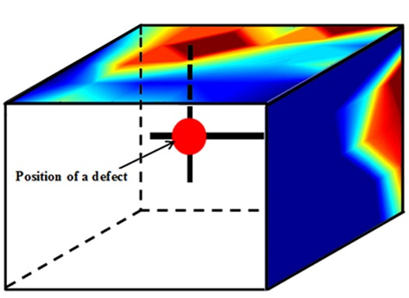  µΩm  (a) | 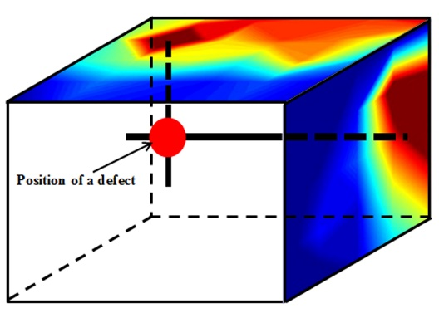  µΩm  (b)
Figure 3: Distribution of electrical resistivities measured with SERMA in horizontal and vertical directions in Anode 3: a) before baking and b) after baking

The values of the resistivity distribution between the top and bottom surfaces of the baked anodes were compared with the tomography results. These are shown in Figures 4, 5, and 6 for Anodes 1, 2, and 3, respectively.

Figures 4 (a), 5 (a), and 6 (a) show the resistivity distribution between the top and bottom surfaces for Anodes 1, 2, and 3, respectively, after baking. In all the anodes, high resistive points can be found. The positions with high resistivity indicate the presence of defects/cracks. The average resistivity value of Anode 2 was lower than that of Anode 1. The presence of large butt particles in Anode 2 likely affected the average resistivity since butt particles are usually denser and relatively better conductors compared to the more porous fresh coke particles.

For Anode 3, two distinct regions with different resistivity values can be observed. This is due to the particle distribution in the anode. The large particles in one section increased the porosity, and consequently increased the electrical resistivity in that zone. This is an extreme situation that does not normally happen in an industrial anode; however it helped test the ability of the system to detect highly resistive regions in a heterogeneous anode.

  - Tomographic analysis

As explained previously, an X-ray tomography analysis was carried out on the baked anodes used in this study. A simple visualisation of a tomographic image may not necessarily permit a good comparison between this tomographic analysis and the resistivity measurement. The defects are sometimes small, discontinuous and spread everywhere inside the anode. On the other hand, the measured resistivity reflects the total resistance encountered by the current in its path due to those defects. Therefore, it is important to quantify the cumulative number of defects in vertical lines between the top and the bottom surfaces of the anode in the tomographic analysis.

Figures 4, 5, and 6 compares the cumulative number of defects obtained from the tomographic analysis with the electrical resistivity measurement in the vertical direction. In order to make this comparison easier, the cumulative number of defects was calculated at the same points as for those of the resistivity measurement. A high value in the tomography result shows the presence of large number of defects. Similarly, a high value of resistivity represents the presence of crack/defects. Thus, a high value in one of the figures should ideally correspond to a high value in the other figure. These figures show that there is globally a good agreement between the resistivity measurements and the tomographic analyses for the three anodes. Despite few differences, most of regions showing high resistivity values corresponded to those of high cumulative number of defects. It is important to keep in mind that these contours were plotted only on the measurement points and not on all the voxels. The difference between the two plots might also be explained by the uncertainty on the probe position in the experimental setup, the roughness of the anode surfaces, and the threshold value of the optical density chosen to detect the defects.

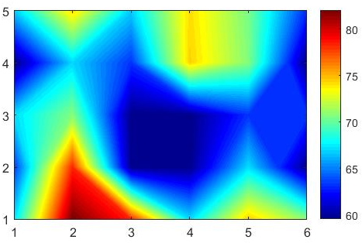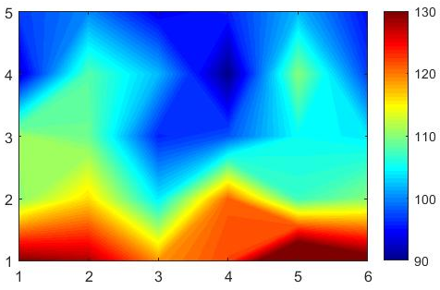
µΩm
- (b)
Figure 4: Distributions of (a) the electrical resistivity measured with SERMA and
b) the defects by tomographic analysis between the top and bottom surfaces for Anode 1
after baking

µΩm
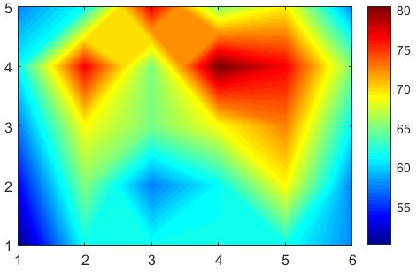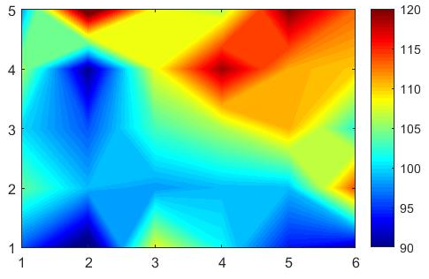
- (b)
Figure 5: a) Distributions of (a) the electrical resistivity measured with SERMA and
b) the defects by tomographic analysis between the top and bottom surfaces for Anode 2
after baking

µΩm
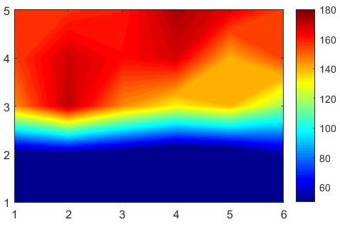

Figure 6: a) Distributions of (a) the electrical resistivity measured with SERMA and
b) the defects by tomographic analysis between the top and bottom surfaces for Anode 3
after baking
Figure 7 shows an image obtained from the tomography analysis of Anode 1 for a particular level between the top and the bottom surfaces. It shows a crack propagating along the length of the anode. Figures 4 (a) and (b) show the presence of defects in the region where this crack is located. Its presence and its location confirm the prediction made by the electrical resistivity measurement (see Figure 4 (a)).

Figure 7: Visualization of a cracked region in Anode 1 by tomography.

- Conclusions

In this work, a non-destructive testing method for the quality control of carbon anodes is presented. This method involves measuring the electrical resistivity of the anode in two directions and analyzing its distribution. Highly resistive region of the anode indicates the presence of defects/cracks in the material. The analysis of the highly resistive regions in two directions helps locate the position of defects.

A software has been developed to analyze the tomography results. The software can locate defects in a particular layer as well as cumulative defects in a particular direction.

The resistivities in green and baked laboratory anodes were measured at a number of points. The results show that there is a similarity in the distribution of resistivity before and after baking. The resistivity measurement method for baked anodes was validated by tomography analysis. The experimental results showed that the locations of high resistivity values matched with the regions containing large numbers of defects obtained by the tomographic analysis.

- Acknowledgments

The financial support of the National Science and Engineering Research Council of Canada (NSERC), the University of Quebec at Chicoutimi (UQAC) and the Foundation of the University of Quebec at Chicoutimi (FUQAC) are greatly appreciated. The authors also thank Aluminerie Alouette Inc. for providing the raw material for the anodes.

- References

1. K. L. Hulse, Anode Manufacture: Raw Materials, Formulation and Processing Parameters. 001 ed. 2000, Sierre, Switzerland: Calligraphy Sierre.
2. M. W. Meier, Cracking Behaviour of anodes. 1996, Sierre, Switzerland.
3. A. Charette and Y. Kocaefe, Le carbone dans l'industrie de l'aluminium. 2012, Chicoutimi, Canada: Les Presses de l'aluminium.
4. NDT Ressources center. 2016 [cited June 2016]; Available from: https://www.nde-ed.org/index_flash.htm.
5. S. Amrani et al. Effect of Heating Rate on the Crack Formation during Baking in Carbon Anodes Used in Aluminum Industry. in Light Metals. 2014. San Diego, California, USA: Wiley.
6. S. Amrani, Impact de la préparation des anodes crues et des conditions de cuisson sur la fissuration dans des anodes denses. 2015, University of Québec at Chicoutimi: Chicoutimi, Canada.
7. N. Yusa et al., Eddy current data for characterizing less volumetric stress corrosion cracking in nonmagnetic materials. Materials Letters, 2007. 61(3): p. 827-829.
8. Y. He et al., Pulsed eddy current technique for defect detection in aircraft riveted structures. NDT & E International, 2010. 43(2): p. 176-181.
9. M. Carboni. Application of eddy currents to the inspection of fatigue-corroded railway axles. in 18th World Conference on Nondestructive testing. 2012. Dublan, South Africa.
10. P. R. Haldemann and E. P. Fawzi, Method and apparatus for non-destructively detecting flaws in a carbon anode. 1995, The University of Maryland at College Park: US.
11. D. Audet and L. Parent, System and method to forecast the electrical conductivity of anodes for aluminum production before baking. 2009, University of Quebec at Chicoutimi: US.
12. T. Matsui et al. Relationship between electrical resistivity and physical properties of rocks. in GeoEng2000, an International Conference on geotechnical & geological engineering. 2000. Melbourne, Australia.
13. R. Schueler et al., Damage detection in CFRP by electrical conductivity mapping. Composites Science and Technology, 2001. 61(6): p. 921-930.
14. K. Karhunen et al., Electrical Resistance Tomography imaging of concrete. Cement and Concrete Research, 2010. 40(1): p. 137-145.
15. J. F. Lataste et al., Electrical resistivity measurement applied to cracking assessment on reinforced concrete structures in civil engineering. NDT & E International, 2003. 36(6): p. 383-394.
16. E. J. Seger, Method and means for measuring electrode resistance. 1973, Aluminum Company of America US.
17. M. J. Chollier-Brym et al. New method for representative measurement of anode electrical resistance. in Light Metals. 2012. Orlando, USA: TMS (The Minerals, Metals & Material Society).
18. G. Leonard et al. Anode electrical measurements: learning and industrial on-line measurement equipment development. in Light Netals. 2014. San Diego, USA: TMS (The Minerals, Metals & Material Society).
19. D. Kocaefe et al. Measurement of anode electrical resistivity for quality control in aluminium industry. in COM (Conference of Metallurgists). 2014. Vancouver, Canada.
20. Y. Kocaefe et al. Quality control via electrical resistivity measurement of industrial anodes. in Light Metals. 2015. Orlando, USA: TMS (The Minerals, Metals & Materials Society).

