**Prediction of contact angle of coke-pitch system from raw material properties using artificial neural network**

Arunima Sarkar1, ([arunima.sarkar@uqac.ca](mailto:arunima.sarkar@uqac.ca)) (first author)

Duygu Kocaefe1, ([Duygu_Kocaefe@uqac.ca](mailto:Duygu_Kocaefe@uqac.ca)) (corresponding author)

Yasar Kocaefe1, ([Yasar_Kocaefe@uqac.ca](mailto:Yasar_Kocaefe@uqac.ca))

Dipankar Bhattacharyay1 ([Dipankar_Bhattacharyay@uqac.ca](mailto:Dipankar_Bhattacharyay@uqac.ca))

Patrick Coulombe2 ([patrick.coulombe@alouette.qc.ca](mailto:patrick.coulombe@alouette.qc.ca))

1University of Quebec at Chicoutimi, Dept. of Applied Sciences, 555, boul. De l’Université, Chicoutimi, Québec,

Canada G7H 2B1

2Aluminerie Alouette Inc., 400, Chemin de la Pointe-Noire, C.P. 1650, Sept-Îles, Québec, Canada, G4R 5M9

## Abstract :

Carbon anodes used during the electrolytic aluminum production are made of aggregate material (petroleum coke, butts, and recycled green and baked anodes) and coal tar pitch. These raw materials are mixed to form anode paste, which is compacted to form green anodes. Finally, green anodes are baked to obtain baked anodes to be used in electrolysis.

A clear understanding of chemical and physical interactions taking place during mixing would facilitate the selection of raw materials and optimization of mixing parameters that improve anode properties. It is well-known that good interaction between coke and pitch is essential for the creation of a satisfactory bond between them, and contact angle is a measure of this interaction. To optimize and predict the contact angle for a given coke/pitch pair artificial neural network (ANN) model is employed to predict the contact angles at 80 s and 1500 s of contact time. A quantitative relationship between raw material chemical properties and contact angle is established. It was found that oxygen containing functional groups are the most important factor impacting the wettability of coke by pitch. The obtained results demonstrated that the developed models are highly effective in estimating the contact angle of coke/pitch pair. The analysis provided an insight into the effect of different parameters on contact angle. In turn, this might help improve the quality of bonding between coke-pitch, consequently, anode properties.

**Keywords:** Coke; Pitch; Contact angle; Artificial neural network; Predictive tools.

## 1. Introduction

One of the major steps of the primary aluminum fabrication process is carbon anode production. Carbon anodes are made by baking a compacted mixture of calcined coke, recycled anode butts, recycled green and baked anodes, and coal tar pitch. During mixing, pitch has to penetrate into the void spaces between the particles as well as into the pores of the particles. In the course of baking, pitch carbonizes and bonds the solid particles together. Good interaction between coke and pitch (wettability) leads to better bonding, which is one of the factors influencing the final anode properties.

The wettability of solid surfaces is a very important property of surface chemistry, which is controlled by the physics and chemistry of a surface. A wide range of studies are reported in literature on the effect of petroleum coke surface chemistry on wetting behavior. Lahaye *et al.*[1] studied the correlation between surface chemical functional groups of coke and the wetting behavior of coke by coal-tar pitch. Adams *et al.* [2] found that the carboxyl, lactonic and phenolic functional groups are predominant in sponge coke surface and predominantly affect the wettability. The surface oxygen groups are by far the most significant surface functional groups which influence physico-chemical properties such as wetting, formation of ionic and covalent bonds with other groups [3]. In previous studies, it was found that the presence of different impurities and functional groups of coke and pitch have an effect on their interactions [4, 5].

Several parameters can influence coke-pitch interactions during mixing. Industries often maintain vast amount of data on the raw material properties and operational parameters However, the industrial data is highly nonlinear in nature, and there is no mathematical relation available between data and the quality of the end product. In addition, it is difficult to study experimentally the effect of an individual raw material property on contact angle since it is difficult to change one property at a time. For example, to study the effect of coke sulfur content, different cokes with different sulfur contents are needed. Nevertheless, this is impossible to have because cokes with different sulfur contents contain also different amounts of other impurities. In such a situation, ANN model has a substantial potential to predict the desired result by making use of the available data.

Regarding the wettability of coke by pitch, a trained ANN model can predict the contact angle without performing any additional tests. This is especially important for choosing the compatible coke and pitch pairs to be used in anode production if the properties of raw materials change continuously. An artificial neural network (ANN) model processes information in a similar way the human brain does. The network is composed of a large number of highly interconnected processing elements, called neurons. Neural networks learn by example. The requirements for the implementation of ANN are a large set of experimental data, choice of the most suitable ANN model, proper training and learning algorithms.

ANN models were extensively used in numerous research fields including quality control [6-13], prediction of compositions and properties of metallic and nonmetallic compounds [14-16], prediction of properties effecting performance of aluminum reduction cell [17-19]. Few articles are also available in prediction of contact angle of electrospun pan nanofiber mat using ANN [20, 21]. In spite of various applications of ANN model, there are only a few studies available in literature which are directly associated to carbon anodes production [22-24].

In this article, the applications of ANN model to predict contact angles between coke and pitch as a function of raw material chemical properties and impurity contents are presented.

**2. Materials and Methodology**

**2.1. Materials**

Eight different calcined petroleum cokes and seven different pitches were used as raw material. Each coke and pitch was paired to measure their contact angle at 170°C, which is the industrial mixing temperature. Surface chemical compositions of raw materials were measured by XPS which is a quantitative technique to measure the elemental composition of the material surface. Database for raw material impurities was taken from suppliers certificates. All the data were normalized before analysis using the following equation.

|  |  |
| --- | --- |
| $\text{Normalized value}\text{ = }\frac{\text{Value to be Normalized - Minimum Value}}{\text{Maximum Value - Minimum Value}}$ | **(1)** |

Chemical compositions and impurities of coke and pitch is shown in Table 1 and Table 2, respectively.

Table 1 Surface chemical compositions and impurities of calcined petroleum cokes used

| **Comp.** | **Coke 1** | **Coke 2** | **Coke 3** | **Coke 4** | **Coke 5** | **Coke 6** | **Coke 7** | **Coke 8** |
| --- | --- | --- | --- | --- | --- | --- | --- | --- |
| **Supplier**  **(wt%)** |  |  |  |  |  |  |  |  |
| Si | 0.01 | 0.0055 | 0.0046 | 0.01 | 0.012 | 0.0192 | 0.02 | 0.002 |
| V | 0.03 | 0.0348 | 0.0296 | 0.024 | 0.03 | 0.0303 | 0.04 | 0.01 |
| Na | 0.01 | 0.0012 | 0.0012 | 0.008 | 0.006 | 0.0052 | 0.2 | 0.001 |
| Ca | 0.01 | 0.0026 | 0.0027 | 0.011 | 0.007 | 0.0149 | 0.02 | 0.001 |
| Fe | 0.02 | 0.0121 | 0.0092 | 0.02 | 0.028 | 0.0292 | 0.035 | 0.009 |
| Ni | 0.02 | 0.018 | 0.0159 | 0.02 | 0.019 | 0.0182 | 0.03 | 0.009 |
| **XPS**  **(At%)** |  |  |  |  |  |  |  |  |
| C | 95.4 | 97.3 | 96.96 | 95.78 | 96.57 | 97.12 | 95.0 | 99.0 |
| O | 2.95 | 1.35 | 1.87 | 2.66 | 2.43 | 1.81 | 3.0 | 1.0 |
| N | 0.95 | 0.06 | 0.19 | 0.89 | 0.3 | 0.21 | 1.0 | 0 |
| S | 0.68 | 1.29 | 0.99 | 0.67 | 0.7 | 0.85 | 1.0 | 0 |

Table 2 Surface chemical compositions and impurities of coal tar pitches used

| **Comp(%)** | **Pitch 1** | **Pitch 2** | **Pitch 3** | **Pitch 4** | **Pitch 5** | **Pitch 6** | **Pitch 7** |
| --- | --- | --- | --- | --- | --- | --- | --- |
| **Supplier (wt%)** |  |  |  |  |  |  |  |
| Si | 0.0113 | 0.0091 | 0.0127 | 0.0099 | 0.0085 | 0.0094 | 0.0250 |
| V | 0.0000 | 0.0000 | 0.0000 | 0.0000 | 0.0000 | 0.0000 | 0.0000 |
| Na | 0.0105 | 0.0108 | 0.0111 | 0.0108 | 0.0094 | 0.0130 | 0.0100 |
| Ca | 0.0044 | 0.0029 | 0.0028 | 0.0028 | 0.0037 | 0.0027 | 0.0096 |
| Fe | 0.0112 | 0.0122 | 0.0124 | 0.0120 | 0.0109 | 0.0101 | 0.0153 |
| Ni | 0.0000 | 0.0000 | 0.0000 | 0.0000 | 0.0000 | 0.0000 | 0.0000 |
| Pb | 0.0172 | 0.0134 | 0.0126 | 0.0157 | 0.0141 | 0.0176 | 0.0147 |
| Zn | 0.0233 | 0.0192 | 0.0183 | 0.0200 | 0.0191 | 0.0202 | 0.0197 |
| **XPS**  **(At%)** |  |  |  |  |  |  |  |
| C | 98.52 | 93.02 | 96.78 | 97.32 | 97.12 | 98.73 | 98.49 |
| O | 1.58 | 3.95 | 1.59 | 1.44 | 1.89 | 0.19 | 0.68 |
| N | 0.03 | 3.2 | 1.46 | 1.19 | 0.86 | 0.95 | 0.69 |
| S | 0.03 | 0.26 | 0.17 | 0.06 | 0.13 | 0.13 | 0.14 |

**2.2. Methodology**

***Contact angle test***

The wettability of calcined coke by molten pitch drop can be characterized with the contact angle formed between the molten pitch drop and a coke bed. The contact angles were measured using the sessile-drop method. In this method, a drop of liquid pitch is placed on a bed of fine coke particles at 170°C. The dynamic contact angle is measured from the video images using FTA 32 software [1, 25-29]. Inert nitrogen atmosphere is maintained during the experiment. Contact angle smaller than 90° indicates that the solid is wettable by the liquid. The lower the contact angle is, better the wettability is. The details of the experimental system and the measurement method can be found elsewhere [30].

***Artificial neural network analysis***

Analytical mathematical tools are often used to predict values of dependent parameters if there is an existing mathematical relationship between the dependent and the independent parameters. Artificial neural network is an important tool in predicting the values of dependent parameters where no mathematical model is available [7] or even though some mathematical relationship is available, it is hard to find numerical parameters [31].

Neural networks are inspired by biological nervous systems [32]. They are used as a mathematical tool to find patterns and classify data, to express output parameter as a function of a number of input parameters, and to predict the value of an output parameter for a set of input parameters.

It basically contains different interconnected layers such as input layer, hidden layers and the output layer. The input variables are connected to the input layer, the output layer is connected to the output variable and the hidden layers are in between the input and the output layers. There may be one or more hidden layers and the connections between the hidden layers may be in series, in parallel or their combination.

The steps involved in the development of an artificial neural network model are:

1) Modeling

2) Training

3) Validation

4) Prediction of output for a new set of values of input parameters.

Modeling an artificial neural network involves association of a transfer functions to each layer, setting up connections between different layers, finding the contribution (weight and bias) of the connections. During training, training data set is used to find appropriate weight and bias values for all the connections. Validation consists of predicting the values of output parameters using input data for which output values are known, plotting the predicted values of output variable against known values, finding the equation of the best-fit straight line [32] (the equation of the straight line has the form y = 1.x + 0 where R2 is ideally equal to 1, y is the predicted value corresponding to the known value x). Then, the output is predicted for a new set of values of input parameters for which there are no available data.

**3. Results and discussions**

### *Development of ANN model*

A feed-forward network which consisted of four layers of neurons, namely, an input layer, two hidden layers, and an output layer was developed. The transfer functions associated to the first and second hidden layers were sigmoidal and linear, respectively. In this study, normalized input data and their corresponding contact angles were used to train the program. As there were few experiments compared to number of input parameters, principal component analysis was used to reduce the number of input parameters. In principal component analysis, a correlation matrix was created with all the input and output parameters. The correlation matrix gives the table of probability values, which is commonly known as ‘p’ value. In principal component analysis, input parameters having ‘p’ value less than a specified value are chosen as the principal components. Usually the value is chosen as 0.05 for 95% confidence level. It helps reduce the number of input parameters for the ANN model. Initially, all 20 variables were used as input parameters to determine the ‘p’ values for each input variable. A small ‘p’ value (typically ≤ 0.05) indicates that the effect of the input variable on the output variable is statistically significant. Based on the ‘p’ value results, four input parameters, which affected the contact angle most, were chosen to feed the ANN model to predict the contact angle at 80 s and effect of different impurities and composition of raw materials on contact angle at 80 s were noted. Similarly eight input parameters were chosen to feed the ANN model to predict the contact angle at 1500 s and effect of different impurities and composition of raw materials on contact angle at 1500 s were studied. The final model was validated using a set of data with a known output which was not used in the training phase. The model was selected based on the value of the regression coefficient for the predicted output of the model with respect to the experimental results. The models for which the regression coefficients were close to 1 were considered suitable. To study the effect of one single parameter, the neural network model was applied to a set of input data where only that parameter was changed keeping all other parameters constant.

#### *Contact angle at 80s*

Figure 1 presents the ‘p’ value results. In this figure, “C” refers to coke and “P” refers to pitch in input variables. For example, “NaC” refers to the sodium content (Na) of coke (C) whereas “NaP” refers to the sodium content (Na) of pitch (P). The results indicate that the oxygen content of calcined petroleum coke and silicon, iron and sulfur contents of pitch wee statistically significant (≤ 0.05) for contact angle at 80 s (Figure 1).

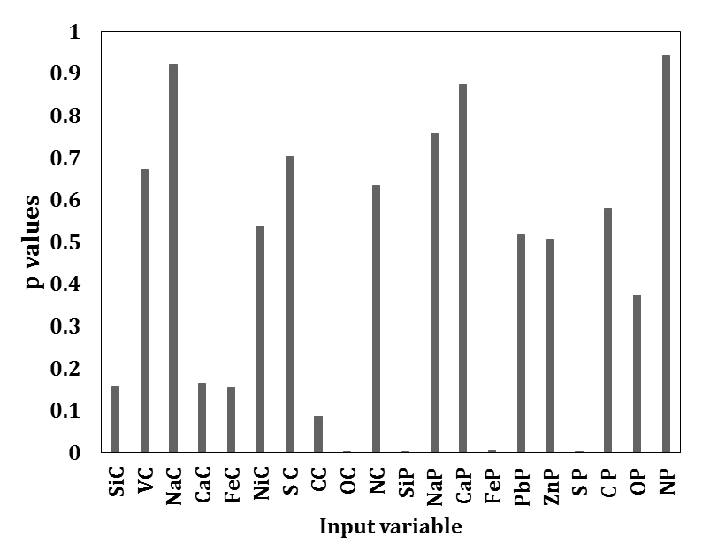

Figure 1 “p” value for different input variables (chemical compositions and impurity contents of coke and pitch) for contact angle at 80 s

Trial and error methods were used to initialize all the parameters. Thirty eight points were used to train the model and four points were used for validation (Figure 2). The input variables are oxygen content of calcined petroleum coke and silicon, iron and sulfur content of pitch. Due to the small number of data available for this study, the model was chosen based on a correlation coefficient R2 for all the 38 points and the tolerance of predicted and experimental values which was set to ±5o. The R2 was 0.784. The percentage of points within ±5o was 71%.

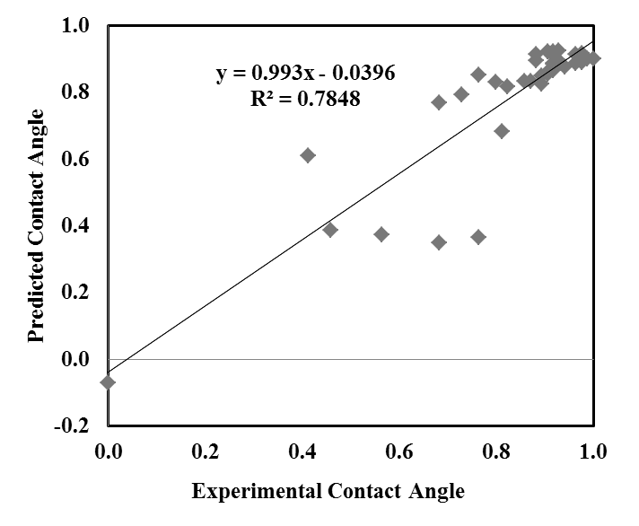

Figure 2 Normalized predicted vs. experimental contact angles at 80 s

The negative values of contact angles seen in Figure 2 are due to the error in prediction of low contact angles and lack of enough data for training. The effect of different material properties on contact angles at 80 s obtained by ANN model are shown in Figure 3 and Figure 4. All the input variable data in Figure 2 and Figure 3 are normalized based on equation 1.

The Figure 3 shows that presence of oxygen in coke improves wetting at the beginning. Oxygen is highly electronegative and can form covalent/hydrogen bonds with conjugate functional groups and support wetting [4].

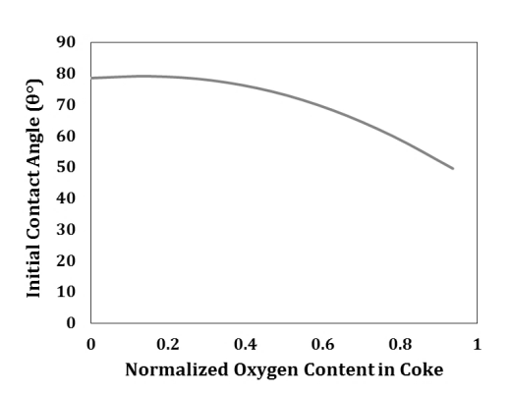

Figure 3 Effect normalized oxygen content in coke on contact angle at 80 s

Figure 4 (a) shows that contact angle at 80 s reduced with increasing silicon (Si) content. Due to its non-metallic character, silicon could form covalent/Van der Waal’s bonds with electronegative components in coke and pitch resulting in increased wettability (lower contact angle). It can be seen from Figure 4 (b) that iron had a negative effect on coke-pitch wetting. Iron is mostly present as sulfide form and only activated at higher temperatures [33]. It was possible that presence of sulfur in FeS, might have polarized the electron cloud of Fe. Sulfur is also electronegative, and it was probable that the amount of free sulfur increases at higher total sulfur content, which could help the formation of covalent bonds and improve wetting.

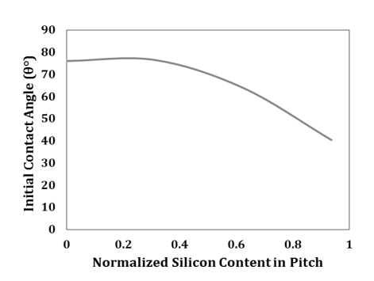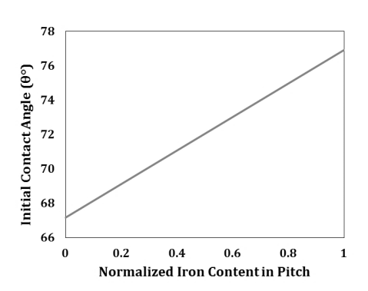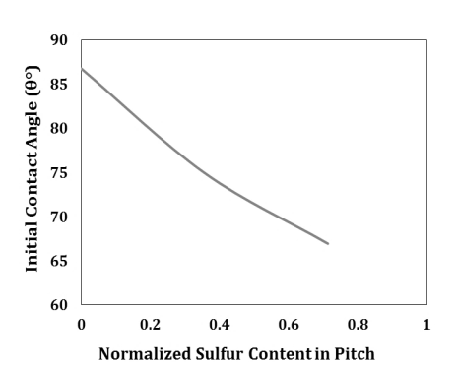

**(a)**

**(c)**

**(b)**

Figure 4 Effect normalized pitch impurities on contact angle at 80 s (a) silicon (b) iron (c) sulfur

#### *Contact angle at 1500 s*

Figure 5 illustrates the ‘p’ value results and indicates that vanadium, sodium, nickel, carbon, oxygen, nitrogen content of calcined petroleum coke and silicon and sulfur content of pitch were statistically significant (Figure 5).

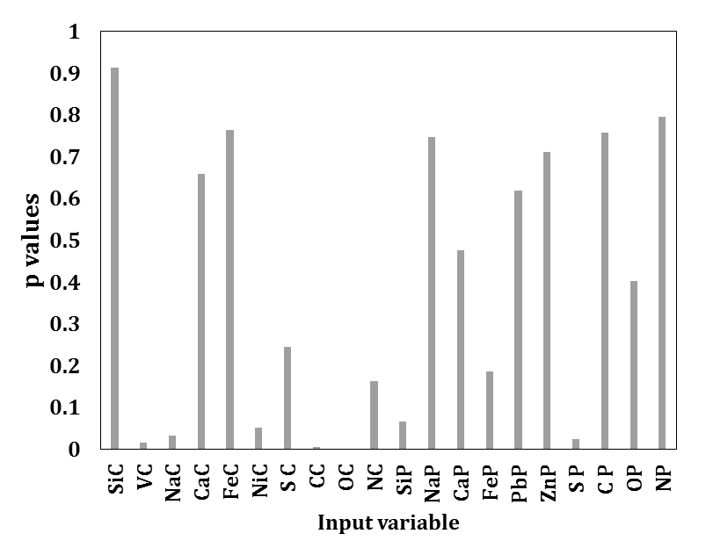

Figure 5 ‘p’ value for different input (chemical compositions and impurity contents of coke and pitch) variables (XC denotes element X in coke, XP denotes element X in pitch)

A similar ANN model was developed for contact angle at 1500 s. Trial and error methods were used to adjust all the parameters. Thirty eight points were used to train the model and four points were used for validation (Figure 6). The input variables were vanadium, sodium, nickel, carbon, oxygen, and nitrogen content of calcined petroleum coke and silicon and sulfur content of pitch. Due to the small number of data available for this study, the model was chosen based on a correlation coefficient R2 for all the 38 points and the tolerance of predicted and experimental values which was set to ±5o. The R2 was 0.902. The percentage of points within ±5o was 85%. The model was validated based on four data sets.

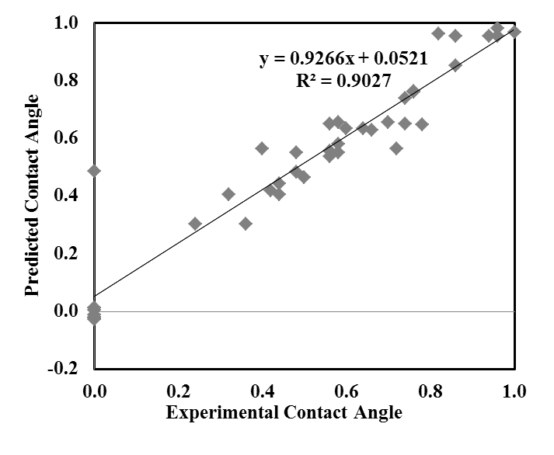

Figure 6 Normalized predicted vs. experimental contact angles at 1500 s

Thus, it can be seen that the customized feed-forward neural network model with back-propagation training was able to predict the output (contact angle) for the test data set better than the linear multivariable analyses (Figure 2). Similarly, the negative values of contact angles seen in Figure 6 are due to the error in prediction of low contact angles and lack of data for training. The effect of different material properties on contact angles at 1500 s obtained by ANN model are shown in Figure 7 and Figure 8. ANN model allows the study of the variation in each parameter individually while keeping all other parameters constant. All the input variable data in were normalized based on equation 1.

Figure 7 presents the results of the ANN model showing the effect of vanadium in coke on the contact angle at 1500 s when all other parameters are kept constant. As can be seen from this figure, the wettability decreased (contact angle increased) with increasing vanadium and nickel content of coke, but on the other hand the contact angle decreased (wettability increased) to a certain extent when sodium in coke increased. Coke and pitch both contains polycyclic aromatic compounds. Sodium formed additional compounds with naphthalene and other aromatic polycyclic compounds and with aryl alkenes. Sodium could also react with alcohols to produce sodium salts and hydrogen. These reactions in returns could improve the wettability of coke by pitch. Vanadium, which is mostly stable at lower temperatures, needs some activation period before reacting [34]. Vanadium and Nickel are transition metals. They can form coordinate covalent bonds with non-metals having lone pair of electrons. For this they need to be in metallic or ionic form. As a compound their electronic configurations are stable. In solid coke they cannot stay as ionic species. Also they do not stay as pure metal in coke. They usually stay as metal-ligand complexes. So it is difficult for them to react with O/N of pitch at lower temperature. Sufficiently high amount of energy is required to break those bonds. The wettability test was done only at 170°C. It was possible that at this temperature the vanadium compounds were inactive and needed to transfer to an active state or it might not be in a catalytic form which could have speed up the reaction. This may be a reason for lower wettability. The lower wettability in presence of nickel again could be explained with its inactivity at lower temperatures. It can be also seen from this figure that wettability of coke by pitch increased as carbon percentage in coke increased. Coke contains C-C bond and C=C [4]. In general, presence of higher amount of C=C indicates presence of higher aromatics. Thus the increase in carbon could correspond to the increase in aromatic content. The presence of aromatics could improve wetting by electrostatic interaction due to their pi electron cloud. Equally Figure 7 shows that presence of oxygen and nitrogen improves wetting. Oxygen and nitrogen are hetero atoms and they are highly reactive. Also, these atoms are highly electronegative and might form covalent/hydrogen bonds with conjugate functional groups and support wetting.

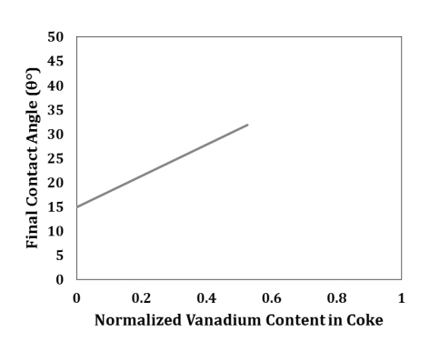 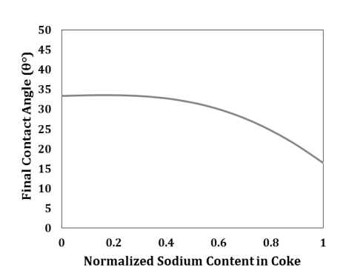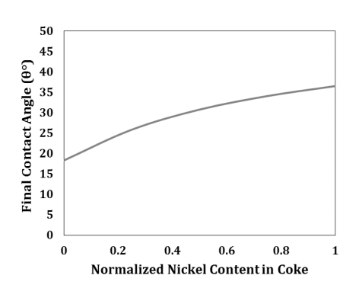

**(f)**

**(a)**

**(c)**

**(b)**

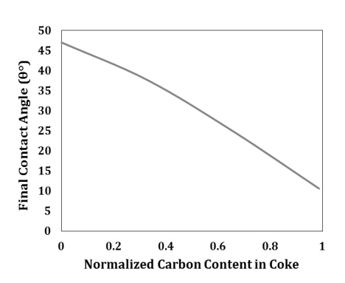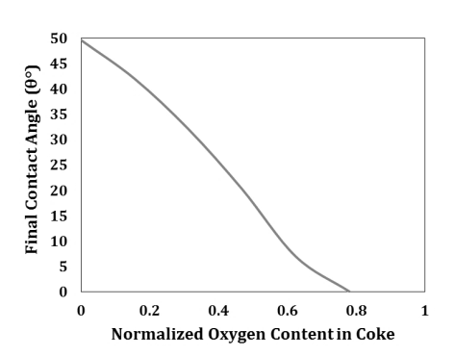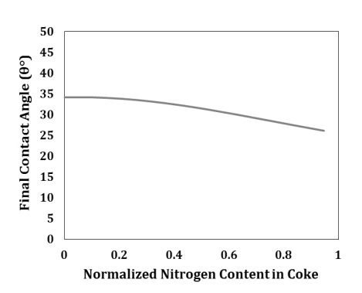

**(e)**

**(d)**

Figure 7 Effect of normalized coke chemical compositions and impurities on contact angle at 1500 s (a) vanadium (b) sodium (c) nickel (d) carbon (e) oxygen (f) nitrogen

Figure 8 presents the effect of pitch properties on the contact angle at 1500 s, hence, on the wetting capacity of pitch. Figure 8 (a) displays that contact angle at 1500 s reduces with increasing silicon content. Similar trend was observed for contact angle at   
80 s. The ANN model shows that, an increase in sulfur resulted in a slight increase in the contact angle (lower wetting) up to a certain value of sulfur (S from 0 to 0.4 and contact angle from 30.8° to 32.5°; see Figure 8(b)). It is possible that at lower sulfur content, there was not enough free sulfur remaining to form covalent bonds and hence increased the contact angle at 1500 s. Further increase in sulfur seemed to reduce the contact angle at 1500 s (Figure 8(b)). At higher sulfur content, it was probable that the amount of free sulfur increased which could aid the formation of covalent bonds and improve wetting. It should be mentioned that the change in contact angle is very small with changing sulfur content and most probably not significant.

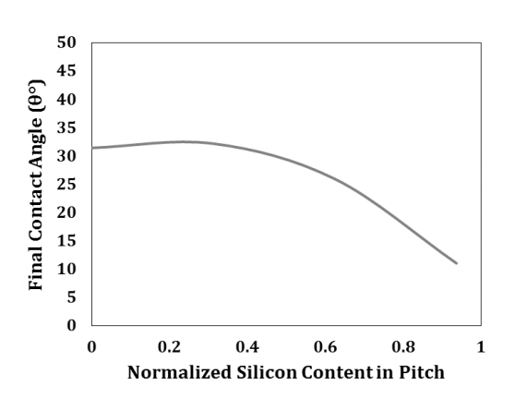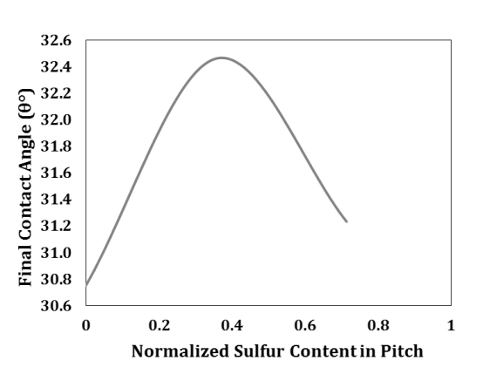

**(b)**

**(a)**

Figure 8 Effect normalized pitch impurities on contact angles at 1500 s (a) silicon   
(b) sulfur

#### *Validation of contact angle predictions*

The predictive ability of the ANN model derived from the training sets was validated by using the test sets, which enabled the reliable evaluation and interpretation of the model. Therefore, the results of the test sets were scrutinized in more detail. The contact angles at 80 s and 1500 s for four test sets were predicted, and the results are presented in Figure 9 which gives a comparison of the experimental and predicted values. The predictions for the contact angles at 80 s and 1500 s were quite satisfactory. The R2 value for predictive ability for unknown test sets was 0.89 for contact angle at 80 s and 0.98 for contact angle at 1500 s. The average percent errors in prediction were 8 % and 5% for contact angles at 80 s and 1500 s, respectively.

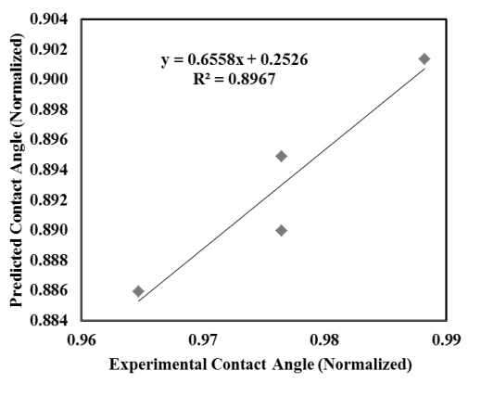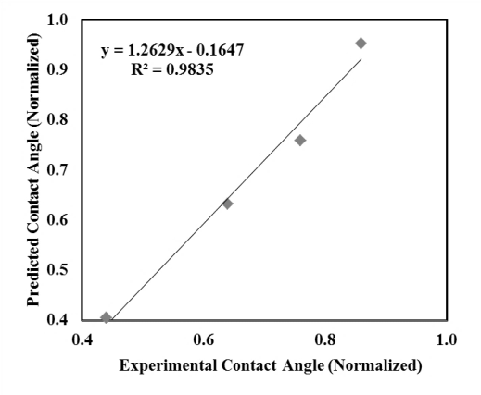

Figure 9 Predicted values of (a) normalized contact angle at 80 s (b) normalized contact angle at 1500 s using the test sets for the two cases

### 4. Conclusions

First, principal component analysis was used to identify the parameters which significantly affect the contact angle. Then, those selected parameters were used as inputs in an ANN model. In this study, models based on the artificial neuron network was developed to predict the contact angles at 80 s and 1500 s for different pitch-coke pairs on the basis of their surface chemical composition and presence of impurities. The ANN results showed that O content of coke and Si, S content of pitch helped in wetting, and Fe content of pitch reduced wetting at the initial stage whereas increasing amount of Na, C, N, O content in coke decreased contact angle at 1500 s and V, Ni content of coke increased contact angle at 1500 s. Increasing Si content in pitch reduced contact angle at 1500 s. The contact angle at 1500 s initially increased with increasing S content in pitch up to a certain level but later that it decreased. The current predictive ANN model, demonstrated how the suitable coke-pitch pairs to be used for anode paste preparation can be identified based on their surface chemical properties and impurity contents without the need for further experiments. This novel approach can be used as a tool in evaluating the potential of a given pitch to wet the dry aggregate during pre-assessment of various anode recipes. The major advantage of ANN over the other method is that it can efficiently handle highly nonlinear data with fluctuations where there is no existing mathematical relationship.

The predictive ability of the model can be improved by introducing more training sets of data. Development of ANN model is laborious and challenging because it involves numerous trials and errors. However, once it’s developed it gives more accurate results compared to any other statistical model.

**5. References**

1. Lahaye, J., Ehrburger, P., *Pitch-coke interactions.* Fuel., 1985. **64**(9): p. 1187-1191.

2. Adams, A.N., Schobert, H. H., *Characterization of the surface properties of anode raw materials.* Light Metals., 2004: p. 495-498.

3. Daniel, C. and J.O. Besenhard, *Handbook of Battery Materials*. 2nd ed. Handbook of Battery Materials: Second Edition. 2011: John Wiley & Sons. .

4. Sarkar, A., Kocaefe, D.,Kocaefe, Y.,Sarkar, D.,Bhattacharyay, D.,Morais, B.,Chabot, J., *Coke–pitch interactions during anode preparation.* Fuel, 2014. **117, Part A**(0): p. 598-607.

5. Sarkar, A., Kocaefe, D.,Kocaefe, Y.,Bhattacharyay, D.,Morais, B.,Lagacé, C. L., *Determination of contact angle from raw material properties using linear multivariable analysis.* Light Metals, 2014: p. 1099-1104.

6. Bahlmann, C., Heidemann, G., Ritter, H., *Artificial neural networks for automated quality control of textile seams.* Pattern Recognition, 1999. **32**(6): p. 1049-1060.

7. Parthiban, T., Ravi, R.,Kalaiselvi, N., *Exploration of artificial neural network [ANN] to predict the electrochemical characteristics of lithium-ion cells.* Electrochimica Acta, 2007. **53**(4): p. 1877-1882.

8. Shang, G.Q., Sun, C. H. *Application of BP neural network for predicting anode accuracy in ECM*. in *2008 International Symposium on Information Science and Engineering, ISISE 2008*. 2008.

9. Fruhwirth, R.K., Filzwieser, A., Pesl, J., Steinlechner, S., *Computational intelligence - Neural computation in a copper refinery.* Proceedings - European Metallurgical Conference, EMC 2007, 2007. **1**: p. 13-29.

10. Piuleac, C.G., Rodrigo, M. A., Cañizares, P., Curteanu, S., Sáez, C., *Ten steps modeling of electrolysis processes by using neural networks.* Environmental Modelling and Software, 2010. **25**(1): p. 74-81.

11. Pang, G., Xu, W., Zhai, X., Zhou, J., *Forecast and control of anode shape in electrochemical machining using neural network*, in *Lecture Notes in Computer Science (including subseries Lecture Notes in Artificial Intelligence and Lecture Notes in Bioinformatics)*. 2004. p. 262-268.

12. Saengrung, A., Abtahi, A., Zilouchian, A., *Neural network model for a commercial PEM fuel cell system.* Journal of Power Sources, 2007. **172**(2): p. 749-759.

13. Bhagavatula, Y.S., Bhagavatula, M. T., Dhathathreyan, K. S., *Application of artificial neural network in performance prediction of PEM fuel cell.* International Journal of Energy Research, 2012. **36**(13): p. 1215-1225.

14. Wang, L., Apelian, D., Makhlouf, M., Huang,W., *Predicting compositions and properties of aluminum die casting alloys using artificial neural network.* Metallurgical Science and Technology, 2008. **26**(1): p. 16-21.

15. Mohanty, C., Jena, B. K. , *Optimization of aluminium die casting process using artificial neural network* International Journal of Emerging Technology and Advanced Engineering, 2014. **4**(7): p. 146-149.

16. Asadi-Eydivand, M., Solati-Hashjin, M., Farzadi, A., Osman, N. A. A., *Artificial neural network approach to estimate the composition of chemically synthesized biphasic calcium phosphate powders.* Ceramics International, 2014. **40**(8 PART A): p. 12439-12448.

17. Biedler, P., Banta, L., Dai, C., Love, R., Tommey, C., Berkow, J., *Development of a state observer for an aluminum reduction cell.* Light Metals, 2002: p. 1091-1098.

18. Meghlaoui, A., Bui, R. T.,Thibault, J., Tikasz, L., Santerre, R., *Predictive control of aluminum electrolytic cells using neural networks.* Metallurgical and Materials Transactions B: Process Metallurgy and Materials Processing Science, 1998. **29**(5): p. 1007-1019.

19. Boadu, K.D., Omani, F. K., *Adaptive control of feed in the Hall-Héroult cell using a neural network.* JOM, 2010. **62**(2): p. 32-36.

20. Moghadam, B.H., Hasanzadeh, M., *Predicting contact angle of electrospun pan nanofiber mat using artificial neural network and response surface methodology.* Advances in Polymer Technology, 2013. **32**(4).

21. Hadavi Moghadam, B., Hasanzadeh, M., Haghi, A. K., *On the contact angle of electrospun polyacrylonitrile nanofiber mat.* Bulgarian Chemical Communications, 2013. **45**(2): p. 169-177.

22. Berezin, A.I., Polaykov, P. V.,Rodnov, O. O.,Klykov, V. A.,Krylov, V. L., *Improvement of green anodes quality on the basis of the neural network model of the carbon plant workshop.* Light Metals, 2002: p. 605-608.

23. Bhattacharyay, D., Kocaefe, D., Kocaefe, Y., Morais, B., Gagnon, M., *Application of the artificial neural network (ANN) in predicting anode properties.* Light Metals, 2013: p. 1189-1194.

24. Bhattacharyay, D., Kocaefe, D., Kocaefe, Y., Morais, B., *An artificial neural network model for predicting the CO2 reactivity of carbon anodes used in the primary aluminum production.* Neural Computing and Applications, 2015.

25. Mirchi, A.A., Savard, G.,Tremblay, J. P.,Simard, M., *Alcan characterisation of pitch performance for pitch binder evaluation and process changes in an aluminium smelter.* Light Metals, 2002: p. 525-533.

26. Couderc, P., P. Hyvernat, and J.L. Lemarchand, *Correlations between ability of pitch to penetrate coke and the physical characteristics of prebaked anodes for the aluminium industry.* Fuel., 1986. **65**(2): p. 281-287.

27. Rocha, V.G., Blanco, C.,Santamaría, R., Diestre, E. I., Menéndez, R.,Granda, M., *Pitch/coke wetting behaviour.* Fuel., 2005. **84**(12-13): p. 1550-1556.

28. Rocha, V.G., Blanco, C.,Santamaría, R.,Diestre, E. I.,Menéndez, R., Granda, M., *An insight into pitch/substrate wetting behaviour. The effect of the substrate processing temperature on pitch wetting capacity.* Fuel., 2007. **86**(7-8): p. 1046-1052.

29. Rocha, V.G., Blanco, C.,Santamaría, R., Diestre, E. I., Menéndez, R.,Granda, M., *The effect of the substrate on pitch wetting behaviour.* Fuel Processing Technology., 2010. **91**(11): p. 1373-1377.

30. Sarkar, A., *Effect of coke properties on anode properties*, in *Applied Science*. 2015, University of Quebec at Chicoutimi: Chicoutimi, Canada. p. 1-313.

31. Milewski, J., Świrski, K., *Modelling the SOFC behaviours by artificial neural network.* International Journal of Hydrogen Energy, 2009. **34**(13): p. 5546-5553.

32. Madic, M.J., Marinković, V.J., *Assessing the sensitivity of the artificial neural network to experimental noise: a case study.* FME Transactions, 2010. **38**: p. 189-195

33. Eidet, T., Thonstad,J.,Sorlie,M., *Iron catalyzed reactivity of carbon anodes for aluminium electrolysis*, in *Conf. Carbon*. 1995: Bienn. p. 638-639.

34. Hume, S.M., *Anode reactivity : influence of raw material properties*. 2 nd ed. 1999, Sierre Suisse., : R & D Carbon Ltd. . 433.