Correlation between anode recipe and anode properties
Yadian Xie
Student, University of Quebec at Chicoutimi, Chicoutimi, Quebec, Canada
Duygu Kocaefe
Professor, University of Quebec at Chicoutimi, Chicoutimi, Quebec, Canada, corresponding author
Yasar Kocaefe
Professor, University of Quebec at Chicoutimi, Chicoutimi, Quebec, Canada
Liu Wei
Professor, School of Mat. and Architectural Eng, Guizhou Normal University (GNU), China;
Shaoling Zou, Anjing Wu
Guizhou Section, Aluminum Corporation of China Limited (CHALCO), China

Abstract— The variation of anode raw material quality is becoming more and more challenging for the industry. Therefore, the anode recipe should be adjusted according to the available anode raw material in such a way that the quality of the anode remains consistent. The CO₂ and air reactivities as well as air permeability are important indices to evaluate carbon anodes because they relate not only to anode density but also to anode consumption, which can help assess the anode performance. This paper presents the anode formulation tests carried out together with SEM image analysis with the objective of decreasing the anode reactivities and air permeability by optimizing the anode recipe.

Index Terms— air and CO₂ reactivity, carbon anode recipe, permeability, SEM analysis

INTRODUCTION
Carbon anodes are used in aluminium electrolysis. To manufacture anodes, calcined coke, coal tar pitch as well as recycled materials (butts, green and baked scrap) are mixed in certain percentages and kneaded. The composition of this mixture is called the “anode recipe” or the “anode paste recipe”. Afterwards, the paste is compacted in a vibrocompactor or a press to form green anodes which are then baked in a furnace using a given schedule to produce baked anodes. Considering the variation in raw material quality, optimizing the anode recipe becomes a very important task to ensure good anode quality.
The calcined coke and recycled anodes are crushed, screened, and sized to prepare the required size distribution and are mixed to form a dry aggregate. During the industrial carbon anode manufacturing processes, raw materials play an important role in determining the final product (anode) properties; and the aluminum industry has to deal with the declining quality of the available petroleum coke around the world [1-2]. Thus, today more and more industries, internally or through collaborative research projects with universities, seek ways, at least, to maintain the quality of anodes at the current level even under variable raw material conditions.
Chinese carbon plants also have to deal with the raw material deterioration and multiple sources of petroleum coke acquisition at the same time. In addition to the transition from extensive production to technology-focused production, some problems such as equipment aging, high energy consumption, and high operation costs always accompany the technology upgrade of Chinese carbon plants. The challenge for carbon plants is to produce a consistently high quality product regardless of changes in the actual circumstances and to cope with such variability [3-4].
Air and CO₂ reactivities and permeability of anodes are commonly used to compare the quality of anodes prepared under different conditions. In the cells, CO₂ is released at the anode during electrolysis which can react with the anode. Similarly, air can diffuse through the cell cover and react with the anode. These reactions increase the anode consumption. In addition, increasing anode permeability increases the diffusion of both CO₂ and air in to the interior of the anode, consequently, increases the extent of the reaction. Therefore, the anode quality improves as the reactivities and permeability decreases. Also, scanning electron microscopy (SEM) can be used to study the structure of the cokes and anodes (presence of pores, cracks, etc.) [5].
In this study, a method has been developed for adjusting the particle size distribution of the dry aggregate for anode production. This method combines the scanning electron microscopy (SEM) analysis with anode property tests (reactivities and air permeability) in order to optimize the anode recipe and to evaluate the effect of anode recipe adjustment on anode properties.

EXPERIMENTAL
Cylindrical anode samples with a diameter of 50 mm and a length of 120 mm were prepared using a series of RDC (R&D Carbon) equipment as explained below.

Green anode preparation
Kneader and press for green anode preparation: clearly the particle size distribution of dry aggregate and pitch quantity used influence the anode properties. The coke characteristics have a big impact on the physical, thermal, and mechanical properties of anodes. Also the wetting behavior of pitch strongly affects the properties of anode paste, consequently, the anode performance. Depending on the coke porosity, shape, and surface characteristics, different particle size distributions require different pitch contents [6]. For this reason, the pitch content should be adjusted taking the variation in particle size into account. RDC bench scale unit was used to prepare green anodes using different anode recipes. The calcined coke and recycled butts were crushed, sized, and screened to have a certain aggregate size distribution. Pitch was preheated to temperatures above its softening point and then mixed with the prepared dry aggregate. Table 1 shows an example of a typical anode paste recipe used for a green anode preparation.

Anode baking
The RDC-166 anode baking furnace was used for the baking of the green anodes. The furnace closely simulates the industrial conditions. All the green anodes to be baked were put in to the furnace and surrounded by the packing coke. These tests are essential for maintaining appropriate raw material selection by testing the anode properties and the quality of pre-baked anodes every time a recipe change is considered [7].

Anode characterization tests
CO₂ reactivity, air reactivity, and air permeability of baked anodes were measured using standards ISO 12988-1, 12988-2 and ISO 15906, respectively. For CO₂ reactivity measurements, anode samples (50 mm in diameter, 60 mm in height) were exposed to CO₂ gas flow (200L/h) for 7 hours at 960ºC (after 30 min of preheating in nitrogen) using the RDC-146 apparatus. This temperature represents the temperature of the anode bottom in an electrolysis cell. Similarly, for air reactivity measurements, same size anode samples were exposed to air (200L/h) for 3 h at 550ºC (after 30 min of preheating in nitrogen) which is approximately the temperature of the top of the anode in the cell during electrolysis. The RDC-151 apparatus was used for air reactivity measurements. After cooling and weighing, the samples were mechanically tumbled to remove any loosely bound particles. The total weight loss was taken as the difference between the original sample weight and the final weight, which corresponds to loss due to reaction including dusting. The remaining part is called the residue. The higher the residue is, the lower the reactivity of the anode is [8].
The permeability of anode was determined by measuring the time required for a gas to pass through a sample in order to refill a partly evacuated system. This test was carried out with the RDC-145 apparatus. Disc shaped samples with a diameter of 50 mm and a length of 20 mm were used [9].
All the characterization tests were repeated three times. The values given are the average of the three measured values.

Image analysis
A JSM-6490LV scanning electron microscope (SEM) was used to study the microstructure and pitch-dry aggregate interactions of the anode samples produced. Anode samples were cut, polished, and fixed by following the ASTM standard D2797. A secondary electron image (SEI) was used for the investigation of the surface characteristics of the samples [10].

METHODOLOGIE FOR ANODE RECIPE TESTS
- The anodes were prepared with the base recipe using the same raw material utilized in the plant as shown in Table 1 and were baked using the same conditions as those of the plant. The reactivities (air and CO₂) and air permeability of base anodes were measured (see Table 1), and the SEM images of the anode paste and baked anode samples were analysed. As indicated in the experimental section, all the properties are the average of three tests.
- Then, a series of experiments were carried out in order to determine the best recipe which will result in better anode properties and pitch penetration than those used in the plant before this study:
  - Anodes were prepared using two groups of recipes with different particle size distributions in the laboratory. The first one was identified as the small particle size group. For this group, the maximum particle size used was less than 12 mm. The second group, identified as the big particle size group contained particles with the maximum particle size greater than 12mm. In each group, different recipes were tested to determine the effect of each size fraction. The same pitch of the same quantity and the same kneading, compacting, and baking conditions were used. Only the percentages of coarse and fine particle fraction groups, and the maximum particle sizes (6mm, 8mm, 10mm, 12mm, and 15mm) were changed. The properties (electrical resistivity and reactivities) of anodes which were prepared using the base recipe were taken as the reference.
  - Baked anodes were prepared as described above using different recipes. Their properties were measured. From the results, the particle size distribution which gave the best anode properties was chosen among the recipes studied. This chosen recipe was used for further improvement of the anodes.
  - After the tests in which the maximum particle size was varied as described above, several groups of single factor experiments, using the best recipe chosen above as the reference, were carried out to determine the suitable percentages of different calcined coke and recycled butt fractions. The total variation was about ±5%. For each group of tests, only the percentage of a chosen fraction group was changed gradually (1% at a time).
  - Finally, an anode recipe with a suitable maximum particle size and percentage for each fraction was determined from the measured anode properties. Anodes made with different recipes were analysed using SEM. Both the image analysis results and the properties of the anodes were compared with each other.
- The relationship between the anode recipe adjustments and the anode properties were studied.
- The best recipe determined among those tested was transferred to the carbon plant of CHALCO in order to improve the properties of currently used anodes.

RESULTS AND DISCUSSION

Analysis of the anode paste characteristics and the anode properties of the base recipe
Fig. 1 and Table 1 show the anode paste characteristics and properties of the baked anodes made with the base recipe, respectively. Fig. 1b is a magnification of the region indicated in Fig. 1a. Fig. 1a shows that the calcined coke was not evenly covered by the pitch matrix (the mixture of pitch and dust). As shown by Fig. 1b, the pitch matrix didn’t penetrate through the pores and cracks of the calcined coke particle. It was accumulated at the upper part. It can be seen clearly from Fig. 1 that the thickness of the pitch matrix around the particle was about 0.5mm. The presence of thick pitch layer around the particles is likely to cause new pore and crack formation due to the pitch volatiles released during anode baking. As it is well-known, the pores and cracks deteriorate the anode properties and anode performance in the reduction cell. However, at the lower part of the calcined coke, there is hardly any pitch matrix around the particle. Fig. 1c shows that it is harder to cover the recycled butt particle by pitch matrix than calcined coke. Fig. 1d present a typical calcined coke particle used with large numbers of interior pores and fissures. This type of coke can be found frequently in anode paste of base recipe used in this plant.
The experiments were carried out with the objective of increasing the contact area of coke and pitch and decreasing the effect of coke porosity as well reducing the local pitch accumulation. Two different groups of recipes (one with small particle size group with a maximum particle sizes of 6 mm, 8 mm, and 10 mm and the other one with the big particle size group in which maximum particle size was 15mm) were prepared, tested and their characteristics were compared with those of the base recipe. Small particle size recipe increased the pitch penetration. This will be discussed in section C.

Anode recipe optimization
In the anode recipe experiments, a recipe with the 8mm maximum particle size gave better anode properties than
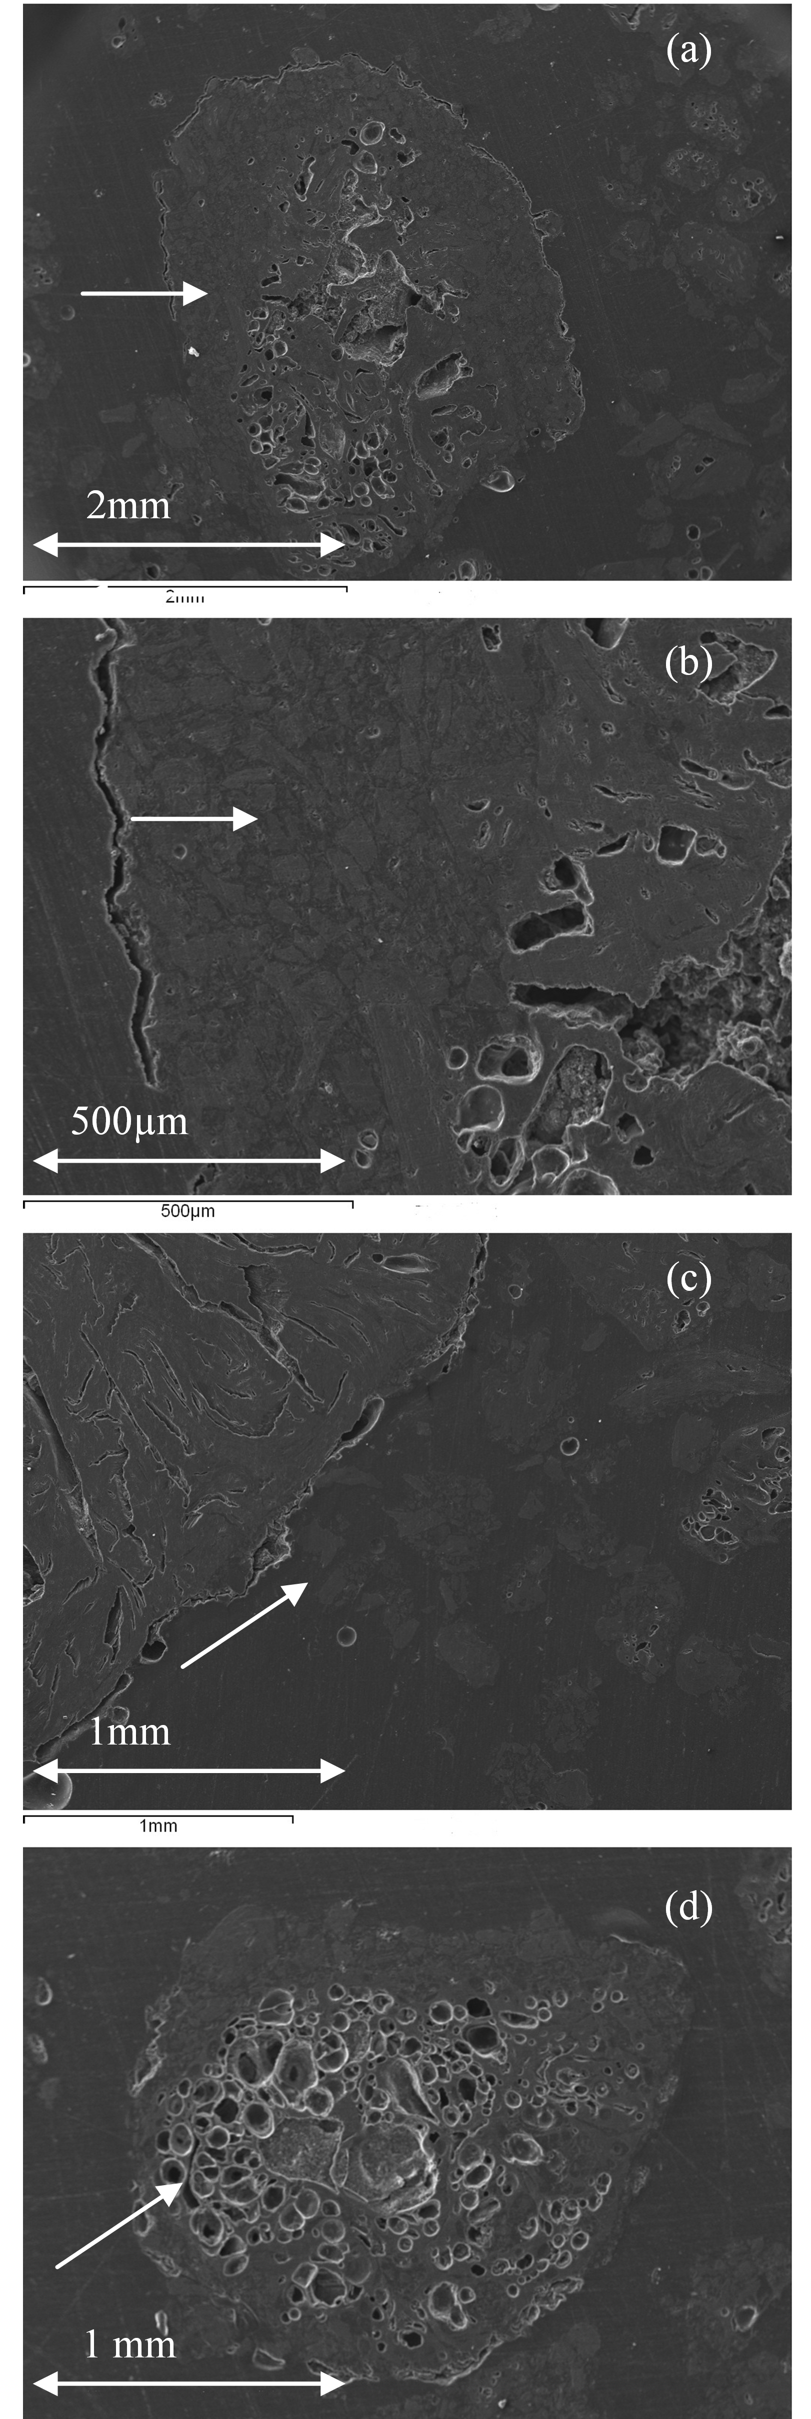
Fig. 1 Images of anode paste used for the base recipe: (a) the image shows a coke particle covered by pitch matrix, the arrow indicates the region that is magnified in b; (b) the arrow shows the area where pitch matrix accumulates on the coke surface; (c) the image shows that is hard to cover a recycled butt with the pitch matrix, the arrow indicates such a region; (d) the arrow points to the large amount of internal pores inside a coke particle.
those of the others tests. Table 2 shows the recipe of the anode paste chosen as best among the recipes tested.

Table 1 Base recipe of anode paste and properties of anode produced with this recipe
 | Particle size  (mm) | (%)
Coke, coarse | 12～6 | 60
Coke, medium | 6～3 | 60
Coke, fine | ＜3 | 60
Coke, dust | BM | 60
Recycled coarse | 12～3 | 13
Recycled, fine | ＜3 | 12
Pitch | Pitch | 15
Kneading Temperature  (Range 160±5℃) | 165℃
Kneading Time | 10 min
CO₂ reactivity (% residue) | 79.71
Air reactivity (% residue) | 58.51
Air permeability (npm) | 7.32

The properties of anodes made with the above recipe are compared with those of the others in Table 3. After, another group of experiments were carried out to determine the right percentages for each fraction of dry aggregate.
Table 2 shows the final recipe. In this recipe, the percentage sum of four fractions is 65%, recycled butt is 20% in dry aggregate and pitch content is 15%. Compared to the Table 1 which presents base recipe, the maximum particle size was decreased from 12mm to 8mm, the percentage of coke was increased from 60% to 65% and the recycled butt is reduced from 25% to 20%. Table 3 shows that the recipe using smaller particle sizes gave better anodes.

Table 2: New anode recipe with the maximum particle size of 8 mm
 | Particle Size  (mm) | (%)  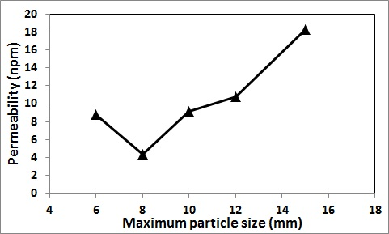
Coke, coarse | 8～6 | 65
Coke, inter-medium | 6～3 | 65
Coke, fine | ＜3 | 65
Coke, dust | BM | 65
Recycled, coarse | 8～3 | 12
Recycled, fine | ＜3 | 8
Pitch | - | 15
Kneading Temperature (°C)
Range: 160±5 Actual: 160
Kneading Time (min): 10

Table 3 Comparison of properties for different particle size groups with the base recipe
Recipe | CO₂ reactivity  At 960ºC  (%) residue | Air reactivity  At 525ºC  (%) residue | Air  permeability  (npm)
Small particle  size group | 89.44 | 60.21 | 2.58
Big particle  size group | 83.55 | 61.85 | 8.85
Base recipe | 79.71 | 58.51 | 7.32

The correlation between anode recipe adjustment and anode properties
Fig. 2 shows that when the maximum particle size is 8mm, the baked anodes have the better properties than the rest of the recipes tested. Fig.s 2a and 2b show that the reactivities and permeabilities are best when 8mm particle size was the maximum particle size used in a recipe. This recipe results in the highest residue after reactivity tests with air and CO₂ (least reactive) and lowest permeability. It was observed that if the maximum particle size was less than 8mm, the amount of coke dust and pitch mixture (binder matrix) staying between large particles was high. This might result in increased porosity and
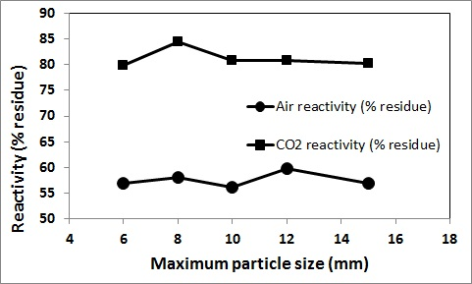
(a)

(b)

Fig. 2 Correlation between anode properties and maximum particle size: (a) air and CO₂ reactivities, (b) air permeability.

reduced density of anodes or even cause anode cracking during anode baking and cooling. When the maximum particle size is larger than 12mm, the binder-matrix might not cover the particles evenly (Fig. 1). During this study, the percentage of recycled butts was also reduced from 25% to 20% in the new recipe; this not only improved the anode reactivities but also reduced the cost due to the high cost of recycled butt cleaning compared to the price of coke.
If Fig. 3 is compared with Fig. 1, it can be seen that the new recipe gives a paste with better characteristic than that of the base one. Fig. 3 shows that a thin pitch matrix film covered the coke surface (Fig. 3a) and penetrated into the crack (Fig. 3b). This was not the case for the base recipe (Fig. 1a).

CONCLUSIONS
The stability of the raw materials supply is one of the important issues in the CHALCO plant. A few years ago, the 15% pitch addition was suitable for the 12mm maximum size recipe, however, now as it is explained above, it is not enough due to the change in raw material quality. This recipe yields to pitch accumulation at certain regions and creates under-pitched regions at other positions. The anode paste recipe had to be adjusted in according to the raw materials presently available. A new recipe was developed which gave

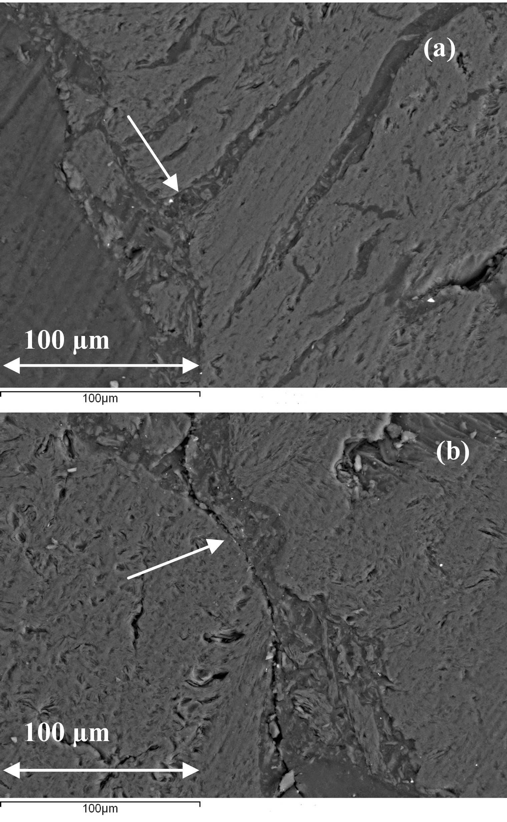
Fig. 3 Images of anode paste after recipe optimization showing the good penetration of pitch matrix into the coke: arrow indicates (a) the pitch matrix wet a crack and form a thin pitch film on the coke surface and (b) the pitch matrix cover and fill a pore.
better anode properties compared to those of the old one. In addition, it was possible to keep the pitch content of the new recipe same as that of the base recipe (15%). This means that the pitch percentage used, consequently, the pitch requirement, was kept stable even with changing aggregate recipe.
The new recipe was tested at the plant. Now it is being used in industrial anode production.
In this study, a method was developed to for adapting anode paste recipes while improving the anode properties or at least keeping them constant when the available raw material properties change. The developed anode recipe optimization will be repeated in the plant more and more frequently in order to assure the anode quality.

ACKNOWLEDGEMENTS
This project was supported financially by the NSERC, the Guizhou Provincial Research Fund, and the China Aluminum Cooperation (Chalco Guizhou branch). Technical support of the University Research Centre on Aluminum (CURAL) of the University of Quebec at Chicoutimi, Canada, and the School of Materials and Architectural Engineering of the Guizhou Normal University (GNU), China, is greatly appreciated.

REFERENCES

- K. L. Hulse and R. C. Perruchoud, “Process adaptations for finer dust formulations: mixing and forming”. Light Metals, pp. 467-472, 2000.
- Y. Zhao, “The study of optimizing the quality of pre-baked anodes”, Master’s thesis, Central South University , China, 2004
- Internal report, Chalco Guizhou branch, 2(3),pp.483-488, 2009.
- Internal report, Chalco Guizhou branch, 2(5),pp.523-529 2010”
- M. A. Engvoll, H. A. Oye and M. Sorlie, “Gas Reactivity Inside Industrial Anodes”, Light Metals, pp. 561-68, 2002.
- R. C. Perruchoud, “Effect of coke properties and its blending recipe on performances of carbon anode for aluminium electrolysis”, Journal of Central South University of Technology Eng., 13 (6), pp. 647-652, 2002.
- M. Aanvik and M. Sorlie, “Reactivity and texture of cokes doped with aluminum compounds”, Light Metals, pp.555-561, 2000.
- G.J. Houston and H.A.Oye, “Reactivity testing of anode carbon materials” Light Metals, pp.885-899, 1985.
- M, R.J. Tosta and E.M. .Inzunza, “Structural evaluation of coke of petroleum and coal tar pitch for the elaboration of anodes in the industry of the aluminum”, Light Metals, Pages 887-892, 2008.
- A. N. Adams, J.P. Mathews and H.H. Schobert, “The use of image analysis for the optimization of pre-baked anode formulation” Light Metals, pp. 547-552, 2002.

 

