Abstract— Heat-treated wood is a natural product heat-treated at high temperatures in the range of 180 to 240°C. Heat treatment modifies wood both chemically and physically. However, heat-treated wood is susceptible to weathering degradation. It is of considerable importance to investigate the influence of weathering on the degradation processes of heat-treated wood under different conditions. Jack pine (Pinus banksiana) heat-treated at different temperature were exposed to artificial weathering with and without water spray for different periods in order to understand the effect of weathering factors on degradation processes. Before and after weathering, their color and wettability by water were determined. Structural changes and chemical modifications at exposed surfaces were also investigated using florescent microscopy imaging, SEM, FTIR spectroscopy, and XPS. The results revealed that heat-treated wood was degraded more during weathering with water spray than without water spray.
Study of the Degradation of Heat-treated Jack Pine Under Different Artificial Weathering Conditions
Duygu Kocaefe, Xianai Huang, Yasar Kocaefe

Keywords— Heat-treated wood, weathering, jack pine, chemical modification, water spray.

INTRODUCTION
Heat treatment in the range of 180 to 240°C modifies wood both chemically and physically. Consequently, heat-treated wood possesses new physical properties such as reduced hygroscopy, improved dimensional stability, better resistance to degradation by insects and micro-organisms, and attractive darker color. These new versatile and attractive properties make heat-treated wood popular for outdoor applications. However, similar to untreated wood, heat-treated wood is also susceptible to weathering degradation. Among the weathering factors, UV radiation which is part of the solar radiation spectrum is known to be mainly responsible for initiating a variety of chemical changes and the discoloration of wood surfaces . The investigations on the chemical and physical changes of different types of heat-treated wood during artificial weathering with water spray to simulate the rain under natural weathering conditions have been previously carried out and published .
Comparative studies on the different changes the heat-treated wood undergoes after exposure to artificial weathering under various conditions are very limited, and there is no publication available in the literature on the comparison of changes in the wettability behavior as well as those of chemical and microscopic nature during different weathering processes for the heat-treated North American jack pine wood.
The objective of this work is to understand the effect of weathering factors on chemical and physical changes taking place in heat-treated wood. It is important to note that, in the weathering tests without water spray, air had a relative humidity of 50%. The regional jack pine was chosen to investigate the different degradation mechanisms due to artificial weathering with and without water spray. The changes in microscopic and chemical structures and the modifications taking place on heat-treated wood surfaces due to different artificial weathering conditions were analyzed using different methods: color measurement and contact angle test for wettability analysis; Fourier transform infrared spectroscopy (FTIR) and X-ray photoelectron spectroscopy (XPS) for chemical analysis; scanning electron spectroscopy (SEM) for microscopic structural analysis.

Material and methods

Materials
The jack pine (Pinus banksiana), which is commonly used for outdoor applications in North America, was studied. The dimensions of wood boards were approximately 30 × 200 × 6500 mm in the radial, tangential, and longitudinal directions, respectively.

Heat treatment
The high temperature thermal treatment of wood can be considered as a simultaneous heat and mass transfer through a porous medium . Several mathematical models describing the simultaneous unsteady heat and moisture transfer between a gas phase and a solid phase during heat treatment have been developed and published previously . A new technology for wood treatment was developed which is adaptable to any given load. Its capacity and energy efficiency are higher compared to other technologies per unit volume of the chamber (Figure 1).The wood is placed vertically in the furnace and is subjected to uniform flow, consequently resulting in uniform temperature distribution. It consists of different chambers for the conditioning of gas and the treatment of wood.
In this furnace, propane was used as the fuel and the wood was modified thermally in a non-oxidizing environment composed of hot combustion gases (CO₂ and H₂O). The wood samples were treated at different maximum temperatures, heating rate, and holding time. Holding time refers to the soaking time at the constant maximum treatment temperature. The conditions of heat treatment used during the study are shown in Table 1.
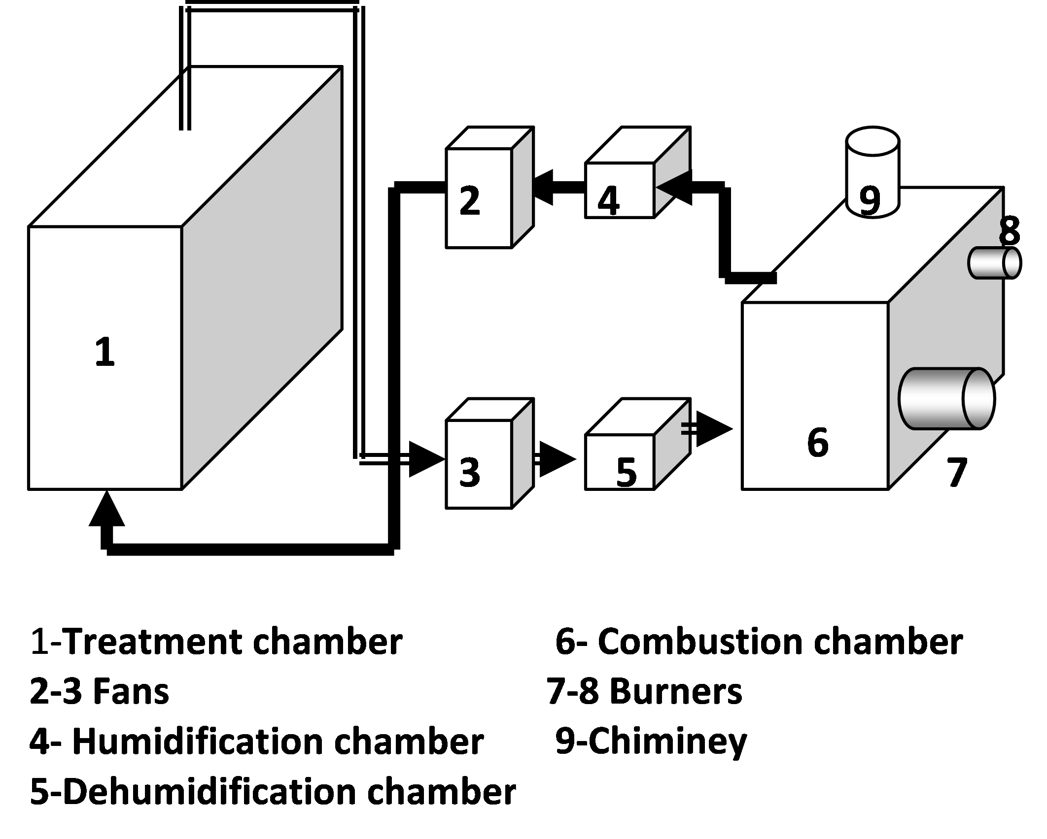
Figure 1 A schematic view of the wood heat-treatment furnace
Table 1 Conditions of heat treatment
No. | Surface | Temp.  (°C) | Heating rate  (°C/h) | Holding time  (h) | Humidity  (g water vapor/m3 dry gas)
1 | TL | - | - | - | -
2 | RL | - | - | - | -
3 | TL | 190 | 15 | 1 | 100
4 | RL | 190 | 15 | 1 | 100
5 | TL | 200 | 15 | 1 | 100
6 | RL | 200 | 15 | 1 | 100
7 | TL | 210 | 15 | 1 | 100
8 | RL | 210 | 15 | 1 | 100
The samples heat-treated to a maximum temperature of 210°C at a heating rate of 15°C/h and a holding time of 1 h were chosen for the study on the weathering behavior. The gas humidity was controlled at 100 g of water vapor/m³ dry gas during the entire heat treatment process. Specimens of 70 × 65 mm cross-section on longitudinal tangential (TL) or longitudinal radial (RL) surfaces and 20 mm in width were cut from the sapwood of heat-treated wood and then planed to have smooth surfaces. All samples were arbitrarily selected for complete statistical randomization. They were stored in an controlled-environment chamber at 20°C and 40% relative humidity (RH) until they were exposed to artificial weathering, and the characterization tests were carried out as described below.

Artificial weathering tests
The artificial weathering with water spray test was conducted at the Laval University. The prepared samples were exposed to artificial weathering using a commercial chamber, Atlas Material Testing Technology LLC (USA) Ci65/Ci65A Xenon Weather-Ometer. A controlled irradiance water-cooled xenon arc with a CIRA inner filter and a Soda outer filter was used as the source of radiation to simulate sunlight. Tests were performed according to Cycle 1 of Standard ASTM G155: 102 min Xenon light, 18 min light and water spray (air temperature is not controlled) without dark cycle to simulate rain during natural weathering. The black panel temperature was set to 63±3˚C and the irradiance level was 0.35W/m² at 340 nm.
The artificial sunlight exposure without water spray test was carried out at the South Florida Test Service, Accelerated Weathering Laboratory (ATLAS weathering services), using an Atlas Ci65/Ci65A Xenon Weather-Ometer. There was no water spray but relative humidity was set at 50±5%. The black panel temperature was 63 ±3°C and the irradiance level was 0.55 W/m² at 340 nm. Both tests were interrupted after 72, 168, 336, 672, 1008, and 1500 h of weathering and samples from each set were taken out at the end of each time period for the evaluation of surface properties. They were stored at a room temperature of 20°C and 40% relative humidity until they were used for characterization.

Surface characterization
The surface color of specimens was measured using a reflectance spectrophotometer (Datacolor, CHECK TM). The total color difference (ΔE) was calculated according to the equation given below.
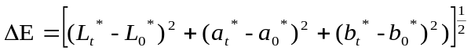 (1)
where L* represents the lightness intensity ranging from 0 to 100, where 0 represents black and 100 represents white, a* value describes the chromatic coordinates on the green/red axis, b* value represents the position on the blue/yellow axis. The subscript “0” represents the values before artificial sunlight irradiation, and “t” denotes those after exposure of t h.
The transverse sections cut through wood at a thickness of 7-20 μm were examined and photographed with the Nikon eclipse E600 microscope.
The contact angles were determined using a sessile-drop system, First Ten Angstroms FTA200, equipped with a CCD camera and an image analysis software. Six to twelve tests were performed for each set of experimental conditions.
FTIR analysis was carried out using Jasco FT/IR 4200 equipped with a diamond micro-ATR crystal. All relative intensity ratios were normalized relative to the peak of the band at 2900 cm⁻¹.
A Jeol scanning electron microscope (JSM 6480LV) was used to analyze sample surfaces with magnification up to 300000× at 10kV of accelerating voltage.
The XPS measurements were performed on AXIS Ultra XPS spectrometer (Kratos Analytical) at the University of Alberta.

Results and discussion
The heat treatment conditions were optimized with respect to mechanical properties and dimensional stability, and these works were previously published elsewhere . Here, the weathering of jack pine was studied using the samples that were heat-treated under the conditions identified as optimal in these studies.
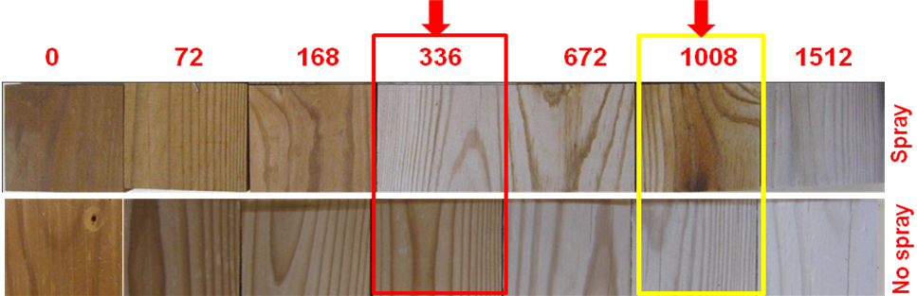
Figure 2 Jack pine surfaces during artificial weathering
Figure 2 shows the comparison of color changes and physical changes on the surfaces of heat-treated jack pine during artificial weathering with and without water spray. Visible differences in color changes are clearly observed on the specimens’ exposed surfaces under the two different weathering processes.
The visual inspection shows that the colors of heat-treated jack pine during the weathering process without water spray become whiter with increasing weathering time. On the other hand, the color starts to become white during the initial weathering period followed by a darker appearance on the surface of the specimens after accelerated weathering of 1008h with water spray, and then turns back to lighter again after 1500h. These results indicate that the variation of color change due to weathering is more significant with water spray than without water spray for heat-treated jack pine. This phenomenon is probably due to the effect of UV light combined with that of water spray. The color of heat-treated wood changes to lighter due to UV light and then changes back to darker due to the washing action of water spray on the surface layer during weathering. After long time weathering, the colors seem similar for both weathering tests. This means that the presence of humidity during artificial weathering without water spray plays a similar role, yielding similar results.
The curves of Figure 3 were generated using the CIE- L*a*b* system in order to verify the existence of a relationship between the chromatic variation occurring during weathering under different conditions and the color changes for jack pine wood.

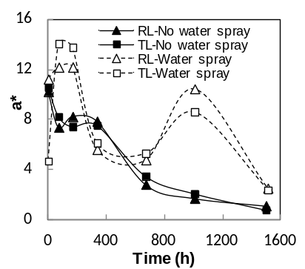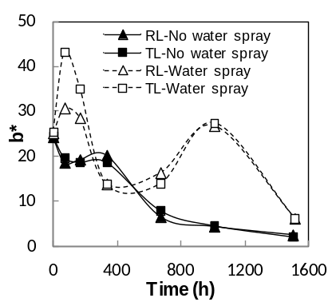
(a)
(b)
(b)
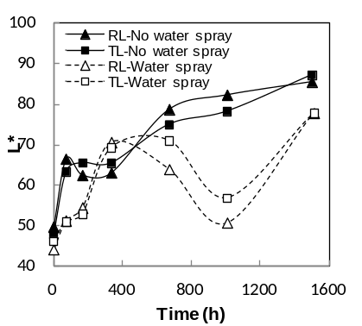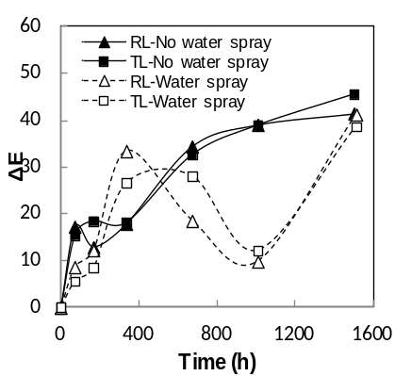
(c)
(d)
Figure 3 Color changes of heat-treated jack pine during different weathering conditions, reported using CIE-L*a*b* system: (a) red/green coordinate (a*), (b) yellow/blue coordinate (b*), (c) lightness coordinate (L*), (d) total color difference (ΔE)
Increase in a* values and b*values indicates a tendency of the wood surface to become redder and yellower while decrease in their values shows a tendency to become greener and bluer. During early times of weathering with water spray, a*values of wood increase significantly with artificial weathering up to 72 h while those during weathering without water spray decrease significantly on both radial and tangential surfaces (see Figure 3 (a)). Then the a*values of heat-treated radial and tangential surfaces during both weathering tests decrease rapidly and reach almost the similar end value at the weathering time of 672 h. Subsequently, the a* values of heat-treated jack pine during weathering without water spray continue to decrease at a slower rate up to 1500 h. On the other hand, the values appear to increase to a maximum value at 1008 h and then decrease rapidly after weathering for 1500 h. As shown in Figure 3 (b), the trend observed for the b*value changes of heat-treated wood on both radial and tangential surfaces due to different artificial weathering are similar to those of a*value.
As shown by the changes in L* values, brightening and darkening of wood surfaces were evaluated. Figure 3 (c) shows L* plotted as a function of weathering time for heat-treated jack pine. L*values indicate different tendency for different weathering tests, and the trends observed for radial and tangential surfaces of heat-treated wood are similar to those of a* and b*values.
L* increases at different rates during weathering without water spray, implying that heat-treated wood surface becomes lighter as the weathering time increases. Changes in lightness of heat-treated wood with increasing time of artificial weathering are mainly due to the lignin photo-degradation, and the color becomes lighter starting from the beginning. The lightening of heat-treated wood increases during the early stage of weathering up to 168 h with water spray, stays more or less stable up to 672 h, and then decreases to 1008 h, followed by an increase again until the end of the test. This matches with the results obtained by visual observation. It is demonstrated that the darkening of samples during the artificial weathering with water spray is mainly due to the washing off of cellulose layer left on the surface caused by the photo-degradation of lignin. After the weathering of 1500 h, similar to the tendencies observed for redness (a*) and yellowness (b*), the lightness levels for the two different weathering processes are mainly similar. This indicates that their final colors after artificial weathering with and without water spray for 1500 h become alike.
Although the color change (ΔE) trends of samples on radial and tangential surfaces due to weathering have some similar features, samples have a uniquely different color change pattern during two different artificial weathering processes (see Figure 3 (d)). The rapidness and the extent of the weather effects on heat-treated wood at different weathering periods are different.
Figure 4 (a) and (b) presents the dynamic contact angles of wood/water system as a function of time for heat-treated jack pine during artificial weathering without and with water spray, respectively. As it can be seen in the figure, weathering both with and without water spray reduces the hydrophobic behavior of heat-treated wood; consequently, all dynamic contact angles of weathered wood are lower than those before weathering (0 h). The contact angles of heat-treated samples after weathering reduces with increasing exposure time to different extents depending on weathering time and weathering conditions. The contact angles after weathering with water spray for 72 h are considerably lower than those during weathering without water spray due to the effect of water spray on the degradation of samples. The contact angles during the two tests do not seem to differ significantly after weathering for 1500 h, and water is absorbed by both woods within one second.
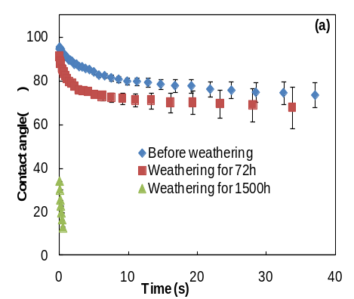
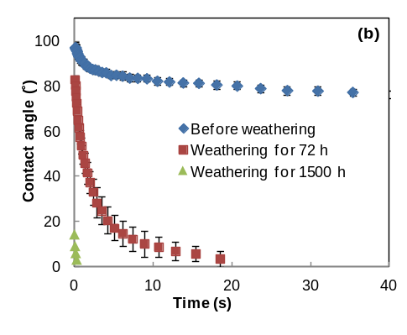
Figure 4 Wettability of heat-treated jack pine surface during artificial weathering under different conditions: (a) without water spray, (b) with water spray
The difference in wood surface structure can cause wettability differences . Figure 5 shows the fluorescence microscopy images of heat-treated jack pine before and during artificial weathering without and with water spray for 1500 h, respectively. Delamination and thinning of cells appear after 1500 h of both weathering tests in this study. The degree of damage to wood weathered without water spray is less compared to that of weathering with water spray at the same weathering time. This indicates that water spray intensifies the weathering degradation on heat-treated jack pine wood surface.
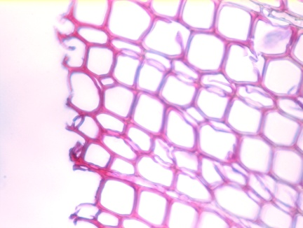
(a)
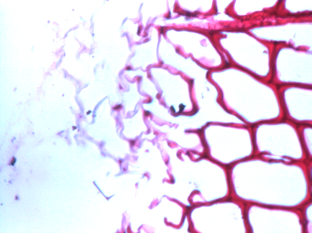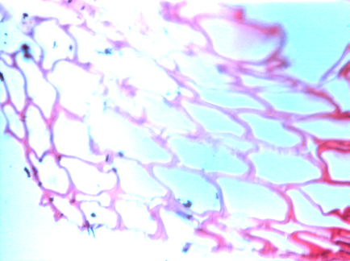
(c)
(b)
Figure 5 Fluorescent microscopy images (x50) of transverse surface of heat-treated jack pine after weathering for 1500 h: (a) before weathering, (b) without water spray, (c) with water spray
SEM micrographs of the untreated and heat-treated jack pine before weathering revealed that the high temperature heat treatment shows slight effect on the wood structure (see Figure 6 (a) and (b)): the micro-cracks are formed on cell walls during the heat treatment (see arrow in Figure 6 (b)). SEM micrographs of the heat-treated jack pine revealed the formation of different patterns of cell wall cracks due to artificial weathering under different conditions (see Figure 6 (c) and (d)). Both weathering processes changed significantly the structural properties of heat-treated wood (see arrows in Figure 6 (c) and (d)). The SEM analysis indicated that the anatomical structure of samples was affected less during weathering without water spray than with water spray, for example, the formation of less checks (Figure 6 (a)). This confirms the results of florescence microscopy imaging.
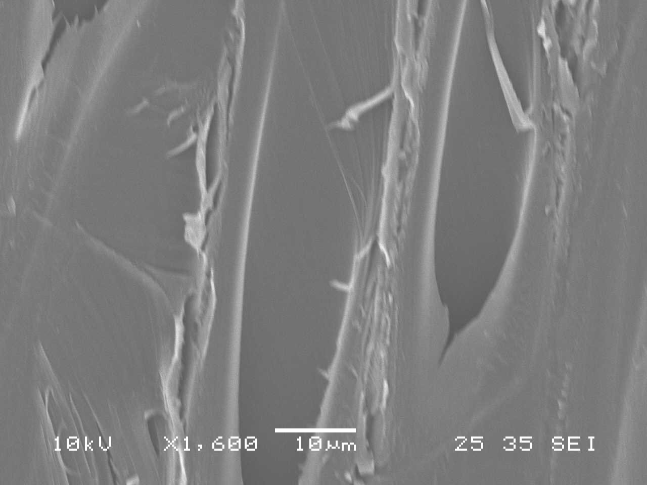
(a)
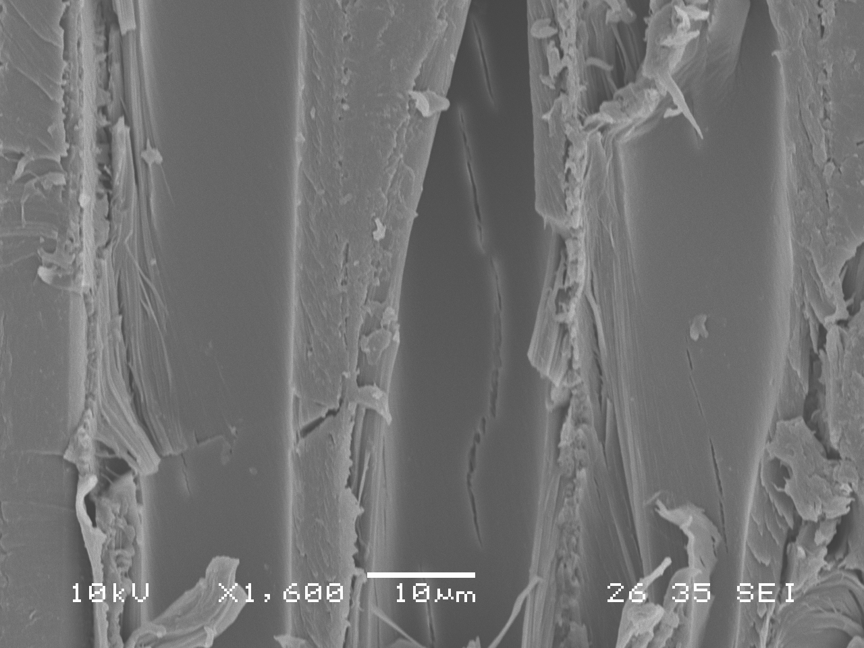
(b)
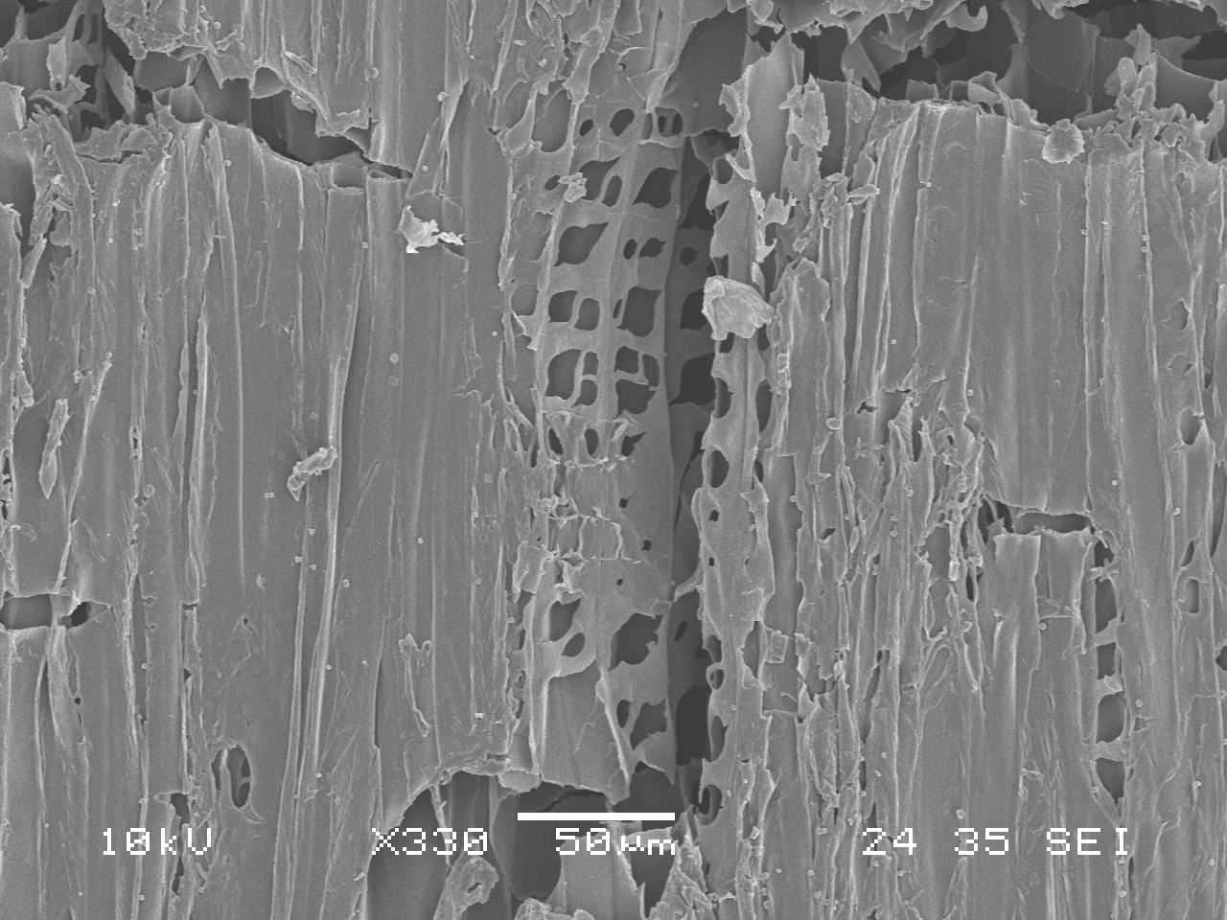
(c)
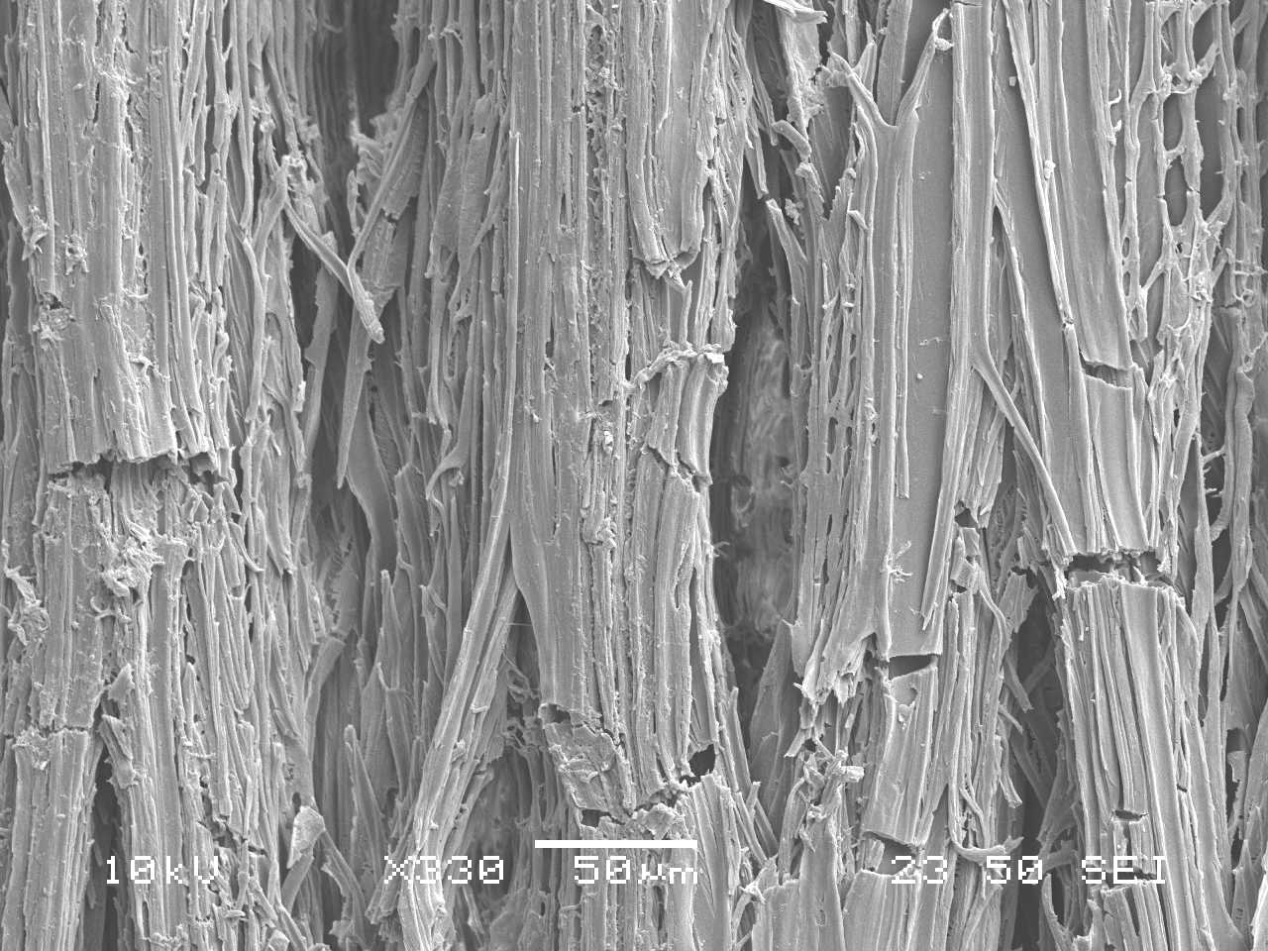
(d)
Figure 6 SEM images of radial longitudinal surfaces of jack pine: (a) untreated wood, (b) heat-treated wood before weathering, (c)heat-treated wood after weathering for 1500 h without water spray, (d) heat-treated wood after weathering for 1500 h with water spray
It seems that the binding of cellulose microfibrils by lignin in various cell wall layers has been degraded by UV light. Consequently, separation between two adjacent cells occurred and cracks formed. The water flow into the wood cell lumena and the diffusion within the cell wall give rise to the wettability of wood surface by water . Cracks present on heat-treated sample surfaces after weathering (shown in Figure 6 (c) and (d)) resulted in easier entrance of water into cell lumena and cell wall, which consequently decreased contact angles and increased wettability (see Figure 4). In addition, water spray in artificial weathering allowed more opportunity of water entrance into wood, which accelerated the degradation process.
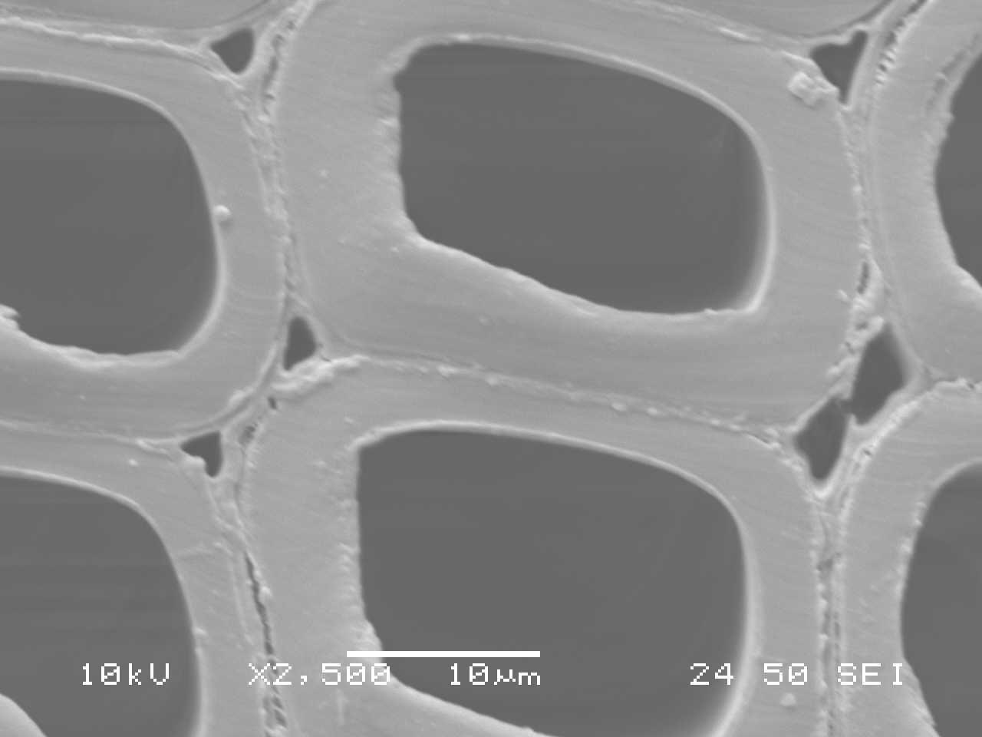
(a)
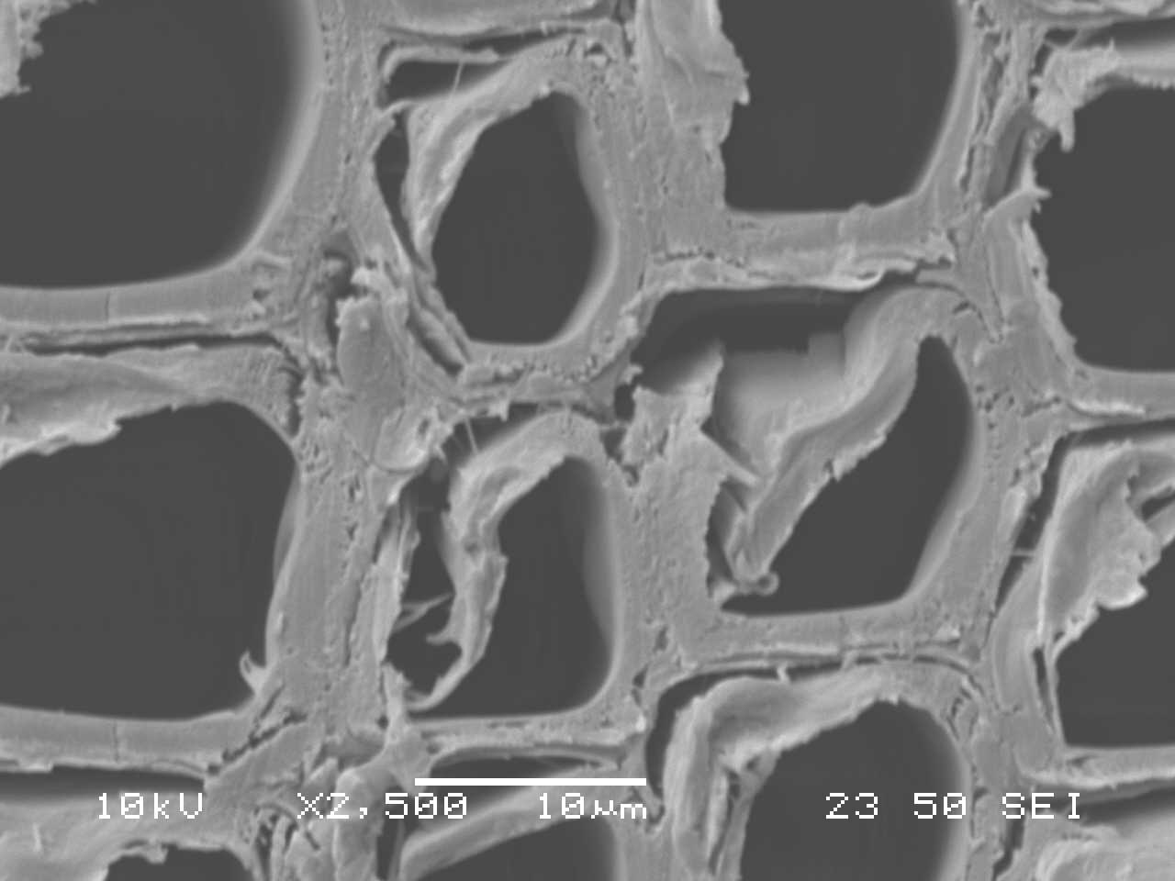
(b)
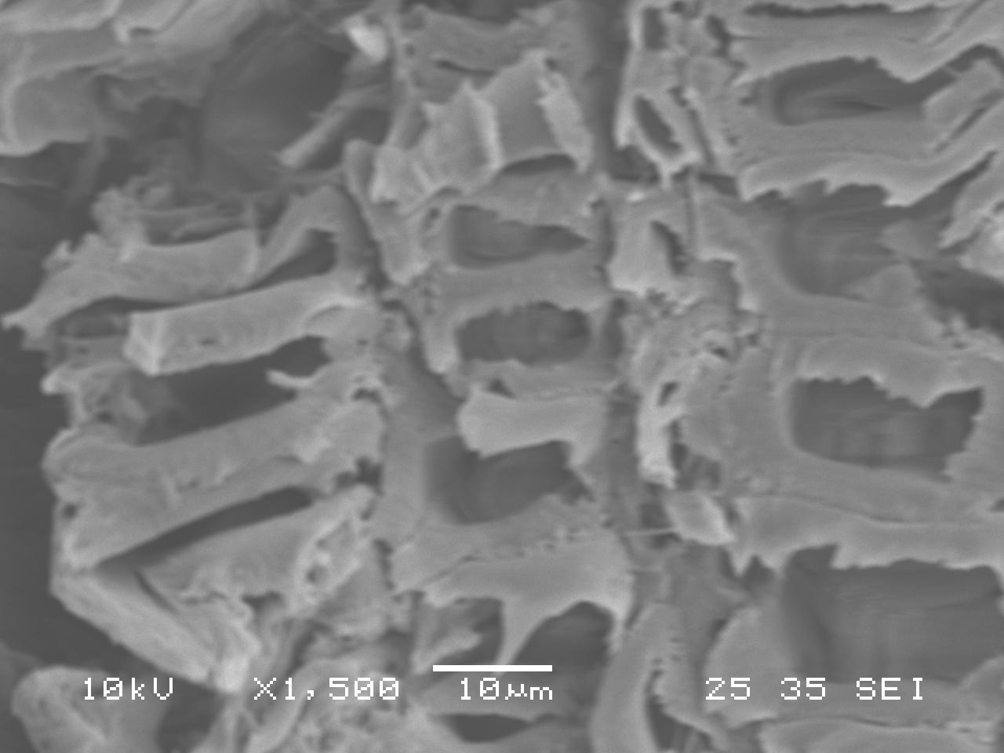
(c)
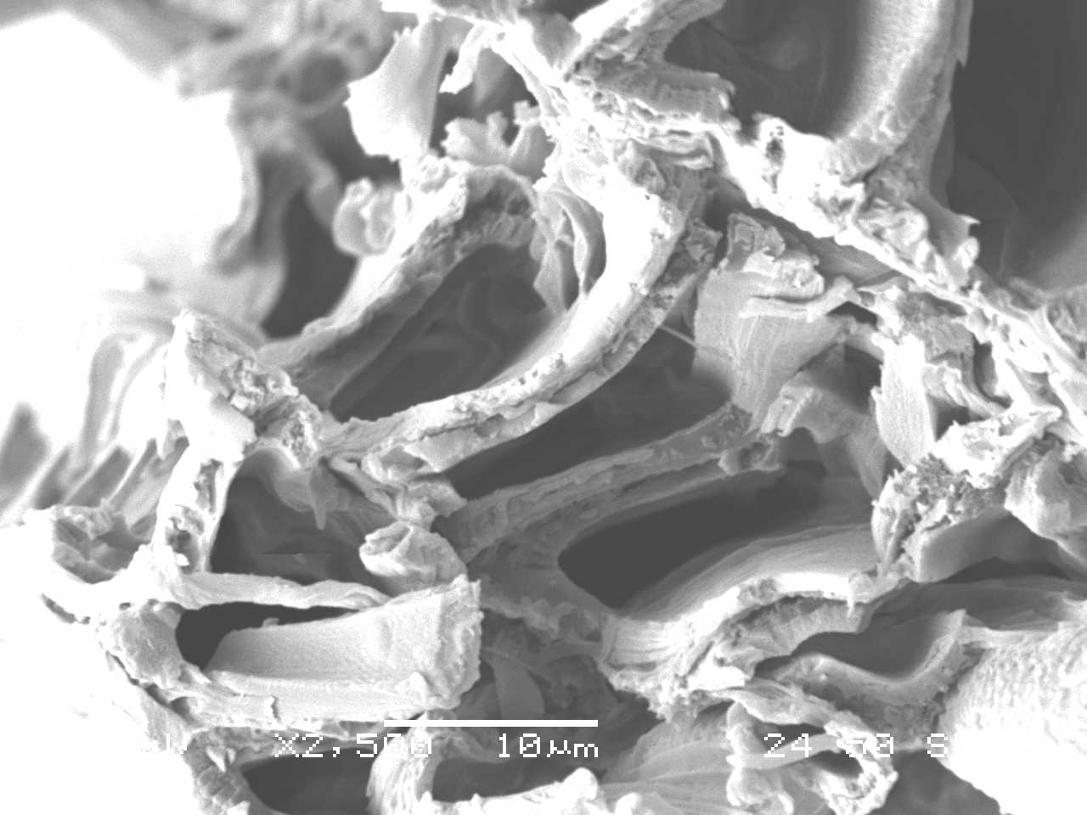
(d)
Figure 7 SEM images of transverse surfaces of heat-treated jack pine: (a) untreated wood, (b) heat-treated wood before weathering, (c) heat-treated wood after weathering for 1500 h without water spray, (b) heat-treated wood after weathering for 1500 h with water spray
Additional information on micro-structural changes can be seen on the SEM micrographs on transverse surfaces of the specimens. Figure 7 shows the SEM micrographs on transverse surfaces of untreated and heat-treated specimens before and after weathering for 1500 h under different weathering conditions. Comparing Figure 7 (a) and (b), it can be seen that the slight thinning of cell wall on middle lamella takes place on jack pine transverse surface after heat treatment at 210°C. It seems that there is small crack formation (see arrow in Figure 7 (b)). Heat-treated jack pine wood looks more brittle than its untreated counterpart. However, the structural changes due to heat treatment are not distinct, and it is likely that plasticization of cell wall material occurs only to a limited degree during heat treatment. This is in agreement with the results of Kollmann and Sachs who found comparable features in spruce after heat treatment between 190°C and 240°C and those of previous studies by Huang et al. . Figure 7 (c) and (d) show the micro-structural changes of cell occurring on the transverse surfaces of heat-treated jack pine after artificial weathering for 1500 h without and with water spray, respectively. The significant thinning of cell wall width for the two specimens take place compared to samples before weathering; however, their magnitude which is different for different samples is difficult to differentiate after the weathering of 1500 h. This indicates that the effect of weathering on the cell wall of heat-treated jack pine surface is similar after long term weathering with and without water spay.
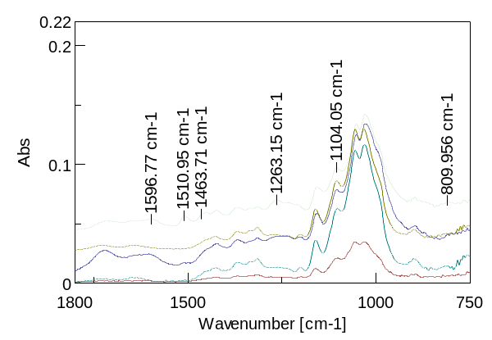
a
b
c
d
e
Figure 8 FTIR spectra of heat-treated jack pine on radial longitudinal surfaces: (a) before weathering, (b-c) weathering for 72 h without and with water spray, (d-e) weathering for 1500 h without and with water spray
Weathering induces changes also in the chemical properties of a wood surface, which is linked to the color change and increase in wettability during weathering . Figure 8 shows the FTIR spectra within the spectral region of 1800-750 cm⁻¹ on heat-treated jack pine before and after artificial weathering for 1500 h with and without water spray. Differences due to weathering can be clearly seen in the band shapes of the infrared spectra.
The spectra in Figure 8 (b-e) show uniquely different infrared spectra for heat-treated samples after weathering for different times and conditions, respectively. A general observation that can be made from the results is that the degradation of heat-treated wood samples in both weathering tests caused the changes in the absorption intensity at the peaks shown in Figure 8. As shown in Figure 8, all the characteristic bands of lignin at 1600 cm⁻¹, 1510 cm⁻¹, 1483 cm⁻¹, and 1263 cm⁻¹ decreased differently as a result of artificial weathering, depending on different weathering times and conditions. The peak at 1510 cm⁻¹ is mainly the characteristic absorption of C=C in an aromatic ring that originates from lignin in wood. It can be observed that the peak at 1510 cm-1 disappeared after weathering for 72 h during both weathering tests. The loss of lignin made the surface more hydrophilic (see Figure 4). New bands at 1730 cm⁻¹ and 1650 cm⁻¹ were detected for heat-treated wood surfaces after weathering with water spray for 72 h (see Figure 8 c). According to Erin et al. , this may be due to the formation of unconjugated free carbonyl groups and quinines and quinine methides that were generated and changed as a result of the significant photochemical degradation of lignin by weathering. However, these changes depend on different artificial weathering conditions.
As Figure 8 shows, the new bands at 1730 and 1650 cm⁻¹ were not detected for heat-treated wood surfaces after weathering without water spray for 72 h and after 1500 h of weathering with and without water spray. In this study, the natural rain was simulated with water spray during the artificial weathering test, which might have leached out the by-products of the degradation of lignin such as quinines and quinine methides after long term weathering. The leaching out of these by-products left white cellulose and hemicelluloses layer on the wood surface, which is responsible for the lightening of heat-treated wood. As the weathering continues, the leaching of remaining polymers on the wood surface occurs, and, consequently, the color returns to darker tone (see data at 1008 h in Figure 3). The degradation processes continue repeatedly and sequentially throughout the entire weathering period.
In the XPS analysis, the focus was on the high-resolution of C 1s and O/C ratio. The high-resolution of C 1s was fitted with their decomposition into four components. The spectra of C1s of heat-treated sample surfaces before and after weathering (with and without water spray) for 1500 h are shown in Figure 9. The concentrations of contributions at C₁ and C₂ peaks are higher than those of C₃ and C₄ for all samples, and they are also modified by the weathering process even without water spray. The most important contributions for heat-treated jack pine surfaces before weathering come from the C₁ class which corresponds to C–C and C-H groups present in lignin, hemicelluloses, and extractives However, the contributions from the C₂ class, corresponding to OCH groups of lignin and C–O–C linkages of extractives and polysaccharides of wood , become more important for surfaces after weathering (see Figure 9 (b-c)). This indicates that the weathering increases the contribution of hemicelluloses and celluloses for heat-treated jack pine. The weathering with water spray shows similar effects on the changes in component contributions.
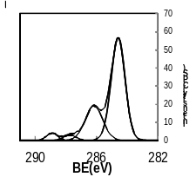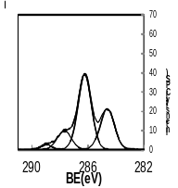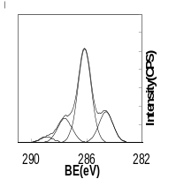
(a)
(b)
(c)
C₁
C₂
C₃
C₄
C₁
C₂
C₃
C₄
C₁
C₂
C₃
C₄

Figure 9 C1s spectra of heat-treated jack pine: (a) before weathering, (b) after weathering for 1500 h without water spray, (c) after weathering for 1500 h with water spray
The variations in the peak area contributions of C1 and C2 components and O/C ratio as a function of weathering time for both weathering tests are shown in Figure 10. As stated previously, the C₁ is associated with the presence of lignin, and the C₂ mainly originates from cellulose and hemicelluloses on wood surface. The C₁ contribution decreases while the C₂ contribution increases with increasing weathering time during both tests (Figure 10 (a)). This indicates that the lignin is more sensitive than cellulose to weathering and is degraded more; consequently, the lignin content becomes less important after weathering. The results show that the weathered heat-treated jack pine surface is rich in cellulose and poor in lignin. C₁ and C₂ contributions change less during weathering without water spray compared to those with water spray, implying that water spray intensifies the influence on the C1s component change of heat-treated wood surface. The changes provoked in wood composition by weathering without water spray are less compared to those induced by weathering with water spray on the wood surface. This can be confirmed by the changes in the O/C ratio shown in Figure 10 (b).

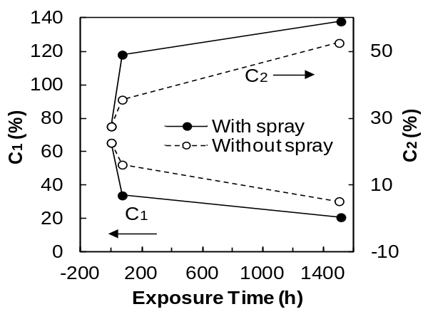
(a)
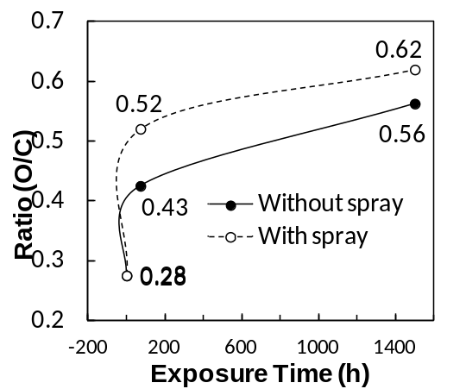
(b)
Figure 10 (a) Effect of weathering on the C1 and C2 component; (b) O/C ratio of heat-treated jack pine wood surface during different artificial weathering processes
To evaluate the influence of oxygen content on the surface acid-basic properties, the ratios of acid/base are plotted as a function of the atomic concentration ratio (O/C) for heat-treated jack pine wood samples after weathering for different periods (see Figure 11). A linear correlation between the atomic concentration ratio O/C and the acid/ base ratio can be observed from this figure with a correlation coefficient of 0.9169. The O/C ratio gives a direct measurement of the surface oxygen content, and a high oxygen content normally points to the oxidation of the surface. Therefore, the results indicate that the acid/base ratio is increased proportionally as a result of oxidation caused by weathering for heat-treated jack pine investigated in this study. This result is in agreement with the findings of a previous study for heat-treated aspen and birch woods .

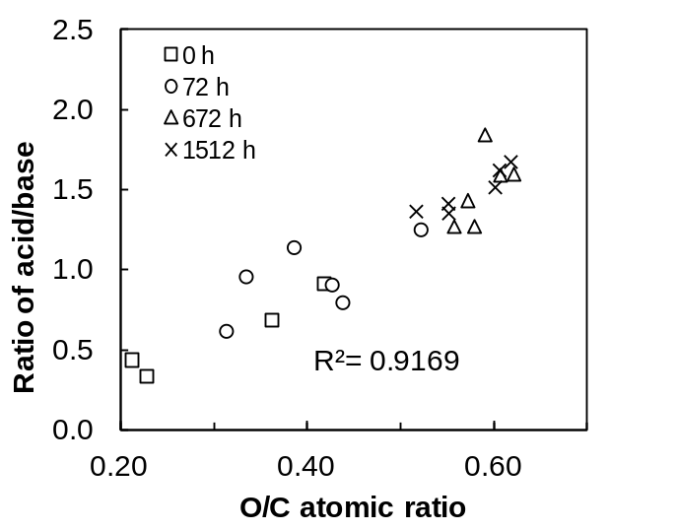Figure 11 Correlation of the acidity to basicity ratio (A/B) with the oxygen to carbon atomic ratio (O/C) for heat-treated jack pine wood during weathering

Conclusion
The combined action of sunlight and humidity (water spray or simulated high humidity) results in lightening of the surface during the weathering of heat-treated wood surface and leads to the formation of macroscopic and microscopic cracks or checks. As weathering continues, humidity washes out degradation by-products present on the wood surface, and the exposed surface goes through further degradation. Thus, a cyclic damage of heat-treated wood surface occurs during the weathering process. Discoloration and checking of heat-treated wood surfaces during different weathering tests differ in intensity. The formation of macro-cracks and micro-cracks during weathering results in easier entrance of water into the cells, which consequently increases wood wettability. Lignin is more sensitive to irradiation compared to other wood components; therefore, the heat-treated wood surface becomes richer in cellulose and poorer in lignin after weathering.
Acknowledgment
The authors thank Fonds québécois de la recherche sur la nature et les technologies (FQRNT), Développement Économique Canada (DEC), Ministère du Développement Économique, de l’Innovation et de l’Exportation (MDEIE), Conférence Régionale des Élus du Saguenay-Lac-St-Jean (CRÉ), Université du Québec à Chicoutimi (UQAC), Fondation de l’Université du Québec à Chicoutimi (FUQAC), FPInnovation, Alberta Innovates, and industrial partners (PCI Ind., Kisis Technology, and Industries ISA), for their technical and/or financial contributions. The authors also thank the Centre universitaire de recherche sur l’aluminium (CURAL) at UQAC for technical support during the SEM analysis.
References
[1] W.C. Feist, R.M. Rowell, R.J. Barbour, Outdoor wood weathering and protection, Archaeological Wood: Properties, Chemistry, and Preservation, (1990) 263-298.
[2] M. Nuopponen, H. Wikberg, T. Vuorinen, S.L. Maunu, S. Jämsä, P. Viitaniemi, Heat-treated softwood exposed to weathering, Journal of Applied Polymer Science, 91 (2004) 2128-2134.
[3] X. Huang, D. Kocaefe, Y. Kocaefe, Y. Boluk, C. Krause, Structural analysis of heat-treated birch (Betule papyrifera) surface during artificial weathering, Applied Surface Science, 264 (2013) 117-127.
[4] X. Huang, D. Kocaefe, Y. Kocaefe, Y. Boluk, A. Pichette, Changes in wettability of heat-treated wood due to artificial weathering, Wood Science and Technology, 46 (2012) 1215-1237.
[5] X. Huang, D. Kocaefe, Y. Kocaefe, Y. Boluk, A. Pichette, A spectrocolorimetric and chemical study on color modification of heat-treated wood during artificial weathering, Applied Surface Science, 258 (2012) 5360-5369.
[6] D. Kocaefe, X. Huang, Y. Kocaefe, Y. Boluk, Quantitative characterization of chemical degradation of heat-treated wood surfaces during artificial weathering using XPS, Surface and Interface Analysis, 45 (2013) 639-649.
[7] M.C. Popescu, A. Bulucea, L. Perescu, Improved transformer thermal models, WSEAS Transactions on Heat and Mass Transfer, 4 (2009) 87-97.
[8] T. Al-Azab, Unsteady mixed convection heat and mass transfer past an infinite porous plate with thermophoresis effect, WSEAS Transactions on Heat and Mass Transfer, 4 (2009) 23-33.
[9] H. Merouane, A. Bounif, Theoretical and numerical analysis of fuel droplet vaporisation at high temperatures, WSEAS Transactions on Heat and Mass Transfer, 5 (2010) 189-196.
[10] S. Ioan, Energy analysis of low temperature heating systems, WSEAS Transactions on Heat and Mass Transfer, 5 (2010) 123-132.
[11] D. Kocaefe, S. Poncsak, J. Tang, M. Bouazara, Effect of heat treatment on the mechanical properties of North American jack pine: Thermogravimetric study, Journal of Materials Science, 45 (2010) 681-687.
[12] R. Younsi, D. Kocaefe, S. Poncsak, Y. Kocaefe, L. Gastonguay, A high-temperature thermal treatment of wood using a multiscale computational model: Application to wood poles, Bioresource Technology, 101 (2010) 4630-4638.
[13] F. Thibeault, D. Marceau, R. Younsi, D. Kocaefe, Numerical and experimental validation of thermo-hygro-mechanical behaviour of wood during drying process, International Communications in Heat and Mass Transfer, 37 (2010) 756-760.
[14] R. Younsi, S. Poncsak, D. Kocaefe, Experimental and numerical investigation of heat and mass transfer during high-temperature thermal treatment of wood, Drying Technology, 28 (2010) 1148-1156.
[15] D. Kocaefe, R. Younsi, S. Poncsak, Y. Kocaefe, Recipe adaptation and new recipe development for high temperature heat treatment of North American wood species, International Journal of Energy, Environment and Economics, 19 (2011) 257-278.
[16] D. Kocaefe, Kocaefe, Y., Poncsak, S., Lekounougou, S.T., Younsi,R., Oumarou, N., Comparison of the Mechanical Properties of Three Heat-Treated North American Species, 4th International Conference & Exhibition on Environmentally-Compatible Forest Products, (2010).
[17] M. Kishino, T. Nakano, Artificial weathering of tropical woods. Part 1: Changes in wettability, Holzforschung, 58 (2004) 552-557.
[18] T.C. Patton, SIMPLIFIED REVIEW OF ADHESION THEORY BASED ON SURFACE ENERGETICS, Tappi, 53 (1970) 421-429.
[19] W.B. Banks, Water uptake by scots pine sapwood, and its restriction by the use of water repellents, Wood Science and Technology, 7 (1973) 271-284.
[20] M.J. Boonstra, J.F. Rijsdijk, C. Sander, E. Kegel, B. Tjeerdsma, H. Militz, J. Van Acker, M. Stevens, Microstructural and physical aspects of heat treated wood. Part 1. Softwoods, Maderas: Ciencia y Tecnologia, 8 (2006) 193-208.
[21] X. Huang, D. Kocaefe, Y. Boluk, Y. Kocaefe, A. Pichette, Effect of surface preparation on the wettability of heat-treated jack pine wood surface by different liquids, European Journal of Wood and Wood Products, 70 (2012) 711-717.
[22] Y. Kataoka, M. Kiguchi, Depth profiling of photo-induced degradation in wood by FT-IR microspectroscopy, Journal of Wood Science, 47 (2001) 325-327.
[23] B.A. Horn, J. Qiu, N.L. Owen, W.C. Feist, FT-IR studies of weathering effects in Western red cedar and Southern pine, Chemical Modification of Lignocellulosics, (1992).
[24] E.L.P. Anderson, Zenon1; Owen, Noel L.1; Feist, William C.2, Infrared Studies of Wood Weathering. Part I: Softwoods Society for Applied Spectroscopy, 45 (1991) 521-714 (May 1991) , pp. 1641-1647(1997).
[25] G. Nguila Inari, M. Petrissans, J. Lambert, J.J. Ehrhardt, P. Gérardin, XPS characterization of wood chemical composition after heat-treatment, Surface and Interface Analysis, 38 (2006) 1336-1342.

D. Kocaefe This author has a B.Sc.(‘78) from the Middle East Technical University, Turkey, and M.Sc.E.(’81) and Ph.D.(’86) from the University of New Brunswick, Canada, in Chemical Engineering. She is a member of the Forest Product Society, the Order of Engineers of Quebec, the Minerals, Metals, and Materials Society, and the Canadian Chemical Engineering Society. She is also a member of the Board of Directors of AFFESTIM and FR-QNT.
Prof. Kocaefe is full professor in the Department of Applied Sciences at the University of Quebec at Chicoutimi (UQAC). She is also the director of the Research Group on the Thermotransformation of Wood and the chair holder of the Aluminerie Alouette/UQAC Research Chair on the Use of Carbon in Aluminum Industry. She has published extensively in the fields of wood thermotransformation and aluminum, including contributions to a number of books.

X. Huang This author was born in China, September 1982. She got her Ph.D.(’12) from the University of Quebec at Chicoutimi, Canada. Her major field of study is in the heat-treated wood science and technology.
She is working as a Post-Doctoral Fellowship at the Department of Applied Science in the University of Quebec at Chicoutimi, (UQAC). She has many publications on heat-treated wood, including contributions to a chapter of book and magasin.

Y. Kocaefe This author has a B.Sc.(‘78) from the Middle East Technical University, Turkey, and a M.Sc.E.(’83) from the University of New Brunswick, Canada, in Chemical Engineering. He has a Ph.D.(‘03) from the University of Quebec at Chicoutimi in Mechanical Engineering. He is a member of the Order of Engineers of Quebec, and the Minerals, Metals, and Materials Society.
Prof. Kocaefe is a research professor in the Department of Applied Sciences at the University of Quebec at Chicoutimi (UQAC). He has many publications on wood thermotransformation and aluminum, including contributions to a number of books.

 D.Kocaefe is with the University of Quebec at Chicoutimi, 555, boul de l'Université, Chicoutimi, Quebec, Canada G7H 2B1 (phone: 418-545-5011 ext.5215; fax: 418-545-5012; e-mail: duygu_kocaefe@uqac.ca). X. Huang, is with the University of Quebec at Chicoutimi, 555, boul de l'Université, Chicoutimi, Quebec, Canada G7H 2B1 (e-mail: xianai.huang1@uqac.ca). Y. Kocaefe is with the University of Quebec at Chicoutimi, 555, boul de l'Université, Chicoutimi, Quebec, Canada G7H 2B1 (e-mail: yasar_kocaefe@uqac.ca).

