Comparison of the Protection Effectiveness of Acrylic Polyurethane Coatings Containing Bark Extracts on Three Heat-treated North American Wood Species: Surface Degradation

DUYGU KOCAEFE*, SUDESHNA SAHA
Department of Applied Sciences (Groupe de Recherche sur le Thermotransformation du Bois)
Université du Québec a Chicoutimi
555, Boul. de l’Université, Québec, G7H2B1
CANADA
Duygu.Kocaefe@uqac.ca (D. Kocaefe); sudeshna.saha@uqac.ca (S. Saha)
Ph No: 1-418-5455011 (5215)

Fax No: 1-418-5455012

Abstract: - High temperature heat-treatment of wood is a very valuable technique which improves many properties (biological durability, dimensional stability, thermal insulating characteristics) of natural wood. Also, it changes the natural color of wood to a very attractive dark brown color. Unfortunately, this color is not stable if left unprotected in external environment and turns to gray or white depending on the wood species. The acrylic polyurethane coatings which have high resistance against aging are further modified by adding bark extracts and/or lignin stabilizer to enhance their effectiveness in preventing the wood aging behaviour. The aging characteristic of this coating is compared with acrylic polyurethane combined with commercially available organic UV stabilizers. In this study, their performance on three heat-treated North American wood species (jack pine, quaking aspen and white birch) are compared under accelerated aging conditions. Both the color change data and visual assessment indicate improvement in protective characteristic of acrylic polyurethane when bark extracts and lignin stabilizer are used in place of commercially available UV stabilizer. The results showed that although acrylic polyurethane with bark extracts and lignin stabilizer was more efficient compared to acrylic polyurethane with organic UV stabilizers in protecting heat-treated jack pine, it failed to protect heat-treated aspen and birch effectively after 672h of accelerated aging. This degradation was not due to the coating adhesion loss or coating degradation during accelerated aging; rather, it was due to the significant degradation of heat-treated aspen and birch surface beneath this coating. The XPS results revealed formation of carbonyl photoproducts after aging on the coated surfaces and chain scission of C-N of urethane linkages.

Key-Words: - Heat-treated wood, Acrylic polyurethane coatings, Bark extracts, Accelerated aging, Color measurement, Surface characterizations,
- Introduction

High temperature heat-treatment of wood is a feasible alternative to chemical treatment which has adverse effect on human health as well as environment . Heat-treated wood gained much attention in the recent past due to its dark brown color, better dimensional stability, and improved biological resistance compared to those of natural wood . Heat-treated woods are mainly used for decorative purposes in building materials. Unfortunately, the color of heat-treated wood is not stable in outer environment if left unprotected . To overcome this problem a non toxic and transparent coating need to be developed which can protect this value-added product from outer environment without changing its appearance and texture. Acrylic polyurethane coatings containing bark extract and lignin stabilizer found to be highly effective in protecting heat-treated jack pine under accelerated aging conditions . In this paper, the efficiency of this coating in preventing the discoloration of heat-treated jack pine is compared with its efficiency in protecting heat-treated white birch and heat-treated quaking aspen. These results are also compared with acrylic polyurethane coating containing commercially available light stabilizers to give an overview about the effectiveness of bark extracts.

- Materials and Methods
Color measurement technique is a very useful measurement of wood surface degradation under the actions of several environmental factors such as UV/VIS light, water in the form of humidity and rain, heat, pollution and several others. UV/VIS light and water are the main factors for wood aging. To study their effect in a shorter time period on heat-treated and coated surfaces of different wood species, accelerated aging tests were carried out. The color of each sample was measured before and after aging.
The surface degradation of these coatings on heat-treated jack pine (Pinus banksiana), quaking aspen (Populus tremuloides) and white birch (Betula papyrifera) which were subjected to accelerated aging conditions for different exposure periods were quantified mainly by discoloration of their surfaces with the help of color measurements. Visual assessments were carried out to detect the presence of any cracks or check on the coated heat-treated surfaces during accelerated aging. Changes in the chemical compositions of these coatings taking place during accelerated aging were quantified by carrying out XPS analysis. In addition, the wood-coating interactions and degradation at the wood coating interface were investigated using Fluorescence Microscope and SEM analysis.

2.1 Wood Sample Preparation
The heat treatment of white birch (205°C) and quaking aspen (210°C) was carried out in a prototype furnace of UQAC at Chicoutimi (Quebec, Canada). The boards obtained from a local sawmill in Saguenay-Lac-St-Jean (Quebec, Canada) were heated up to temperatures given above with a heating rate of 15°C/h in humid inert gas, and were kept at that temperature for one hour. Heat-treated jack pine (210°C) on the other hand was obtained from Industries ISA, Normandin, Quebec. It is heat treated with the same heating rate used for the treatment of birch and aspen.
The heat-treated wooden boards were then planed followed by sawing. The wood samples for different tests were chosen carefully from the lot by avoiding any visible defects or cracks.

2.2 Acrylic Polyurethane Coatings
Sunlight cured water based acrylic polyurethane composed of two components was obtained from Bayer Corporation, Germany. The color protection effectiveness of bark extracts (synthesized in laboratory, UQAC and preparation details were given in another publication) [15] and lignin stabilizer (obtained from CIBA speciality Chemicals) were compared with commercially available organic UV absorber and HALS (tinuvin 123 and tinuvin1130, obtained from CIBA speciality Chemicals). Three layers of each coating were applied on heat-treated aspen, jack pine, and birch by brush along the grain direction. The theoretical coverage rate (what is theoretical coverage?) of the above mentioned two coatings were 2.28 m²/L and 1.75 m²/L for acrylic polyurethane with organic UV stabilizers and acrylic polyurethane with bark extract and lignin stabilizer respectively.

2.3 Aging Test
Accelerated aging tests were conducted in Atlas Xenon Weather-Ometer (with a daylight filter, irradiation 0.35W/m² at 340nm, BPT 63±3◦C and continuous light cycle with 102min light and 18 min specimen spray with light). All the samples were exposed to UV light and water spray for different times. The maximum exposure time was 1500h. Samples of each species painted with different coatings were taken out after 72h, 168h, 336h, 672h, 1008h and 1500 h exposure.

2.4 Color Measurement
The color of all the samples was measured before and after the aging test using Datacolor CHECK® spectrocolorimeter with diffuse illumination 8° viewing in conformance with CIE publication No.15.2 (Colorimeter based on D65 light source by simulating day light). The CIE L*, a*, b* coordinates were characterized by three parameters. L* axis represented the lightness and it varies from 100 (white) to 0 (black). a* and b* were the chromaticity indices where +a* was the red, -a* was the green, +b* was the yellow, -b* was the blue directions. The color differences were calculated using the equations [1] to [3] and the total color difference was calculated from equation [4] for each sample.
[1]
[2]
[3]
[4]
2.5 Visual Assessment
The visual assessments were done by taking photographs of heat-treated and coated wood surfaces at different aging times. The color change and other changes in surface appearances were carefully noted and reported in the results section.

2.6 XPS measurement
The XPS measurements of heat-treated and coated wood samples were performed by AXIS Ultra XPS spectrometer (Kratos Analytical) at the Alberta Centre for Surface Engineering and Science (ACSES), University of Alberta. The base pressure in the analytical chamber was lower than 2×10-8 Pa. Mono-chromate Al Kα (hν = 1486.6 eV) source was used at a power of 210 W. The resolution function of the instrument for the source in hybrid lens mode was 0.55 eV for Ag 3d and 0.70 eV for Au 4f peaks. The photoelectron exit was along the normal of the sample surface with an analysis spot of 400×700 μm. Charge neutralizer was used to compensate sample charging during the analysis. The survey scans spanned from 1100 eV to 0 eV binding energies which were collected with analyzer pass energy (PE) of 160 eV and a step of 0.35 eV. For the high-resolution spectra the pass-energy of 20 eV with a step of 0.1 eV was used. CASA software was applied in the data processing. A linear background was subtracted from each peak, and then the peak area was evaluated and scaled to the instrument sensitivity factors. The composition was calculated from the survey spectra with sum of all peaks after scaling equal to 100 %. The spectra fitting and component analysis were performed using the high-resolution spectra.
2.7 Fluorescence microscopy analysis
The fluorescence microscopy tests were carried out in Laboratoire d’écologie Végétale et Animale, UQAC. Small microcores were cut and were dehydrated in successive immersions in ethanol and Histo-Clear and embedded in paraffin as recommended by Rossi et al. . Transverse sections, 7 μm thick, were cut with a rotary microtome, placed on glass slides. All sections were stained with a 0.5% aqueous solution of Toluidine Blue and with 1% Sudan IV solution prepared in 95% ethanol to enhance the contrast of the wood tissue and coatings. A camera mounted on an optical microscope was used to record numerical images with an image analysis system specifically designed for wood cells (WinCELL).

2.8 SEM analysis
Small samples of dimension 1cm×1cm×1cm were cut from the heat-treated and coated wood samples before and after aging for different periods. The specimens were vacuum dried for one week at room temperature prior to SEM analysis. Each sample was then sputtered (in three directions-axial, radial and exposed surface) with gold-platinum coating with a plasma current of 10mA, chamber pressure of 6×10⁻²mbar, and sputtering time of 140s by using a Polaron Range sputter coater. The SEM analysis was done by using JEOL-JSM-6480LV with secondary electron scattering and with a low voltage of 10KV to avoid damage from charging.

- Results and Discussions

3.1 Color Measurement
The color measurement results revealed that after aging all coated wood surfaces became lighter in nature (See Fig. 1a). Variation in lightness index was less for acrylic polyurethane containing bark extract and lignin stabilizer coated heat-treated wood species compared to color change of acrylic polyurethane with organic UV stabilizer coated heat-treated wood species. The least change in lightness index was observed for acrylic polyurethane with bark extract and lignin stabilizer coated heat-treated jack pine. Highest variation in the same index was noticed for acrylic polyurethane coating containing organic UV stabilizers applied to heat-treated aspen. After 1500h of accelerated aging, the lightness index variations converged to each other for all the three wood species coated with acrylic polyurethane containing organic UV stabilizers. After aging, all the coated wood surfaces became greener in nature and the most change in red-green index was observed for coated heat-treated aspen coated with acrylic polyurethane coating containing organic UV stabilizers (See Fig. 1b). Other than heat-treated jack pine coated with acrylic polyurethane containing bark extract and lignin stabilizer, all other surfaces became bluish in nature after aging for 1500h whereas the former surface became yellowish (See Fig. 1c).
The color measurement results (Fig.1) showed that the efficiency of acrylic polyurethane was enhanced and stabilized by bark extracts and lignin stabilizer compared to that of organic UV stabilizers on all heat-treated wood species. The acrylic polyurethane with organic UV stabilizers exhibited similar total color change on all the three heat-treated wood species (Fig 1d). Conversely, acrylic polyurethane coating containing bark extract and lignin stabilizer showed comparatively less color change on heat-treated jack pine whereas on heat-treated aspen and birch it exhibited very significant color change.There might be several different reasons for this difference:
- The total percentage of lignin in heat-treated jack pine (35%) is more than the lignin percentage in heat-treated aspen (26%) and birch (26%).
- Also, lignin present in jack pine (softwood) is generally guaiacyl lignin which is mainly composed of coniferyl alcohol units. Guaiacyl-syringyl lignin found in hardwoods (aspen and birch), on the other hand, contains monomeric units from coniferyl and sinapyl alcohol. Pandey and Tapani in 2008 reported that the syringyl moieties of the lignin are more sensitive to UV light than the guaiacyl units which resulted in higher degradation rate of lignin in hardwoods compared to softwoods.
- The extractives present on the jack pine surface are different than those of birch and aspen.

3.2 Visual Assessment
The visual assessment supported the color measurement results. The results revealed marked improvement in discoloration of acrylic polyurethane coated heat-treated jack pine when bark extracts and lignin stabilizer were used in place of organic UV stabilizers available in the market. However, when the same coating is applied to heat-treated aspen and birch surfaces, hardly any improvement in color protection was observed during color measurement. It was clear from visual evaluation of color change that acrylic polyurethane coating containing bark extracts and lignin stabilizer protected heat-treated aspen and birch better for initial 672h of accelerated aging compared to acrylic polyurethane coating containing organic UV stabilizers. Also small cracks were noticed on the heat-treated wood surfaces coated with acrylic polyurethane containing organic UV stabilizer after 1008h of aging. However, checks or cracks were not visible on heat-treated wood surfaces coated with the acrylic polyurethane containing bark extracts and lignin stabilizer even after 1500h of accelerated aging. This proved the fact that addition of bark extracts and lignin stabilizer certainly improved the characteristics of acrylic polyurethane coating.
On the whole, acrylic polyurethane coating containing bark extract and lignin stabilizer exhibited very good protective characteristic on heat-treated jack pine, however, it failed to protect heat-treated aspen and heat-treated birch surfaces from degradation after 672h of accelerated aging (Fig. 2). As explained above, bark extracts enriched with phenolic compounds have high antioxidant properties. Therefore, they mainly act as singlet oxygen quencher or free radical scavenger once the photo degradation starts at wood surface. Lignin content of heat-treated jack pine is much higher compared to that of heat-treated hard wood species (birch and aspen). Probably due to this reason, photodegradation of heat-treated jack pine was much less compared to that of heat-treated aspen and birch.

3.3 Fluorescence Microscopy Assessment
The light microscopy observations facilitates evaluation of penetration characteristics of different coatings in early wood and late wood regions and change in coating thickness with aging time.
The light micrographs of transverse section of the coating containing bark extract and lignin stabilizer and heat-treated jack pine, aspen and birch surfaces under this coating have been compared in Fig. 3 for different aging times. The light microscope pictures revealed good adhesion between heat-treated jack pine, aspen and birch with the coating before aging (Fig. 3) although almost no penetration was observed for jack pine (Fig. 3a). On the contrary, considerable penetration was observed for aspen (Fig. 3c) and birch (Fig. 3b) due to the presence of vessels which have much bigger radii compared to tracheids present in jack pine. If birch and aspen are compared, the coating material penetrated into aspen more due to its lower density compared to the density of birch. Since the most penetration was detected for aspen, the coating thickness was lower for this species compared to the thickness observed for others for the same number of coating layers.
It was clear from light micrographs that there was no degradation at jack pine-coating interface even after 1500h of aging, although coating detachment was observed in early wood region (Fig. 3). Complete detachment of the cells from each other for 5-6 cell layers was observed for birch after 672h of aging. The extent of degradation increased further after 1500h of aging and complete detachment of the coating layer was noticed at this time. Same phenomenon was also observed for aspen but the extent of degradation was more important than that of heat-treated birch. After 1500h of aging, not only the middle lamella region but also the cell walls degraded significantly for aspen. Therefore, it can be concluded that coating thickness is a very important parameter in protection of wood from outer environment.

3.4 SEM Analysis
The main interest of SEM examination of coated wood is the wood-coating interface. The objective is to investigate the micro-structural changes occurring beneath the coating surface and study the mode of failure of coating. Adhesion between wood surface and coating has been studied by scanning electron microscopy to detect early evidence of photo degradation as explained by Turkulin . The results of harmful UV transmittance to the wood surface through semitransparent coatings can cause crack formation in the pit membranes, loss of occurrence of radial fibril agglomeration and the development of the brittleness on fractured cross sections of softwood tracheids . The micrographs of aged coated surfaces did not reveal any information about the chalking, porosity and brittleness.

The SEM micrographs of coated (acrylic polyurethane coating containing bark extract and lignin stabilizer) and heat-treated aspen, birch, and jack pine are compared at different aging times in Fig.4. It was clear from these micrographs that the coating containing bark extract and lignin stabilizer was in good contact with the outer cell layer before aging (Fig. 4). After 672h of aging, no structural changes were observed for heat-treated jack pine whereas micro-structural damage was evident for aspen and birch (Fig. 4b). The damage for aspen was almost doubled after 672h of aging compared to that of birch. Small local degradation was noticed for jack pine after 1500h of aging but only in the early wood regions although the degradation mainly took place in middle lamella region (Fig.4c). In contrast, complete destruction of middle lamella region as well as the cell wall was evident for aspen which manifested to coating detachment and also significant color loss (Fig.4c). For birch, the depth of degradation after 1500h of aging was almost similar to that after 672h of aging but extent was more than the degradation observed after 672h of aging. Comparison of the degradation of birch and aspen after 1500h of aging (Fig.4c) showed that the coating protected the birch better than the aspen. This difference in degradation for these two hardwoods might be explained by the fact that the percentage of syringical lignin was more in birch compared to that of aspen.

3.5 XPS Analyses
Atomic percentages of different components of acrylic polyurethane coating containing bark extract and lignin stabilizer on heat-treated jack pine, aspen and birch are presented in Table 1 for different aging times along with deconvoluted C1s spectrum and O/C ratio. The deconvoluted C1S spectrum of acrylic polyurethane coating on heat-treated jack pine before and after accelerated aging for different time periods is presented in Fig. 5.
It was evident from XPS results (Table 1) that the carbon concentration on the top surface of the coating increased with increasing aging time for all the wood species. On the other hand, O% decreased as aging time increased. This was due to the depletion of oxidation photoproducts during accelerated aging with water spray. The nitrogen concentration also increased as the aging time increased for heat-treated aspen and birch. For heat-treated jack pine, the nitrogen concentration increased for initial 672h of aging followed by a decrease. The increase in nitrogen concentration on the coating surface was attributable to crosslinking whereas decrease of the same component was due to the chain scission reactions. Si concentration decreased during aging which could be due to the depletion of surface tension reducing agent from the polymer matrix.
The high resolution C1s spectra of heat-treated jack pine coated with acrylic polyurethane coating containing bark extract and lignin stabilizer revealed that the C-C/C-H bond linkages increased whereas C-N concentration decreased with increasing aging time. This indicates that there was chain scission of C-O and NH-CO bonds in the polyurethane main chain. A similar behavior was observed for the coated and heat-treated birch, and aspen. Relative increase in C=O was observed for coated aspen, and birch with increasing aging time (Table 1) which might correspond to COO carboxyl and N-C=O functions occurred. The carboxyl groups were produced during oxidation of polyurethane coatings and N-C=O function was produced from urea or urethane. Since COO groups are easy to decompose, the increase of the C=O component was probably due to the increase of urethane groups on the surface. For coated jack pine, there was increase in C=O group up to 672h of aging followed by a drastic reduction of the same group. A separate peak was found for COO carboxyl groups and a drastic increase in the same group was observed after 1500h of aging for jack pine but this peak was not observed for aspen and birch.

- Conclusions
Acrylic polyurethane containing bark extracts and lignin stabilizer was more effective in protecting heat-treated wood surfaces compared to organic UV stabilizers. The acrylic polyurethane with bark extract and lignin stabilizer coating protected heat-treated jack pine more efficiently than heat-treated birch and aspen. This was mainly due to the fact that UV/VIS light penetrated through this coating to start the degradation at the wood surface which resulted in color change. The natural antioxidants (bark extracts) and lignin stabilizer were effective at this stage as they mainly act as radical scavenger and singlet oxygen quencher. Lignin is the component which mainly absorbs (95%) the harmful UV light. Since heat-treated aspen and birch contains less lignin compared to the lignin content of heat-treated jack pine, heat-treated aspen and birch were degraded more, consequently, became lighter compared to heat-treated jack pine. Also addition of bark extract and lignin stabilizer improved coating properties as no cracks or checks were noticed on the surfaces of all the three heat-treated wood species coated with acrylic polyurethane containing bark extracts and lignin stabilizer. In contrast, small cracks were detected after 1008h of aging on the surfaces of same wood species coated with acrylic polyurethane coating containing organic UV stabilizer. XPS results revealed highest chain scission in the polyurethane main chain linkages for this coating on heat-treated jack pine compared to aspen and birch which further proved the fact that discoloration was not due to the coating degradation but it is due to the wood surface degradation beneath the coating.

- Acknowledgements

Authors would like to thank Fonds québécois de la recherche sur la nature et les technologies (FQRNT), Développement Économique Canada (DEC), Ministère du Développement Économique, de l’Innovation et de l’Exportation (MDEIE), Conférence Régionale des Élus du Saguenay-Lac-St-Jean (CRÉ), Université du Québec à Chicoutimi (UQAC), Fondation de l’Université du Québec à Chicoutimi (FUQAC), FPInnovation, Alberta Innovates, and industrial partners (PCI Ind., Ohlin Thermotech, Kisis Technology, and Industries ISA) for their technical and financial contributions. Authors would also like to thank Tommy Larouche of UQAC for sample preparation for Fluorescence Microscope and Shihong Xu (University of Alberta, ACSES) for XPS experiments.

References:
[1] D. Kocaefe, R. Younsi, S. Poncsak, and Y. Kocaefe, Comparison of different models for the high-temperature heat-treatment of wood, Int. J. Therm. Sci. 46 (2007) 707-716.
[2] M. Boonstra, J. van Acker, E. Kegel, and M. Stevens, Optimisation of a two-stage heat treatment process: durability aspects, Wood Sci. Technol. 41 (2007) 31-57.
[3] B. Esteves and H. Pereira, Wood modification by heat-treatment: A review, BioResources, 4 (2009) 370-404.
[4] M. Hakkou, M. Pétrissans, P. Gérardin, and A. Zoulalian, Investigations of the reasons for fungal durability of heat-treated beech wood, Polym. Degrad. Stab. 91 (2006) 393-397.
[5] D. P. Kamdem, A. Pizzi, and A. Jermannaud, Durability of heat-treated wood, Eur. J. Wood and Wood Prod. 60 (2002) 1-6.
[6] D. Kocaefe, S. Poncsak, and Y. Boluk, Effect of thermal treatment on the chemical composition and mechanical properties of birch and aspen, BioResources, 3 (2008) 517-537.
[7] D. Kocaefe, S. Poncsak, G. Doré, and R. Younsi, Effect of heat treatment on the wettability of white ash and soft maple by water, Eur. J. Wood and Wood Prod. 66 (2008) 355-361.
[8] S. Poncsák, D. Kocaefe, M. Bouazara, and A. Pichette, Effect of high temperature treatment on the mechanical properties of birch (Betula papyrifera), Wood Sci.Technol. 40 (2006) 647-663.
[9] S. Poncsák, S. Q. Shi, D. Kocaefe, and G. Miller, Effect of thermal treatment of wood lumbers on their adhesive bond strength and durability, J. of Adhes. Sci. Technol. 21 (2007) 745-754.
[10] J. Shi, D. Kocaefe, T. Amburgey, and J. Zhang, A comparative study on brown-rot fungus decay and subterranean termite resistance of thermally-modified and ACQ-C-treated wood, Eur. J. Wood and Wood Prod. 65 (2007) 353-358.
[11] B. Tjeerdsma, M. Boonstra, A. Pizzi, P. Tekely, and H. Militz, Characterisation of thermally modified wood: molecular reasons for wood performance improvement, Eur. J. Wood and Wood Prod. 56 (1998) 149-153.
[12] N. Ayadi, F. Lejeune, F. Charrier, B. Charrier, and A. Merlin, Color stability of heat-treated wood during artificial weathering, Eur. J. Wood and Wood Prod. 61 (2003) 221-226.
[13] G. Nguila Inari, M. Petrissans, and P. Gerardin, Chemical reactivity of heat-treated wood, Wood Sci. and Technol. 41 (2007) 157-168.
[14] M. Nuopponen, H. Wikberg, T. Vuorinen, S. L. Maunu, S. Jämsä, and P. Viitaniemi, Heat-treated softwood exposed to weathering, J. Appl. Polym. Sci. 91 (2004) 2128-2134.
[15] S. Saha, D. Kocaefe, Y. Boluk, and A. Pichette, Enhancing exterior durability of jack pine by photo-stabilization of acrylic polyurethane coating using bark extract. Part 1: Effect of UV on color change and ATR–FT-IR analysis, Prog. Org. Coat. 70 (2011) 376-382.
[16] S. Rossi, T. Anfodillo, and R. Menardi, Trephor: a new tool for sampling microcores from tree stems, IAWA Journal, 27 (2006) 89-98.
[17] A. Singh and B. Dawson, Microscopic assessment of the effect of saw-texture Pinus radiata plywood surface on the distribution of a film-forming acrylic stain, J. Coat. Technol. Res. 3 (2006) 193-201.
[18] K. K. Pandey and T. Vuorinen, UV resonance Raman spectroscopic study of photodegradation of hardwood and softwood lignins by UV laser, Holzforschung, 62 (2008) 183-188.
[19] H. Turkulin, High Performance Wood Coatings Exterior and Interior Performance, presented at the COST A 18 Final Seminar, Paris, 2004.
[20] H. Turkulin, M. Arnold, H. Derbyshire, and J. Sell, Structural and fractographic SEM analysis of exterior coated wood, Surf. Coat. Int. Part B: Coat. Trans. 84 (2001) 67-75.

Table 1 Atomic percentages of different components of acrylic polyurethane coating containing bark extract and lignin stabilizer applied to surfaces of different wood species at different aging times

aging time (h) | Species | C (%) | Carbon Components |  |  |  | O (%) | N (%) | Si (%) | O/C
 |  |  | C-H/  C-C | C-N/  C-O | C=O | COO
0 | Birch | 72.06 | 42.2 | 50.36 | 7.44 |  | 22.21 | 2.18 | 3.56 | 0.31
72 | Birch | 72.28 | 50.53 | 39.12 | 10.35 |  | 22.64 | 2.61 | 1.88 | 0.31
1500 | Birch | 75.7 | 58.43 | 29.99 | 11.57 |  | 19.86 | 3.54 | 0.81 | 0.26
0 | Aspen | 71.71 | 45.42 | 47.51 | 7.07 |  | 22.62 | 2.12 | 3.55 | 0.32
72 | Aspen | 72.69 | 55.97 | 34.05 | 9.99 |  | 22.07 | 2.75 | 1.93 | 0.30
1500 | Aspen | 79.21 | 53.32 | 37.43 | 9.25 |  | 16.93 | 2.87 | 0.77 | 0.21
0 | Jack pine | 72.16 | 45.8 | 46.86 | 7.33 |  | 22.49 | 1.76 | 3.59 | 0.31
72 | Jack pine | 74.31 | 34.22 | 55.79 | 9.99 |  | 20.43 | 3.35 | 1.89 | 0.27
672 | Jack pine | 76.48 | 41.71 | 46.69 | 10.5 | 1.1 | 19.26 | 3.98 | 0.27 | 0.25
1500 | Jack pine | 81.88 | 72.19 | 18.44 | 2.19 | 7.18 | 14.6 | 2.46 | 0.71 | 0.18

List of Figures
Figure 1 Comparison of color change of acrylic polyurethane coatings (PUA) on heat-treated jack pine, aspen, and birch surfaces at different aging times (a) lightness index change, (b) red-green index change, (c) yellow-blue index change, and (d) total color change

Figure 2 Color change of acrylic polyurethane coating containing UV stabilizers on heat-treated surfaces of (a) jack pine, (b) aspen, and (c) birch and acrylic polyurethane coating containing bark extract and lignin stabilizer on heat-treated surfaces of (d) jack pine, (e) aspen, and (f) birch

Figure 3 The light micrographs of transverse sections of the wood surfaces and the coating (containing bark extract and lignin stabilizer) interface at different aging times (a) heat-treated jack pine, (b) heat-treated birch, and (c) heat-treated aspen

Figure 4 SEM micrographs of transverse sections of heat-treated birch, aspen and jack pine surfaces and the coating (containing bark extract and lignin stabilizer) interface (a) before aging, (b) after 672h of aging and (c) after 1500h of aging

Figure 5 C1s spectrum of the acrylic polyurethane coating containing bark extract and lignin stabilizer on heat-treated jack pine surface at (a) 0h, (b) 72h, (c) 672h, and (d) 1500h of aging
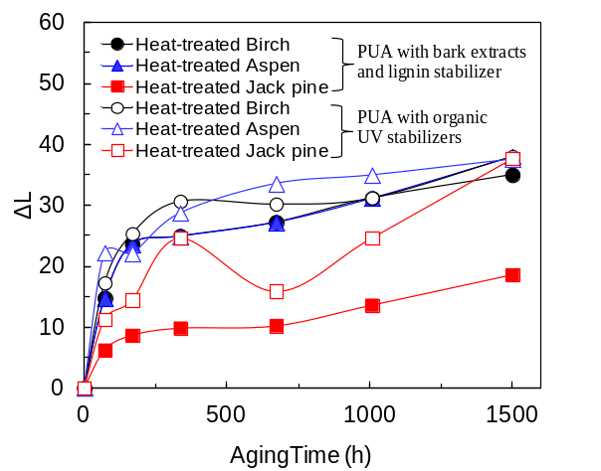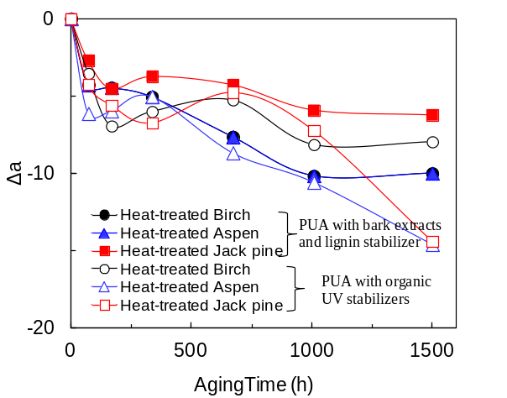
(a) (b)
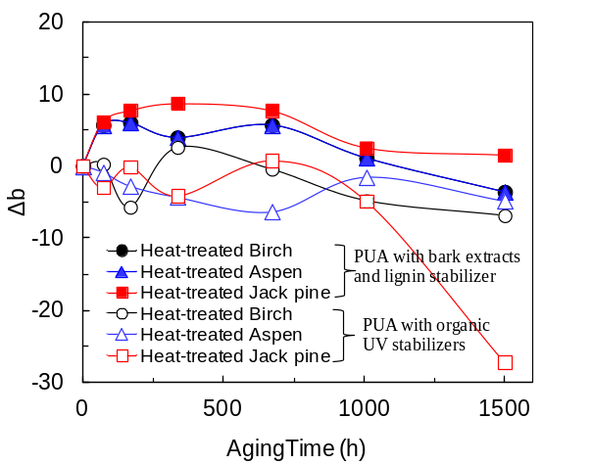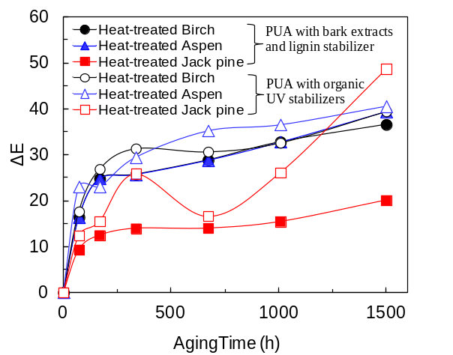
(c) (d)

Figure 1 Comparison of color change of acrylic polyurethane coatings (PUA) on heat-treated jack pine, aspen, and birch surfaces at different aging times (a) lightness index change, (b) red-green index change, (c) yellow-blue index change, and (d) total color change

0h 72h 168h 336h 672h 1008h 1500h
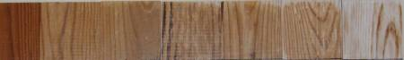
(a)
Acrylic polyurethane with organic UV stabilizers
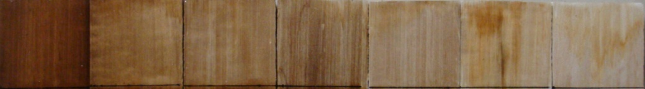
(b)
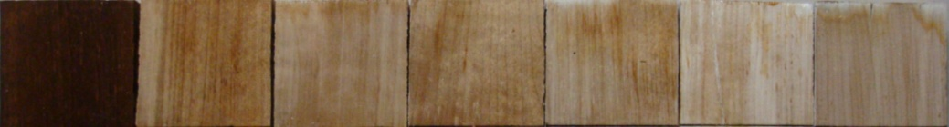
(c)
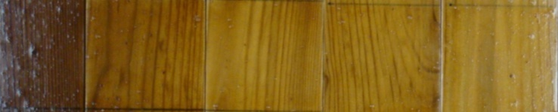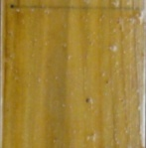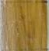
(d)
Acrylic polyurethane with bark extracts and lignin stabilizer
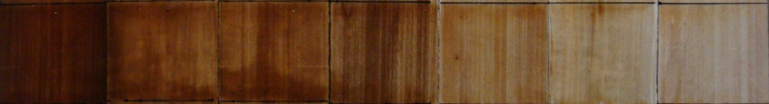
(e)
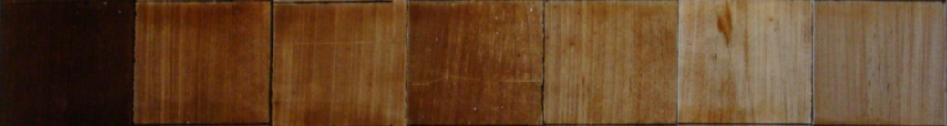
(f)
Figure 2 Color change of acrylic polyurethane coating containing UV stabilizers on heat-treated surfaces of (a) jack pine, (b) aspen, and (c) birch and acrylic polyurethane coating containing bark extract and lignin stabilizer on heat-treated surfaces of (d) jack pine, (e) aspen, and (f) birch
0h 72h 672h 1500h
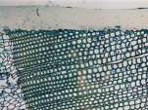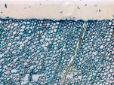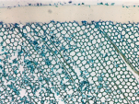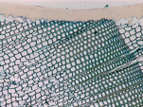
(a)
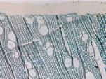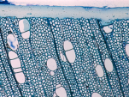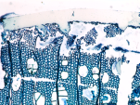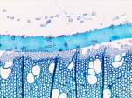
(b)
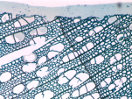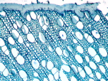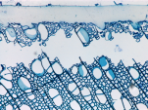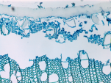
(c)
Figure 3 The light micrographs of transverse sections of the wood surfaces and the coating (containing bark extract and lignin stabilizer) interface at different aging times (a) heat-treated jack pine, (b) heat-treated birch, and (c) heat-treated aspen

Birch Aspen Jack pine
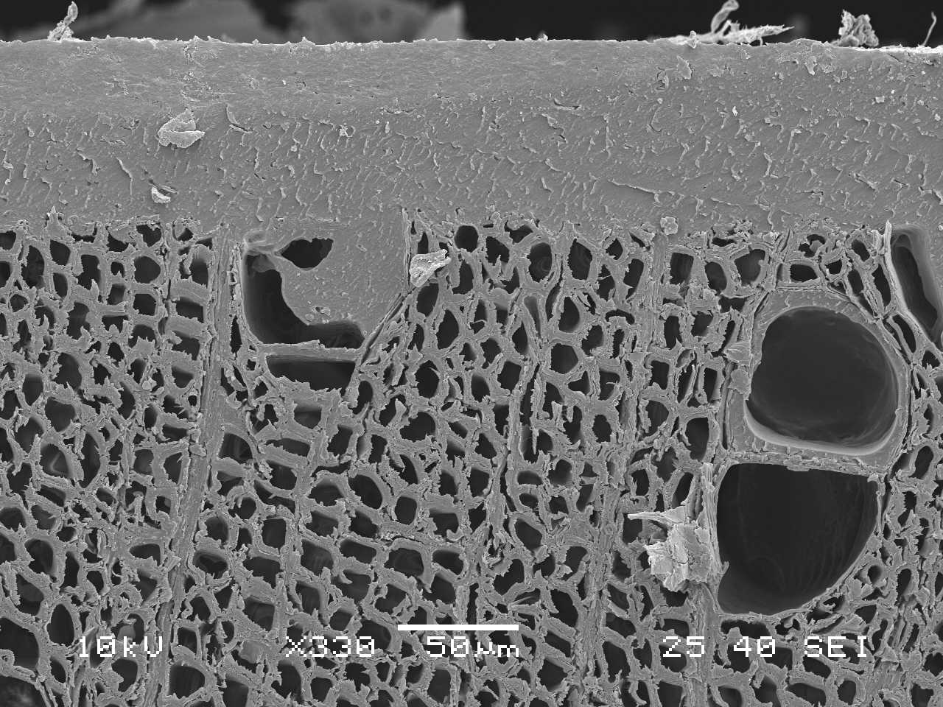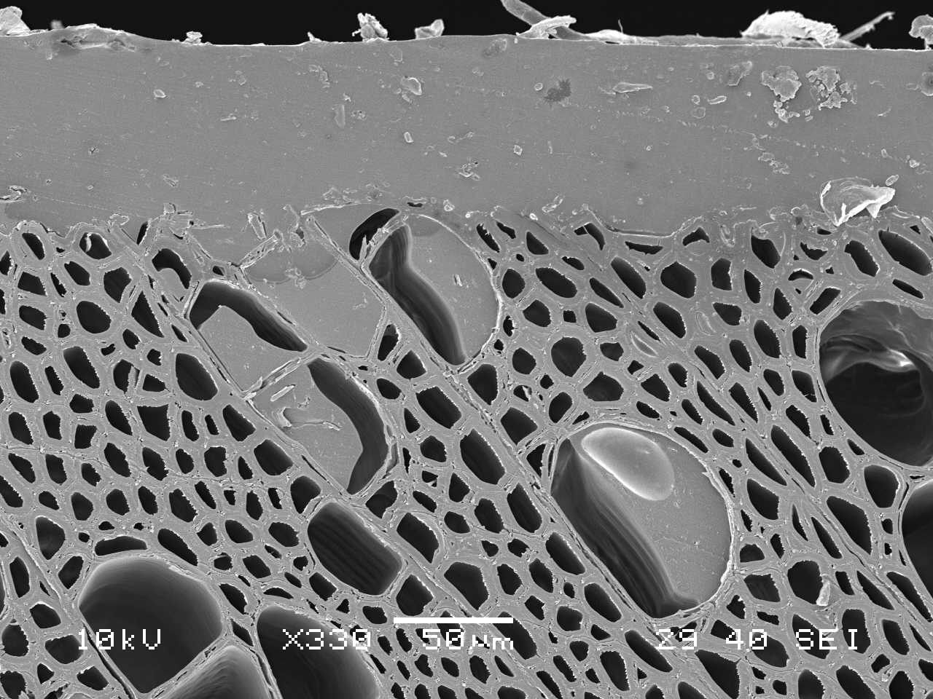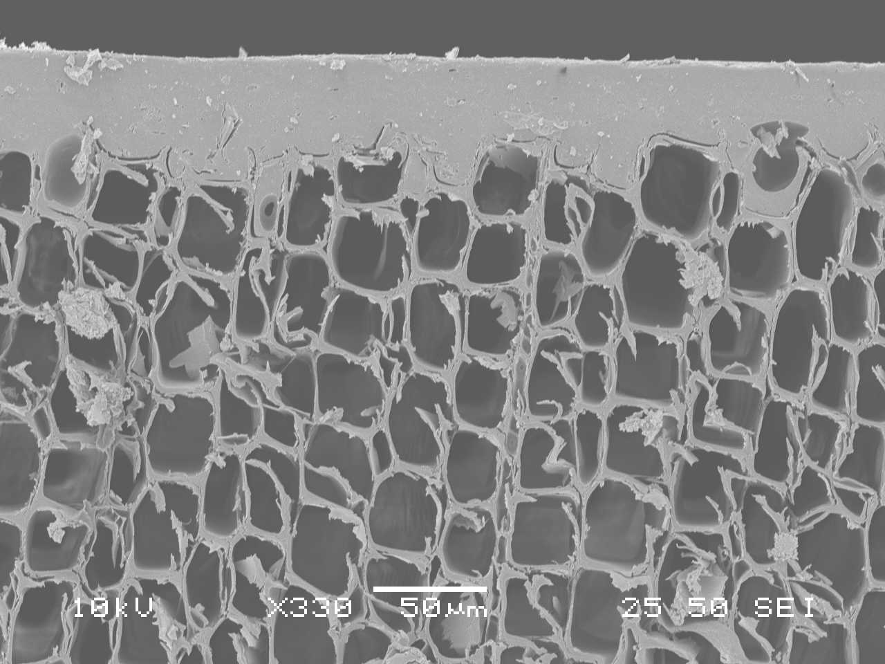
(a)
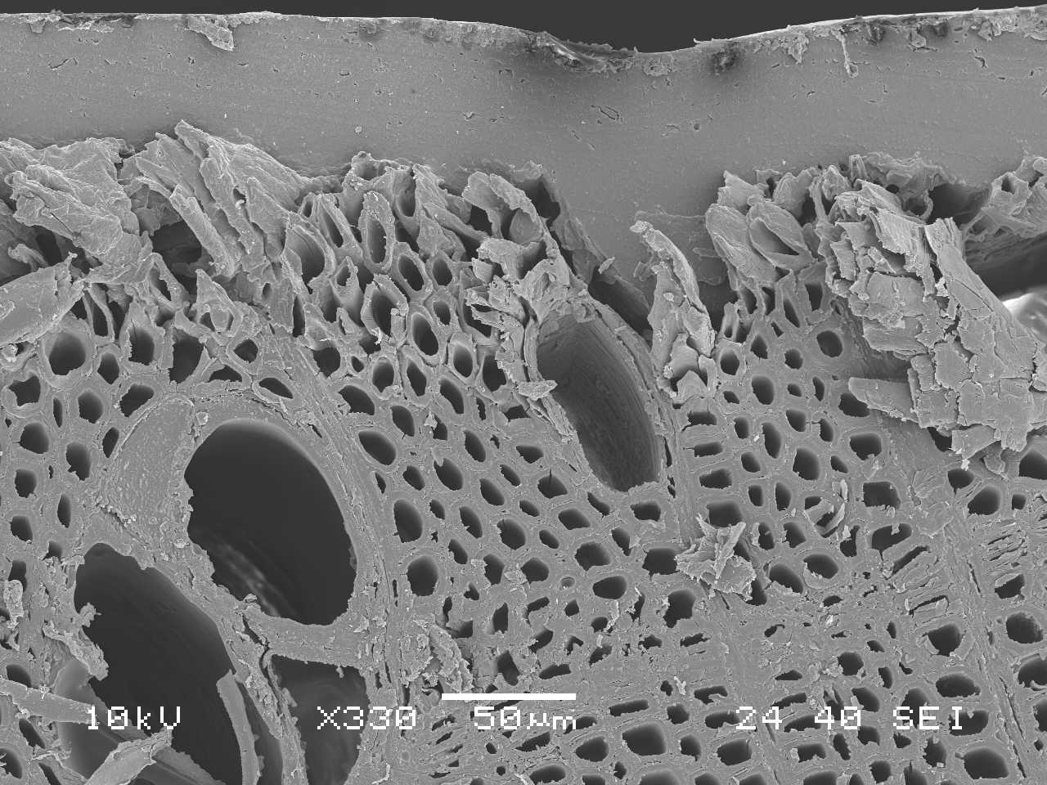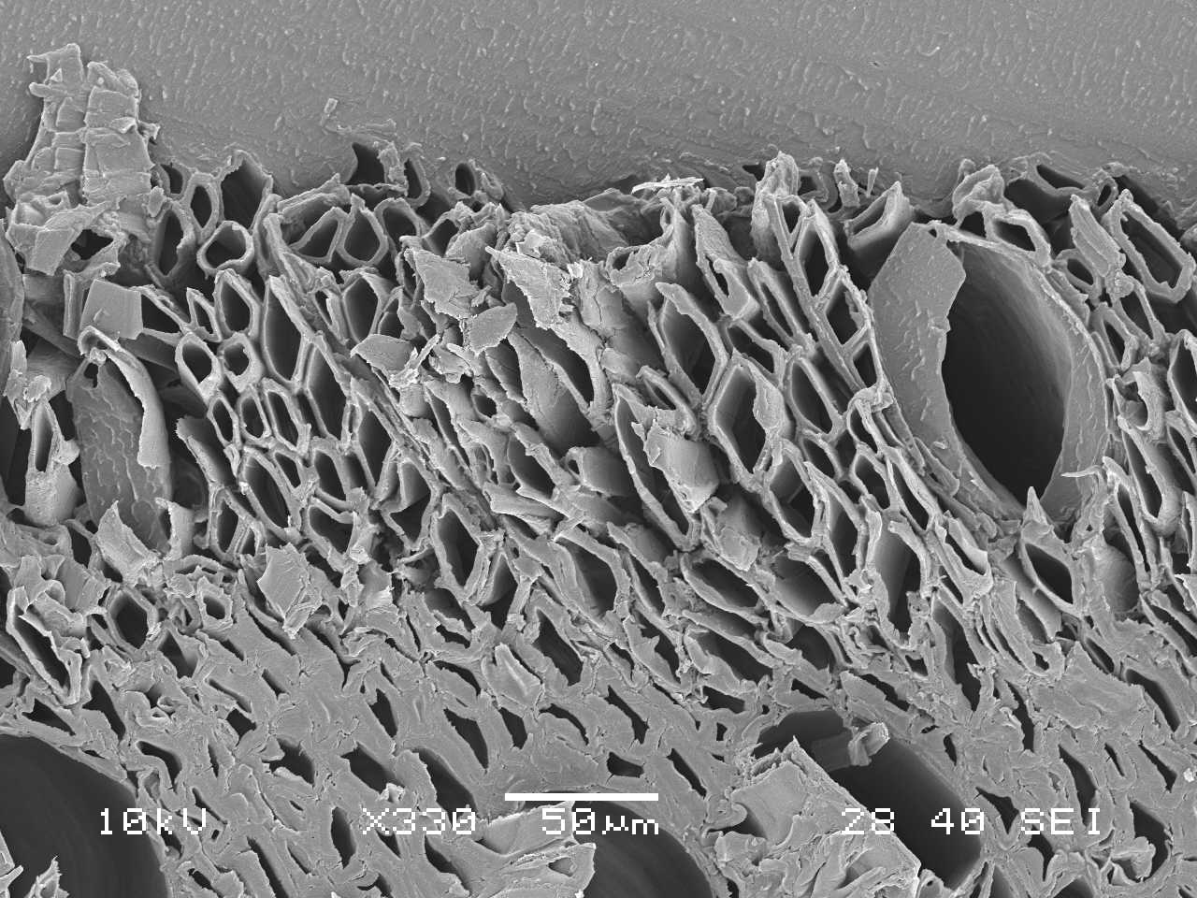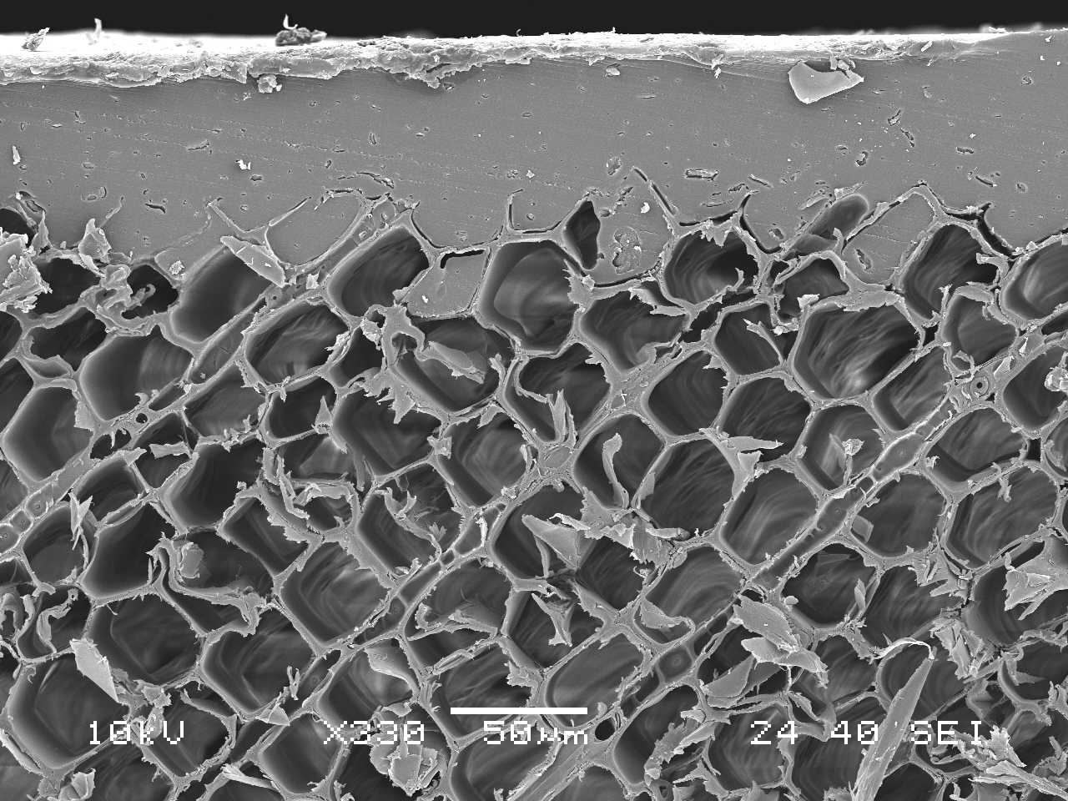
(b)
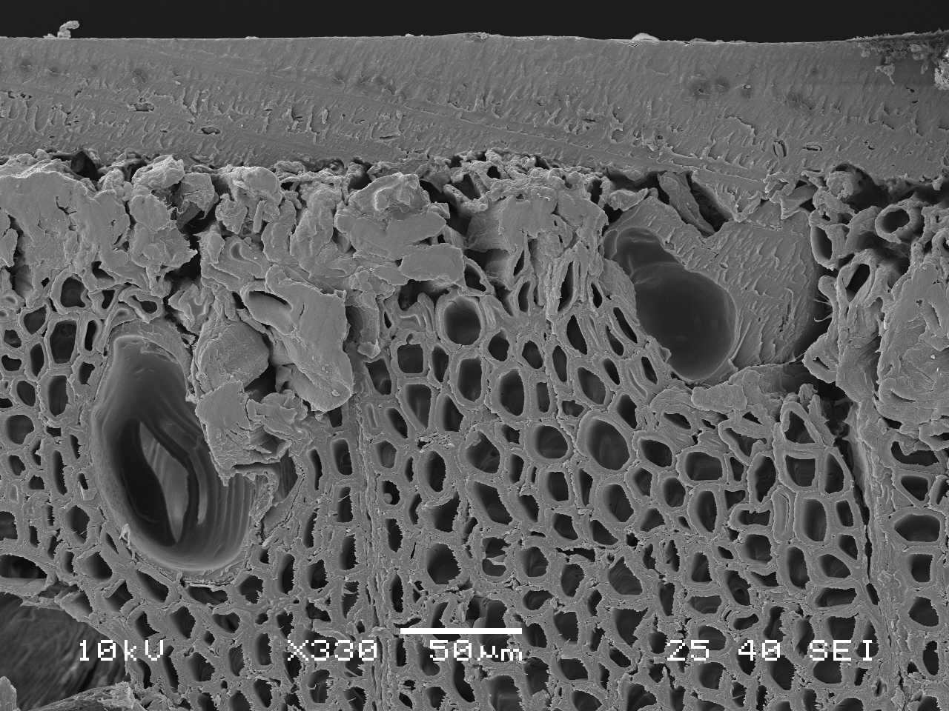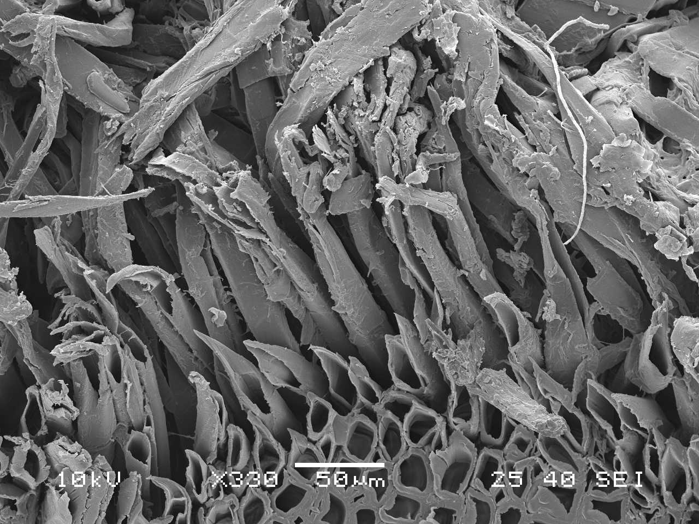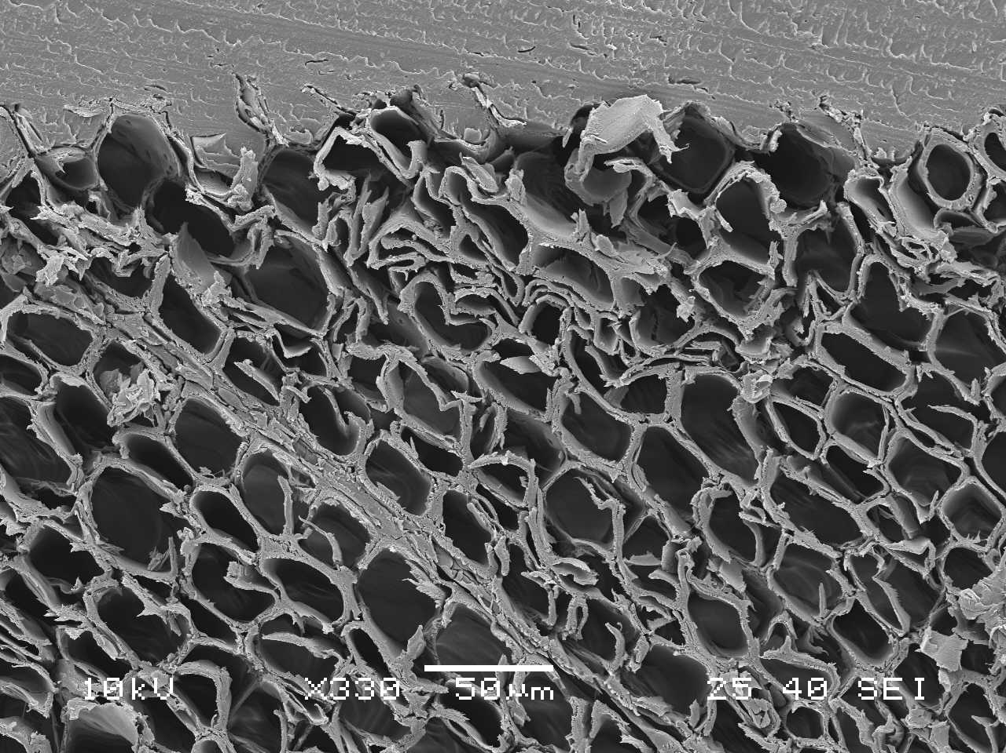
(c)
Figure 4 SEM micrographs of transverse sections of heat-treated birch, aspen and jack pine surfaces and the coating (containing bark extract and lignin stabilizer) interface (a) before aging, (b) after 672h of aging and (c) after 1500h of aging

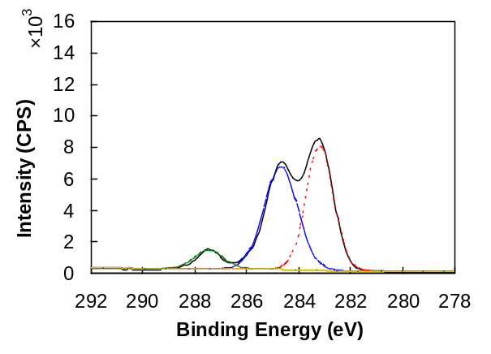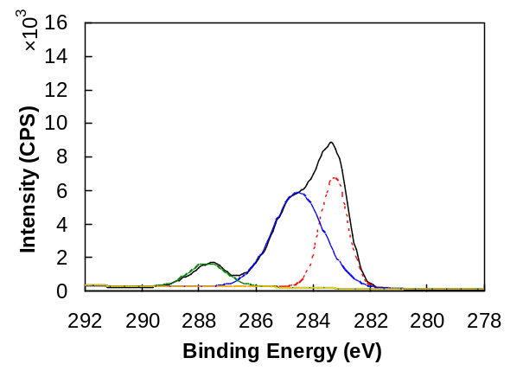
C-C/C-H
C-N/C-O
C=O
C-C/C-H
C-N/C-O
C=O
(a) (b)
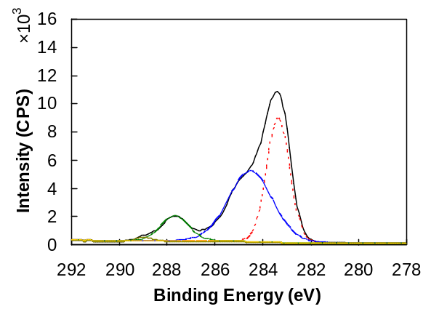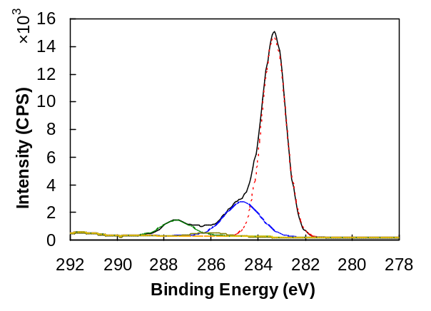
C-C/C-H
C-N/C-O
C=O
C-C/C-H
C-N/C-O
C=O
COO
COO
(c) (d)
Figure 5 C1s spectrum of the acrylic polyurethane coating containing bark extract and lignin stabilizer on heat-treated jack pine surface at (a) 0h, (b) 72h, (c) 672h, and (d) 1500h of aging

