MORPHOLOGICAL AND MICROSTRUCTURAL CHARACTERIZATION OF BIO-COKE AS POTENTIAL ANODE RAW MATERIAL FOR ALUMINUM INDUSTRY

X. Huang, D. Kocaefe, D. Bhattacharyay, Y. Kocaefe

University of Québec at Chicoutimi
555, boul de l'Université, Chicoutimi, Québec, Canada G7H 2B1

Abstract
Calcined petroleum coke and coal tar pitch are the raw materials used in producing carbon anodes for aluminum electrolysis. Carbon materials derived from biomasses are low in cost and considered renewable. Partial replacement of petroleum coke with bio-coke has the potential to reduce the environmental emissions during aluminum production. However, bio-coke usually exhibits low density compared to petroleum coke. High porosity not only decreases the density of a coke, but also increases the pitch requirement during anode production. Therefore, the physical and chemical structure of coke plays an important role in anode quality. Analysis of the physical structure is the first step in the determination of the raw material quality. In this study, the structural and morphological characterization of two calcined petroleum cokes and two bio-cokes were carried out using microscopic techniques. The results which compare the structures of bio-coke and petroleum cokes are presented.

Keywords: structural and morphological characterization, petroleum coke, bio-coke, optical microscopy, SEM
Introduction
Carbon anodes for aluminum electrolysis are manufactured by mixing calcined petroleum coke, coal tar pitch and recycled material (rejected anodes and butts) [1, 2]. Carbon materials derived from biomasses are low in cost and considered renewable. A few studies on some of the physical properties of electrode grade carbons prepared with bio-coke and petroleum pitches are reported in the literature [1, 3-11]. Carbon material originated from babassu coconuts showed similar Young’s modulus and rupture strength with those observed in electrodes produced using conventional cokes [10]. Eucalyptus wood was pyrolized to form both bio-coke and bio-pitch, and they were used as renewable sources to make small experimental electrodes [1]. The results indicated that the electrodes made from biomass had comparable electrical and mechanical properties to those made with conventional carbonaceous materials. In addition, the bio-coke is a sulfur-free renewable raw material, which does not contribute to carbon and sulfur oxide pollution [3]. Therefore,, as the carbon anodes are consumed during the smelting process, petroleum-coke-based anodes contribute to environmental emissions, and this could be reduced through partial replacement of petroleum coke with bio-coke [4] . However, very little literature has been found on the use of bio-coke in anodes for aluminium production [1, 7]. The possibility for replacing petroleum coke with industrial bio-coke and pure bio-cokes, produced from maple and spruce, has been examined by Monsen et. al. [7] using pilot scale anodes made with bio-coke to produce aluminum. It was reported that low density of bio-coke had adverse effects on anode properties. CO₂ emissions did not decrease, and the open pores of bio-coke have not been successfully filled with pitch during mixing [7]. There is no literature reporting the mechanical properties of bio-coke and anode made from bio-coke in aluminum production.
The structure of coke undoubtedly has an influence on the final properties of the carbon anode [12]. The structure might be an important criterion for the selection of a particular coke for a given application. Cokes of higher anisotropy are needed to produce ultra high power electrodes (UHP) [12]. The UHPs have the following featured properties: low electrical resistance, high current load capacity, low coefficient of thermal expansion (CTE), and high flexural strength [12, 13]. A comparative study of structural properties of cokes and anodes were reported [14-18]. The scanning electron microscope (SEM) technique has been used successfully to view directly the 3-D nature of petroleum cokes [14, 15, 19].
As explained previously, various studies were carried out on the structural analysis of petroleum cokes. However, to the authors’ knowledge, although there are several previous studies on the properties of anode grade carbons prepared with biomass [1, 3-11], a detailed and comprehensive study of macro and micro-structure of bio-coke carried out with optical microscopy and SEM are not available in the literature. In addition, the comparison of bio-coke and petroleum coke structures is not completely clear. The present study aims to fill this void. Furthermore, an improved understanding of the bio-coke micro-structural evolution would help guide process development to further improve bio-cokes properties [5].
The objectives of this study are to investigate in detail the differences in macro and micro structures of bio-cokes and petroleum cokes and to identify the relation between the physical structure and the utilization potential of bio-cokes as anode raw material for aluminum industry. The chemical composition of bio-cokes was also analyzed and compared with those of petroleum cokes.

Experimental
Materials studied
Two bio-coke samples were used. Bio-coke-1 was made from leafy trees and the bio-coke-2 was obtained from softwood trees. Specimens for experimental study were arbitrarily selected for a complete statistical randomization. One shot coke and one petroleum coke were chosen to compare their structures with that of bio-coke. Coke samples were divided and sieved to different ranges of particle sizes. The particle sizes within the range of 600–1000 µm were used in this study.

Specimen Preparation
Since the internal structure of bio-coke can be preserved during pressing and polishing, the liquid resin is preferable to powdered resin in preparing polished blocks of bio-coke particles [8]. Epoxy liquid resin was chosen for the preparation of polished blocks for both bio-cokes and petroleum cokes to be characterised in this study. Polishing was carried out using Struers polisher to create a scratch free surface. Afterwards, a Nikon Eclipse ME600 optical microscopy (Nikon Inc., Melville, NY) with a total of 1000 × magnification was used to analyse particle morphology. Composite images were obtained from the digital camera attached to the microscope and operated with Optical Image Analyzer (Clemex JS-2000). The optical analysis of polished blocks provides sectioned images of the internal structure of the cokes whereas the analysis using the SEM microscopy gives 3D structural information.

Specimen Preparation for SEM
To prepare SEM sample surfaces, all small test samples without polishing were mounted onto an aluminum block surface with dimensions of 20 ×30 mm using electrically conducting paste. The test pieces were cleaned with high pressure dust-removing gas to remove surface debris and to provide stronger attachment to the electrically conducting paste. For electrical conduction, all samples were sputter-coated with a palladium/gold layer (20 nm) and then mounted onto standard aluminum stubs using electrically conducting paste.

SEM examination
The samples were scanned using a Jeol scanning electron microscope (JSM 6480LV) with a magnification up to 300000× at accelerating voltage of 10kV. The distance between sample and electron microscope head was 10-25 mm with a spot size of 40. The specimen temperature was approximately 20˚C and the column vacuum was 6.66×104 Pa. Electron micrographs of both longitudinal tangential and radial surfaces for two bio-cokes were taken. SEM micrographs of different surfaces of petroleum cokes were also taken to investigate the difference with those of bio-cokes from different directions.

Results and Discussion
Characterization by Optical Microscopy
Figure 1 exhibits optical microscopy images of the cokes: (a) shot coke, (b) petroleum coke, (c,e) bio-coke-1, (d,f) bio-coke-2.The coke structure can be examined on the macrostructural and microstructural scale [2]. The macrostructure can be observed using optical microscopy. Two extremes of macrostructure can be classified as isotropic and anisotropic [2]. An isotropic structure is an almost random arrangement of packed lamellae, and isotropic cokes are cokes with a fine grained texture which shows similar properties in all directions [2, 18]. It can be observed that shot coke is an isotropic coke with a unique structure (see Figure 1(a)), which is in agreement with the results reported in literature [13]. Isotropic cokes are harder to grind and crush, and produce finer particle size distributions than anisotropic cokes during milling which can produce dust problems [2]. On the other hand, anisotropic cokes have a coarse texture with essentially parallel arrangements of lamellae and their properties change with orientation [2, 18]. The highest anisotropic coke is needle coke which has a needle-like structure [18]. As mentioned previously, the highest anisotropic (most needle-like) coke is premium coke used in the ultra-high power electrode production (UHP) [13]. The petroleum coke used in this study exhibits a heterogeneous structure with a mixture of fine (isotropic) and coarse (anisotropic) textures (see Figure 1(b)), which is defined as sponge cokes preferred by anode producers [18]. It is quite difficult to observe the structure of bio-cokes referred to the arrangement of lamellae (isotropic or anisotropic) on the photo-micrographs of transverse surfaces with the same magnification by optical microscopy (Figure (c) and (d)). However, bio-coke pore structures are seen in Figure 1 (c) and (d). Typical pore diameter in bio-coke-1 is 2-10 µm, but there are a few considerably larger pores and cracks of around 10-40 µm (see Figure 1(c)). Typical pore diameter in bio-cokes-2 is much greater, around 10-20 µm (see Figure 1(d)).The structure differs by the appearance of longitudinal walls, see Figure 1(e) and (f). The degree of isotropy can also be meausred by the distribution of the pore axial ratio defined as the pore depth divided by the pore diameter [2]. A typical median axial ratio is 0.3 for an anisotropic coke and 0.6 for an isotropic coke [20].The axial ratios for the two bio-cokes was determined as 0.04-0.3 and 0.2-0.4, respectively. This implies that both bio-cokes used in this study can be defined as more anisotropic than isotropic, which is acceptable for utilisation in anode production. However, it is clearly observed that porosities of both shot coke and petroleum coke at the same level of magnification are lower than those of bio-cokes (see Figure 1 (a-b)).
(b)
10 µm
(a)
(d)
(c)
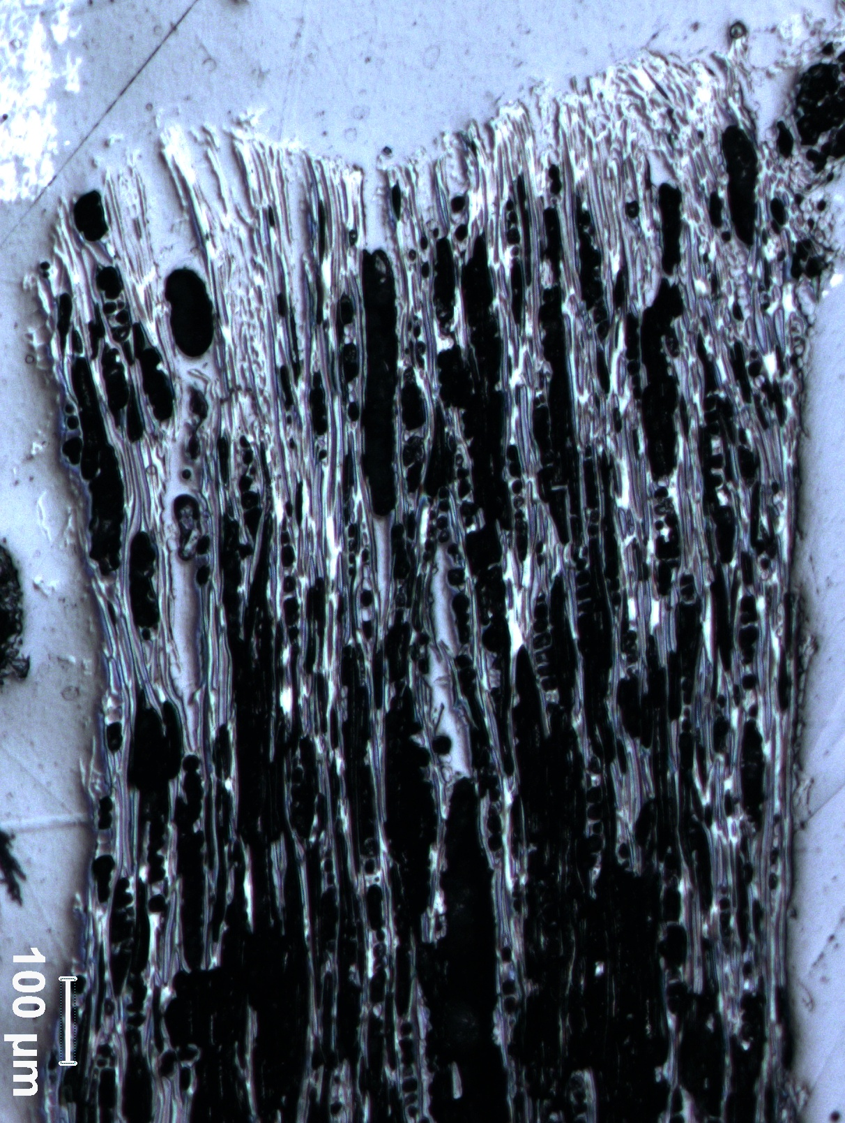
(f)
100 µm
(e)
Figure 1 Optical micrographs of two petroleum cokes and two bio-cokes: (a) shot coke, (b) petroleum coke (c,e) bio-coke-1, (d,f) bio-coke-2
Characterization by SEM
The rough nature of coke surface makes the examination by optical microscopy at high magnification difficult. A scanning electron microscope (SEM) with its large depth of focus is well suited to such a study and to view directly the 3-D nature of coke particles. SEM micrographs illustrating the appearance, at low magnification (~×20), of bio-cokes, shot coke, and petroleum coke are shown in Figure 2. Even at this low magnification, differences in the morphology of particles can be detected. As shown in Figure2 (a), most of the particles of bio-coke-1 exhibits needle or ribbon-like shapes which is indicative of the high anisotropic structure. Bio-coke-2 particles do not seem to be needle-like as bio-coke-1; however, the differences in different directions can be clearly observed (shown in Figure2 (b)). The particles of shot coke, Figure 2 (c), seem to be in spherical shape and more uniform in size. The petroleum coke particles shown in Figure 2 (d), display the shape pattern between bio-coke and shot coke. As stated above, it can be concludes that the structures of both bio-cokes show more similarity with the structure of petroleum coke than that of shot coke. The SEM analysis of cokes confirmed the anisotropic structure of bio-cokes.
(b)
(d)
(c)
(a)
Figure 2 Low- magnification SEM micrographs of (a) bio-coke-1, (b) bio-coke-2, (c) shot coke, (d) petroleum coke

Figure 3 (a-d) are the SEM images of the structures in all investigated samples at high magnification. The longitudinal and transverse surfaces of bio-coke particles have been examined with SEM. Longitudinal surfaces are considered to give a truer impression of the nature of the structural units present in wood. From Figure 3 (a), it can be observed that the microstructure morphology of bio-coke-1 sample includes some cell lumen formations, with the diameter in the range of 10 µm, regular dispersed on a continuous surface forming some peaks and valleys. The samples of bio-coke-2 present similar morphology to that of bio-coke-1; however, it has a larger-diameter cell lumen as seen in Figure 3 (b). The categories of structural units identified in metallurgical cokes, flat, lamellar, intermediate, and granular, are widely applicable [15]. The shot coke sample surface presents some evident intermediate components in Figure 3 (c). The term intermediate carbon is used to describe carbon components which are either small distorted lamellae or elongated grains [15]. The surface of shot coke shows distorted lamellae type of intermediate component in Figure 3 (c). The micrograph in Figure 3 (d) illustrates lamellar components in the surface of the petroleum coke used. The appearance of delicately corrugated lamellae in Figure 3(d) seems similar to the well-defined lamellar components in a particle of good quality needle-type petroleum coke of a study reported in the literature [15]. Comparing the images in Figure 3, the regularly directive surfaces of bio-coke are closer to that of the petroleum coke, showing corrugated lamellae. It was reported in the literature that the coke containing low proportions of intermediate carbon produced anodes of higher strength [15]. According to the information in the literature and the structure results, biocoke seems to have a suitable structure for use in anode production. However, there are other properties to be tested such as the wettability, the chemical compatibility with the pitches, mechanical and electrical properties, etc. to determine its potential as anode raw material.
(d)
(c)
(a)
(b)
Figure 3 SEM image of longitudinal surfaces on (a) bio-coke-1, (b) bio-coke-2, (c) shot coke, (d) petroleum coke
The examination of transverse surfaces of bio-cokes is also recommended since they give complementary information. Figure 4 (a-b) shows the SEM images of the structures of transverse surfaces of bio-coke particles at a magnification of ×1000. However, pore structures can be seen clearly in Figure 4 (a) and (b). The pore diameters in bio-coke-1 (Figure 4 (a)) seem to be smaller than those of bio-coke-2 (Figure 4 (b)). The micrograph shows low levels of open microporosity on shot coke as shown in Figure 4 (c). Figure 4 (d) displays the dendritic micro-cracks on the surface of petroleum coke. The surface exhibits river patterns indicative of rapid crack propagation but is quite smooth. It might be interesting to compare the directly displayed folds of layer surface in Figure 4 (d) with the pattern in the drawings based on extinction contours in polarized light micrographs [15]. The microporosity of coke plays an important role in the acceptance of pitch binder by the coke. Different structures have an influence on the strength of the filler-binder bond, and thus affect strength, density, resistivity and coefficient of thermal expansion [12]. The high level of open porosity of bio-coke might mean that pitch could interlock and bond the structure together during carbonization if the wettability of bio-coke by pitch is suitable. However, the porous structure of bio-coke might result in low density and high pitch utilisation which are considered as disadvantages. Porous bio-coke will need extra pitch binder as the binder will penetrate deep into the pores. Carbonized pitch has a much lower strength than the coke itself. Therefore, too much pitch is not appropriate.This can again influence the strength of the coke-pitch bond and final anode properties. In addition, it is expensive to increase the pitch utilisation. Monsen and his co-workers suggested that the finer fractions of bio-coke should be used to break down the porous structure [7].
(c)
(b)
(d)
(a)
Figure 4 SEM image of transverse surfaces on (a) bio-coke-1, (b) bio-coke-2, (c) shot coke, (d) petroleum coke
Conclusions
The structures and morphologies of two bio-cokes from different origins were investigated and compared with those of shot coke and one calcined petroleum coke. Optical microscopy and SEM images for both bio-coke samples present anisotropic and lamellar structure similar with that of petroleum coke which is considered suitable for aluminum anode making. The high level of open porosity of bio-cokes allows penetration of pitch into coke and bond the structure together during carbonization. However, whether the pitch will enter the pores or not depends on the wettability of bio-coke by the pitch to be used. Even if the pitch enters the pores, the pitch utilization will increase accompanied with possible decrease in mechanical properties. Therefore, it is suggested that the bio-coke is used in fine fraction of the anode raw material. Bio-cokes seem to have a suitable structure as anode raw materials provided that the other properties are also appropriate and used in fine fraction of the anode raw material
Acknowledgements
The authors thank the Natural Sciences and Engineering Research Council of Canada (NSERC) and the industrial partner Boisaco for the technical and financial contributions as well as the Centre universitaire de recherche sur l'aluminium (CURAL) for valuable assistance and technical support during SEM tests.
References
[1] A.R. Coutinho, J.D. Rocha, C.A. Luengo, Preparing and characterizing biocarbon electrodes, Fuel processing technology, 67 (2000) 93-102.
[2] K.L. Hulse, Anode Manufacture, in, R&D Carbon Ltd., New Zealand, 2000.
[3] J.D. Rocha, A.R. Coutinho, C.A. Luengo, Biopitch produced from eucalyptus wood pyrolysis liquids as a renewable binder for carbon electrode manufacture, Brazilian Journal of Chemical Engineering, 19 (2002) 127-132.
[4] J.M. Burgess, Biomass and renewables as alternative energy sources and reductants in the minerals industry, in, Fremantle, 2004, pp. 9-13.
[5] A.K. Kercher, D.C. Nagle, Microstructural evolution during charcoal carbonization by X-ray diffraction analysis, Carbon, 41 (2003) 15-27.
[6] M.J. Antal Jr, M. Grønli, The art, science, and technology of charcoal production, Industrial and Engineering Chemistry Research, 42 (2003) 1619-1640.
[7] B.E. Monsen, A.P. Ratvik, L.P. Lossius, Charcoal in anodes for aluminium production, in, Seattle, WA, 2010, pp. 929-934.
[8] C. Avila, C.H. Pang, T. Wu, E. Lester, Morphology and reactivity characteristics of char biomass particles, Bioresource Technology, 102 (2011) 5237-5243.
[9] M.J. Wornat, R.H. Hurt, N.Y.C. Yang, T.J. Headley, Structural and compositional transformations of biomass chars during combustion, Combustion and Flame, 100 (1995) 131-143.
[10] F.G. Emmerich, J.C. de Sousa, I.L. Torriani, C.A. Luengo, Applications of a granular model and percolation theory to the electrical resistivity of heat treated endocarp of babassu nut, Carbon, 25 (1987) 417-424.
[11] K. Mochidzuki, F. Soutric, K. Tadokoro, M.J. Antal Jr, M. Tóth, B. Zelei, G. Várhegyi, Electrical and physical properties of carbonized charcoals, Industrial and Engineering Chemistry Research, 42 (2003) 5140-5151.
[12] E.A. Heintz, Influence of coke structure on the properties of the carbon-graphite artefact, Fuel, 64 (1985) 1192-1196.
[13] P.J. Ellis, J.D. Bacha, Shot coke, in: Y. Lin Ray, Y.A. Chang, G. Reddy Ramana, C.T. Liu (Eds.), Anaheim, CA, USA, 1996, pp. 477-484.
[14] D. Hays, J.W. Patrick, A. Walker, Application of SEM to studies of the strength of carbons, Polymer - Plastics Technology and Engineering, 33 (1994) 713-732.
[15] D. Hays, J.W. Patrick, A. Walker, SEM characterization of cokes and carbons, in: Fuel, 1983, pp. 1079-1083.
[16] T. Hamada, K. Suzuki, T. Kohno, T. Sugiura, Structure of coke powder heat-treated with boron, Carbon, 40 (2002) 1203-1210.
[17] I. Carazeanu Popovici, S. Birghila, G. Voicu, V. Ionescu, V. Ciupina, G. Prodan, Morphological and microstructural characterization of some petroleum cokes as potential anode materials in lithium ion batteries, Journal of Optoelectronics and Advanced Materials, 12 (2010) 1903-1908.
[18] L. Edwards, F. Vogt, M. Robinette, R. Love, A. Ross, M. McClung, R.J. Roush, W. Morgan, Use of shot coke as an anode raw material, (2009) 985-990.
[19] K. Safarova, A. Drovak, R. Kubinek, M. Vujtek, A. Rek, Usage of AFM, SEM and TEM for the research of carbon nanotubes, Modern Research and Educational Topics in Microscopy, 1 (2007) 513-519.
[20] S.M. Hume, W.K. Fischer, R.C. Perruchoud, J.B. Metson, R.T.K. Baker, Influence of petroleum coke sulphur content on the sodium sensitivity of carbon anodes, in, Publ by Minerals, Metals & Materials Soc (TMS), Denver, CO, USA, 1993, pp. 535-541.

