A 3D MATHEMATICAL MODEL OF A HORIZONTAL ANODE BAKING FURNACE AS A DESIGN TOOL

Mounir Baiteche¹, Yasar Kocaefe¹, Duygu Kocaefe¹,
Brigitte Morais², Jacques Lafrance²

¹University of Québec at Chicoutimi, Department of Applied Sciences, 555, boul. de l’Université, Chicoutimi, Québec, Canada G7H 2B1

²Aluminerie Alouette Inc., 400, Chemin de la Pointe-Noire, C.P. 1650, Sept-Îles, Québec, Canada, G4R 5M9

Abstract
The production of primary aluminum is carried out via the Hall-Héroult process in electrolysis cells using carbon anodes. Their consumption during electrolysis requires the production of a large number of anodes. The final step in the production of anodes is the baking that takes place in large ring furnaces. It is difficult to determine directly the impact of design changes in these furnaces on their performance and anode quality. Modelling allows the evaluation of such modifications in a cost-effective manner. The reliability of mathematical models in the design and optimization of these furnaces has been demonstrated on several occasions. A 3D design model was developed including all the important phenomena occurring in the furnace and was validated using plant data. In this paper, the model is described and the results are presented, which show how the model predictions help improve the baking of carbon anodes and their qualities.

Keywords: mathematical modelling, 3D model, anode baking furnace, design model, carbon anodes

Introduction
The manufacture of carbon anodes for the primary aluminum industry requires the use of calcined coke and coal tar pitch. These raw materials are preheated and mixed in precise portions and well-determined size fractions in a mixer or a kneader. The next step is to form the anodes in a mold, and generally a press or a vibratory compactor is used. Then, they are cooled and stored until the following step which is baking. The green anodes are cooled by natural cooling with air, in pools of water or a combination of the two modes in the form of shower [1]. Anode baking is an irreversible process; the final properties (density, electrical resistivity, air and CO₂ reactivities, etc.) are fixed during this stage, and baking is also by far the most expensive operation in the manufacture of anodes [2]. Apart from the cost of raw materials, costs related to baking account for 70% to 80% of the total cost due to the furnace itself, its maintenance costs, and ongoing expenses related to operations and fuel used as the energy source for heating.

Anode baking is done in large annular kilns. There are currently two types of furnaces; vertical and horizontal. The vertical type is called closed top ring furnace, and the horizontal type the open top ring furnace. More details on both types of furnaces and a comparison between them are available in [3]. The horizontal baking furnace, which is the subject of this modeling work, is currently the most widely used in smelters for the primary aluminum industry. This type of furnace is characterized by its simplicity in operations, less fuel consumption, and a higher number of baking cycles during its service life (longer service life).

The horizontal anode baking furnaces are usually made up of several sections (up to 70 sections in larger furnaces) arranged in two parallel lines. Each section consists of a number of flues in which the air and the flue gases flow and the pits in which the anodes are placed for thermal treatment. For “n” flues in a section, the number of pits is “n-1” so as to have a pit between two flues. Anodes are loaded into the furnace inside the pits and are covered with granular calcined coke called filler coke. This serves as a mechanical support for the anodes during baking where they undergo several thermal and mechanical stresses and serves as an insulator against heat losses from the furnace.

The pit is simply the space between two parallel flues. The flue wall has a particular structure to provide a favorable geometry for uniform flow and heating of the anodes in the furnace. The flue walls are built with refractory bricks. The most common geometry is that with baffles and tiebricks, which serve to distribute the flow more uniformly throughout the volume of the flue. Figure 1 shows the overall view of a horizontal baking furnace and an overview of its structure. However, there may be several versions of the flue structure [4, 5] (a larger number of baffles or a smaller number of them by adding many tiebricks to replace their role. However, the main idea remains the same: the flow inside the flue and the velocity distribution must always stay optimal to ensure more homogeneous heating of the anode.
Burner ramps
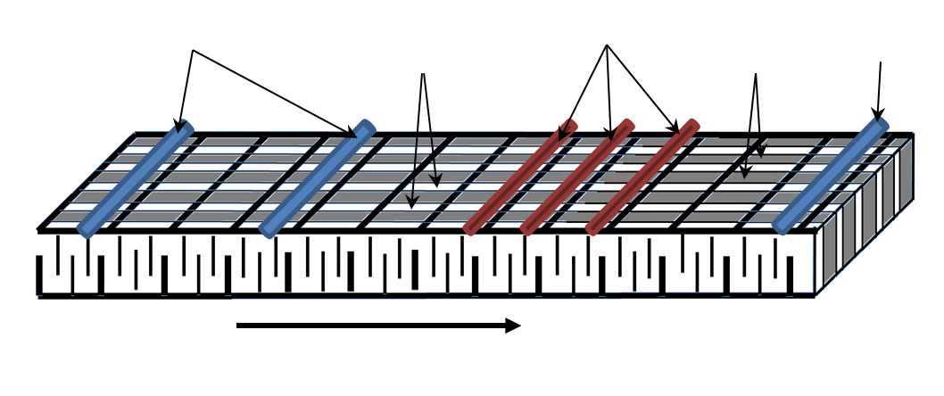Figure 1 Overall view of a horizontal anodes baking furnace.
Flue walls
Gas flow direction
Exhaust ramp
Pits
Blower ramps
The anode baking furnace for the aluminum industry is considered to be a counter-flow heat and mass exchanger [6-8]. The anodes with a substantial mass and size cannot be moved along the different stages of baking, thus, once loaded into the furnace, different ramps are moved along the furnace to ensure first preheating, then heat soaking, and finally cooling (this is commonly called a fire). The term counter-flow heat and mass exchanger is used to indicate that the anode baking cycle takes place in the opposite direction of the flow of air and flue gases and the mass transfer for the infiltration air into the flues and the release of volatile material from the anodes. Figure 2 presents a fire cycle of the anode baking process in a furnace.
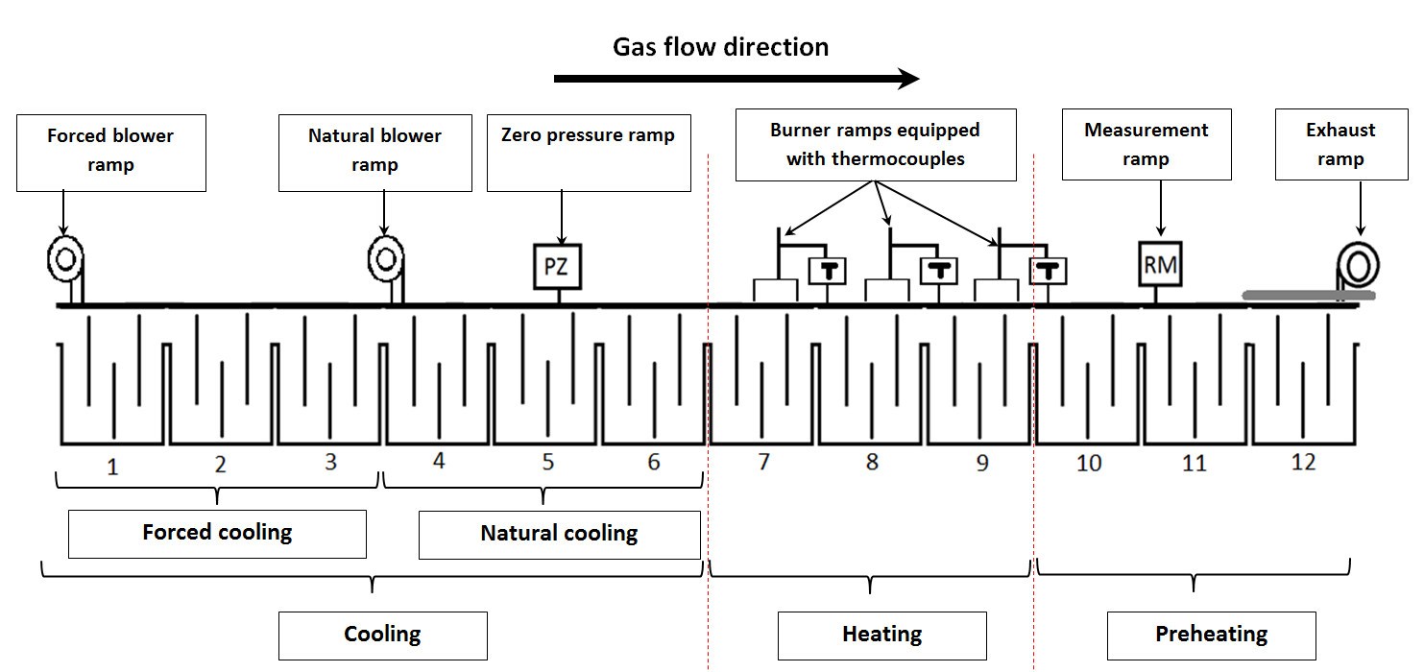
Figure 2 Baking fire cycle in a horizontal furnace.

A fire usually consists of 12 to 16 successive sections. Over a furnace, there can be up to four fires depending on the number of sections in the furnace. Out of 12 to 16 sections of the fire, the first 3 to 5 provide the preheating of the anodes and the combustion of volatile matter, commonly 3 sections equipped with burner ramps ensure the thermal soaking of anodes, and the remaining sections are dedicated to the cooling. The flow of air and fumes through different sections is provided by 1 or 2 blowing ramps according to the cooling method [9] and an aspiration manifold at the other end. As in the ramps move, green anodes are gradually heated to a maximum temperature of 1050°C to 1150°C at a heating rate of about 12°C/hour.

Anode baking is highly energy consuming; fuel is used (usually natural gas or fuel oil) to reach the target temperature. However, there are other sources of heat: the combustion of volatiles and the packing coke. More details on the sources and sinks of heat in the anodes baking furnaces are available in reference [10].

The baking of carbon anodes in horizontal furnaces has been the subject of several experimental and modeling works. A comprehensive knowledge of the phenomena occurring and a good control of the operations are primary objectives. More detailed information on anode baking and practical information on furnaces are available in [11, 12].

Relationship between the baking parameters and the quality of anodes has been studied [13]. A methodology for assessing the quality of baking in a horizontal baking furnace was proposed [14], but this method is quite costly in time. In addition, this method does not allow the direct determination of the effect of the furnace design on the final product quality.

A solution for the analysis of the furnace design and its impact on anode baking is the modeling and numerical simulation. This can be done without making any change on the furnace and its operations. The gas flow, the width of the flue, the arrangement of tiebricks, the type of materials (packing coke and bricks), and the arrangement of anodes in the pit, etc. can be tested with a mathematical model.

This work complements other works on the modelling of anode baking furnaces. The first models were fairly simple in their representation of the furnace, but effective to give an overview of the temperature profiles in each part of the furnace, to see the distribution of the pressure gradient along the fire cycle, and to calculate the energy balance of the baking process. These models are called process models; the approach is to consider discrete elements of geometry and to solve the phenomenological equations in one or two dimensions. The first models [15] were specially designed for a vertical baking furnace; then, several models have been developed with the same simplifications, each time adding details that are closer to reality [6-8]. In these works, most phenomena were similar (the infiltration of air, the control of the pressure gradient, the evolution of volatiles and their combustion, and heat losses to the atmosphere and to the foundation of the furnace). Eventually, more sophisticated process models were developed including more details [16-19]. More complex 3D models began to emerge later in order to analyze in more detail the design of the furnace. The exchange of heat and mass with the solids, the combustion, the temperature distributions were determined using these models; flow was visualized, and the geometry of the flue wall was optimized [20]. This work has been the starting point for the design of furnaces using 3D mathematical models [21, 22].

Mathematical Model Description
Anode baking takes place over a period of 250 to 350 hours depending on the practice (period of baking cycle) and the number of sections in a fire cycle. The simulation of the baking process is to reproduce as accurately as possible all phenomena related to the furnace. The entire structure of the furnace is a repetition of a single basic structure that consists of a pit and a flue. Due to symmetry, only half of the flue and half of the pit can be considered in the model.

Each part of the furnace (pit and flue) is modelled separately because the type of phenomena that occur in each is different. In the flue (gas side), the model takes into account the gas flow, the distribution of pressure, the heat transfer by convection and radiation, the combustion of volatiles and fuel, the infiltration of air through the seals of the furnace and the porous packing coke, and the heat losses to the atmosphere from the top of the flue wall and to the foundation of the furnace from the bottom. On the side of the pit (solids side), the model takes into account the heat transfer by conduction through the refractory brick wall, the packing coke layer, and the anodes, the release of volatiles (tar, methane, and hydrogen), the transfer of volatile matter through all the solids, the infiltration of air through the packing coke (through the porous medium), and again heat losses from the top of the pit and to the foundation of the furnace. In addition to these phenomena, there are variations of the geometrical parameters: the dimensions of the furnace, the dimensions of the anodes, and the possible deformations of the walls which have an impact on the operation of the furnace.

The two sub-models are coupled together to enable the simulation of the entire anode baking cycle. Since the 3D design model takes into account several phenomena at once on three dimensions in detail, the simulation of one fire cycle is not carried out altogether at once. The simulation is done section by section separately, using boundary conditions at the exit of one section as the input conditions for the following section. This way, the entire cycle is simulated.

Anode temperatures targeted in this application are in the order of 1200°C. In these temperature ranges, the properties of materials (anode, packing coke, and refractory bricks) vary widely so it is necessary to take into account changes in thermo-physical properties of each material as a function of temperature to reproduce better the baking process. Figure 3 shows a schematic diagram of the model geometry with all parts considered.

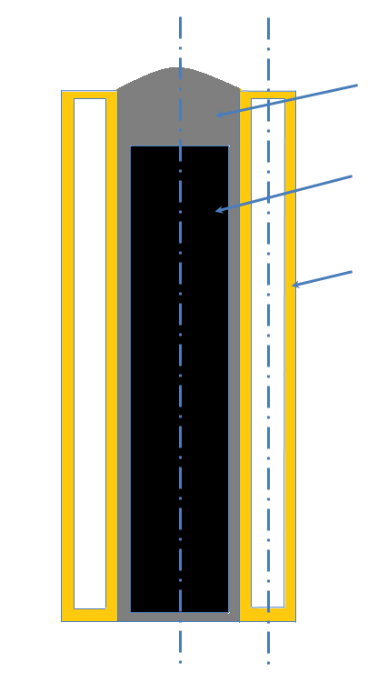
Brick wall
Anodes
Packing coke
Symmetric field
Figure 3 The pit, the flue, and symmetry considered in the model.
The 3D model allows visualizing in detail the influence of different parameters on the distribution of temperatures throughout the furnace and flow in the flue, to determine the optimal dimensions of the furnace, to calculate the combustion patterns of the fuel and the volatiles, etc.

Figure 4 shows the geometry of the overall model. The model is built on the geometry presented in reference [23]. It is a typical geometry whose overall structure resembles to other flue walls of the same type of furnaces; but, here are some geometric variations from one furnace to another.

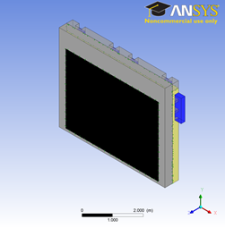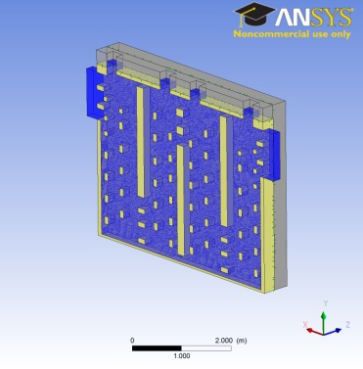
Figure 4 Overview of the global model.

On the flue part (gas side) of the furnace, the following equations are solved:
- Navier-Stokes (momentum) equation,
- Equation of continuity,
- Energy equation including the radiative heat transfer
- Equations for chemical species,
- k-ε turbulence model equations,
- Equation of state for the thermo-physical properties.
On the pit part (solids side), the equations solved are:
- Heat transfer by conduction,
- Equations of chemical species for the volatile evolution from the anodes,
- The transfer of volatile materials through different solid media,

All the above equations are solved in 3D and transient mode using the ANSYS 14 commercial code.

Results and Discussion

Some simulation results are presented in this section. One of the most important factors is the flue geometry and the improvement of flow distribution. The 3D design model allows visualizing the gas flow in the flue; Figure 5 shows a view of the flow via streamlines. The tiebricks and baffles ensure a good distribution of the gas flow which leads to more uniform heat and mass exchanges across the entire wall surface. The impact of the various arrangements of tiebricks in the flue has been presented in reference [24].

After a certain period of furnace operation, the refractory walls tend to change shape and show deformities [25]. The flue and pit widths change, and this has a direct impact on the flow of gases inside. The model allows determining the impact of such changes in the flow and assessing the severity of these changes which can be quite unfavorable. These flow changes may be a clue to intervene in the maintenance for the recovery of the flue walls.

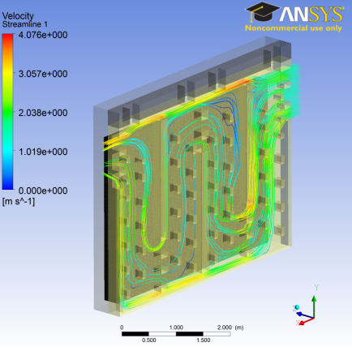
Figure 5 Streamlines and gas flow in the flue.

One way to quantify changes in the flow is to determine the impact of the flue width on the resulting distribution of different velocity ranges in the flue. Given the large size of the furnace, the flow can cover a relatively wide range of velocities. Figure 6 shows the distribution of velocity over 0.5 m/s intervals as a function of the flue width.

Figure 6 Distribution of different velocity ranges depending on the flue width.
The results show clearly that an overly large flue (19 cm half width) results in low velocities. This does not give good heat and mass exchange. Thinner flues give higher velocities as expected. When the channel is narrower for the same mass flow, the velocities increase.

Other factors are also important for flow characterization: the pressure drop through the flue and the average velocity of flow. Figure 7 shows the simulation results for these factors. As expected, the pressure drop and the average velocity increase with decreasing flue width. It is desirable to have higher velocities to favor heat transfer (as in the case of narrower flues); however, larger flues give lower pressure drop which reduces the blower power requirement. Thus, an optimization is necessary.

Figure 7 Variation of average velocity and pressure drop depending on the flue width

On the solids side, the deformation of the walls creates more or less space in the pit to bake anodes. Any change will have an impact on the consumption of packing coke (quantities of coke used for baking); and, from the thermal point of view, the thickness of the packing coke layer could change the temperature profile in the anodes and the maximum baking temperature.

Figure 8 shows the temperature profiles at 20, 60, 100 and 140 hours for different packing coke layer thicknesses. As the thickness increases, the anode temperature decreases at a given time. This is due to the lower effective thermal diffusivity of the packing coke layer compared to those of the refractory wall and the anodes. The impact could be significant for the baking cycle, thus such changes should be handled appropriately.

Figure 8 Transient temperature profiles along the centerline of the solids as a function of the packing coke layer thickness (ranging from 20 mm to 100 mm).
Another case of interest is that the dimensions of the pit and the anodes are kept constant, but the anodes are not accurately installed in the middle. In this case, the temperature profile is not symmetrical since the thicknesses of the packing coke layers are not the same on the two sides of the anodes. Higher heat transfer would take place from the smaller coke layer side. To simulate this, a more complete model was built to include two refractory walls, anodes in their full size, and all the packing coke.

Figure 9 shows a sketch of the geometry considered and compares the temperature profiles obtained for one symmetrical (packing coke layer thicknesses are 60mm on both sides of the anodes) and two asymmetrical (in one case, packing coke layer thicknesses are 80mm on one side and 40mm on the other side of the anodes; in the second case, packing coke layer thicknesses are 100mm on one side and 20mm on the other side of the anodes) cases at different time steps. Inside the pit, the anode position is moved by 20mm for one case and 40mm for the other between the refractory walls, thus creating an asymmetry in terms of the thicknesses of the packing coke layers between the anode and the walls. The results show the presence of an asymmetry with respect to the temperature profile across the anodes.

Figure 9 Transient temperature profiles along the centerline of the solids depending on the position of anodes in the pit (symmetric vs. asymmetric positioning).

Figure 10 shows the results of the overall model. Transient temperature profiles of gas and anodes are presented for two cases tested: the first with a packing coke thickness of 40mm and the second 60mm. The lower (40mm) packing coke thickness leads to higher anode temperatures at earlier times as expected.

Figure 10 Transient average anode temperatures with different packing coke layer thicknesses.
Conclusions

A 3D transient design model of a horizontal anode baking furnace was built; and the model is presented in this article. The impact of certain geometric parameters on the flow and anode temperatures is given and discussed. The results show that the packing coke layer thickness, having the lowest thermal diffusivity, influences the heat transfer to anodes considerably. It is preferable to position the anodes in the center of the pit to heat the anodes uniformly from both sides. Also, anodes are heated more rapidly when the packing coke layer thickness is thinner on both sides of the anodes, and they reach the final baking (soaking) temperature faster.

The model gives an insight into the phenomena occurring in the furnace which are otherwise highly difficult and costly to measure or determine. The 3D design model is a valuable tool for the analysis of various design parameters for anode baking furnaces.

Acknowledgements

The technical and financial support of Aluminerie Alouette Inc. as well as the financial support of the National Science and Engineering Research Council of Canada (NSERC), Développement économique Sept-Îles, the University of Québec at Chicoutimi (UQAC), and the Foundation of the University of Québec at Chicoutimi (FUQAC) are greatly appreciated.

References
- Fischer W.K., Meier M.W. & Lustenberger M.W. (1999), “Cooling of green Anodes After Forming”, Light Metals, AIME, San Diego, 547 – 553
- J. Hurlen and T. Naterstad (1991), “Recent Developments in Carbon Baking Technology”, JOM 20 – 25
- Maiwald D., Leisenberg W. (2007), “The development of anode baking technology from past to future”, Light Metals,
- Keller F., Disselhorst J.H.M. (1981), “Modern Anode Bake Furnace Developments”, Light Metals (AIME), 611-621
- Magali Gendre, Jean-Christophe Rotger, Yann El Ghaoui, Nicolas Mathieu (2007), “A Breakthrough in Anode Baking Furnace Fluewall Design”, Light Metals 969 – 972.
- Bui R.T., Charrette A., Bourgeois T., Simulating the process of carbon anode baking used in the aluminum industry, Metallurgical Transactions B, 1984a, 15B, 487-492.
- Bui R.T., Charette A. and Bourgeois, T., A computer Model for the Horizontal Flue Ring Furnace, IEEE Trans. IA, 1984b, IA-20, 4, 894-901.
- Bui R. T., Dernedde E., Charette A. and Bourgeois T., Mathematical simulation of horizontal flue ring furnace, Light Metals, 1984c, 1033-1040.
- Maiwald D., Schneider M., Krupp C., Advanced cooling of anodes in an open ring type baking furnace, Light Metals, 2002.
- H. Martirena, J. Marletto, “Thermal phenomena in anode baking furnaces”, Light Metals (New York), Edited by American Institute of Mining, Metallurgical, and Petroleum Engineers, (1980) 531 – 543
- Keller, F. and Sulger, P.O., “Anode Baking”, R&D Carbon, 2nd Edition, Sierre, Switzerland, 2008.
- Charette, A., Kocaefe, Y, Kocaefe, D., “Le carbone dans l’industrie d’aluminium”, La Presses de l’aluminium (PRAL), Chicoutimi, Quebec, Canada, 2012.
- Werner K. Fischer, Felix Keller, “Baking parameters and the resulting anodes quality”, Light Metals (1993), 683 – 689.
- Luis Bonomie, Wilfredo Salas, José A. Rojas P., “Methodology for the Evaluation of a Baking Furnace”, Light Metals 1990
- Furman A., Martirena, H., A Mathematical Model Simulating an Anode Baking Furnace, Light Metals (AIME), 1980, 545-552.
- Thibault M.A. et al., Simulating the dynamics of the anode baking furnace, Light Metal, 1985, 1141-1151.
- Bui R.T., Charette A. and Bourgeois,T., Performance analysis of the ring furnace used for baking industrial carbon electrodes, Th Canadian Journal of Chemical Engineering, 1987, 65, 96-101
- Bourgeois T., Bui R.T., Charette A., Sadler B.A. and Thomsett A.D., Computer Simulation of a vertical ring furnace, Light Metals, 1990, 547-552.
- Peter S., Charette A., Bui R.T., Tomsett A. and Potocnik V., An extended Two-Dimensional Mathematical Model of Vertical Ring Furnaces, Metallurgical and Materials Transactions B, volume 27B, 1996, 297-304.
- Kocaefe Y., Dernedde E., Kocaefe D., Ouellet R., Jiao Q., Crowell W.F., “A 3D mathematical model for the horizontal anode baking furnaces”, Light Metals,1996, 529-534.
- Severo D. S., Gusberti V., Pinto E. C. V., “Advanced 3D modelling for anode baking furnaces”, Light Metals, 2005, 697-702.
- Zhang L., Zheng C., Xu M., “Simulating the heat transfer process of horizontal anode baking furnace”, Dev. Chem. Eng. Mineral Process., 2004, 12(3/4), 427-440
- Chen, E.S, “Thermomecanical improvement of a flue wall in anode baking furnace”, Unitecr’95, vol. 3, 1995, pp. 432-433.
- Yasar Kocaefe, Noura Oumarou, Mounir Baiteche, Duygu Kocaefe, Brigitte Morais, Marc Gagnon, “Use of Mathematical Modelling to Study the Behavior of a Horizontal Anode Baking”, Light Metals (2013)
- Detlef Maiwald, Wolfgang Leisenberg, “Flue Condition Index – A New Challenge To Increase Flue Lifetime, Operational Safety And Fuel Efficiency In Open Pit Anode Baking Furnaces”, Light Metals (2006), 625 – 629

