HEFAT2012

**9th International Conference on Heat Transfer, Fluid Mechanics and Thermodynamics**

**16 – 18 July 2012**

**Malta**

**Effectiveness of Bark Extracts and CeO2 Nano Particles as Coating Additives for the Protection of Heat-Treated Jack Pine**

Kocaefe D.*, Saha, S., Kocaefe Y., C. Krause, Pichette A., and Boluk Y.

*Author for correspondence

Department of Applied Sciences,

University of Quebec at Chicoutimi,

Quebec, G7H2B1,

Canada,

E-mail: [duygu.kocaefe@uqac.ca](mailto:duygu.kocaefe@uqac.ca)

Abstract

High temperature heat-treatment of wood for wood preservation is more beneficial compared to chemical treatment. There are several advantages of heat-treated wood compared to kiln dried wood due to the chemical modifications during high temperature heat-treatment. Heat-treated woods have improved dimensional stability, improved thermal insulating properties, and improved biological resistance. Also high temperature heat-treatment changes wood color to a dark brown color which is very important for decorative purposes. But unfortunately this color is not stable and it changes to grey or white depending on the wood species during weathering. Protection of heat-treated wood against discoloration due to weathering is the main objective of this study without changing its natural appearance. For this purpose waterborne acrylic polyurethane base was chosen for their high durability against weathering and non toxic nature. Since heat-treated wood is green product minimal use of chemicals during coating formulation was another very important factor. For this reason natural antioxidants were extracted from barks which are easily biodegradable and the source is renewable in nature. Also CeO2 nano particles were also used alone or together with lignin stabilizer to achieve a better protection against weathering on heat-treated jack pine. The protective characteristics of these coatings are compared with highly pigmented industrial coating under accelerated weathering condition. The results showed better protection of these acrylic polyurethane coatings compared to commercially available coatings used in this study. The chemical modifications during accelerated weathering of these coated heat-treated wood surface was monitored by XPS analysis and the morphological changes took place during weathering was studied by fluorescence microscope analysis.

introduction

Heat treatment at high temperatures (150–240°C) initiates irreversible chemical conversions in wood in contrast to the simple drying process where the temperature never exceeds 120-140°C [1]. Chemicals are not used during high temperature heat-treatment which makes it environmentally safer to use compared to chemical treatment which is harmful to human health as well as to environment [1-6]. The heat-treated wood becomes hydrophobic with better dimensional stability, and its resistance against fungi and mold attack is improved [2, 7, 8]. Wood also attains dark brown color which enables its use for decorative purposes and they are mainly used for external purposes. High temperature heat-treatment not only changes wood’s physical properties but also responsible for its chemical structure change such as decrease in amorphous polysaccharide content, condensation and demethoxylation of lignin, softening of cellulose and hemicellulose structure and removal of certain extractives [9]. There are several advantages of heat-treated wood compared to kiln dried wood due to these chemical modifications during high temperature heat-treatment. Heat-treated woods have improved dimensional stability, improved thermal insulating properties, and improved biological resistance.

The only disadvantage of heat-treated wood is mechanical property loss [5, 6]. Unfortunately, the dark brown color is also not stable in external environment and turns to grey or white if not protected. Especially sunlight (UV and visible light) and water (moisture or rain) are the two main components responsible for discoloration of heat-treated wood. Although a numerous research work are published which are devoted to understand the degradation behavior of natural wood and their protection mechanism [10-14], few studies are reported on discoloration of heat-treated wood [9, 15] and none is available on their protection mechanism.

Commercially available coatings usually are highly pigmented and contain toxic compounds. Highly pigmented coatings can protect wood surfaces but they tend to cover the natural color and texture of wood. Heat-treated woods are mostly used for their attractive darker color. Therefore, the main goal of this work is to prevent discoloration of heat-treated jack pine by maintaining a balance between protection and aesthetic and most importantly the coating has to be non toxic. In the present study, the coatings were prepared using natural antioxidants extracted from bark, commercially available CeO2 nano particles and a lignin stabilizer in acrylic polyurethane base. The effectiveness of these coatings for the prevention of discoloration is compared with those of industrial coatings for heat-treated jack pine during accelerated aging tests. Also the effectiveness of bark extract and CeO2 nano particles are compared with that of commercially available organic UV stabilizers.

ExPERIMENTAL METHODS

Heat-treated jack pine thermo wood (210°C) was obtained from Industries ISA, Normandin, Quebec. The heat-treated wooden boards were then planed followed by sawing. The wood samples for different tests were chosen carefully from the lot without any visible defects or cracks.

The stem of the trees were collected from Lac Simoncouche area of Saguney-Lac-St-Jean region of Quebec. The barks were extracted with methanol-water solutions: [100:0], [80:20], [70:30], respectively. The details of extraction procedure are reported in another article.

Sunlight-cured two component water borne acrylic-polyurethane (Bayer Corporation) coating was used for this study as the base. Organic UV stabilizers (Tinuvin123 and Tinuvin1130 obtained from CIBA specialty chemicals), natural antioxidant (bark extract, synthesized in the laboratory), CeO2 nano particles (obtained from BYK Chimie) and lignin stabilizer (obtained from CIBA specialty chemicals) were used as additives. Alone or different combinations of these additives were tested. The additives were added to the coatings while stirring continuously in order to get a homogeneous mixture. All the additives used in this study were either water soluble or they were dispersed in water.

Samples (6.6cm×7cm×1.9cm) were coated with three layers (for heat-treated jack pine) of coatings except for industrial Laurentide coating. For this coating only two layers were used as recommended by the manufacturer. Seven samples were prepared for each coating. Six of these samples were exposed to accelerated aging test and one sample for each coating was kept as a reference. The reference samples were protected from the light exposure.

Accelerated aging tests were conducted in Atlas Xenon Weather-Ometer (with a daylight filter, irradiation 0.35W/m2 at 340nm, BPT 63±3◦C and continuous light cycle with 102min light and 18 min specimen spray with light). All the samples were exposed to UV light for different times. The maximum exposure time was 1500h. A sample for each coating was taken out after 72h, 168h, 336h, 672h, 1008h and 1500 h exposure.

Small microcores were cut from the original surface to test with Fluorescence Microscope. Microcores were dehydrated in successive immersions in ethanol and Histo-Clear and embedded in paraffin as recommended by Rossi et al. (2006) [16]. Transverse sections, 7 μm thick, were cut with a rotary microtome and the sections were then stained by Toludene blue and Sudan IV solution as explained by Saha et al., (2012) [17].

The XPS measurements of heat-treated and coated jack pine samples were performed by AXIS Ultra XPS spectrometer (Kratos Analytical) at the Alberta Centre for Surface Engineering and Science (ACSES), University of Alberta. The detailed measurement technique is explained by Saha et. al., (2011) [18].

Trends and Results

**Color Measurement**

The accelerated aging tests were carried out in order to study the effect of UV/VIS exposure on color change of coated and heat-treated wood within a shorter time span compared to that of natural aging.

The color measurement data suggested that, other than industrial coating and acrylic polyurethane coating containing CeO2 nano particles and lignin stabilizer, all the other coatings became greener (Figure 1a) with increasing aging time. Only industrial coating and acrylic polyurethane with CeO2 nano particles and lignin stabilizer became redder. The acrylic polyurethane with CeO2 nano particles exhibited least variation in red–green index while acrylic polyurethane coating containing organic UV absorber showed most variation of the same index. The acrylic polyurethane coating without light stabilizers, acrylic polyurethane coating containing organic UV stabilizers, and acrylic polyurethane with lignin stabilizer demonstrated bluish nature whereas other coatings showed yellowish nature after 1500h of aging. For acrylic polyurethane coatings with bark extracts, CeO2 nano particles, bark extracts and lignin stabilizers, and industrial Laurentide coating, the yellow–blue index increased during the initial stages of aging. This was followed by a decrease in the same index though extent of this change was less for industrial coating (Figure 1b). The most change in yellow–blue index was observed for base acrylic polyurethane coating, conversely, the least variation of the same index was observed for the acrylic polyurethane coating containing bark extracts with or without lignin stabilizer, and CeO2 nano particles.

The lightness of all the coatings increased with aging time; however, lightness variation of industrial Laurentide coating was less for initial 1100h of accelerated aging (Figure 1c) compared to those of coatings developed during this study. After 1100h of aging, the acrylic polyurethane coatings containing bark extract or CeO2 nano particles pertained least lightness variation. The most change in lightness index was observed for the base acrylic polyurethane coating. The acrylic polyurethane coating stabilized with organic UV stabilizers also exhibited very high lightness index change. The acrylic polyurethane coating containing lignin stabilizer showed almost similar lightness variation as the acrylic polyurethane coating containing bark extract and lignin stabilizer; however for initial period of aging, the former coating showed comparatively more variation in lightness index. The acrylic polyurethane with CeO2 nano particles and lignin stabilizer showed similar lightness index variation as industrial Laurentide coating.

The most color change was detected for the base acrylic polyurethane coating (Figure 1d) nevertheless the acrylic polyurethane coating stabilized by organic UV stabilizers also showed a significant total color change after 1500h of aging. The acrylic polyurethane coating containing CeO2 nano particles pertained highest protection (Figure 1d) among all coatings during the accelerated aging test. Although, at the end of 1500h of aging, acrylic polyurethane coating containing bark extracts showed similar total color change as that of acrylic polyurethane with CeO2 nano particles. Similar protective characteristics were observed for the acrylic polyurethane coating containing bark extract alone or with lignin stabilizer, acrylic polyurethane with CeO2 nano particles and lignin stabilizer, and the industrial Laurentide coating during initial 400h of aging but the color of acrylic polyurethane coating containing bark extract and lignin stabilizer varied less compared to the color of the industrial coating and acrylic polyurethane containing CeO2 nano particles and lignin stabilizer from 400h to 1400h of aging. The acrylic polyurethane coating with bark extract exhibited better protection throughout compared to the industrial coating. The acrylic polyurethane coating containing lignin stabilizer also showed high protective characteristic. High UV/VIS resistance of industrial coating was expected as it is a highly pigmented (almost green and opaque) solvent based coating which tends to cover the natural grain texture of heat-treated jack pine surface completely. Also, this coating contains some toxic substances. On the other hand, the acrylic polyurethane is transparent, non-toxic and water borne coating which contains natural antioxidant or CeO2 nano particles with or without a very small amount of lignin stabilizer. This study showed that acrylic polyurethane coating containing bark extract, CeO2 nano particles and lignin stabilizer alone or together can replace effectively the pigments and organic UV stabilizers which are used for slowing down the degradation of wood in outer environment.

The color change occurred during accelerated aging test was mainly due to the degradation of the wood surfaces rather due to the coating failure. The coatings were transparent in nature which enabled UV and VIS light to penetrate through the coatings and reached to the wood surface initiating photochemical reactions. Light penetration through the coatings depends not only on the opacity of the coatings but also on the UV absorbing capacity of the additives present in the coatings. The UV absorbers usually absorb UV lights and dissipate them as heat energy whereas HALS acts as radical scavenger. The CeO2 nano particles have high UV absorption capacity which made these coatings highly protective during aging test.



(a)



(b)



(c)



(d)

**Figure 1**  Comparison of color change of heat-treated jack pine coated with acrylic polyurethane with or without light stabilizers and commercially available Laurentide coating after different aging period (a) red-green index, (b) yellow-blue index, (c) lightness index, and (d) total color change

**Visual Assessments**

The visual assessment is very important from end user’s perspective as this is the main factor which accounts for coating’s durability and period for repainting the substrate surface.

The visual assessment of different coatings on heat-treated jack pine revealed that the base acrylic polyurethane coating showed poor protective characteristics starting from the initial period of aging and became completely white at the end of 1500h of aging (Figure 1a). On the other hand, the acrylic polyurethane coating with organic UV absorbers displayed better protection than the base coating but also underwent heavy color loss (Figure 1b). Small cracks were formed on the surface after 1500h of aging for both of the above mentioned coatings. When the acrylic polyurethane coating was stabilized with bark extract, it became highly efficient in protecting the heat-treated jack pine surface from aging (Figure 1d). According to naked eye evaluation, almost no color change was observed for this coating with the exception of two or three local degradation points (small white patches) at the end of 1500h of aging. On the other hand, acrylic polyurethane coating containing lignin stabilizer demonstrated significant degradation at the edges after 1008h of aging and the coating degradation started only after 672h of aging (Figure 1c). The acrylic polyurethane coating containing bark extract and lignin stabilizer was one of the three most efficient coatings for the protection of heat-treated jack pine, developed during this study and no degradation was observed with naked eye for this coating even after 1500h of aging (Figure 1e). Very small color change (became slightly lighter) was detected for this coating but the color change was homogeneous. Acrylic polyurethane coatings containing CeO2 nano particles alone or together with lignin stabilizer were other two coatings which showed significant protection against aging of heat-treated jack pine. For coating containing CeO2 nano particles, no degradation on the surface was found although the surface became slightly lighter at the end of 1500h of aging (Figure 1f). In contrast, for coating containing CeO2 nano particles and lignin stabilizers almost no color change was detected at the end of 1500h of aging (Figure1g). The industrial coating, although it covered fully the heat-treated jack pine surface, did not protect the surface completely. Local degradation started only after 672h of accelerated aging and complete degradation took place after 1500h of aging (Figure 1h). The cracks and fissures were also observed on the surface after 1008h of aging for this coating.

0h 72h 168h 336h 672h 1008h 1500h

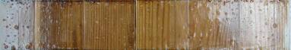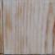

(a)

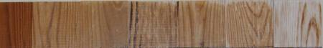

(b)

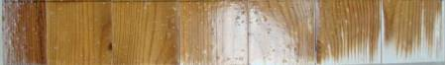

(c)

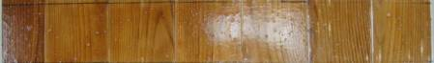

(d)

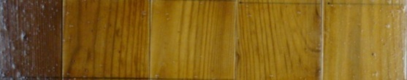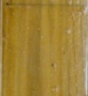

(e)

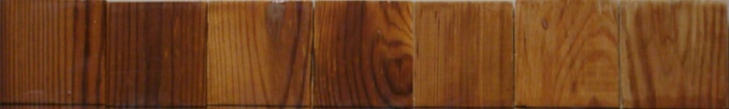

(f)

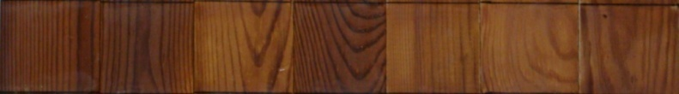

(g)

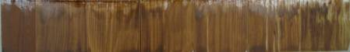

(h)

Increasing aging time

**Figure 2** Visual assessment of coated heat-treated jack pine for different aging times (a) acrylic polyurethane without any light stabilizers, (b) acrylic polyurethane with organic UV stabilizers, (c)acrylic polyurethane with lignin stabilizer, (d) acrylic polyurethane with bark extracts, (e) acrylic polyurethane with bark extracts and lignin stabilizer, (f) CeO2 nano particles, (g) CeO2 nano particles and lignin stabilizer, and (h) industrial laurentide coating

**Fluorescence Microscopy Assessment**

The light microscopy of transverse sections of coated-wood provides useful information on the distribution of the coatings by facilitating the observation of relatively large areas at low magnification, thus, enabling a comparison of coated-wood surfaces at different aging times.

The light micrographs of transverse section of heat-treated jack pine and the acrylic polyurethane coatings containing bark extract and lignin stabilizer; and CeO2 nano particles and lignin stabilizer for different aging times have been compared in Figure 3 and Figure 4 respectively. The heat-treated jack pine and industrial Laurentide coating interface for different aging times are presented in Figure 5.

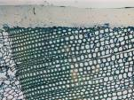 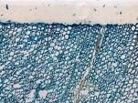 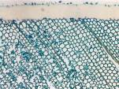 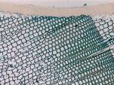

0h

72h

672h

1500h

Figure 3 The light micrographs of transverse section of the heat-treated jack pine-coating containing bark extract and lignin stabilizer interface for different aging times

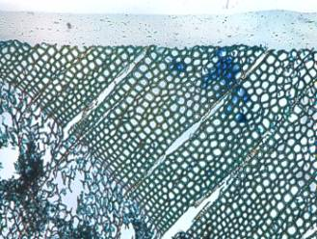 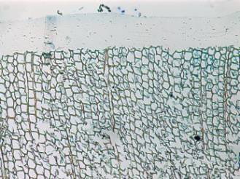

1500h

0h

72h

672h

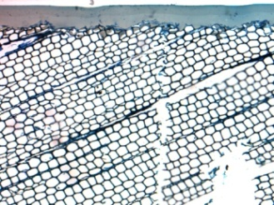 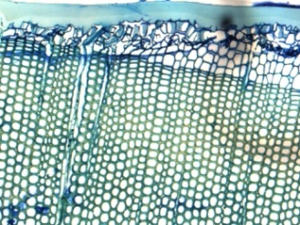

**Figure 4** The light micrographs of transverse section of the heat-treated jack pine-coating containing CeO2 nano particles and lignin stabilizer interface for different aging times

Light micrographs of heat-treated jack pine and coatings interface before aging (Figs. 3, 4, 5) showed good adhesion between coatings and heat-treated jack pine. For both the acrylic polyurethane coatings containing bark extract and lignin stabilizer; and CeO2 nano particles and lignin stabilizer, there were no degradation at the wood-coating interface even after 1500h of aging (Figs. 3 and 4). On the other hand small degradation at the early wood-coating interface was visible for industrial Laurentide coating only after 672h of aging (see Fig. 5). With increasing aging time the degradation at wood-coating interface further increased and complete detachment of the coating from the wood surface was noticed at the end of 1500h of aging.

These results directly support color measurement and visual assessment results. The color change of the coated aged surface was mainly due to the degradation of the wood surface beneath the coatings and not due to the degradation of the coatings.

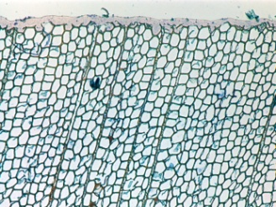 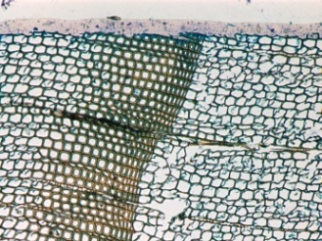

1500h

672h

72h

0h

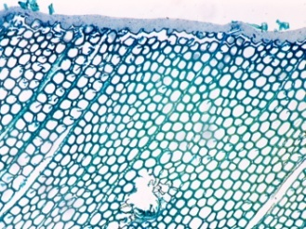 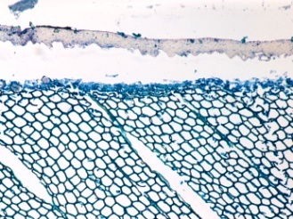

**Figure 5** The light micrographs of transverse section of the heat-treated jack pine-industrial Laurentide coating interface for different aging times

**XPS analysis**

The changes in surface chemical compositions were investigated using XPS analyses. The C1s spectrum for heat-treated jack pine, coated with acrylic polyurethane coating containing bark extract and lignin stabilizer, for different aging times has been shown in Figures 6. Atomic percentages of different components of these two coatings for different aging times on heat-treated jack pine are presented in Table 1 along with deconvoluted C1s spectrum and O/C and N/C ratios.



(a) (b)



(c) (d)

**Figure 6** C1s spectrum of the acrylic polyurethane coating containing bark extract and lignin stabilizer on heat-treated jack pine: (a) 0h, (b) 72h, (c) 672h, and (d) 1500h of aging

It was evident from XPS results that C% on the coated surfaces was increased whereas O% decreased with increasing aging time for both the acrylic polyurethane coatings on heat-treated jack pine consequently O/C ratio decreased with increasing aging time. This was probably due to the depletion of photoproducts with water spray during accelerated aging condition. Also N% for both the coatings increased for initial 672h of aging but decreased at a later stage of accelerated aging resulting in increase in N/C ratio for 672h of aging followed by a decrease. This confirms increase of urethane linkages during initial stages of aging followed by chain scission in the urethane linkages due to prolonged exposure of coated surfaces in accelerated aging condition. The decrease in Si% was attributable to the depletion of surface tension reducing agent during accelerated aging for both the acrylic polyurethane coatings. For both the coatings C-C+C-H bond on the surface were increased with increasing aging time whereas C-N bond decreased. This indicates that there was chain scission of C-O and NH-CO bonds in the polyurethane main chain. For coated jack pine, there was increase in C=O group up to 672h of aging followed by a drastic reduction of the same group. A separate peak was found for COO carboxyl groups and a drastic increase in the same group was observed after 1500h of aging for jack pine coated with acrylic polyurethane with bark extract and lignin stabilizer.

Table 1 Atomic percentages of different components of heat-treated jack pine coated with acrylic polyurethane coatings for different aging times

|  |  |  |  |  |  |  |  |  |  |  |  |  |
| --- | --- | --- | --- | --- | --- | --- | --- | --- | --- | --- | --- | --- |
| **Aging time (h)** | **Coatings** | **C (%)** | **Carbon Components** | | | | **O (%)** | **N (%)** | **Si (%)** | **Ce (%)** | **O/C** | **N/C** |
|  |  |  | **C-H+ C-C** | **C-N** | **C=O** | **COO** |  |  |  |  |  |  |
| 0 | Bark extract + lignin stabilizer | 72.16 | 45.8 | 46.86 | 7.33 |  | 22.49 | 1.76 | 3.59 |  | 0.31 | 0.024 |
| 72 | 74.31 | 34.22 | 55.79 | 9.99 |  | 20.43 | 3.35 | 1.89 |  | 0.27 | 0.045 |
| 672 | 76.48 | 41.71 | 46.69 | 10.5 | 1.1 | 19.26 | 3.98 | 0.27 |  | 0.25 | 0.052 |
| 1500 | 81.88 | 72.19 | 18.44 | 2.19 | 7.18 | 14.6 | 2.46 | 0.71 |  | 0.18 | 0.030 |
|  |  |  |  |  |  |  |  |  |  |  |  |  |
| 0 | CeO2 + lignin stabilizer | 76.39 | 58.47 | 28.57 | 0.53 | 12.44 | 22.77 | 0 | 0.84 | 0 | 0.30 | 0.000 |
| 72 | 76.64 | 61.74 | 24.83 | 0.24 | 13.19 | 22.59 | 0.2 | 0.57 | 0 | 0.29 | 0.003 |
| 672 | 74.03 | 61.48 | 27.4 | 0.89 | 10.23 | 21.77 | 3.96 | 0.05 | 0 | 0.29 | 0.053 |
| 1500 | 84.05 | 80.88 | 11.52 | 2.07 | 5.54 | 13.76 | 2.18 | 0 | 0.1 | 0.16 | 0.026 |

CONCLUSIONS

Protective characteristics of acrylic polyurethane coatings on heat-treated jack pine showed better protection against discoloration during accelerated aging was achieved when the acrylic polyurethane coatings were stabilized with bark extracts or CeO2 nano particles compared to commercial organic UV stabilizers. Also the acrylic polyurethane coatings with bark extract or CeO2 nano particles along with lignin stabilizer showed better protective characteristic compared to industrial Laurentide coating. So the main objective of this study was well achieved by developing acrylic polyurethane coatings with bark extracts or CeO2 nano particles and lignin stabilizer. Also the discoloration of the aged coated wood surface was due to the degradation at wood-coating interface during aging and not due to the coating failure completely. Also XPS results revealed coating surface degradation during aging. Chain scission of the urethane main linkage and depletion of surface reducing agent during accelerated aging were also noticed.

References

[1] D. Kocaefe, R. Younsi, S. Poncsak, and Y. Kocaefe, "Comparison of different models for the high-temperature heat-treatment of wood," *International Journal of Thermal Sciences,* vol. 46, pp. 707-716, 2007.

[2] B. Esteves and H. Pereira, "Wood modification by heat-treatment: A review," *BioResources,* vol. 4, pp. 370-404, 2009.

[3] D. Kocaefe, S. Poncsak, and Y. Boluk, "Effect of thermal treatment on the chemical composition and mechanical properties of birch and aspen," *BioResources,* vol. 3, pp. 517-537, 2008.

[4] D. Kocaefe, S. Poncsak, G. Doré, and R. Younsi, "Effect of heat treatment on the wettability of white ash and soft maple by water," *European Journal of Wood and Wood Products,* vol. 66, pp. 355-361, 2008.

[5] S. Poncsák, D. Kocaefe, M. Bouazara, and A. Pichette, "Effect of high temperature treatment on the mechanical properties of birch (Betula papyrifera)," *Wood Science and Technology,* vol. 40, pp. 647-663, 2006.

[6] S. Poncsák, S. Q. Shi, D. Kocaefe, and G. Miller, "Effect of thermal treatment of wood lumbers on their adhesive bond strength and durability," *Journal of Adhesion Science and Technology,* vol. 21, pp. 745-754, 2007.

[7] M. Boonstra, J. van Acker, E. Kegel, and M. Stevens, "Optimisation of a two-stage heat treatment process: durability aspects," *Wood Science and Technology,* vol. 41, pp. 31-57, 2007.

[8] D. P. Kamdem, A. Pizzi, and A. Jermannaud, "Durability of heat-treated wood," *European Journal of Wood and Wood Products,* vol. 60, pp. 1-6, 2002.

[9] N. Ayadi, F. Lejeune, F. Charrier, B. Charrier, and A. Merlin, "Color stability of heat-treated wood during artificial weathering," *European Journal of Wood and Wood Products,* vol. 61, pp. 221-226, 2003.

[10] D. N. S. Hon and S.-T. Chang, "Surface degradation of wood by ultraviolet light," *Journal of Polymer Science: Polymer Chemistry Edition,* vol. 22, pp. 2227-2241, 1984.

[11] D. N. S. Hon, S. T. Chang, and W. C. Feist, "Participation of singlet oxygen in the photodegradation of wood surfaces," *Wood Science and Technology,* vol. 16, pp. 193-201, 1982.

[12] D. N. S. Hon, S.-T. Chang, and W. C. Feist, "Protection of wood surfaces against photooxidation," *Journal of Applied Polymer Science,* vol. 30, pp. 1429-1448, 1985.

[13] D. N. S. Hon and W. C. Feist, "Hydroperoxidation in photoirradiated wood surfaces," *Wood and Fiber Science,* vol. 24, pp. 448-455, 1992.

[14] D. N. S. Hon and N. Shiraishi, *Wood and cellulosic chemistry*: Marcel Dekker, 2001.

[15] M. Nuopponen, H. Wikberg, T. Vuorinen, S. L. Maunu, S. Jämsä, and P. Viitaniemi, "Heat-treated softwood exposed to weathering," *Journal of Applied Polymer Science,* vol. 91, pp. 2128-2134, 2004.

[16] S. Rossi, T. Anfodillo, and R. Menardi, "Trephor: a new tool for sampling microcores from tree stems," *IAWA Journal,* vol. 27, pp. 89-98, 2006.

[17] S. Saha, D. Kocaefe, C. Krause, and T. Larouche, "Effect of titania and zinc oxide particles on acrylic polyurethane coating performance," *Progress in Organic Coatings,* vol. 70, pp. 170-177, 2011.

[18] S. Saha, D. Kocaefe, D. Sarkar, Y. Boluk, and A. Pichette, "Effect of TiO2-containing nano-coatings on the color protection of heat-treated jack pine," *Journal of Coatings Technology and Research,* vol. 8, pp. 183-190, 2011.