**A NOVEL HIGH TEMPERATURE HEAT TREATMENT PROCESS FOR WOOD**

Kocaefe D.*, Kocaefe Y., and Oumarou N.

*Author for correspondence

Department of Applied Sciences,

University of Quebec at Chicoutimi

555, boul. de l’Université, Chicoutimi, Quebec, Canada G7H 2B1

E-mail: [Duygu_Kocaefe@uqac.ca](mailto:Duygu_Kocaefe@uqac.ca)

Abstract

Wood is heated to temperatures in the range of 180–240°C in heat-treatment furnaces. At these temperatures, the wood structure undergoes changes leading to better dimensional stability, better resistance to biological attacks, and a darker attractive color. The high-temperature heat treatment of wood is an alternate and ecologically-sound wood preservation process to chemically treated wood.

During heat treatment, wood goes through simultaneous heat and mass transfer. The heat is transferred from the hot gases to the wood boards in the furnace. As the temperature of wood increases, water content of wood vaporizes and diffuses out of the boards. At higher temperatures, a number of irreversible structural changes take place in wood cells. The furnace design is important to carry out the heat treatment process uniformly and effectively. A new heat treatment furnace design has been proposed at UQAC and a prototype furnace has been built and tested. Also, a 3D model of the furnace was developed to complement the experimental work and to gain insight into the heat treatment process taking place in the furnace.

In this article, the new furnace design and its advantages are discussed. Results of the measurements and predictions of the mathematical model are presented to show the effectiveness of the new furnace design for heat treating standard wood boards as well as pieces of wood with different geometries.

introduction

The objective of heat treatment is to protect wood without using chemicals and, regardless of the type of species, to improve its dimensional stability, durability, and color. High-temperature heating of wood permanently changes several of its chemical and physical properties due to thermal degradation (pyrolysis) [1, 2]. As a result of this treatment, swelling and shrinkage, which occur when wood is subjected to an environment with fluctuating humidity, are decreased [3-7]. In addition, its biological durability improves [8, 9], its color darkens [4, 10-12], the equilibrium moisture content and pH decrease, and the thermal insulation properties are improved. However, the wood’s mechanical properties (rigidity and strength) might slightly deteriorate depending on the species used [13-19].

During heat treatment, wood is heated by convection in an inert environment. Existing heat treatment processes differ by the heating medium, process conditions, and furnace design [20-22]. The Perdure technology uses hot combustion gases whereas the Thermowood technology uses air saturated with steam. In the Plato process, heating medium is hot oil. All heat treatment processes involve simultaneous heat and mass transfer. The heat is transferred from the heating medium to wood and the moisture is transferred from wood to the heating medium. Therefore, it is important how the wood is brought in to contact with the gas. The contact should be uniform for a homogeneous wood treatment that would result in a wood product with uniform properties. The Research Group on the Wood Thermotransformation (GRTB) at the University of Quebec at Chicoutimi (Quebec, Canada) developed a new technology to have an efficient contact with the heating medium and consequently a uniform heat treatment of wood. A mathematical model of the heat treatment furnace has also been developed. Using this model, the wood-gas contact schemes used in the industry were compared with that of the proposed technology in order to demonstrate the improvement of the heat treatment process.

TECHNOLOGY

The proposed system consists of two parts: a chamber for the heat treatment of wood and a gas treatment system (see Figures 1 and 2). The gas enters the wood treatment chamber from the bottom and leaves from the top. Each piece of wood is placed at an angle or vertically and separated from other wood by separators as illustrated in Figure 3. Figure 4 shows the prototype furnace charged with wood placed vertically. This system allows the flow of hot gas uniformly around each piece of wood of any shape; therefore, the surface of each wood piece, regardless of its shape, is completely in contact with the gas during the treatment. The angle allows the movement of gas around wood. This close contact allows uniform and rapid treatment of wood. The flow configuration of the furnace allows easy adjustment of furnace dimensions during design. This is important since the industrial furnaces have large capacities; a small furnace is not commercially available to fulfill the needs of the small industries.

In general, the difficulty of wood treatment increases with increasing size of the wood cross-section to be treated. However, this is less of a problem in the proposed system due to the type of contact between wood and gas. The gas treatment chamber consists of a number of chambers (Figure 1). The gas is heated with a burner using natural gas in the combustion chamber. The gas can be conditioned depending on the treatment recipe used. In the humidification chamber, gas can be humidified as needed. The humidity released from the wood during the treatment accumulates in the gas. In the dehumidification chamber, the surplus humidity can be condensed to keep the gas humidity within a desired range. Therefore, the humidity of the gas can be adjusted easily with the help of a controller. The furnace can be used both for drying or thermally treating wood at high temperature. A second burner in the combustion chamber is used to destroy all harmful components of the gas before part of the exhaust gas is released to atmosphere. The other part is recirculated to the treatment chamber (see Figure 1).

The gas is circulated between the wood processing chamber and the gas treatment chamber via two fans, one pushes the gas through the wood processing chamber, and the other draws the gas from the outlet of the same chamber while maintaining a positive pressure in the chamber to prevent the infiltration of fresh air from outside.

Water can be injected into the gas in liquid or vapor form. The vapor, which is generated by passing water from a serpentine placed in the chimney, is injected to prevent the cooling of the gas at the beginning of the process. During the treatment, gas can reach relatively high temperatures. Therefore, at this stage of the process, liquid water is injected to cool the gas to the desired temperature.

The wood treatment chamber also contains a device that continuously measures the total weight loss of wood. This makes the monitoring of the humidity release (up to about 120°C) and the volatile release (approximately above 150°C) possible and facilitates the control of the process.

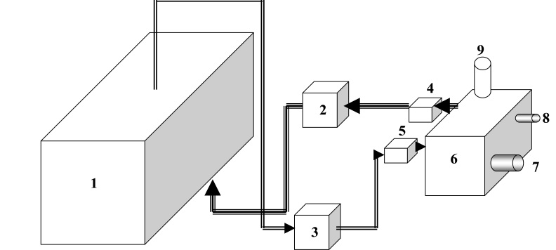

1. Wood treatment chamber 6- Combustion chamber
2. Inlet fan 7, 8- Burners
3. Outlet fan (suction) 4 to 8- Gas treatment chambers
4. Humidification chamber 9-Chimney
5. Dehumidification chamber

Figure 1: Wood heat treatment system (drying and high-temperature heat treatment)

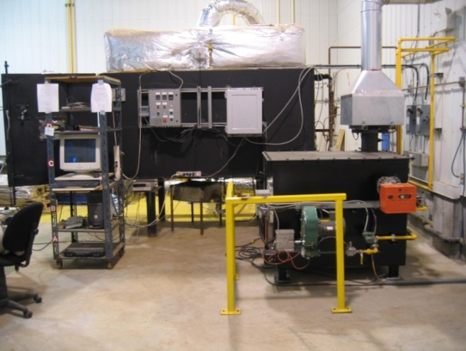

Figure 2: A picture of the prototype furnace

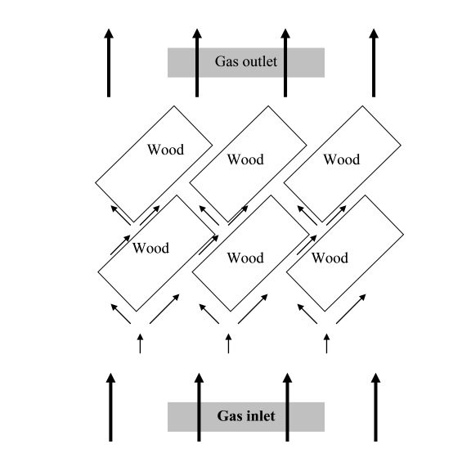

Figure 3: Placement of wood and the gas flow inside the treatment chamber

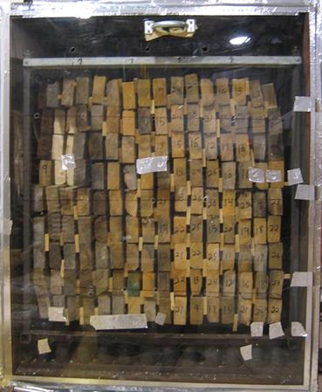

Figure 4: Vertical placement of wood in the treatment chamber

MATHEMATICAL MODEL

The general mathematical formulation is based on the solution of 3D unsteady-state conservation equations for heat, mass, and momentum transfer. The model has two parts: gas and wood. Coupled together, they represent the entire furnace. This modular approach allows the use of the full model to simulate the entire heat-treatment process or the individual modules exclusively to simulate and study a specific case such as isothermal flow in gas or heating of wood under particular conditions.

On the gas side, the gas temperature, moisture content, and velocity profiles are calculated whereas on the wood side, the wood temperature and humidity profiles are determined. At the gas/wood interface, the heat is transferred from gas to wood and the moisture is transferred from wood to gas.

The equations are solved using the commercial code Ansys-CFX. The wood properties used and the details of the mathematical model can be found elsewhere [23-29].

RESULTS AND DISCUSSION

**Flow field**

First, the isothermal flow distribution was studied. The uniformity of the flow field is important for a uniform treatment of wood since the contact between wood and hot gas provides the medium for heat and mass transfer. The flow field was calculated in a furnace where the wood boards were placed horizontally and the gas is introduced in the same direction, which is the case for most of the commercial wood drying and treatment furnaces. The thickness of each wood layer was   
0.05 m. For different inlet velocities, although the maximum velocities were different, the flow field was always found to be non-uniform between most of the wood layers (see Figure 5).

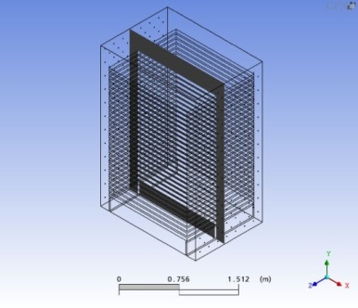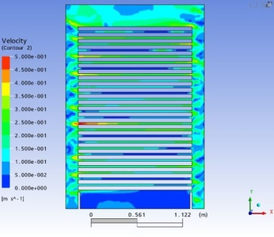

(a)

(b)

Flow

direction

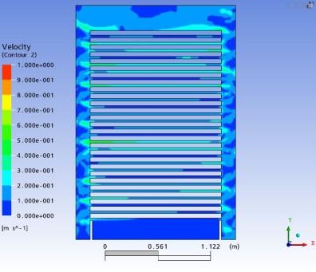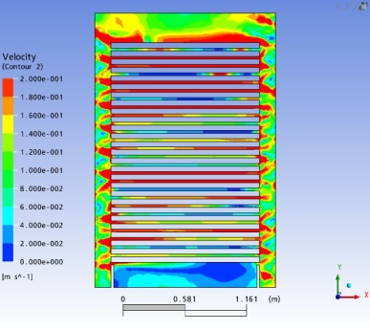

(d)

(c)

Figure 5: (a) The vertical section of a conventional furnace where the flow distribution is presented. The maximum velocity in the field (b) 1 m/s, (c) 0.5 m/s, (d) 0.2 m/s

The flow field in the prototype furnace based on the new technology is presented in Figures 6 and 7 for different inlet velocities and different configurations for the arrangement of wood. This technology allows the use of different wood configurations. Figure 6 presents the flow field when the wood is placed at a certain inclination. The results show that the flow field in general is more uniform compared to the one found in a conventional furnace. Similarly, when wood is placed vertically, the flow distribution is also quite uniform for different inlet velocities as illustrated in Figure 7.

One of the challenges in the wood heat treatment industry is the treatment of large size boards such as poles of different cross-sections. The heat and mass transfer occurs slowly creating large gradients and consequently cracking in wood due to thermal and mechanical stresses. A uniform flow around the wood pieces would help alleviate this problem significantly by reducing the gradients. Figure 8 shows the flow field in a furnace using the new technology (a) and (c) for wooden poles of rectangular and circular cross-sections, respectively, and compares them with the flow fields in a conventional furnace (b) and (d) for the same cases. Thus it is possible to treat the rectangular and circular wooden poles more uniformly using the new technology since the flow distribution is more uniform compared to the one in a conventional furnace (Figure 8).

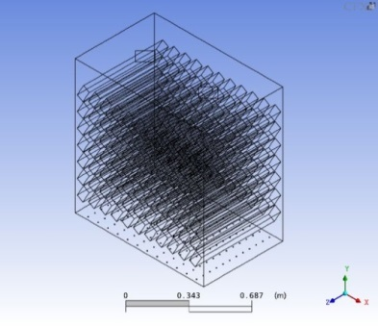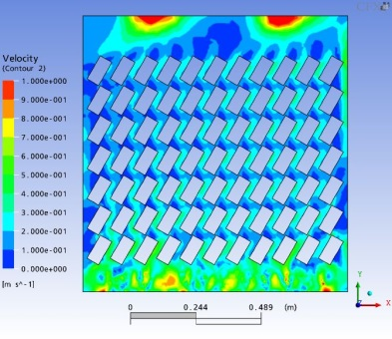 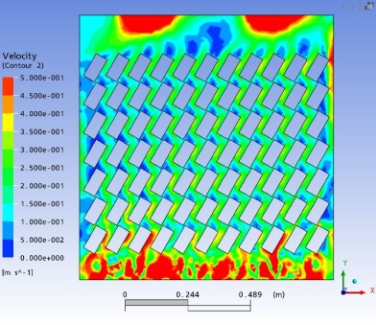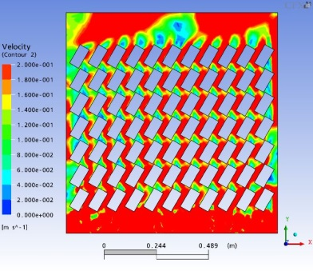

(d)

(b)

(a)

(c)

Flow

direction

Figure 6: (a) The vertical section of the prototype furnace (using the new technology with inclined wood configuration) where the flow distribution is presented. The maximum velocity in the field (b) 1 m/s, (c) 0.5 m/s, (d) 0.2 m/s

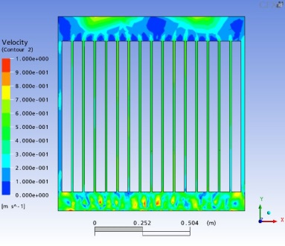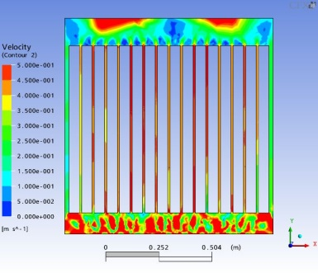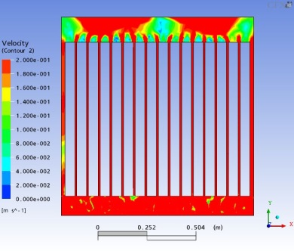

(c)

(b)

(a)

Figure 7: Furnace using new technology with vertical wood configuration. The maximum velocity in the field (a) 1 m/s, (b) 0.5 m/s, (c) 0.2 m/s (the velocity fields are presented on the plane shown in Figure 6(a))

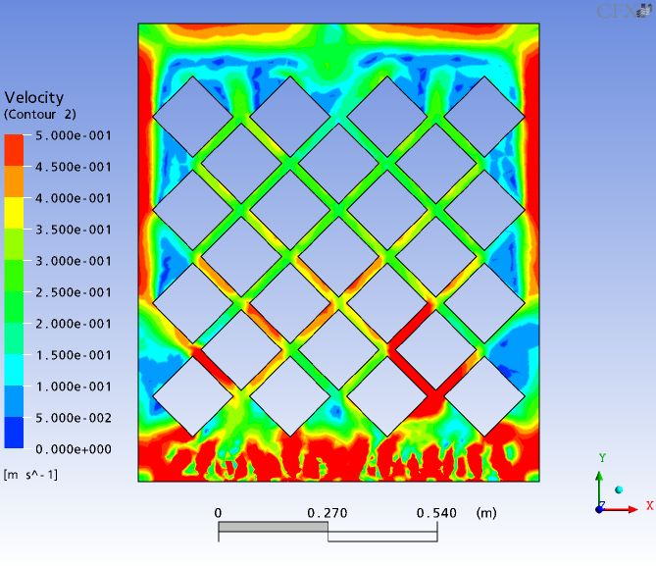

(a)

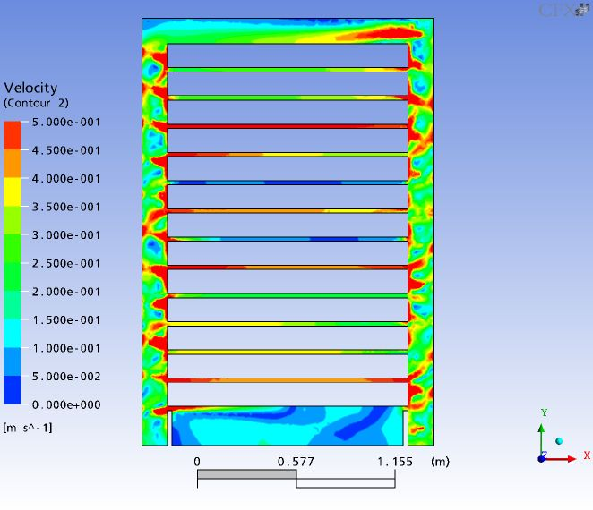

(b)

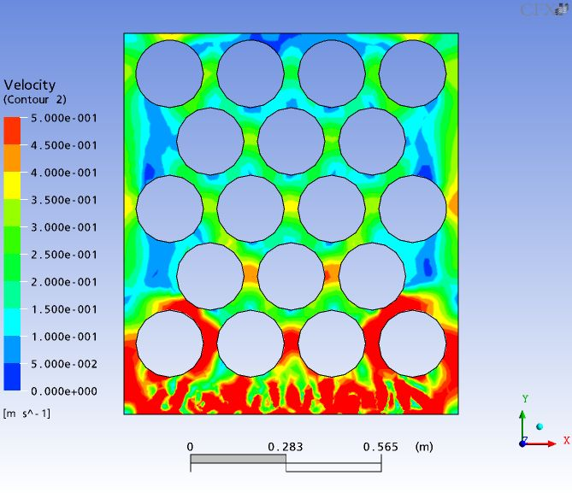

(c)

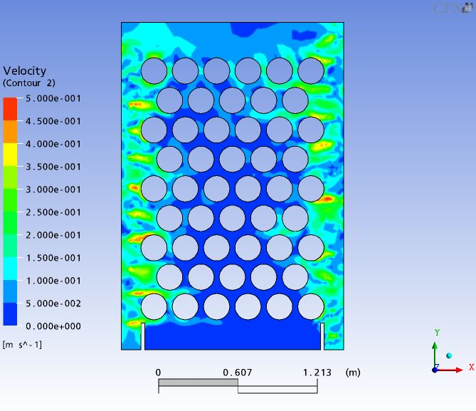

(d)

Figure 8: Velocity field in the furnace around the wooden poles with: a rectangular cross-section (a) the new technology, (b) the conventional technology; a circular cross-section (c) the new technology, (d) the conventional technology

**3D Model**

After the isothermal flow study for flow uniformity, the temperature and moisture content profiles in the furnace (both in gas and wood) were calculated using the global 3D model. Some of the results are presented in Figures 9 to 11.

In Figure 9 (a) and (b), the temperature profiles are shown after 8 and 12 hours of heat treatment, respectively. In general, the profiles are similar, but the scales are different. As the treatment process continues, the temperatures increase in the furnace. The gas temperature decreases in the vertical direction due to heat transfer from hot gas to wood.

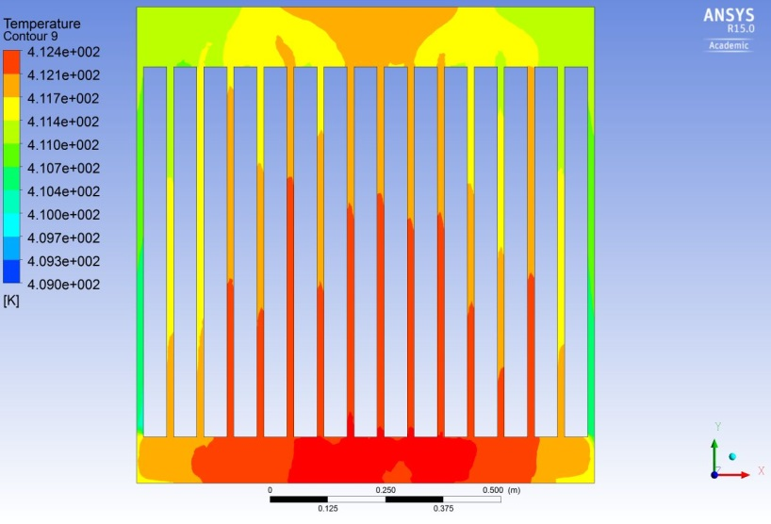

(a)

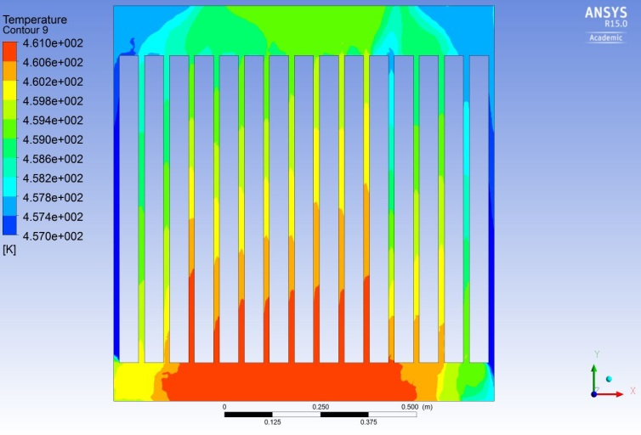

(b)

Figure 9: Temperature distribution in gas after (a) 8 hours,   
(b) after 12 hours

Figure 10 shows the temperature variation in wood as a function of time at the center and on the surface. As expected, the surface temperature is higher due to the contact with hot gas. The center lags because of the additional heat transfer between the surface and the center. Around 8 hours, when the wood temperatures reaches 100-120°C, there is considerable moisture loss from the wood, and most of the heat supplied is used for vaporization. The temperature remains more or less constant during this period and allows the center temperature approach the surface temperature.

Figure 10: Evolution of wood temperature as a function of time

Figure 11 shows the variation in the wood moisture content as a function of time at the center and on the surface of the wood. The surface moisture content decreases rapidly due the proximity to the hot gas medium which also helps remove moisture from the surface. At the center, there is not much change until the wood temperatures are around 100°C. The moisture transfer increases in this range and causes a rapid decrease in the moisture content of wood in the center. Also, in this period, the high mass flux of moisture to the surface becomes greater than the moisture removal by the hot gas from the surface. This results in a slight increase in the surface moisture content between 6 and 10 hours. The final moisture content is slightly below 4%. It is important to note that the final moisture content depends on the treatment duration, initial moisture content, and the wood properties.

Figure 11: Variation of moisture content as a function of time   
in the wood

**Measurements**

A number of tests and measurements were carried out in the prototype furnace. Velocities were measured under isothermal conditions using a hot-wire anemometer. Thermocouples were placed in gas and in wood throughout the furnace, and the temperatures were monitored during treatment in both media. Cracks were measured before and after the treatment to verify if any new cracks are created due to treatment. Wood moisture content was measured before and after the treatment as well.

Figure 12 shows an example of a wood product that was heat-treated at high temperature in the prototype furnace. The color is relatively uniform. The variation in color of the entire charge is within 12.2%. Wood is a heterogeneous material, and such variation is normal. Non-uniform treatment of wood would result in much greater variation. The temperatures vary about 20°C within the gas and 10°C within the wood in the furnace. Near the end of heat treatment, the soaking period helps homogenize the wood temperature.

The treatment did not create any cracks. Less than 3% of the wood had cracks. This value would be higher if the treatment is carried out non-uniformly, creating large thermal and mechanical gradients in wood.

The velocities measured at the entrance of gas into the wood charge indicated that there is a small variation of less than 5% (in one case, the average entrance velocity was 0.97±0.04 m/s). The average velocity between the wood layers was 0.415±0.057 m/s, a variation of less than 15%.

The uniform wood treatment also helps reduce the energy consumption. It was found 0.3-0.4 kWh/pmp of wood, which is the lowest among all treatment technologies.



Figure 12: Wood product heat-treated at high temperature

CONCLUSIONS

A new high-temperature heat treatment technology for wood has been developed. A prototype furnace has been built, and a number of tests have been carried out. The results predicted by the mathematical model as well as those measured in the prototype furnace indicate that this new process would allow a relatively uniform heat treatment of wood. Consequently, a better wood product would be obtained with uniform properties. There would also be less loss due to the prevention of crack formation. The design of different capacity furnaces is also simpler due to the flow configuration.

**ACKNOWLEDGEMENTS**

The authors would like to thank the administration of the University of Quebec at Chicoutimi (UQAC), the Foundation of the University (FUQAC), The Natural Sciences and Engineering Research Council of Canada (NSERC), [Canada Economic Development for Quebec Regions](http://www.dec-ced.gc.ca/eng/index.html) (CED), Ministère de l’Économie, de l’Innovation et des Exportations (MEIE, previously MDEIE) and SOVAR.

References

[1] Poncsak S, Kocaefe, D., Simard, F. and Pichette, A., Evolution of Extractive Composition During Thermal Treatment of Jack Pine, *Journal of Wood Chemistry and Technology,* Vol. 79, No 3, 2009, pp. 251-264.

[2] Kocaefe, D., Poncsak, S. and Boluk, Y.,Effect of Thermal Treatment on the Chemical Composition and Mechanical Properties of Wood, *BioResources*, Vol. 3, No 2,2008, pp. 517-537.

[3]Alén R., Kotilainen R. and Zaman A., Thermochemical Behavior of Norway Spruce (Picea abies) at 180-225°C, *Wood Sci. Technol*., Vol. 36, 2002, pp.163-171.

[4] Pavlo B. and Niemz P., Effect of Temperature on Color and Strength of Spruce, *Wood. Holzforschung*,, Vol.57, 2003, pp. 539–546.

[5] Aydemir D., Gunduz, G., Altuntaş, E., Ertas, M., Şahin, T. H. and Alma, M. H., Investigating changes in the chemical constituents and dimensional stability of heat-treated hornbeam and uludag fir wood, *BioResources,* Vol. 6, 2011, pp. 1308-1321.

[6] Brosse, N., El Hage, R,, Chaouch, M., Pétrissans, M., Dumarçay, S. and Gérardin, P., Investigation of the chemical modifications of beech wood lignin during heat treatment, *Polymer Degradation and Stability*, Vol. 95, 2010, pp. 1721-1726.

[7] Tumen, I., Aydemir, D., Gunduz, G., Uner, B. and Cetin, H., Changes in the chemical structure of thermally treated wood, *BioResources*, Vol. 5, 2010, pp. 1936-1944.

[8] Lekounougou, S. and Kocaefe, D., Effect of thermal modification temperatureon the mechanical properties, dimensional stability and biological durability of Black spruce (*Picea mariana*), *Wood Material Science and Engineering*, Vol. 9, No 2, 2014, pp. 59-66.

[9]Lekounougou, S. and Kocaefe, D., Impact of thermal modification on bioresistance of North American wood species, *Pinus banksiana*, *Populus tremuloides* and *Betula papyrifera,* against wood-rotting basidiomycete fungi, *Wood Material Science and Engineering*, Vol. 9, No 2, 2014, pp. 67-75.

[10] Huang, X., Kocaefe, D., Kocaefe, Y., Boluk, Y. and Pichette, A., A spectrocolorimetric study on color modification of heat-treated wood during artificial weathering, *Applied Surface Science*, Vol. 258, No 14, 2012, pp. 5360-5369.

[11] Saha, S., Kocaefe, D., Boluk, Y. and Pichette, A.,Enhancing Exterior Durability of Jack Pine by Photo-Stabilization of Acrylic Polyurethane Coating using Bark Extract: Part 1- Effect of UV on Color Change and ATR-FTIR Analysis, *Progress in Organic Coatings*, Vol. 70, No 4, 2011, pp. 376-82.

[12] Hakkou, M., Pétrissans, M., Gérardin, P. and Zoulalian, A., Investigations of the reason for fungal durability of heat-treated beech wood, *Polymer Degradation and Stability*, Vol.91, 2006, pp. 393-397.

[13] Santos, J. A., Mechanical behaviour of Eucalyptus Wood Modified by Heat, *Wood Sci. Technol*., Vol. 34, 2000, pp. 39–43.

[14] Kubojima, Y., Wada, M., Suzuki Y and Tonosaki, M., Real-time measurement of vibrational properties and fine structural properties of wood at high temperature, *Wood Sci. and Technol*., Vol. 35, 2001, pp. 503-515

[15] Pavlo, B. and Niemz, P., Effect of Temperature on Color and Strength of Spruce Wood, *Holzforschung*, Vol. 57, 2003**,** pp.539–546.

[16]Létourneau, D., Évaluation de l’influence de la température de traitement sur les propriétés mécaniques du pin gris Pinus banksiana Lamb. *Master Thesis, University of Quebec at Chicoutimi*, Chicoutimi Quebec, Canada, 2006.

[17] Poncsak, S., Kocaefe, D., Bouazara, M. and Pichette, A., Effect of High Temperature Treatment on the Mechanical Properties of Birch, *Wood Sci. Technol*., Vol. *40*, 2006, pp. 647-668.

[18] Kocaefe, D., Chaudry, B., Poncsak, S., Bouazara, M. and Pichette, A., Thermogravimetric Study of High Temperature Treatment of Aspen : Effect of Treatment Parameters on Weight Loss and Mechanical Properties. *Journal of Materials Science*, Vol. 42, No 3, 2007, pp. 854-866.

[19] Shi, J.L., Kocaefe, D. and Zhang, J., Mechanical behaviour of Québec wood species heat-treated using ThermoWood process, *Holz als Roh- und Werkstoff,* Vol. 65, No 4, 2007, pp. 255–259.

[20] Rapp, A. O., Review on heat treatments of wood. *COST Action E22 - Environmental of wood protection*, Antibes (France), 2002.

[21] Militz, H., Heat treatment technologies in Europe: Scientific Background and Technological State of Art. Proceedings of Conference – Enhancing the durability of lumber and engineered wood products. Kissimmee, Orlando. *Forest Product Society, Madison*, US, 2002.

[22] Xie, Y., Liu, Y. and Sun,Y., Heat-treated wood and its development in Europe, *Journal of Forestry Research*, Vol. 13, No 3, 2002, pp. 224 -230.

[23] Kocaefe, D., Younsi, R., Poncsak, S. and Kocaefe, Y., Comparison of different models for the high-temperature heat-treatment of wood,*International Journal of Thermal Sciences,* vol. 46, 2007, pp. 707-716.

[24] Kocaefe, D., Poncsak, S. and Tang, J., Effect of Heat Treatment on the Mechanical Properties of North American Jack Pine: Thermogravimetric Study, *Journal of Materials Science*, Vol 45, No 3, 2010, pp. 681-687.

[25] Younsi, R., Poncsak, S. and Kocaefe, D., Experimental and Numerical Investigation of Heat and Mass Transfer During Thermal Treatment of Wood, *Drying Technology*, Vol. 28, No 10, 2010, pp. 1148-56.

[26]Younsi, R., Kocaefe, D., Poncsak, S. and Kocaefe, Y., Computational and Experimental Analysis of High Temperature Thermal Treatment of Wood Based on Thermo Wood Technology, International *Communications in Heat and Mass Transfer*, Vol. [37, No 1, 2010,](http://dx.doi.org/10.1016/j.icheatmasstransfer.2009.08.008) pp. 21-28.

[27] Kocaefe, D., Kocaefe, Y., Younsi, R., Oumarou, N. and Lekounougou, S.T., Mathematical Modelling of the High Temperature Treatment of Birch in a Prototype Furnace, *Special Issue on Numerical Simulation of Fluid Flow and Heat Transfer Processes, Advances in Mechanical Engineering*, Vol. 2013, Article ID 194610, 2013, 8 pages, [http://dx.doi.org/10.1155/2013 /194610](http://dx.doi.org/10.1155/2013%20/194610), .

[28] Oumarou, N., Kocaefe, D. and, Kocaefe, Y., 3D-modelling of conjugate heat and mass transfers: effects of storage conditions and species on wood high temperature treatment, I*nternational Heat and Mass Transfer*, Vol 79, 2014, pp.945-953.

[29] Kocaefe, Y, Oumarou, N., and Kocaefe, D., Comparison of the 1D and 3D Models for the Simulation of Wood Heat Treatment Process, HEFAT2012**,** 9th International Conference on Heat Transfer, Fluid Mechanics and Thermodynamics**,** 16 – 18 July 2012**,** Malta.

.