An experimental testing of the SERMA technology for the quality control of green and baked anodes

Abderrahmane Benzaoui¹, Duygu Kocaefe², Dipankar Bhattacharyay³, Yasar Kocaefe⁴ and Jean-François Desmeules⁵
1. Postdoctoral fellow
2. Professor, Chair Holder
3. Research professor
4. Research professor
UQAC Research Chair on Industrial Materials (CHIMI),
University Research Centre on Aluminium (CURAL),
University of Quebec at Chicoutimi, Chicoutimi, Canada
5. Technical Director, Dynamic Concept, Jonquière, Canada
Corresponding author: duygu_kocaefe@uqac.ca

Abstract

It is well known that the quality of carbon anodes is important for the aluminum industry. Carbon anodes provide the necessary carbon for the reduction reaction in the Hall-Héroult process. An increase in their electrical resistance results in an increase in energy consumption and greenhouse gas emissions. It is thus important to have, at the disposal of the industry, a non-destructive tool to ensure their quality. Current practice uses visual inspection or destructive sampling methods, which offer limited information on the anode quality. In contrast, SERMA (Specific Electrical Resistance Measurement of Anodes) is a non-destructive method that uses the electrical resistivity distribution to determine the state and the integrity of the anode. This method, which can be implemented easily in a production line, allows the quality control of both green and baked anodes. The method used by SERMA has been validated on lab-scale anodes, and the results have been published previously. In this study, a prototype for industrial application has been built, and tests have been carried out on industrial green and baked anodes. In this article, the results of this study will be presented, which shows the ability of the method to detect both green and baked defective anodes.

Keywords: Carbon anodes, quality control, non-destructive method, electrical resistivity.

- Introduction

An important part of the aluminum production cost pertains to carbon anodes, which includes the raw material and fabrication costs. Their poor performance in terms of energy and carbon consumption in the electrolysis cell could increase their contribution to the cost of production even further. Poor mechanical or chemical anode properties decrease the anode life due to breakage, thermal shock or increased air and CO₂ reactivities [1-3]. This, in turn, decreases the productivity. Thus, it is important to fabricate good quality anodes.

Three main steps of the anode production are paste formation, compaction, and baking. During the baking process, the release of volatiles from pitch, which is used as the binder, exerts pressure within the anode. This might cause the formation of cracks and defects in baked anode, which affects its final quality [1-3]. Therefore, it is important to control the anode quality before its introduction into an electrolysis cell. Two main quality control methods that are widely used in the industry are visual inspection and tests on cores from baked anodes. Visual inspection provides limited information on the anode quality based on only surface defects. In contrast, coring provides more, but limited information on the internal anode defects but only in a small region, usually close to the top part of the anode. This does not represent the entire anode quality. Moreover, coring is a destructive technique, which is applied to only a small number of anodes (about 1.5% of the anodes produced) [1].

There exists, however, some non-destructive techniques that are widely used in other fields. Among them, the ultrasound and the eddy current techniques have been applied for material inspection. Some researchers investigated the use of ultrasound inspection for carbon anodes. Amrani et al. [4, 5] applied this technique on core samples obtained from carbon anodes and was able to detect cracks on these samples. More recently, Ben Boubaker et al. [6] used the ultrasound inspection on thin slices taken from an industrial anode and analyzed the acoustic response using wavelet transforms. Then, they combined the signal and multivariable statistical analyses in order to determine the internal morphology of the anode samples. They validated their method comparing with the X-ray tomographic analysis of the same samples. Both works of Amrani et al. [4, 5] and of Ben Boubaker et al. [6] were carried out on small samples. To the best of authors’ knowledge, currently there is no reported study, which demonstrates the possible application of ultrasound inspection on full size anodes due to the short penetration of the acoustic waves into the carbon material. Electrical resistivity measurement is another promising non-destructive technique for inspecting conductive materials. In general, it is based on the strong correlation between the local resistivity and the local density of a material. Variations in the resistivity values indicate variations in the state of the anode, reflecting possibly the presence of cracks or large pores in the material if the values are higher than normal. In addition, electrical resistivity is also related to anode reactivity since air and carbon dioxide can penetrate more easily into a porous structure, increasing the reactivity in the case of carbon anodes. These also affect other physical, thermal, and mechanical properties. Thus, electrical resistivity is a strong indicator of anode quality. This technique is employed in several fields [7-10]. For carbon anode inspection, the use of electrical resistivity has gained the interest of many researchers.

In a recent article of Rouget et al. [11], the use of Van der Pauw method is suggested to measure the resistivity and detect the flaws in a core sample. However, this is limited to a small sample and not applicable to a large anode block. Formerly, Seger [12] developed a system to measure the resistivity of a full size baked anode. In this system, the current enters the anode from the stub holes and leaves through a set of probes at the bottom. The voltage drop between the stub holes and the probe as well as the current flowing through each probe are measured. The electrical resistivity is then calculated from the values of the current and the voltage drop. Later, a similar system was proposed by Chollier-Bryn et al. [13] and by Leonard et al. [14] where they attempted to mimic the current distribution in an electrolysis cell. In this system, the current enters the anode from the stub holes and leaves from a metallic brush carpet at the bottom. The voltage drop is measured between a reference point at the top surface and a number of predefined points on the large side surfaces. The resistivity is determined by comparing the measured voltage drop to that obtained by a numerical model of a homogenous anode. Recently, Gagnon et al. [15] presented the results of the testing of this system in a plant environment.

The last two systems are only applicable to baked anodes. It would be helpful to control the quality of green anodes in order to reject defective ones as early as possible in the process and save the cost of unnecessary baking. Kocaefe et al. [16, 17] developed a technology, SERMA (Specific Electrical Resistance Measurement of Anodes), applicable to both green and baked anodes. SERMA is based on the measurement of electrical resistivities in two directions in the anode and the construction of a map of the anode’s resistivity distribution. The analysis of the resistivity distribution permits the localization of internal defects. The experimental validation of SERMA using laboratory anodes was previously presented [18, 19]. Predefined defects were intentionally created in these anodes. The experiments showed that the resistivity values were correlated well with the anode porosity and the defects present in the anodes. In addition, a comparison with the X-ray tomography results of the same anodes showed the ability of SERMA in localizing the defects.
In this paper, the results of the testing of SERMA on full size green and baked industrial anodes using a prototype, developed by the UQAC Industrial Materials Chair (CHIMI) in collaboration with Dynamic Concept, are presented. A measurement campaign was carried out using 58 green and 55 baked anodes, yielding a total of 113 sets of measurements. Then, these distributions of the green and baked anodes were analyzed to determine the relationship between them.

- Methodology

  - Principle of SERMA

As mentioned above, SERMA has already been described in detail by Kocaefe et al. [16, 17] and more recently by Benzaoui et al. [18, 19]. This method is based on passing a DC current through the anode using multiple points between two opposite faces and then measuring the voltage drop between the two faces (between top and bottom faces as well as two side faces) at each point using probes placed adjacent to the current contacts. The current contacts as well as the voltage drop measurement points are placed at exactly the same positions on the opposing faces of the anode and are distributed over a rectangular grid covering the entire face. The electrical resistivity is then determined directly at each position from the measured voltage drop and the known values of the current and anode dimensions. In addition to the resistivity distribution, the results of the statistical analysis of the distribution give an indication about the anode quality. The arithmetic mean of the distribution in each direction gives an indication of the overall quality while the standard deviation reflects the heterogeneity of the anode.

Using this method, a map of the electrical resistivity distribution is obtained, indicating the actual state of the anode, a reflection of its properties between the two opposite faces. In general, high resistivity values correspond to regions of low density indicating either high porosity or the presence of cracks and defects in baked anodes. However, for green anodes, high resistivity values might also result from a high pitch concentration (non-homogeneous pitch distribution in an anode resulting from non-homogeneous mixing) due to its considerably low conductivity. Nevertheless, overpitched regions are likely to contain more cracks and defects after the baking process due the pressure of the high quantity of volatiles released.

  - The industrial prototype

In order to test SERMA at industrial scale, a prototype that could measure the electrical resistivity distribution of full size industrial anodes was built. In this prototype, four plates are used to measure the resistivity in two directions as described above. The plates contain the current contacts and the voltage probes arranged on a rectangular grid with forty-five points (5×9 grid) for measurements between top and bottom and twenty five points (5×5 grid) for measurements between the small side faces. The current circuit was designed in such a way that uniform electrical resistance of each circuit branch is ensured. A power generator is connected to the circuit in order to supply the desired DC current. The total current is measured via a shunt resistor. The voltage probes and the shunt resistor are connected to an automated data acquisition system to which a digital multimeter is integrated.

  - The measurement campaign

Sixty green anodes were received from the plant for the measurement campaign. However, two green anodes were broken and damaged extensively during the manipulation and the transportation. Measurements were carried out on 58 green anodes. Of the 58 green anodes, 20 were designated as rejects by the plant’s inspection procedure (30% by visual inspection and the rest is due to non-conformity: 25% anodes with particularities such as ‘without slots’ and they were produced for certain testing in the plant, 40% due to height, and 5% a small piece missing from the corner).

After measuring the electrical resistivity distributions of green anodes, they were sent back to the plant for baking. Out of 58 baked anodes, again three were damaged. Thus, the resistivity distributions of the 55 anodes in baked state were measured in order to analyze and correlate the defects of green and baked anodes. It is important to note that the baking conditions and the position of the anodes in the furnace were not controlled. Therefore, the baking process may not have had the same effect on each anode.

- Results and Discussion

  - Preliminary tests

After the prototype was ready, preliminary tests were carried out. First, the influence of the amount of current on the measurements was studied. Since it is possible to measure the resistivity distribution for both green and baked anodes with SERMA, it is important to use currents that permit accurate measurements without affecting the green anode properties by softening and/or pyrolyzing the pitch. For this purpose, five tests were performed on the same green anode, by varying the current from 1 A to 20 A without removing the measurements plates between the tests (i.e. the current contacts and the voltage probes remained at exactly the same positions for all the tests). Then, the five measured voltage drops u_{mes} at each position were compared.

The measured voltage drop vs. the current showed nearly a perfect linear relationship (R²=0.9999). The curve is not presented in the article due to space limitation. This result confirms that:

- the measurements are reliable and repeatable ,
- the measured resistivity, which is proportional to the slope of the curve, is independent of the current,
- within the current range studied, the green anode properties are not influenced by the Joule effect since no sensitive variation of the slope was detected (this is due to the relatively low local current density obtained by distributing the total current on the whole area of the measurement surface),
- the measurement errors are small.

In order to quantify the measurement error, the root mean square error between the measured and the theoretical voltage drop was calculated using:

$RMS=\sqrt{\frac{1}{n}\sum_{i=1}^{n}{{{\left(\frac{u_{mes}-R I}{R I}\right)}_{i}}^{2}}}$ (1)
where: $RMS$ Root mean square error
$I$ Total current intensity, A
$u_{mes}$ Measured local voltage drop, V
$R$ Theoretical resistance (slope of the least square line), Ω
$n$ Number of the current intensity variation tests

The root mean square error was calculated for the seventy measurement points (the two measurement directions) and was found to be less than 0.05.

Since the measured resistivity is independent of the amount of current within the range tested, a constant current of 5 A was used for all the experiments for both green and baked anodes. A low current also means that no new safety issues will arise in the plant environment.

  - Repeatability tests

The electrical resistivity distribution measurements were repeated five times on the same anode under the same conditions. The current was 5 A. The plates containing the current contacts and the voltage probes were removed and reinstalled after each test. It is difficult to place the measurement probes at exactly the same position every time. Thus, the measured resistivity values at a given position may differ slightly from one test to another since the anodes are not homogeneous.

As expected, there was a slight variation in the local resistivity values from one experiment to another. However, the obtained distributions are quite similar. Figure 1 compares the resistivity distributions obtained during these five tests. In this figure, the normalized resistivity values are presented. The normalization was done based on the maximum and minimum values of each test for each direction. Then, in each case, the values measured between the top and the bottom faces are represented on a horizontal plan, whereas those measured between the small side faces are represented on a vertical plan. The results show that there is globally the same high and low resistivity regions in all cases although small shifts in the position and small differences in the resistivities (shown with different colors) were observed.

Quantitatively, although there is a slight variation in the local resistivities, their effect on the mean resistivity, one of the key indicators of the anode quality, is small. The mean resistivity, $ρ_{mean}$, its average, $\overline{ρ_{mean}}$, and the standard deviation, $σ_{ρ_{mean}}$,were calculated for each case and each direction. The relative error of the mean resistivity was calculated from $\frac{σ_{ρ_{mean }}}{\overline{ρ_{mean}}}$ and was found to be about 3%, which means that the mean resistivity measured by SERMA is repeatable.

Green anode resistivity measurements

The resistivity distributions for 58 industrial green anodes were measured. They consisted of both accepted and rejected anodes by visual inspection as well as a number of them rejected due to non-conformity. It should be noted that if the green anodes are non-conform due to their heights, it is expected that they will have high resistivities due to the high resistivity of pitch. After baking, their resistivity will approach to that of the regular anodes. In any case, such anodes need not be tested by SERMA since they cannot be processed. Figure 2 and Figure 3 illustrate the resistivity distributions obtained using SERMA for two anodes, one with low resistivities (Anode 30) and one with high resistivities (Anode 60) among the anodes tested. In Figures 2a and 3a, the maximum and the minimum resistivities of each specific anode were used for normalization. In addition, the maximum and minimum resistivities used to normalize the results between top and bottom face and between two side faces are specific to that direction for the same anode since the resistivities are higher between top and bottom faces compared to those between side faces. Thus, the value “0” corresponds to the lowest resistivity and the value “1” corresponds to the highest resistivity measured on a given anode in the direction of measurement. Therefore, the same color does not necessarily correspond to the same resistivity value for different anodes or in different measurement directions of the same anode. This type of normalization permits the identification of the highest and the lowest resistivity regions of each anode. In these figures, the high and low resistivity regions of both anodes can be seen clearly. However, it is difficult to say if anode quality is poor or good relative to all the anodes tested.

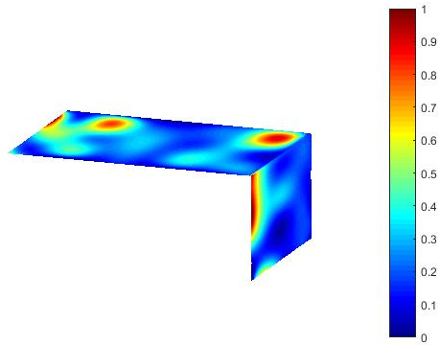 | 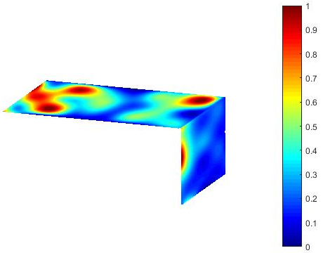
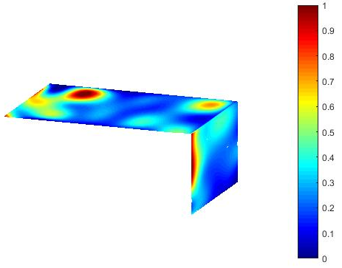 | 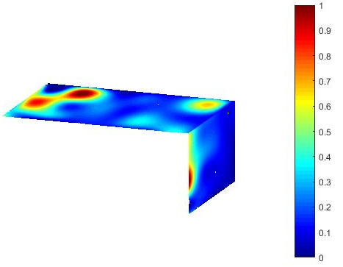
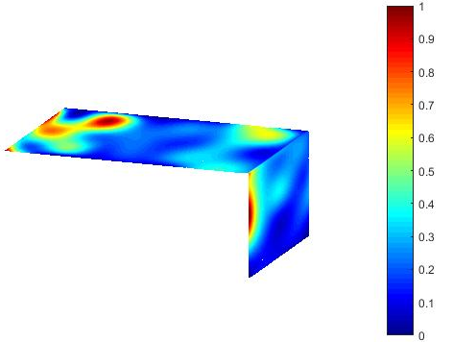
Figure 1. Comparison of the normalized resistivity distributions of the same anode for the five repeatability tests in two measurement directions. Resistivities are normalized based on the maximum and minimum values of each case and each direction.

In Figure 2b and Figure 3b, the maximum and the minimum resistivities used for normalization are the maximum and the minimum of all anodes tested in a given direction. This representation does not show the details of the resistivity distribution in each anode, especially if there are anodes with very high and low resistivities. However, it allows the comparison of the quality of a given anode to those of all the anodes tested. These figures show that Anode 30 has a better quality compared to Anode 60.

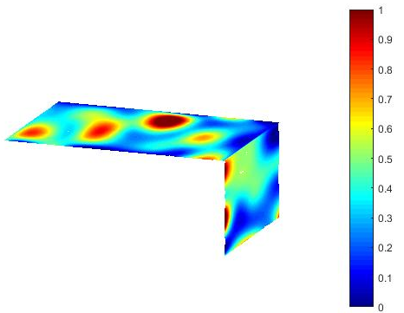 | 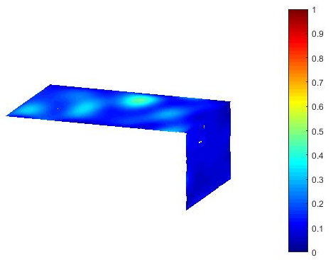
a) | b)
Figure 2. Resistivity distribution for Anode 30 along the two measurement directions:
a) Values are normalized based on the maximum and minimum resistivities measured in each direction for this anode; b) Values are normalized based on the maximum and minimum resistivities measured in each direction for all the anodes tested.

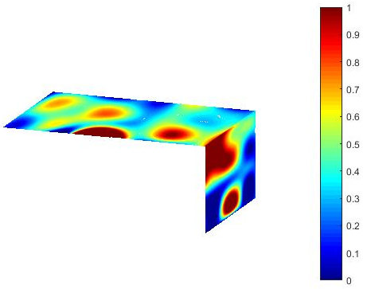 | 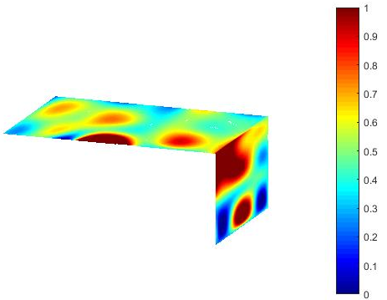
a) | b)
Figure 3. Resistivity distribution for Anode 60 along the two measurement directions:
a) Values are normalized based on the maximum and minimum resistivities measured in each direction for this anode; b) Values are normalized based on the maximum and minimum resistivities measured in each direction for all the anodes tested.
It is also possible to compare the anode quality using the mean resistivity values. Due to the space limitation, only the mean resistivities measured between the top and bottom faces are presented in Figure 4. However, measurements between the side faces show a similar trend. The mean resistivity values are also normalized using the highest and the lowest values found for all the anodes. It appears from this figure that in general anodes rejected by visual inspection have the highest mean values. This confirms that the mean resistivity measured by SERMA is a good indicator of the anode quality. Similar trend is found for the standard deviation, which indicates the heterogeneity of the anodes (rejected anodes generally have much higher standard deviation. Nevertheless, it is important to note that this is not true for all the cases. Some anodes rejected by visual inspection have low mean resistivity while some accepted anodes have high mean resistivity. That is, an accepted anode by the visual inspection might be rejected by SERMA while a rejected anode by visual inspection might be acceptable according to SERMA. This shows the possibility that some anodes rejected based on superficial defects on the surface might not contain major internal defects and can be used for electrolysis. This would decrease the rejection rate and the cost. On the other hand, the anodes accepted based on the external appearance might have internal defects, which might increase the carbon and energy consumption. In order to verify these points, the anodes tested with SERMA should be followed during the electrolysis.

The rejection criteria have to be adjusted to each plant individually since the acceptable anode quality varies from plant to plant. For example in Figure 4, if a threshold value of 0.4 is used, it appears that 12 anodes rejected by plant are acceptable according to SERMA; however, if the non-conform anodes are excluded, 6 anodes could be saved. If a threshold value of 0.2 is used, 6 anodes appear to be acceptable by SERMA, and 4 could be saved after the exclusion of non-conform anodes.

Figure 4. Dimensionless mean resistivity values (the minimum value of 0 for anode 5 and the maximum value of 1 for anode 60) for the green anodes measured between the top and the bottom faces (acceptance or rejection was determined by visual inspection).

  - Baked anode resistivity measurements

As mentioned previously, after the resistivities of the green anodes were measured, they were baked in an industrial furnace, but they were baked in different batches and the placement of anodes in the furnace was not prearranged. Thus, anodes may not have been all subjected to the same baking environment because of the differences in their positions in the furnace as well as in baking conditions of different batches.

Figure 5 shows the normalized mean resistivities of the baked anodes between the top and bottom faces. Rejected anodes with internal defects in green state have high mean resistivities. However, those that were rejected in green state due to non-conformity have in general low mean resistivities, showing that they did not have internal defects. Meanwhile, some of the anodes accepted in green state have high resistivities; this shows that defects have formed during baking. A bad green anode cannot be improved during baking; however, the quality of a good green anode could deteriorate if the baking is not done properly.

Figure 5. Dimensionless mean resistivity values (the minimum value of 0 for anode 26 and the maximum value of 1 for anode 10) for the baked anodes measured between the top and the bottom faces (acceptance or rejection refers to the visual inspection results of these anodes in green state).

In order to understand the relationship between green and baked anode resistivities, the baked anode mean resistivities were plotted as a function of the green ones mean resistivities (Figure 6). Although there is some scatter (which is normal due the non-homogeneous nature of the large industrial anodes), a correlation exists. In general, the higher the green anode mean resistivity is, the higher the baked anode mean resistivity is. This shows that it is important to detect the defective green anodes, which is the objective of SERMA, since the quality will also be poor after baking. This will help prevent the baking of poor quality anodes and reduce the baking cost. It can be seen in Figure 6 also that green anodes with high mean resistivities, rejected due to non-conformity (but with no internal defects), gave low mean resistivities after baking. A few accepted green anodes with low mean resistivities resulted in baked anodes with high mean resistivity due to baking conditions.

There is a great deal of variability in the anode production parameters ranging from changes in raw material quality to differences in operating conditions. A green anode may have a very high resistivity only in a small region, but this may be sufficient to result in a high mean resistivity for that green anode. The corresponding baked anode quality will be different than the others. Thus, a statistical analysis of the measurement results is also carried out (not presented here). This helps better understand the relationship between the green and baked anode resistivities.

Figure 6. Correlation between the green and baked mean resistivity of anodes measured between the top and the bottom faces (acceptance or rejection refers to the visual inspection results of these anodes in green state).

SERMA gives the mean resistivities and the resistivity distributions in both directions. In addition, the statistical analysis provides additional information that gives insight into the state of a given anode (green or baked). The rejection is based on a number of criteria based on the results of the measurements and statistical analysis. The threshold for the criteria has to be adjusted according to the needs of each plant.

- Conclusions

In this paper, the results of an experimental testing of the SERMA technology are presented. For this purpose, a prototype was built to measure the electrical resistivity distributions of full size industrial anodes. Using the prototype, a measurement campaign was carried out on industrial anodes to measure their electrical resistivity distributions before and after baking. Results show that SERMA can give detailed information on anode quality, and it can be used for quality control. Some of the anodes rejected by visual inspection were found acceptable by SERMA while others found acceptable by visual inspection were rejected by SERMA. This is due to the limitation of the visual inspection since the decision is based on the surface defects while SERMA evaluates the quality of the whole anode. This means that it is possible to save good quality anodes that are rejected or to reject poor quality anodes that are accepted. Furthermore, the experiments indicated that the higher the green mean resistivity is, the higher the baked mean resistivity is. It is thus possible to use SERMA to reject green anodes based on their resistivity values. This will also help identify the problems in the paste plant and take corrective action before the poor quality anodes are baked. SERMA can be used for baked anode quality control as well; however, it is preferable to use it for green anodes to avoid their further processing.

Further testing of the SERMA technology on industrial anodes will be carried out. A follow-up of these anodes during baking and their performance in the electrolytic cell would help improve greatly the understanding of the relationship between the resistivity values and the anode quality.

- Acknowledgments

The financial support of the Centre québécois de recherche et de développement de l’aluminium (CQRDA), the National Science and Engineering Research Council of Canada (NSERC), the University of Quebec at Chicoutimi (UQAC), the Foundation of the University of Quebec at Chicoutimi (FUQAC) are greatly appreciated. The authors also thank Aluminerie Alouette Inc. for providing the industrial anodes for the experiments.

- References

1. K. L. Hulse, Anode manufacture: raw materials, formulation and processing parameters. R.D. Carbon. 2000, Sierre, Switzerland: Calligraphy Sierre.
2. M. W. Meier, Cracking behaviour of anodes. R.D. Carbon. 1996, Sierre, Switzerland.
3. A. Charette and Y. Kocaefe, Le carbone dans l'industrie de l'aluminium. L.P.d. l'aluminium. 2012, Chicoutimi, Canada: Les Presses de l'aluminium.
4. S. Amrani et al. Effect of heating rate on the crack formation during baking in carbon anodes used in aluminum industry. in Light Metals. 2014. San Diego, California, USA: Wiley.
5. S. Amrani, Impact de la préparation des anodes crues et des conditions de cuisson sur la fissuration dans des anodes denses. PhD Thesis. University of Québec at Chicoutimi. 2015, Chicoutimi, Canada:
6. M. Ben Boubaker et al. Insepction of prebaked carbon anodes using multi-spectral acousto-ultrasonic signals, wavelet analysis and multivariate statistical methods. in ICSOBA (International Conference for Study of Bauxite, Alumina and Aluminium. 2016. Quebec, Canada.
7. T. Matsui et al. Relationship between electrical resistivity and physical properties of rocks. in GeoEng2000, an International Conference on geotechnical & geological engineering. 2000. Melbourne, Australia.
8. R. Schueler et al., Damage detection in CFRP by electrical conductivity mapping. Composites Science and Technology, 2001. 61(6): p. 921-930.
9. J. F. Lataste et al., Electrical resistivity measurement applied to cracking assessment on reinforced concrete structures in civil engineering. NDT & E International, 2003. 36(6): p. 383-394.
10. K. Karhunen et al., Electrical resistance tomography imaging of concrete. Cement and Concrete Research, 2010. 40(1): p. 137-145.
11. G. Rouget et al. Electrical resistivity measurement of carbone anodes using van der pauw method. in ICSOBA (International Conference for Study of Bauxite, Alumina and Aluminium. 2016. Quebec, Canada.
12. E. J. Seger. Method and means for measuring electrode resistance. Aluminum Company of America 1973. US Patent
13. M. J. Chollier-Bryn et al. New method for representative measurement of anode electrical resistance. in Light Metals. 2012. Orlando, USA: TMS (The Minerals, Metals & Material Society).
14. G. Leonard et al. Anode electrical measurements: Learning and industrial on-line measurement equipment development. in Light Netals. 2014. San Diego, USA: TMS (The Minerals, Metals & Material Society).
15. M. Gagnon et al. Mirea: An on-line quality control equipement integration in an operational context. in Light Metals. 2016. Nashville, USA: TMS (The Minerals, Metals & Materials Society).
16. D. Kocaefe et al. Measurement of anode electrical resistivity for quality control in aluminium industry. in COM (Conference of Metallurgists). 2014. Vancouver, Canada.
17. Y. Kocaefe et al. Quality control via electrical resistivity measurement of industrial anodes. in Light Metals. 2015. Orlando, USA: TMS (The Minerals, Metals & Materials Society).
18. A. Benzaoui et al. A non-destructive technique for the on-line quality control of green and baked anodes in ICSOBA (International Conference for Study of Bauxite, Alumina and Aluminium. 2016. Quebec, Canada.
19. A. Benzaoui et al., A non-destructive technique for the on-line quality control of green and baked anodes Metals, 2017. 7(4): p. 128-138.

