Figure 1
Conceptual mediation PLS structural equations model

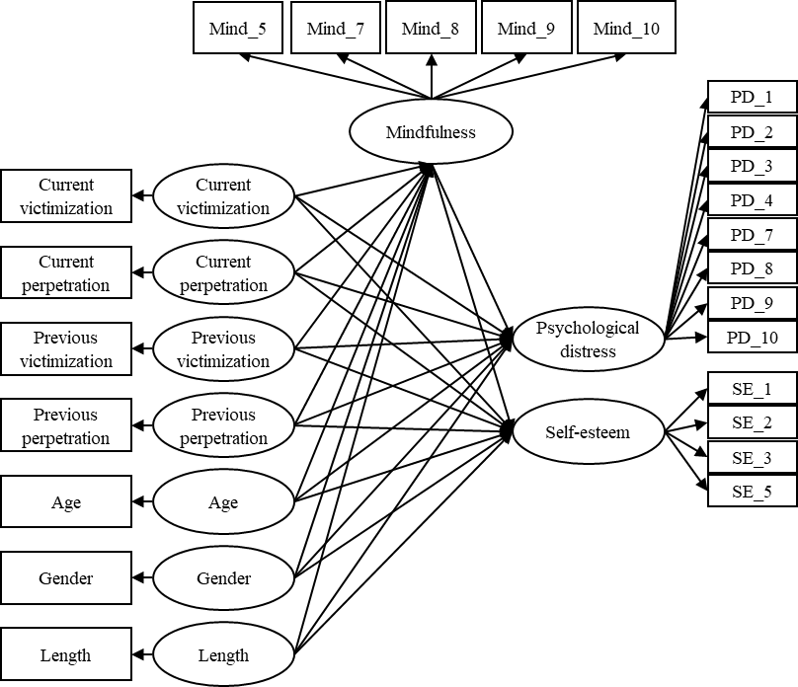

Figure 2
Significant paths for the mediation PLS structural equations model (n = 227)

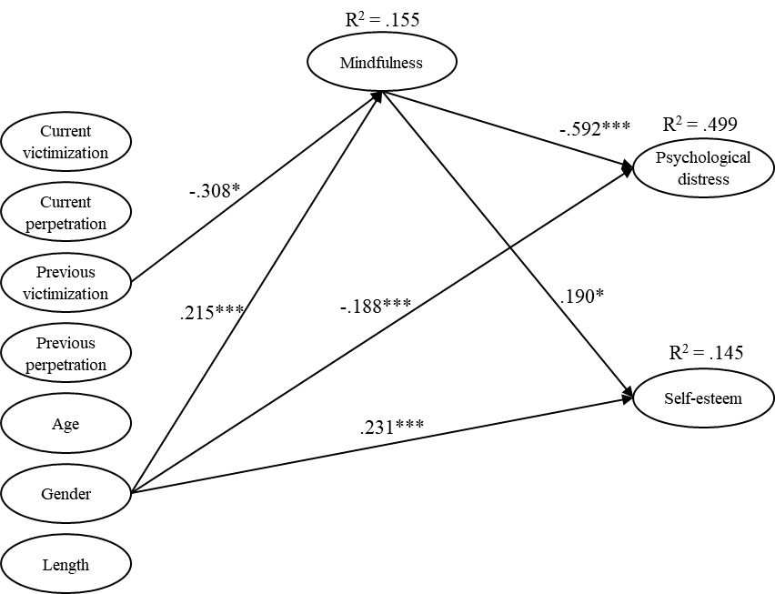
Note. Only statistically significant paths (*<.05, **<.01, and ***<.001) are shown with their estimate. The indirect paths from previous dating violence victimization to psychological distress and self-esteem through mindfulness were statistically significant.

