Simultaneous Analysis of Big Multi-Network Data by Mapping Graphs into Data Model
Ahmad Karawash, Hamid Mcheick, and Mohamed Dbouk

Abstract
Recently, network analysis gained great importance by companies; this is especially due to the gigantic number of social-network users. Analyzing networks is helpful for organizations that profit from how network’s nodes (e.g. Web users) interact and communicate with each other. Currently, network analysis methods and tools support single network analysis. To identify personalization a multi-networks analysis is required. Accordingly, a Web 3.0 trend allowing to merge all web-user accounts (social, business, and others) is recommended. Many efforts are done by specialists to build analytical approach that works on multiple networks simultaneously. This article proposes a new model to map the web multi-network graphs into a data model. The resulting model is multidimensional database that serves deriving a numerous network analysis measures of several networks concurrently. Also the proposed model supports a real time analysis and Online Analytical Processing (OLAP) operations, including data mining and business intelligence analysis.

Keywords:Multi-network analysis, Data model, Multidimensional database, Analysis measures, Online analysis.

Ahmad Karawash
Department of Computer Science, University of Quebec at Chicoutimi (UQAC), 555 Boulevard de l’Université Chicoutimi, G7H2B1, Canada. Ecole Doctorale des Sciences et de Technologie (EDST), Universite Libanaise, Rafic-Hariri Campus, Hadath-Beirut, Lebanon. E-mail: ahmad.karawash1@uqac.ca

Hamid Mcheick
Department of Computer Science, University of Quebec at Chicoutimi (UQAC), 555 Boulevard de l’Université Chicoutimi, G7H2B1, Canada. E-mail: hamid_mcheick@uqac.ca

Mohamed Dbouk
Department of Computer Science, Faculty of Sciences (I), Lebanese University, Rafic-Hariri Campus, Hadath-Beirut, Lebanon. E-mail: mdbouk@ul.edu.lb
- INTRODUCTION
By its very nature, network connection shares Big Data. The amount of data crossing networks will continue to explode. By 2020, 50 billion devices will be connected to networks and the Internet (Cisco IBSG, 2011) and the absolute volume of digital information is predicted to increase to 35 trillion gigabytes, much of it is coming from new sources including blogs networks, social networks, internet search, and sensor networks. The network can play valuable roles in increasing the Big Data’s potential for enterprises. It can assist in collecting data and providing context at a high velocity and it can impact the customer’s experience.
As the amount of the online-network communications increases sharply with time, it becomes difficult to access or analyze relevant information from web. One possible approach to solve this problem by Web 3.0 is the Web personalization (Eirinaki M., and Vazirgiannis M., 2003). Personalization aims at alleviating the burden of information overload by tailoring the information presented based on an individual and immediate user needs (Mobasher et al., 2000). One of the personalization requirements, which can arrange a big part of the network data, is to combine user web accounts and to constitute a personal profile for each user.
Responding to the accounts merging trends, this article studies how to deal with multiple networks using the datamodel view. We will treat the multiple network idea using the graph model perspective. Indeed, network graphs have been growing rapidly and showing their critical importance in many applications, such as the analysis of XML, social networks, Web, biological data, multimedia data and spatial-temporal data.
This article proposes a model to map a multi-network graph into data model, a multidimensional database is achieved which enables a better network analysis. As a result of the proposed model, an OLAP approach concepts (data-mining and business-intelligence analysis) can be applied on numerous networks at once. The network’s data are collected in a way that analysis measures are requested by a database query and for several networks at the same time. Since there are a lot of network analysis measures; this article studies only the network Centrality measures. In order to explain the proposed idea and building a step in the real implementation, this article also consists of real study case simulation of three social network groups. Also to illustrate the importance of our study, we show two real examples from different domains where the model is applicable.
The article is organized as follows: section 2 explains the problem. Then section 3 decribes a background and the state-of-art. Section 4 discusses the proposed model of mapping multi-network graph into a multidimensional database. Section 5 explains the simulation steps and shows some results. Section 6 highlights the benefits of the proposed model. Section 7 gives a conclusion and outlines our future work.
- PROBLEM STATMENT
The huge random Web connections and the unorganized store of big data through the Web 2.0 announced the computer scientists to develop the Web 3.0. The new Web is based on wide arrangements of data. One of the problems of Web 2.0 is the random distribution of multi-accounts of a Web user (accounts as social, business or others). Web 3.0 proposed the idea of personalization that changed the web concepts from working with words into dealing with personal profile. In order to achieve a personal profile, all the user accounts treated as one block (account aggregation). Although the personalization model solved the problem of random accounts and searched engine difficulties but it caused a problem in the analysis level. Before personalization, the analysis methods were easier to be applied because the analysis target was one network.While in the new Web the goal is changed into multi-network analysis (or multidimensional network graph analysis). For example, if we take the social network case it is easy to apply analysis on one network as calculation of centrality measures. But how can we analyze several graph seach with a different purpose for one person at the same time? (Such as calculating the Degree centrality of a person in both Facebook and Twitter networks at the same time and by one request).
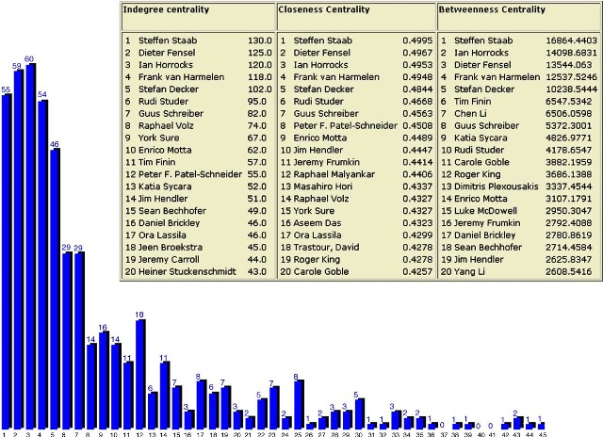
Figure 1: Simple network statistics of the Centrality distribution (Peter M., 2005)
As we know the available methods and tools deal with one dimensional graphs. Thus as a challenge for the new web, is it possible to analyze the multi-network (multidimensional) graphs simultaneously? What is the degree of online network analysis that can be achieved by Web 3.0?
- BACKGROUND & RELATED WORKS
‘Network’ is a heavily overloaded term, so that ‘network analysis’ means different things to different people. Specific forms of network analysis are used in the study of diverse structures such as the Internet, transportation systems, the Web graph, electrical circuits, project plans, and so on (Brandes, et al., 2005). Numerous network analysis measures had been developed through the history as the inﬂuence measures of Katz (1953), Hubbell (1965), and Hoede (1978), Taylor’s (1969) and Freeman’s Closeness and Betweenness (Freeman, 1979), ﬂow Betweenness (Freeman et al., 1991), Bonacich’s eigenvector (1987, 1991), etc.
While studies on network analysis have been around for decades, and a surfeit of algorithms and systems have been developed for multidimensional analysis in relational databases, none has taken both aspects into account in the multidimensional network scenario.
Ulrik Brandes proposed algorithms for petunias are introduced to compute centrality indices on large network graphs (Ulrik Brandes, 2001). Then, Elizabeth et al.discussed, in 2003, a study about how to analyze a research network and they used bootstrap sampling procedures research network to determine how sampling affects the stability of several different network centrality measures (Elizabeth et al., 2003). In 2008, Chen et al. developed a graph OLAP framework, which presents a multi-dimensional and multi-level view over graphs (Chen et al., 2008). In 2010, Tore et al. proposed generalizations that combine Centrality measures (Tore et al., 2010). Also in 2010, Manuel and al. proposed the ManyNets to analyze several networks at the same time with visualization (Manuel et al., 2010). While Xi-Nian et al. investigated a broad array of network centrality measures to provide novel insights into connectivity within the whole-brain functional network (Xi-Nian et al., 2012). Also in 2012, the HMGraph OLAP is developed by Mu et al., that provide more operations on a multi-dimensional heterogeneous information network (Mu et al., 2012). In 2013, Daihee et al. proposed NetCube network traffic analysis model using online analytical processing (OLAP) on a multidimensional data cube, which provides an easy and fast way to construct a multidimensional traffic analysis of long-term network traffic data (Daihee et al., 2013). Besides Wararat et al. proposed a framework to materialize this combination of information networks and discussed the main challenges to build that framework (Wararat et al., 2013).
- MULTI-NETWORK GRAPH AND DATA MODEL
This section highlights the relationship between the graph model and the data model. The new web trends to use a multi-network graph model instead of graph model to deal with the explosive growth of the online networks.
A graph is a representation of a set of objects where some pairs of objects are connected by links. The interconnected objects are represented by mathematical abstractions called vertices, and the links that connect some pairs of vertices are called edges. Typically, a graph is depicted in diagrammatic form as a set of dots for the vertices, joined by lines or curves for the edges (Trudeau and Richard, 1993). The edges may be directed or undirected. A multi-network graph is generally understood to mean a graph in which multiple edges are allowed.
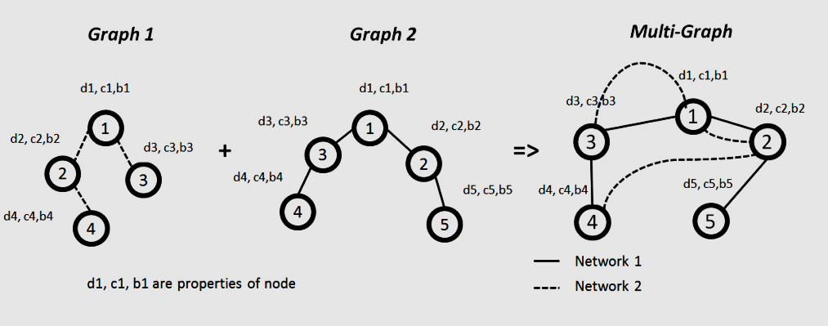
Figure 2: Multi-network graph
Figure 2 shows an example of how a multi-graph is obtained from several graphs. Graph1 and Graph2 represent the node connections in two different networks.
A multi-graph is based on vertices, edges, belonging network and vertex properties. A multi-graph is an ordered pair M=(V, L, N, P) such that: V is a set vertex, L= {{p,q}: p,q ε V}is a set of two elements (edge) subsets of V edges, N={n₁, n₂,…, n_{k}} is the set of belonging networks that node belong and P= {degree centrality, Closeness, Betweeness, …, other analysis measures} is the set of properties of the node.
In order to talk about the relationship between the multi-graph model and the Data model, it is necessary first to introduce the reader to the ER data model. ER is the most widespread semantic data model, it was proposed by Chen in 1976 (Chen, 1976) and it has become a standard, extensively used in the design phase of commercial applications.
The basic elements of the ER Model R = (E, R, A) are entities, relationships, and attributes. An entity setE denotes a set of objects, called its instances, that have common properties. Element properties are modeled through a set of attributesA,whose values belong to one of several predefined domains, such as Integer, String, or Boolean. Properties that are due to relations to other entities are modeled throughthe participation of the entity in relationships. A relationship set R denotes a set of tuples, each of which represents anassociation among a different combination of instances of the entities that participate in the relationship.
Let g: V->E and h: N->E be two function maps the values in set Vand N to set E, in which if xεV, then g(x) εE. The knowledges g (V) and h(N), derived from multi-graph M,are defined as follows: every vertex (node)x in the set of vertices Vand every belonging networky in the set N are mapped by the g and h respectively into entities in the set E.
Let k: L->Rbe a function such that k(i )ε R, where iεL. This means that every edge belongs to set L is mapped to relationship by k.
Let w: P->Abe a function such that w(c)ε A, where cε P. This means that every property in the multi-graph is mapped into attribute in the ER diagram.

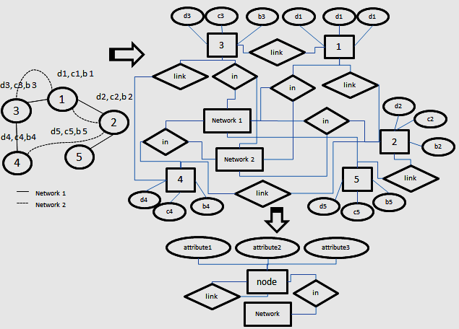
Figure 3: Mapping a multi-network graph into ER diagram
Figure 3 shows how a multi-network graph is mapped into ER diagram. The multi-network graph consists of five nodes each with the properties. Also some of the nodes belong to network 1 (lined link) while the others belong to network 2 (dotted line) (and may belong to both networks at the same time). As shown in the figure, the top ER diagram forms the result of the translation, in which nodes are translated to entities, properties to attributes and links to relationships. Because the same information are repeated (node name, network type and attributes) the top ER diagram is optimized into the bottom one in the figure. The obtained ER diagram is the same for any multi-network graph (only the number of attribute may vary).

- ANALYSIS OF MULTI-NETWORK GRAPH
This section explains how to benefit from the mapping of the multi-network graph into the ER diagram in the network analysis.

  - BASIC CONCEPTS
In this part some network analysis concepts are discussed. Through the space of graph theory and network analysis, there are several types of measures of the centrality of a vertex within a graph that determines the qualified status of a vertex within the graph (e.g. How important a person is within a social network, how important a room is within a building or how well-used a road is within an urban network). Many of the Centrality concepts were first developed in social network analysis as degree centrality, Betweenness, and Closeness.
Degree Centrality: The first and conceptually simplest concept, which is defined as the number of links incident upon a node. It is the number of nodes adjacent to a given node (sent = out a degree or received = in degree). The measure is entirely local, saying nothing about how you are positioned in the wider network. Degree centrality is defined by a degree of unit x: c_{D} (x) = degree of unit x. Relative degree centrality is:
C_{D}(x) = c_{D} (x) /highest degree-1 = c_{D} (x) /n-1, if n is number of units in a network, the highest possible degree (in a network without loops) is n-1.
Closeness Centrality: Measures how many steps you are from others in the network. Those with high Closeness are those who can reach many people in few steps. Technically it is the sum of network distance to all others. This is not just a local measure, but uses information from the wider network. Sabidussi (1966) suggested the measure of centrality according to the Closeness of unit x: c_{C} (x) = 1 /∑ _{yƐU} d(x, y), where d(x; y) is the length of shortest path between units x and y, U is the set of all units. Also Relative Closeness centrality is defined by : C_{C} (x) = (n-1) * C_{C} (x), where n is the number of units in the network.
Betweenness Centrality:Betweenness centrality measures how often a given actor sits 'between' others, with 'between' referring to the shortest geodesic. An actor that is between many is assumed to have a higher likelihood of being able to control information flow in the network. Freeman (1977) defined the centrality measure of unit x according to Betweenness in the following way:
$$cB\left(x\right)=\sum_{y<z}{\frac{\# of shortest paths between y and z through unit x}{\# of shortest paths between y and z}}$$
Suppose that communication in a network always passes through shortest available paths: Betweenness centrality of unit x is the sum of probabilities across all possible pairs of units, that the shortest path between y and z will pass through unit x.
In network analysis the Relative Betweeness Centrality is used which has two formulas according to the type of network. For undirected graph Relative Betweeness, we have C_{B}(x)= c_{B}(x)/((n-1)*(n-2) /2). For direct graph Relative Betweeness, we have C_{B}(x) = c_{B}(x)/(n-1)*(n-2).
  - ANALYSING AMULTI-NETWORK GRAPHS USING OLAP
This part maps the obtained ER diagram in figure 3 into a multi-dimensional database (cube). In this mapping we will study the three centrality measures (Degree Centrality, Closeness and betweeness) that are explained in section 7.1.
Every data analysis is based on a dataset which is stored in a database. But in our case we have a multidimensional graph, thus we proposed to map this type of graphs into a multidimensional database. The functions and notations in this part depend on the previous definitions in section 4 above. Denote L_{M} (s, x)as link between s,xεV and φs= | ∑_{iεIN} L_{M} (s, xi)/ n-1 |, where n is the number of nodes. Let function d_{M} (s, t) calculates theshortest path distance between s, tεV(G_{M}).
Let S_{st}= |n-1/d_{M} (s, t)|, where n is the number of nodes. Denote P_{st} the set of different shortest path betweens, t εVand β_{st} := |P_{st}|. For every v ε V denotesP_{st}(v) the set of different shortest path containingv with s ≠ v ≠ t, &β_{st}(v) := |P_{st}(v)|.
Let D_{i*j*k} (R_{i*k}(D), C_{j*k}(D)) be a multidimensional database (cube)of order 3, where R_{i*k}(D) denotes the row i at the k level of the cube and C_{j*k}(D) denotes the column j at the level k of the cube, while i, j, kεIN⁺.
Figure 4: : The structure of cube with three faces and “k” levels
0
1
2
k
2
1
3

Let M_{k}(a_{i,j}) be a matrix of i, j dimensions, where a_{i,j} is a value of the matrix element at row i and column jand i, j,k∈IN*.M_{k}:=$\bigcup_{\begin{aligned}0≤i≤n \\ k, n ϵN\end{aligned}}{Ri*k(D)}$ := $\bigcup_{\begin{aligned}0≤j≤n \\ k, n ϵN\end{aligned}}{Cj*k(D)}$, which means matrix M_{k} is formed by the union of cube rows or column at a specific level k. Let R_{D} denote the set of networks tobe studied such that R_{D} = {R₀ (D), R₁ (D), …, R_{n} (D)}= {Networkname₁, Networkname₂, …, Networkname_{n}}. Let set C_{D} denote the set of node names such that C_{D} = {C_{0*k}(D), C_{1*k}(D), …, C_{n*k}(D)}= {C₀ (D), C₁ (D), …, C_{n} (D)} = {nodename₁, nodename₂, …, nodename_{n}} (or ={A, B, …, Z} sorted by first letter). Let set C_{D0} denote the set of number of links divided by n-1 (φs_{x}= | ∑_{iεIN} L_{M} (s, xi)/ n-1 |) between a studied node and the other nodes named in C_{D}, such that C_{D0}= {C_{0*0}(D), C_{1*0} (D), …, C_{n*0}(D)}or in other word C_{D0}represents the face of the cube at level zero. Let set C_{D1}denote the set of the distances (S_{xt}^{i} = |n-1/d_{GM} (x, t^{i})|) from a studied node “x” to all the other nodes “t^{i}”, such that C_{D1} = {C_{0*1} (D), C_{1*1} (D), …, C_{n*1} (D)}. For all the other column C_{Di}wherei >= 2, Let set C_{Di}denote the set of different paths between a nodeany two nodespassing through a specific node vwhich is studied by the cube (β_{st}(v) := |P_{st}(v)| ) divided by the sum of different paths between between any two nodes (β_{st}:= |P_{st}|), such that C_{Di} = {C_{0*i}(D), C_{1*i}(D), …, C_{n*i}(D)}.

Figure.1 explains how the node’s cube is structured in which it is a threedimensional cube of three faces. These faces are divided to the “K” number of levels (0,1,2,…, k). Each level will be studied as a matrix in the next set of figures.
 | Nodename1(n₁) | Nodename2(n₂) | Nodename3 (n₃) | Nodename4(n₄)
Network1(r₁) | Φ_{Øn1}^{r11} | Φ_{sØn2}^{r11} | Φ_{sØn3}^{r1} | Φ_{sØn4}^{r41}
Network2(r₂) | Φ_{Øn1}^{r22} | Φ_{Øn2}^{r22} | Φ_{Øn3}^{r3} | Φ_{Øn4}^{r2}
Network3(r₃) | _{Øn1}^{r3} | _{Øn2}^{r3} | _{Øn3}^{r3} | _{Øn4}^{r3}
Table 1: Matrix examplerepresentsthe level zero of the cube
Table 2 represents the level 0 of the node’s cube “s” as a matrix, in which the columns shows the other node’s name on the graph and the rows shows the networks that a node appears in. Also the values in the matrix entries contain the Degree centralityφ that node “s” has with the other nodes.
 | Nodename1(n₁) | Nodename2(n₂) | Nodename3 (n₃) | Nodename4(n₄)
Network1(r₁) | S_{sn1}^{r1} | S_{sn2}^{r1} | S_{sn3}^{r1} | S_{sn4}^{r1}
Network2(r₂) | S_{sn1}^{r2} | S_{sn2}^{r2} | S_{sn3}^{r2} | S_{sn4}^{r2}
Network3(r₃) | S_{sn1}^{r3} | S_{sn2}^{r3} | S_{sn3}^{r3} | S_{sn4}^{r3}
Table 2: Matrix example represents the level 1 of the cube
Table 3 represents the level 1 of the node’s cube “s” as a matrix. The values in the matrix entries contain the Closeness Centrality of node “s”.
 | Nodename1(n₁) | Nodename2(n₂) | Nodename3 (n₃) | Nodename4(n₄)
Network1(r₁) | $$\sum_{∀xi, yi εV}{\frac{βxiyi [r1] }{βxiyi(n1)[r1]}}$$ | $$\sum_{∀xi, yi εV}{\frac{βxiyi [r1] }{βxiyi (n2)[r1]}}$$ | $$\sum_{∀xi, yi εV}{\frac{βxiyi [r1] }{βxiyi (n3)[r1]}}$$ | $$\sum_{∀xi, yi εV}{\frac{βxiyi [r1] }{βxiyi (n4)[r1]}}$$
Network2(r₂) | $$\sum_{∀xi, yi εV}{\frac{βxiyi [r2] }{βxiyi (n1)[r2]}}$$ | $$\sum_{∀xi, yi εV}{\frac{βxiyi [r2] }{βxiyi (n2)[r2]}}$$ | $$\sum_{∀xi, yi εV}{\frac{βxiyi [r2] }{βxiyi (n3)[r2]}}$$ | $$\sum_{∀xi, yi εV}{\frac{βxiyi [r2] }{βxiyi (n4)[r2]}}$$
Network2(r₃) | $$\sum_{∀xi, yi εV}{\frac{βxiyi [r3] }{βxiyi (n1)[r3]}}$$ | $$\sum_{∀xi, yi εV}{\frac{βxiyi [r3] }{βxiyi (n2)[r3]}}$$ | $$\sum_{∀xi, yi εV}{\frac{βxiyi [r3] }{βxiyi (n3)[r3]}}$$ | $$\sum_{∀xi, yi εV}{\frac{βxiyi [r3] }{βxiyi (n4)[r3]}}$$
Table 3: Matrix example represents the level 2 of the cube
Table 3 represents the level 2 of the node’s cube “s” as a matrix. But the values in the matrix entries contain the result of calculating the number of different paths between any two nodes passing through a node “s”(β_{st}(s) := |P_{st}(s)| ) divided by the sum of different paths between any two nodes (β_{st}:= |P_{st}|).
We obtain a multidimensional cube that represents a multi - network graph at the same time. As a result it is easy to calculate centrality measures for each node depending on its cube (D_{i*j*k}) and directly by applying queries on cube values. To calculate the DegreeCentrality, we invoke cube level k=0 and invoke the level k=1 of the cube to get the Closeness centrality. While for Betweeness centrality invokes the level k=2, and if the graph is undirected, then we divided the result by ((n-1)*(n-2)/2) else if directed graph divides the result by (n-1)*(n-2).
- SIMULATION & RESULTS
In this section we apply a simulation on a real example of a multi-network graph network to show the analytical benefits of mapping a multi-network graph into a multidimensional database.
In the network analysis domain the social networks take the first level of importance. By 2017, the Worldwide Social Network Users will total 2.55 billion (eMarketer report, 2013). Figure 5 shows the distribution of the Internet users through the social network services. As shown, more than 50% of the Internet users are Facebook users.
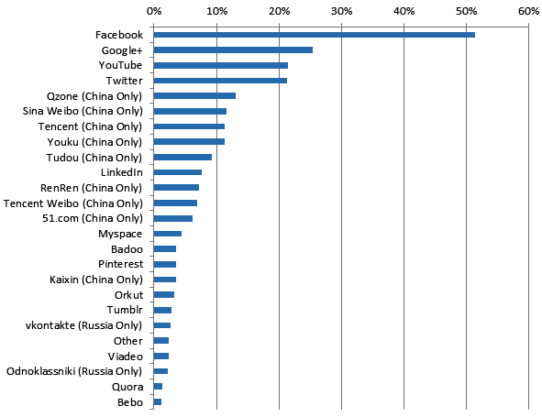
Figure 5: Percentage (%) of global internet users by GlobalWebIndex 2013
Regarding the importance of social networks in the global network data analysis, we have collected and studied three small sets of social data (Facebook, twitter and Google+). The first data set study an undirected graph of a Facebook group of 104 members, the second data set study directed twitter graph of 76 members and the third study anundirected graph of a Google+ group network of 61 members. In a big part of the dataset, we tried to gather the same people that share accounts in different networks.
We applied first applied one of the traditional tools, Gephi 0.8.2 to analyze each of the networks alone to get the centrality results.
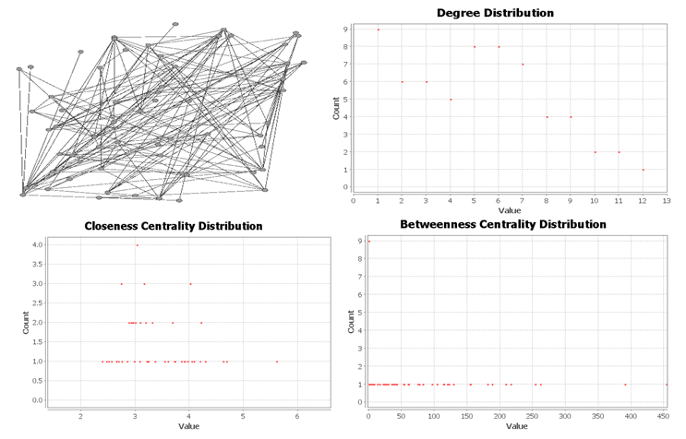
Figure 6: Centrality measure and graph of the Google+ group
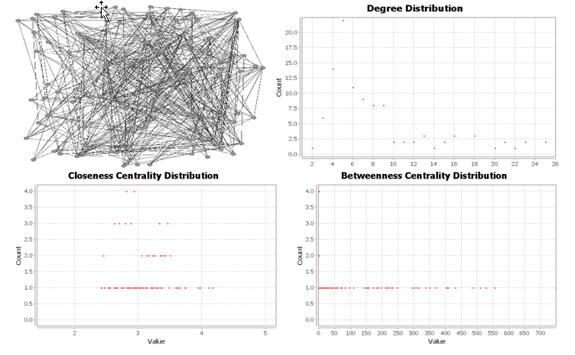
Figure 7: Centrality measure and graph of Facebook group
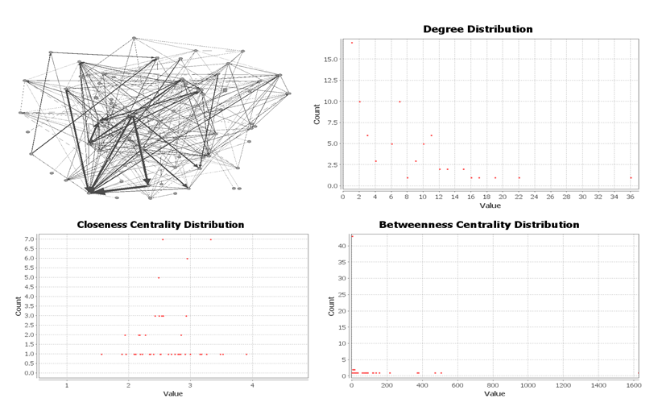
Figure 8: Centrality measure and graph of a Twitter group
Figure 6, 7, 8 present the result of analyzing the studied social network groups respectively Google+, Facebook then Twitter group. The top left diagram shows the connections between nodes through networks. The top right scatter diagram shows the degree distribution over the group. The bottom left scatter diagram shows the Closeness centrality distribution over the group. The bottom right scatter diagram shows the betweeness centrality distribution over the group.
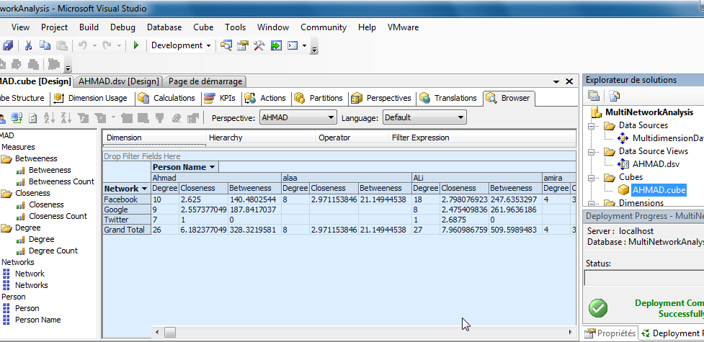
Figure 9: Building data warehouse using Microsoft SQL business intelligence studioand SQL server 2008
Figure 9 shows how to apply the traditional multidimensional database on multi-Networks. First we extract the centrality measures from the given graphs using specific Java codes and this step is similar to the extraction stage in the OLTP (Online Transaction Processing). The second step is summarized by building the Multidatabase schema for the networks using the SQL server 2008 operations. Then, we custom this database as a data source to build the required Cube measures and dimensions using the SQL business intelligence studio. Now we can apply simultaneously on multiple networks all the OLAP (OLAP) operations on the obtained cube and several data mining algorithms such as: Decision Tree, Clustering, Association Rules and Neural Network.
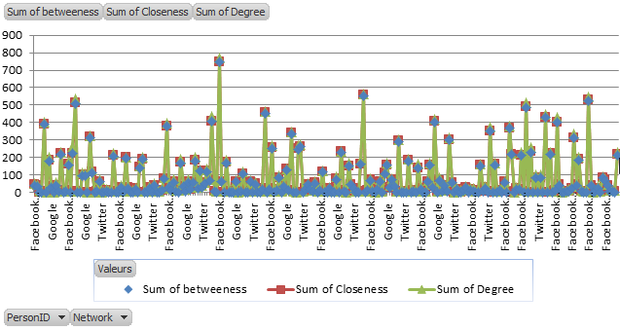
Figure 10: Line Chart of the Multi-Network centrality measures
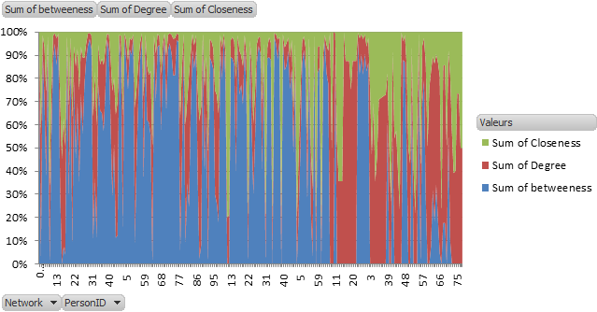
Figure 11: Area Chart reflects the centrality measure distributionover the three networks at the same time
In to obtain a visual analytical report about the obtained multidimensional database, we have imported the obtained cube in the SQL business intelligence studioto the Microsoft Excel 2012. Figure 10 shows a line Chart of the distribution of the centrality measures as a function of the network name. Figure 11 shows in an area chart the distribution of centrality measures as a function of both networks and node id. The above results give an idea about how analysis can benefit from the simultaneous multi-network analysis. But this is not everything, in fact the analyzer now can apply several queries which cannot be achieved when analyzing each network alone for example:
- Give the name of the person who has the highest degree centrality in all his social network services (the answer is “Sara” in our example).
- Give the name of the most important (according to centrality measure) person through all the social network services (the answer is “Cravatte” according to the Freeman measure).
- Give the name of the person who has a centrality degree greater than 5 in a all his social network services (the answer is : “Zephine”).
- Give the number of friends that the most important person has through all his social network services (the answer is “55”).
- BENEFITS & FACILITIES
The proposed model in this article achieved a multidimensional database for three measures of network analysis and it can be extended to all the network analysis measures. By the time the large amount of a network’s data will make hard to analyze the database, thus a bigdata warehouse can be achievedwhich deals with the large storage analysis. The Data warehouse (with its steps extract, transform and load) facilitates reporting and analysis and provides access to structured and unstructured information and operational and transactional data in real time. The obtained data warehouse allows the analyzer to access the multi-Network data and answers such plain-language questions as "What happened?" and "Why?" on a multiple graphs events and he can predict what may happen based on strong analytical results. To show the importance of the proposed way of analysis in the network graph domain, we will show two real examples where the multi-network graph data warehouse is useful. The first example is the way of analyzing the US elections 2012 example. The main challenge was to circumscribe Web content (Web sites, RSS feeds, tweets) coming from the States under scrutiny (Semeon, 2012). The analysis team had collected information from the social networks (multiple networks) over three months before the election. In fact a complete multi-network graph data warehouse, that study all analysis measure, gives the permission to analyze such election information permanently at any time with no need to form a specific instantaneous team to study a small period of time. The second example is related to Bioinformatics, the Alzheimer’s Disease. It is a widespread disease that affects the patient memory and needs a permanent watch on the patient activities. Some proposed technologies reminds the forgotten activities by the patients during the daily life. These technologies depend on a group of smart sensors that record the patient’s daily activities. Every sensor recognizes the patient as an object and returns an activity network that reflects how he deals with the other objects (people, machines,… etc.). But each environment has its special returned activity network and to give a unique solution suitable for all environments, the scientists keep analyzing multiple networks but not simultaneously. Thus, the solution is to map all the returned activity networks (as a multià-network graph) from sensors into a data warehouse to keep on online analysis and reasoning of the patient motion.
- CONCLUSION
Nowadays, Web researches apply big efforts to convert the information retrieval web (Web 2.0) into a semantic Web (Web3.0). Through these works the Web is rearranged according to new notions. One of the new concepts of Web3.0 is the personalization, with all its requirements as search by person or user account aggregation. Indeed, every Web user has several Web accounts (social, business, study, … etc.). If all the networks of these accounts are treated as one side, without affecting the special characteristics of each network, then a multi-network graph of Web account is achieved for every user. Also, if the idea is observed from the network analysis view, it seems harder to analyze multi-networks concurrently. To solve this problem we have proposed, in this article, a novel model that maps a multi-networks graphs into a multidimensional database. To validate our idea, we applied our model on some network analysis measures, the Centrality measures: degree centrality, Closeness and betweeness. Then we discussed a simulation about analyzing three social networks simultinously. As a future work, we will expand this model to cover ontology idea and apply it on real complex networks such as Bioinformatics networks.
ACKNOWLEDGEMENT
This work is supported by the Department of computer science at the University of Quebec at Chicoutimi, Quebec, Canada, the Ecole Doctorale des Sciences et de Technologie at the Lebanese University and the AZM association.
REFERENCES
Wararat, J., Cécile, F., and Sabine, L., 2013. OLAP on Information Networks: a new Framework for Dealing with Bibliographic Data, 1st International Workshop on Social Business Intelligence (SoBI 2013), Genoa, Italy.
Daihee, P., Jaehak, Y., and Jun-Sang, P., 2013. NetCube: a comprehensive network traffic analysis model based on multidimensional OLAP data cube, International Journal of Network Management, Volume 23, Issue 2, pages 101–118
eMarketer report, 2013. Worldwide Social Network Users: 2013 Forecast and Comparative Estimates.
Alkis Papadopoullos, 2012. CASE STUDYSocial Network Analysis of the2012 US Elections, Chief Technology Officer, Semeon.
Mu, Y., Bin, W., and Zengfeng, Z., 2012. HMGraph OLAP: a novel framework for multi-dimensional heterogeneous network analysis, DOLAP’12 Proceedings of the fifteenth international workshop on Data warehousing and OLAP, Pages 137-144
Cisco IBSG. The Internet of Things: How the Next Evolution of the Internet Is Changing Everything,”, 2011
Manuel, F., Catherine, P., Ben, S., Jen, G., 2010. ManyNets: An Interface forMultiple Network Analysis and Visualization, ACM CHI.
Tore, O., Filip, A., John, S., 2010. Node centrality in weighted networks: Generalizing degree and shortest paths, Elsevier, Social Networks, Volume 32, Issue 3, July 2010, Pages 245–251
Chen, C., Yan, X., Feida, Z., Jiawei, H., 2008. Graph OLAP: Towards Online Analytical Processing on Graphs, Data Mining, 2008. ICDM '08. Eighth IEEE International Conference, Pisa, DOI:10.1109/ICDM.2008.30, Pages 103 – 112
Brandes, U., Erlebach, T., 2005. Network Analysis, Lecture note in Computer Science, Springer, Theoretical computer science, Vol.3418, ISBN 978-3-540-24979-5.
Peter Mika, 2005. Flink: Semantic Web technology for the extraction and analysis of social networks, Journal of Semantic Web, The Netherlands, doi:10.1016/j.Websem.2005.05.006.
Elizabeth, C., &Thomas, W., V., 2004. The stability of centrality measures when networks are sampled, Elsevier, Social Networks, Volume 25, Issue 4, October 2003, Pages 283–307
Eirinaki M., and Vazirgiannis M., 2003. Web Mining for Web Personalization, ACM Transactions on Internet Technology, 3(1) (2003) 1-27
Ulrik Brandes, 2001. A faster algorithm for Betweenness centrality, The Journal of Mathematical Sociology, Volume 25, Issue 2, DOI: 10.1080/0022250X.2001.9990249, pages 163-177.
Mobasher, B., Cooley, R., Srivastava, J., 2000. Automatic personalization based on web usagemining. Commun. ACM 43(8) (2000) 142–151
Bonacich, P., 1987. Power and centrality: a family of measures. American Journal of Sociology 92, 1170–1182.
Bonacich, P., 1991. Simultaneous group and individual centralities. Social Networks 13, 155–168.
Freeman, L.C., Borgatti, S.P., White, D.R., 1991. Centrality in valued graphs: a measure of Betweenness based on network ﬂow. Social Networks 13, 141–154.
Friedkin, N.E., 1991. Theoretical foundations for centrality measures. American Journal of Sociology 96,1478–1504.
Xi-Nian, Z., Ross, E., Maarten, M., Davide, I., FXavier, C., Olaf, S., Michael, P., M., 2012. Network Centrality in the Human Functional Connectome, Oxford Journals, Life Sciences & Medicine, Cerebral Cortex, Volume 22, Issue 8, Pp. 1862-1875.
Freeman, L.C., 1979. Centrality in networks: I. Conceptual clariﬁcation. Social Networks 1, 215–239.
Hoede, C. 1978. A new status score for actors in a social network. Department of Mathematics, Twente University, unpublished manuscript.
Chen, P., 1976. The Entity-Relationship Model-Toward a Unified View of Data, ACM Transactions on Database Systems, Vol. 1, No. 1. March 1976, Pages 9-36.
Taylor, M., 1969. Inﬂuence structures. Sociometry 32, 490–502.
Hubbell, C.H., 1965. An input–output approach to clique identiﬁcation. Sociometry 28, 377–399.
Katz, L., 1953. A new index derived from sociometric data analysis. Psychometrika 18, 39–43.

