UTILIZATION OF ARTIFICIAL NEURAL NETWORK TO ANALYZE AND PREDICT THE INFLUENCE OF DIFFERENT PARAMETERS ON ANODE PROPERTIES

Duygu Kocaefe ¹, Arunima Sarkar ¹, Ying Lu ¹, Dipankar Bhattacharyay ¹, Yasar Kocaefe¹,
Brigitte Morais²

¹University of Québec at Chicoutimi, Dept. of Applied Sciences, 555, boul. De l’Université,
Chicoutimi, Québec, Canada G7H 2B1

²Aluminerie Alouette Inc., 400, Chemin de la Pointe-Noire, C.P. 1650,
Sept-Îles, Québec, Canada, G4R 5M9

Duygu_Kocaefe@uqac.ca
arunima.sarkar@uqac.ca
ying.lu1@uqac.ca
Dipankar_Bhattacharyay@uqac.ca

Yasar_Kocaefe@uqac.ca
brigitte.morais@alouette.qc.ca

Abstract

Carbon anode is an important component of the electrolytic production of primary aluminum. Anodes are made of dry aggregates (calcined petroleum coke, butts and recycled green and baked anodes) and the binder coal tar pitch. The production of anodes involves the mixing of the raw materials, the compaction of the paste, and the baking of green anodes to produce baked anodes with appropriate properties.

An anode property is influenced by the quality of raw materials and the process conditions. It is usually difficult to correlate a given anode property with a particular constituent of a raw material or a particular processing condition because of the lack of a well-established mathematical relationship available for such a correlation. In these cases, the artificial neural network (ANN) can be a useful predictive tool to analyze the effect of a variable on a desired anode property. The analysis provides an insight into the effect of different parameters on anode properties and, in turn, helps improve the quality of anodes.

In this article, the ANN approach will be discussed within the context of the analysis of the data on anode production. The results will be presented which show the application of the ANN methods to predict various anode properties.

Keywords: artificial neural network, carbon anodes, data analysis, predictive tools

Introduction

Many challenges the anode industry is facing today such as carbon consumption, greenhouse emissions, energy consumption, cell performance, and production cost are strongly associated with carbon anode quality.

Anodes are produced using dry aggregates such as fresh calcined petroleum coke and recyclables (e.g. butts, rejected green and baked anodes), and coal tar pitch which is used as the binder. The variations in the quality (properties) of the raw materials as well as the operating conditions in different stages of the process (such as mixing, compacting, cooling, and baking) influence the quality of anodes to a great extent. Maintaining or improving the anode quality in spite of the variations in the raw material quality and process conditions is one of the preoccupation of the aluminum industry. However, lack of well-defined mathematical relationships between the physical and chemical properties of raw materials, process conditions and anode properties makes the achievement of this objective challenging.

In addition, it is also difficult to study the effect of an individual raw material property on a specific anode property even in the laboratory. For example, to study the effect of sulfur, it is not possible to obtain cokes with different sulfur contents while keeping the other properties of the cokes the same. Usually, cokes with different sulfur contents have also different metallic impurity contents, and this makes it difficult to understand the effect of sulfur only. The experiments are costly, time consuming and require extensive handling. For such cases, a trained and validated ANN model is a useful tool which can give a faster response and can be improved continuously with additional data. The plants can operate in batch or continuous fashion whereas laboratory equipment is usually run in batch mode. Even if it is possible to obtain pilot anodes with properties similar to those of the industrial anodes in a few laboratories around the world, it is still not possible to study the effect of all the process parameters on anode quality. For example, it is not possible to optimize the operating conditions of continuous kneader in a laboratory environment. In addition, some of the process parameters are controlled based on experience and intuition in industry. The plants have a large amount of data on raw material properties, process conditions, and the properties of anodes produced. Therefore, the development of a tool which can determine the relationship between these parameters and the anode quality will be very beneficial for adjusting the process conditions depending on the available raw material in order to keep the anode properties within an acceptable range.

Multivariable analysis techniques such as linear multivariable analysis, regression analysis, and regression tree are some of the commonly used techniques to study the effect of input parameters on the output properties. Linear multivariable and regression analyses require the assumption of well-defined mathematical relationships between the dependent and independent variables. Regression tree is a nonparametric approach to a regression problem. The threshold value for split is determined based on the minimization of the least-square regression error. Even though it does not necessitate any well-defined mathematical relationship, its drawback is that the threshold does not usually correspond to the optimal boundary for dividing the input parameters in each stage [1]. Thus, its predictions are not very accurate most of the time. As there is usually no well-defined mathematical relationship between the input variables and the anode properties, it is hard to predict changes in anode properties using analytical tools.

In the case of anodes, it is difficult to apply the conventional methods as the relationship between the parameters is complex and difficult to generalize. The limitations of the common multivariable analysis techniques have led researchers to explore the artificial intelligence tools such as artificial neural network (ANN). ANN processes information in a similar way the human brain does. The network is composed of a large number of highly interconnected processing elements, called neurons. Neural networks learn by example. The requirements for the implementation of ANN are a large set of experimental data, choice of the most suitable ANN model, proper training and learning algorithms. Available industrial data can be used for the training of an ANN model [2].

Though ANN finds extensive application in various research fields including quality control [3-11], few researchers have so far applied ANN to the primary aluminum production [12-15]. Only a few articles have been published [12,16] which are directly related to carbon anodes used for the production of primary aluminum. Thus, the potential of ANN in predicting anode properties needs to be explored. This will reduce the number of costly trials.
Berezin et al. [12] applied a perceptron-based ANN to maintain anode quality at OKSA aluminum plant in Russia. The perceptron-based ANN is the simplest ANN model which assumes that the output and the input parameters can be correlated with a single linear function only. The ANN model could predict and adjust variations in the production process for changing quality and quantity of raw materials. They utilized past data recorded by the plant. The ANN system was capable of determining the optimal parameters for the green anode production for a given raw material.

Bhattacharyay et al [16] compared ANN with linear multivariable and regression analyses and concluded that ANN is a better predictive tool than the other two methods. They used published data on the composition and the properties of carbon anodes.

The concept of ANN was first introduced by McCulloch and Pitts in 1943 [17]. ANN started to gain popularity with the introduction of the back-propagation training algorithm in 1980s. There are various ANN models such as perceptron [17], feed- forward [18], recurrent [19], radial basis function neural networks [20-22], etc. Out of these different models, multi-layered feed-forward ANN with back-propagation training is the most widely used one. The advantage of this model is that the feed-forward ANN with sigmoid transfer function [16] is considered as the universal function approximator [23]. Vega [24] also found that the back-propagation algorithm is an efficient pattern identifier. He also analyzed various sources of problems that one may face while handling an ANN model and found that most of the problems were associated with the poor selection of the learning rule and the ANN architecture, the sizes of the training and validation data sets, overtraining, noise on the pattern identification ability, etc. Presently, there are no formal rules available to develop an ANN model [25].

In this paper, the application of ANN models to predict (a) contact angles between coke and pitch as a function of some pitch properties, (b) aggregate density as a function of granulometry of coke, and (c) anode CO₂ reactivity as a function of impurities is presented.

Methodology

A feed-forward network usually consists of three layers of neurons, namely, an input layer, a hidden layer, and an output layer. The network sends information sequentially from the input layer to the output layer. The hidden layer may consist of one or more layers. Different numbers of neurons and transfer functions are associated to each of the hidden layers. The transfer functions process the input to a layer such that the output can be classified into groups of similar data. Initially, some random weights are associated with the input parameters for each layer. The training of a neural network means the identification of optimum values of these weights. Levenberg-Marquardt training algorithm (LMTA) is preferred by many researchers. The LMTA interpolates between the Gauss–Newton algorithm and the method of gradient descent. The advantage of LMTA is that it can usually find a solution even if it starts very far off the final minimum error. LMTA is used to solve non-linear least squares problems. To implement the least square method to experimental data, it uses a parametric function. By using the least square method, it tries to find the values of the parameters such that the total squared error between the measured and calculated values is minimized. To find the values of the parameters, it has to initialize the parameters with appropriate values. The approach is similar to that of a gradient-descent method when the values of the parameters are far from their optimum values and to a Gauss-Newton method when the values of the parameters are close to the optimum values. Thus, it can minimize the error even if the initial values of the parameters are assumed far from the optimum values. Learning means pattern recognition and data classification. Gradient descent learning algorithms are usually used in many ANN models. The empirical risk measures the training set performance. Rumelhart et al. [26] proposed the use of gradient descent algorithm to minimize the empirical risk. Figure 1 shows a representative structure for feed-forward ANN.
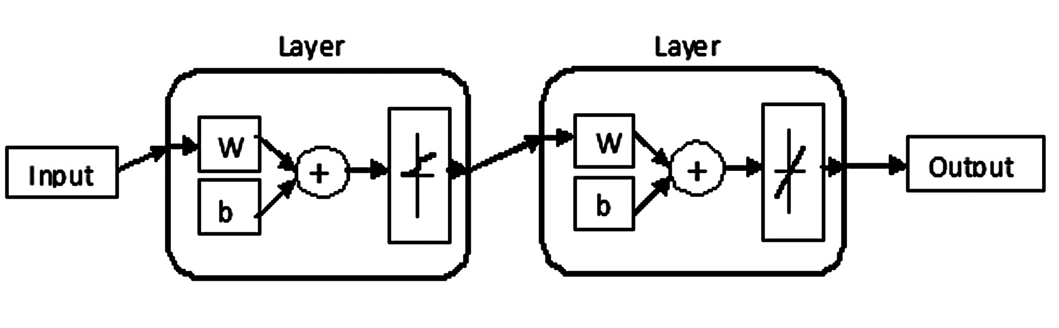Figure 1: Representative Structure for Feed-Forward ANN (w: weight; b: bias)
Data for the analysis

In this work, three different sets of data have been analyzed using different ANN models. First, the data obtained from wettability tests (contact angles) carried out in the laboratory utilizing the sessile drop method were used to study the effect of different properties of pitch on the wettability of coke by pitch. Second, the experiments were performed in the laboratory where granulometry of the dry aggregates were varied and the dry aggregate densities were measured. Third, the effect of sulfur, vanadium, sodium, nickel, and iron on the anode CO₂ reactivity has been studied using industrial data. These results were analyzed using ANN. All the presented data are normalized based on:

$\text{Normalized value}\text{ = }\frac{\text{Value to be Normalized - Minimum Value}}{\text{Maximum Value - Minimum Value}}$ [1]

Development of a neural network model

For all three cases, multilayered feed-forward ANN models with back-propagation training algorithm have been used. Matlab R2014a software was used to develop the ANN models. All the ANN models contain one input layer, two hidden layers and one output layer. The layers were connected as shown in Figure 1.

The transfer functions associated to the first and second hidden layers were sigmoidal and linear, respectively. The network uses values of weights and biases corresponding to each neuron in the hidden layers. Training of the network adjusts the weights and biases, and learning tries to identify patterns and classify the data. The training of the network was done using Levenberg-Marquardt training algorithm. Gradient descent learning algorithm was used as the learning function. The number of neurons in the hidden layers was varied until a suitable ANN model was found. Usually, this is done by trial and error. The number of epochs, which represents the maximum number of iterations during the training process, was set to a certain value that allows the network to carry out sufficient number of iterations to converge. The weights and biases were initialized using a pseudo-random function (available in the neural network toolbox) during the training phase.

Over-training may be detrimental for the prediction capability of a neural network. The validation data set was used to minimize over-fitting. Partitioning of these training, validation, and testing data sets (training / validation - testing: 80% / 10% / 10% of data, respectively) were done on a random basis [27]. The testing data set was used only to test the final solution in order to assess the actual predictive power of the network and take necessary action to improve the predictive ability.

In all three cases studied, the final model was validated using a set of data with a known output which was not used in the training phase. The validation was done by calculating the regression coefficient for the predicted output of the model with respect to the experimental results. The models for which the regression coefficients were close to 1 were considered suitable.

To study the effect of one single parameter, the neural network model was applied to a set of input data where only that parameter has been changed keeping all other parameters constant.

Results and Discussion

Effect of QI on the Wettabilty of Coke by Pitch

The wettability of a petroleum coke by different pitches with different quinoline insolubles (QI), beta resins (BR=QI-TI where TI is the toluene insoluble), and coking values (CV) were studied using the sessile-drop method (see Sarkar et al. [28] for the details of the sessile-drop test). The wettability of coke by pitch is measured in terms of contact angle. As the contact angle decreases, the wettability increases. For all the experiments, the same petroleum coke was used. Table 1 shows the normalized properties of the pitches used.

Table 1: Normalized Pitch Properties

Pitch | Normalized QI | Normalized TI | Normalized Beta Resins | Normalized CV
P1 | 0.00 | 0.00 | 0.43 | 0.00
P2 | 0.23 | 0.30 | 1.00 | 0.30
P3 | 0.38 | 0.44 | 0.86 | 0.57
P4 | 1.00 | 1.00 | 0.00 | 1.00
P5* | 0.84 | 0.86 | 0.21 | 0.89
P6 | 0.53 | 0.58 | 0.64 | 0.67
P7 | 0.27 | 0.33 | 0.97 | 0.37
P8 | 0.34 | 0.40 | 0.90 | 0.50
P9 | 0.09 | 0.11 | 0.54 | 0.14
P10 | 0.25 | 0.25 | 0.33 | 0.25
P11 | 0.75 | 0.75 | 0.11 | 0.75
*Data used for validation.

The change in contact angle was measured with respect to time. Each experiment was repeated twice. The experimental error for the contact angle measurements was ±5º. The average of the contact angles of these two experiments were plotted against time. The contact angles measured for different pitches at a certain time, which corresponds approximately to a residence time of an average industrial mixer, were used to train the ANN model. Figure 2 shows the contact angles used for each pitch studied.

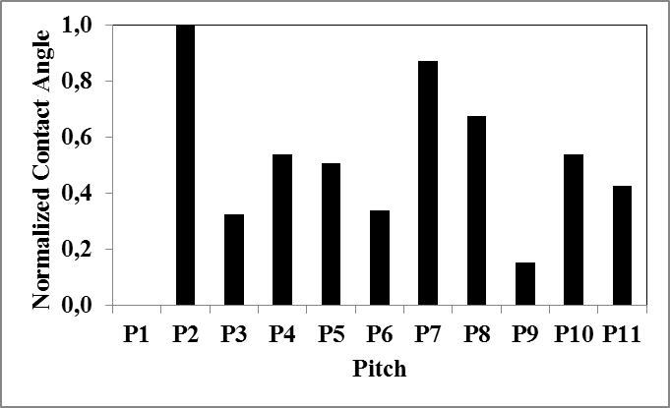
Figure 2: Normalized Experimental Contact Angles for Different Pitches

The ANN model was developed as described earlier. All the initialization parameters were set based on trial and error. Ten points were used to train the model and 1 point was used for validation (Figure 3). Three input variables (QI, BR, and CV) were used. TI can be calculated from beta resins and QI values. Due to the small number of data available for this case, the model validation was based on a correlation coefficient R² for all the 10 points and the tolerance of predicted and experimental values which was set to ±2º. The R² was 0.915. The percentage of points within ±2º was 72%. The experimental work is continuing for this case. As the new experimental data become available, the model will be trained further and validated with the new data.

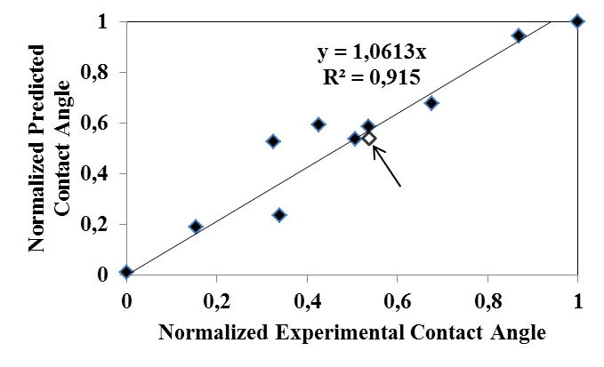
Data used for training
Figure 3: Normalized Predicted vs. Experimental Contact Angles

There are conflicting views in the literature regarding the effect of QI on wetting [29]. Some researchers reported that wetting increases with increasing QI [30, 31] while some others found the reverse trend [32,33] or no correlation at all between QI and the wettability of coke by pitch [34]. The reason for the differences of opinion of different researchers is quite likely due to the fact that when the effect of QI is studied, the pitches used with different QI’s most probably had differences in other properties such as CV, BR, etc. However, it is possible to study the effect of each parameter individually with an ANN model which is one of the major advantages of this approach. The examples of the results, which are obtained using the ANN model developed during this work, are shown below.

Figure 4 presents the results of the ANN model showing the effect of QI on the contact angle when CV and BR are kept constant. As can be seen from this figure, the wettability decreases (contact angle increases) with increasing QI. When the pitch has a high QI content, QI contains higher quantity of larger particles compared to those of the pitch with low QI content. The decrease in wettability can be attributed to the impact of the formation of a filter cake on the surface of the coke particles by the large particles of the high-QI pitch. This layer prevents the penetration of pitch into the pores of the coke [29].

In this figure, there are three curves, each of which was obtained at constant CV and BR. For the curves 1 and 2 with the same BR and different CV values, it can be seen that wettability increases with increasing CV at any given QI. This can be explained as follows. CV increases with the increasing number of molecules with higher carbon to hydrogen ratio (aromatics). Thus, the increase in CV corresponds to the increase in aromatic content. The presence of aromatics can improve wetting through electrostatic interactions due to their pi electron cloud.

Usually, BR improves the wetting as well [35]. They contain medium-size molecules which include aromatic as well as branched chains (heteroatoms containing functional groups). The interaction of the side chains, functional groups, and the aromatic content may have some complex influence on wetting. The ANN model shows that, at high QI region (right hand side of the figure), an increase in BR increases (curves 2 and 3) the wettability of coke by pitch. At low QI content (left hand side of the figure), the wettability of pitch is similar for pitches with different BR content. On the low QI side, the amount of particles in QI is less, which does not prevent the penetration of pitch into the coke. Therefore, wetting is rapid. When QI is high, the effect of BR becomes more prominent.
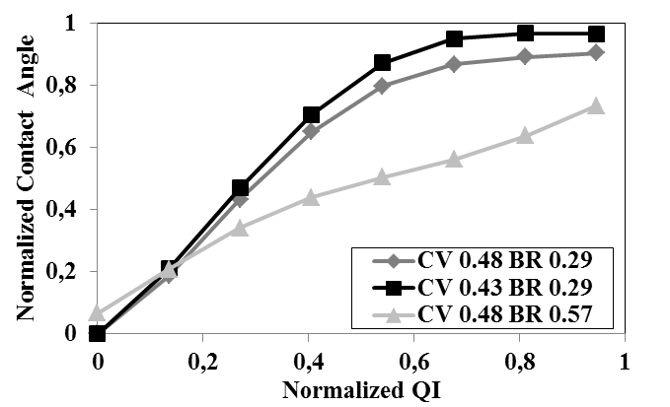
3
2
1
Figure 4: Effect of QI on Contact Angle Predicted with ANN

Dell [36] reported that CV is an indirect measure of aromaticity. Thus, an increase in CV, which is usually accompanied by an increase in QI, corresponds to increased aromatic content [36]. This makes it difficult to study the effect of CV on wetting at constant QI and BR content experimentally. However, this is possible with ANN, and the model results show that increase in CV (at constant QI) improves wetting (Figure 5). This can be explained in terms of the increase in the aromatic content of pitch while the size distribution of the molecules stays similar. For constant BR and CV, if QI increases, then the wettability of pitch decreases (curves 1 and 2 in Figure 5).
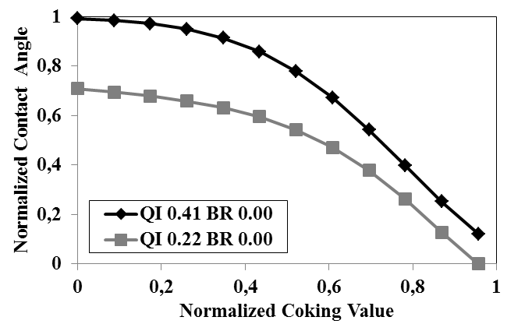
2
1
Figure 5: Effect of CV on Contact Angle Predicted with ANN

Figure 6 presents the effect of BR on the contact angle, hence, on the wetting capacity of pitch. Different experimental results are reported in the literature. Mirchi et al. [34] didn’t find any correlation with the BR content and the wetting. Oye [37] suggested that BR affect the wetting but did not mentioned if this effect is positive or negative. Julien Lauzon-Gauthier [35] revealed that wetting improves with increasing BR content. This is explained by a number of researchers [35,38-39] with the presence of high molecular weight aromatics.

The ANN model shows that, at constant QI and CV, an increase in BR results in a decrease in the contact angle (better wetting) up to a certain value of BR (Figure 6). It is possible that the presence of heteroatoms and medium-size aromatic molecules increases in this region with increasing BR. Heteroatoms such as oxygen and nitrogen can help the formation of covalent bonds and improve wetting [28]. Also, the presence of medium-size aromatic molecules facilitate the electrostatic interactions thereby enhance wetting.

Further increase in BR seems to reduce the wetting (Figure 6). At higher BR content, it is probable that the amount of larger molecules increases. As CV and QI are constant, it is also possible that the aromatic content in pitch does not change significantly but the size of branched chains attached to aromatics might increase. These large molecules with branched chains may reduce wetting due to steric hindrances. The effect of the increase in heteroatoms may have been offset by the steric hindrances offered by the large molecules.

With a decrease in QI content at a given BR (curves 1 and 2 in Figure 6), the contact angle decreases. This again can be explained with the obstruction of pitch penetration into the coke pores by the large QI particles. The general tendency observed with ANN might explain why certain researchers couldn’t establish a relation between BR and contact angle while others observed improved wetting with increasing BR.

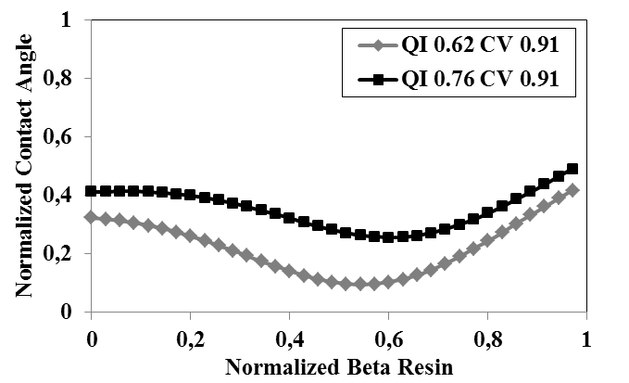
1
2
Figure 6: Effect of BR on Contact Angle Predicted with ANN

Prediction of Dry Aggregate Density from Granulometry

The carbon anodes are made of pitch as binder and dry aggregate (coke, butts, and recycled anodes) as filler material. Granulometry of the dry aggregates is one of the key parameters that control the anode properties. The raw material properties change continuously. It is difficult to do experiments every time to find the suitable granulometry corresponding to a desired dry aggregate density. The objective of this work is to develop an ANN model that can predict dry aggregate density for different granulometry without performing numerous experiments. To develop the model, a number of experiments were performed, and the tapped densities of dry aggregates with known granulometry were measured. The results were used to train the artificial neural network. The percentage of recycled anodes in an anode recipe usually does not significantly vary. In addition, this percentage is usually low and can be obtained as the difference between the total (100%) and the sum of the percentages of other granulometries. Therefore, the percent of green and baked recycled anodes was not used to train the ANN model. Different size fractions of fresh coke and butts as well as the percentages of ball mill product and filter dust were used as the input parameters, and the dry aggregate density was the output parameter.

A multilayered feed-forward ANN model which can correlate the granulometry with the aggregate density was developed based on trial and error. The structure of the network was similar to the one described earlier. The prediction of the network was verified not only on the basis of R² value of the plot of the predicted vs. experimental results, but also on the percentage of correct prediction within a range of ±0.01g/cc. The R² value for the predicted vs. experimental results was found 0.935 by means of a linear trend line, and the percentage of correct predictions within the range of ±0.01g/cc was 93%. The percentages of over and under predictions were 2.32% and 4.66%, respectively. The accuracy of the model can be improved if more data are available for training. Figure 7 shows the data used during the model development.

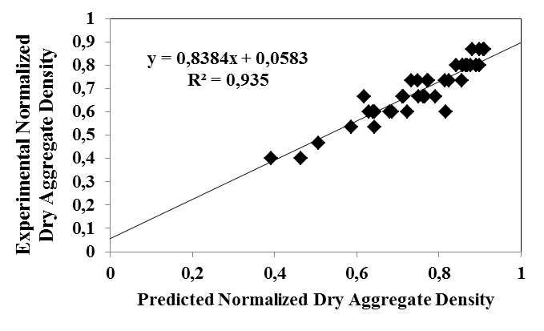
Figure 7: Data Used During the Development of the ANN Model to Predict the Aggregate Density

The ANN model developed can be utilized to determine the granulometry required to obtain a desired tapped density of an aggregate. It is possible to vary the percentages of all the different size fractions which can yield a desired range of dry aggregate density. However, this may lead to a large number of combinations with different granulometry. To demonstrate the application of the model here, only the percentages of 3 particle sizes (described as a, b, and c in decreasing order in size) of fresh coke were varied keeping all other parameters constant. Then, the aggregate densities corresponding to the granulometries were predicted. The percentage of green and baked recycled anodes was not used as input parameter but it was also calculated for each case by subtracting the sum of all other components from 100%. The objective was set to find the granulometric distributions corresponding to aggregate densities of 1.14 g/cc and higher. Table 2 shows the percentages of particle sizes considered which gave desired aggregate densities using ANN model developed.

Table 2: Different Granulometric Distributions for Dry Aggregate Densities Higher than 1.14 g/cc Predicted with ANN

Fresh coke |  |  | Recycled anode, % | Density, g/cc
a,  % | b,  % | c,  %
5.72 | 5.27 | 9.42 | 7.92 | 1.145
3.72 | 7.77 | 9.42 | 7.42 | 1.143
1.72 | 12.77 | 9.42 | 4.42 | 1.147
9.72 | 0.27 | 11.42 | 6.92 | 1.144
7.72 | 2.77 | 11.42 | 6.42 | 1.143
5.72 | 5.27 | 11.42 | 5.92 | 1.142
3.72 | 7.77 | 11.42 | 5.42 | 1.141
3.72 | 10.27 | 11.42 | 2.92 | 1.148
1.72 | 12.77 | 11.42 | 2.42 | 1.143

Effect of Different Impurities on CO₂ Reactivity of Anodes

Carbon, required for the reduction of alumina by electrolysis in the Hall-Héroult process, is provided by anodes. The minimum theoretical carbon consumption is 0.334 kg C per kg Al produced. However, the actual carbon consumption is much higher due to current efficiency and losses caused by the reaction with air and CO₂. The minimization of this excess consumption of anodes by means of improving their quality is a key industrial goal. This requires an understanding of the effect of different impurities on the reactivity of anodes.

It is difficult to study the effect of a single impurity as it is not possible to modify the quantity of a single impurity at a time by changing the quantity and type of raw materials. It is also difficult to add chemical impurities which represent the impurities present in the raw material in their natural state. In such cases, ANN can be a useful tool to study the effect of different impurities on anode CO₂ or air reactivities since it is possible to vary a single impurity content keeping all other components constant in such a model.

In this work, industrial data on impurities present in baked anode samples and the CO₂ reactivities of these samples were used to develop an ANN model. In the two previous examples given above, the data obtained with one type of coke was used in the development of the ANN models. In this case, due to the nature of various industrial raw materials used at different times, the data include different types of cokes. A feed-forward ANN model with back-propagation training was developed similar to the model described above. The model was initialized based on trial and error. The predictions of the model were found to be 84% accurate within a range of ± 2.5 mg/cm²h. The effect of vanadium (V), sodium (Na), nickel (Ni) and iron (Fe) on anode CO₂ reactivity has been presented here. The effects of these impurities were studied for four different combinations of sulfur percentages (S%) and baked anode densities (see Table 3). All other parameters were kept constant. When the influence of one of the four impurities was studied, the percentages of the other three impurities were maintained at their average values.

Table 3: Combinations of S% and Baked Anode Density

Case | % S | Baked Anode Density
HSHD | High | High
HSLD | High | Low
LSHD | Low | High
LSLD | Low | Low

Figures 8 to 11 show the effect of different impurities on the CO₂ reactivity of baked anodes. The results for all four impurities studied here with ANN show that the anode CO₂ reactivity is low for high S% and the reverse trend was observed for low S%. It was also observed that the reactivity is usually low if the density of anode is high for similar S%. This may be due to the fact that high density anodes have lower porosity compared to low density anodes. This slows down the diffusion of CO₂ into the anode and its subsequent reaction with anode carbon.

As shown in Figure 8, the effect of density is the most prominent in case of V compared to those of the other impurities studied (Figures 9 to 11). If the density is high, increase in V content seems to even decrease the CO₂ reactivity. As explained previously, V cannot come in contact with CO₂ easily when the density is high; therefore, it cannot readily catalyze the reaction. In addition, it is known that correlating V content to anode reactivity is not straightforward and presents challenges for the industry. This trend has to be further verified with more plant data. Additional data for the ANN model training will increase the accuracy of the model.
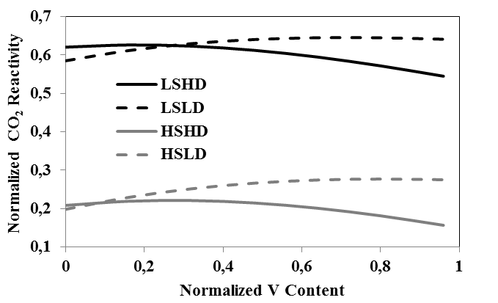
Figure 8: Effect of V Content on CO₂ Reactivity of Baked Anodes Predicted with ANN

Na seems to always catalyze the CO₂ reactivity of both high and low density anodes (Figure 9). However, the effect of Na on reactivity decreases with increasing S content. This might be explained with the offsetting effect of sulfur on the reactivity, and it is in agreement with the literature. Hume [40] reported that S inhibits the CO₂ reactivity of petroleum coke by forming a stable non-mobile complex with Na.

For low S%, the relation between the CO₂ reactivity and the Na content was found to be similar for both high and low-density baked anodes, showing that the effect of density is not significant when the sulfur content is low.

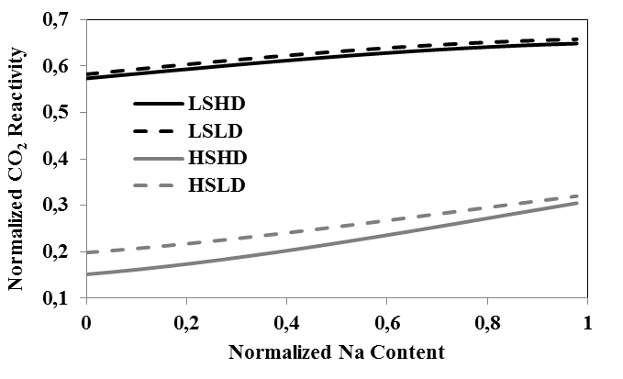
Figure 9: Effect of Na Content on CO₂ Reactivity of Baked Anodes Predicted with ANN

The catalytic activity of Ni appears to be influenced significantly by the presence of S. The effect of Ni on CO₂ reactivity decreases with increasing S content of anodes (Figure 10). Usually, the amount of Ni is low in anodes. At high S content, Ni possibly gets deactivated due to the formation of covalent bonds with S compounds; hence, increasing Ni content does not increase the CO₂ reactivity. At low sulfur content, Ni, being a transition metal, helps increase the CO₂ reactivity. When S% is high, the reactivity of high density anode is lower than that of the low density anode as expected. However, for low S%, density does not seem to affect the reactivity which was also observed for Na.

Figure 10: Effect of Ni Content on CO₂ Reactivity of Baked Anodes Predicted with ANN

The effect of Fe on the CO₂ reactivity displayed the opposite trend (Figure 11) compared to that observed for Ni (Figure 10). It seems that sulfur assists the catalytic activity of Fe. The reason has been investigated by Eidet et al. [41]. They observed that Fe can exist in different forms in coke. During the baking of anode, most of the Fe forms get converted to metallic Fe. Only FeS remains as is during baking. They observed that when baked anodes are heated to 960ºC in the electrolytic bath, FeS can break and produce active Fe catalyst which in turn increases the anode CO₂ reactivity. It is possible that at various stages of baking, which is done in absence of oxygen rather in a reducing atmosphere of carbon, different forms of iron compounds break depending on the stability of the compound to produce active iron metal. But, during the baking process, these iron molecules react with other compounds and lose their reactivity. When the baked anode is placed in the electrolytic bath at high temperature, a certain fraction of FeS, which was thermally treated once during baking, may break to form metallic iron that stays in active form and acts as a catalyst. The percentage of FeS which produces the active iron catalyst should be proportional to the total FeS content. Thus, when the S content is high, there is more chance of the presence of FeS that can catalyze the CO₂ reactivity. It might be possible that there is not enough FeS to form active Fe at low S%.

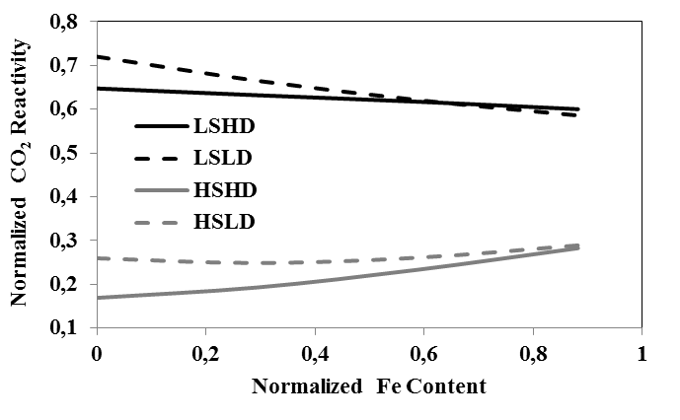
Figure 11: Effect of Fe Content on CO₂ Reactivity of Baked Anodes Predicted with ANN

The effect of Ni and Fe on anode reactivity is complex. According to the literature, the effect of Ni content can influence the effect of Fe on anode reactivity. The reverse is also reported. Baker et al. [42] found a significant increase in catalytic activity of the binary system of Ni and Fe over the activity of either individual element. In the above analysis, the effect of one impurity was studied keeping the other constant. Their combined affect can also be studied with ANN if more data are available.

Conclusions

ANN model with proper learning and training algorithms can be an effective tool for predicting the final anode properties as the raw material properties and/or process conditions change. The accuracy of the model depends on the available data used for training and validating the model. The aluminum plants have vast amounts of data. Utilization of these data in the development of such a tool will help the industry maintain the anode quality in spite of the variations in compositions of raw materials and the process conditions.

In this work, only chemical and physical properties of the raw materials available in literature were used to predict anode or coke properties to illustrate the potential of the model.

As demonstrated in the article, ANN modelling makes it possible to study the effect of one parameter on a given property while the others are kept constant. During this study, first the effects of QI, CV, and BR contents of pitch on contact angle were studied for a given coke. In an experimental study, different pitches have to be used in order to be able to investigate the effect of one of these pitch properties on the wettability of coke by pitch. This will bring, at least to a certain extent, changes in other two properties since it is hard to find different pitches with only one different property while all the others remain constant. Thus, ANN can be used as an effective tool to study the effect of individual parameters on specific properties of raw materials or anodes. The ANN predictions also shed some light on the different findings reported in the literature related to the effect of pitch constituents on wetting. The changes in coke quality might affect the aggregate bulk density, which in turn affects the anode density. In the second application of ANN presented in this article, it is illustrated how such a model can be used to determine the granulometric distribution required to obtain a desired dry aggregate density.

The over-consumption of carbon due to anode reactivity and dusting is among the main concerns of the industry. The third and last application of the article demonstrates the effect of different impurities on the anode CO₂ reactivity in relation with the effect of anode density and the sulfur content. The results give possible reasons for some of the trends observed, which are hard to explain (such as decreasing reactivity with increasing vanadium content).

Acknowledgements

The technical and financial support of Aluminerie Alouette Inc. as well as the financial support of the National Science and Engineering Research Council of Canada (NSERC), Développement économique Sept-Îles, the University of Québec at Chicoutimi (UQAC), and the Foundation of the University of Québec at Chicoutimi (FUQAC) are greatly appreciated.

References

[1] T Tanaka, S Ohsuga, M Ali, Industrial and Engineering Applications of Artificial Intelligence and Expert Systems, Proceedings of the Ninth International Conference, Fukuoka, Japan, 1996, 547-552.
[2] J Milewski & K Świrski, Modelling the SOFC behaviours by artificial neural network, International Journal of Hydrogen Energy, 34(13), 2009, 5546-5553.

[3] C Bahlmann, G Heidemann & H Ritter, Artificial neural networks for automated quality control of textile seams, Pattern Recognition, 32(6), 1999, 1049-1060.

[4] T Parthiban, R Ravi & N Kalaiselvi, Exploration of artificial neural network [ANN] to predict the electrochemical characteristics of lithium-ion cells, Electrochimica Acta, 53(4), 2007, 1877-1882.

[5] G Q Shang, Application of BP neural network for predicting anode accuracy in ECM, International Symposium on formation Science and Engineering, 2, 2008, 428 – 432.

[6] R K Fruhwirth & A Filzwieser, Computational intelligence – neural computation in a copper refinery, EMC 2007, 1-14.

[7] C G Piuleac, M A Rodrigo, P Cañizares, S Curteanu & C Sáez, Ten steps modeling of electrolysis processes by using neural networks, Environmental Modelling & Software, 25(1), 2010, 74-81.

[8] G Pang, W Xu, X Zhai & J Zhou, Forecast and control of anode shape in electrochemical machining using neural network, Advances in Neural Networks, Lecture Notes in Computer Science, 3174, 2004, 262-268.
[9] L Wang, D Apelian, M Makhlouf & W Huang, Predicting compositions and properties of aluminum die casting alloys using artificial neural network, Metallurgical Science and Technology. 26(1), 2008, 16-21.

[10] Y S Bhagavatula, M T Bhagavatula & K S Dhathathreyan, Application of artificial neural network in performance prediction of PEM fuel cell, Int. J. Energy Res. 36(13), 2011, 1215-1225.

[11] M Ray, S Ganguly, M Das, S Datta, N R Bandyopadhyay & S M Hossain, Artificial neural network (ANN)-based model for in situ prediction of porosity of nanostructured porous silicon, Materials and Manufacturing Processes, 24(1), 2008, 83-87.

[12] A I Berezin, P V Polaykov, O O Rodnov, V A Klykov & V L Krylov VL, Improvement of green anodes quality on the basis of the neural network model of the carbon plant workshop, Light Metals, 2002, 605-608.

[13] P Biedler, L Banta, C Dai, R Love, C Tommey & J Berkow, Development of a state observer for an aluminum reduction cell, Light Metals, 2002, 1091-1098.

[14] A Meghlaoui, R T Bui, J Thibault, L Tikasz & R Santerre, Predictive control of aluminum electrolytic cells using neural networks, Metallurgical and Materials Transactions B, 29(5), 1998, 1007-1019 .

[15] K D Boadu & F K Omani, Adaptive control of feed in the Hall-Héroult cell using a neural network, JOM, 62(2), 2010, 32-36.

[16] D Bhattacharyay, D Kocaefe, Y Kocaefe, B Morrais & M Gagnon, Application of the artificial neural network (ANN) in predicting anode properties, Light Metals, 2013, 1189-1194.

[17] W S McCulloch & W Pitts, A logical calculus of ideas immanent in nervous activity, Bulletin of Mathematical Biophysics, 5, 1943, 115-133.

[18] M R Kaul, L Hill & C Walthall, Artificial neural network for corn and soybean yield prediction, Agricultural Systems, 85(1), 2005, 1-18.

[19] J T Connor, R D Martin & L E Atlas LE, Recurrent neural networks and robust times series prediction, IEEE Transactions on Neural Networks, 5(2), 1994, 240-254.

[20] Y Hayashi, J J Buckley & E Czogala, Fuzzy neural network with fuzzy signals and weights, International Joint Conference on Neural Networks. 2: 1992, 696-701.

[21] X Ya, Evolving artificial neural networks, Proceedings of the IEEE, 87(9): 1423-1447.

[22] Z R Yang, A novel radial basis function neural network for discriminant analysis, IEEE Transactions on Neural Networks, 17( 3), 2006, 604-612.

[23] H White, Artificial neural networks: approximation and learning theory (Blackwell, Cambridge, 1992).

[24] J J Vega, R Reynoso & H C Carrillo, Learning limits of an artificial neural network, Revista Mexicana de Física, 54 (1), 2008, 22-29.

[25] G Daqi & Y Genxing, Influences of variable scales and activation functions on the performance of multilayer feedforward neural networks, Pattern Recognition, 36, 2003, 869-878.

[26] D E Rumelhart, G E Hinton & R J Williams, Learning internal representations by error propagation. In Parallel distributed processing: Explorations in the microstructure of cognition, Volume I (Bradford Books, Cambridge, 1986).

[27] G Shmueli, N R Patel & P C Bruce, Data mining for business intelligence: concepts, techniques, and applications in Microsoft office excel with XLminer. 2nd. ed. (Wiley, New Jersey, 2007).

[28] A Sarkar, D Kocaefe, Y Kocaefe, D Sarkar, D Bhattacharyay & B Morais, Coke-pitch interactions during anode preparation, Fuel, 117(A), 2014, 598-607.

[29] R H Wombles & B Sadler, The effect of binder pitch quinolone insoluble content on aluminum anode physical properties, 8th Australasian Aluminium Smelting Technology Conference, Queensland, 2004, 119-146.

[30] R Gray & K Krupinski, Pitch production. Introduction to carbon technologies, 1997, 329-424.

[31] K Krupinski & J Windfelder, Effects of tar quinoline insolubles on manufactured carbon performance, Proc. Ironmaking Conference, 1992, 487-492.

[32] K Hulse, Anode manufacture – Raw materials, formulation and processing parameters, PhD Thesis, Univ. of Auckland, New Zealand, (R&D Carbon Ltd, Sierre, Switzerland), 2000.

[33]. W Roder, The future of coal tar pitch and alternative pitches for carbon electrodes, CIM Light Metals, 1998, 171-182.

[34] A Mirchi, G Savard, J P Tremblay & M Simard, Alcan characterization of pitch performance for pitch binder evaluation and process changes in an aluminium smelter, Light Metals, 2002, 525 -534.

[35] J L Gauthier, Multivariate latent variable modelling of the pre-baked anode manufacturing process used in aluminum smelting, Master Thesis, Laval University, Quebec, Canada, 2011.

[36] M B Dell, Characterization of pitches for carbon anodes, Division of Gas and Fuel Chemistry, American Chemical Society, Urbana, Illinois.

[37] H Oye, How to make the suppliers and the primary aluminum industry to work together, The First International Proficiency Testing Conference, Sibiu, Romania, 2007, 197-208.

[38 ] E R McHenry, Industrial pitch quality of the future, Proceedings of the Fourth
Australasian Aluminium Smelter Workshop, 1992, 192-232.

[39] T A Golubic, S A McKinney & R H Wombles, High softening point coal tar pitch as anode binder pitch, Light Metals, 2010, 909-911.

[40] S Hume, W Fischer, R Perruchoud & B Welch, A model for petroleum coke reactivity, Light Metals, 1993, 525-531.

[41] T Eidet, J Thonstad & M Sorlie, Iron catalyzed reactivity of carbon anodes for aluminium electrolysis, Bienn. Conf. Carbon, 1995, 638-639.

[42] R T K Baker, J J Chludzinski, & R D Sherwood, A comparison of the catalytic influence of nickel, iron and nickel-iron on the gasification of graphite in various gaseous environments, Carbon, 23 (3), 1985, 245-254

