STUDY OF THE EFFECT OF GRANULOMETRY ON COKE BULK DENSITY USING ARTIFICIAL NEURAL NETWORK
Dipankar Bhattacharyay¹, Duygu Kocaefe¹, Yasar Kocaefe¹, Brigitte Morais², Marc Gagnon²
¹University of Quebec at Chicoutimi, Dept. of Applied Sciences, 555, boul. De l’Université, Chicoutimi, Québec, Canada G7H 2B1
²Aluminerie Alouette Inc., 400, Chemin de la Pointe-Noire, C.P. 1650, Sept-Îles, Québec, Canada, G4R 5M9

Keywords: Carbon anodes, coke granulometry, bulk density, artificial neural network

Abstract
Carbon anode is one of the key components in the production of primary aluminum. The important desired properties of the anodes are high density, low electrical resistivity, low air and CO₂ reactivities, and high mechanical strength. The anodes consist of pitch as binder and dry aggregate (coke, butts, and recycled anodes) as filler material. Granulometry of the dry aggregate is one of the key parameters that control the anode properties. In this article, a multilayer feed forward artificial neural network with backpropagation training has been used to correlate the dry aggregate granulometry with its bulk density. Experimental bulk density values of different size fractions of the dry aggregate were used for the training of the neural network. The model helps understand and predict the effect of different dry aggregate size fractions on its bulk density. This article presents the model and the results of the study.
Introduction
Carbon anodes are an essential part of the cost of primary aluminum production [1]. Carbon required for the reduction of alumina by electrolysis is supplied by anodes. The minimum theoretical carbon consumption is 0.334 kg C/kg Al, but the consumption is higher due to current efficiency and other losses. The key industrial goal is to minimize the consumption of carbon. High density, low electrical resistivity, high mechanical strength, and low air/carbon dioxide reactivities are the important desired properties of the anodes.
The carbon anodes are composed of dry aggregates (calcined petroleum coke, recycled butts and anode rejects) and binder pitch. The desired properties of an anode can be achieved by combining a proper recipe with appropriate mixing, forming, baking and cooling conditions. Hulse et al. [2] discussed the effect of bulk density on anode quality. The bulk density of the dry aggregate can indicate the potential of the particles to contribute to the bulk density of the anode [3] as well as the combined effect of particle size, packing density, and porosity [3].
The bulk density of the dry aggregate is usually measured using vibrated bulk density (ASTM D4292, ASTM D7454) or tapped bulk density (ISO 10236) methods [3]. The principle of the measurement is a systematic filling of a volumetric cylinder with a coke sample of a definite mass followed by controlled vibration or tapping for a fixed time to achieve packing. The mass to volume ratio determines the bulk density of the material.
In this article a statistical method has been described to predict the bulk density as a function of the granulometry of a mixture of particles based on few measurements. The method described in this article is a feed-forward artificial neural network (ANN) with back-propagation. In the absence of a definite mathematical relationship (required for conventional analytical approaches), ANN can be useful for estimating the bulk density [4]. ANN is composed of different layers connected by processing elements called neurons. Neural networks learn by example and identify the pattern between the input and the output data sets.
Methodology
Data for Analysis: Various industrial batches of dry aggregates were sieved to separate into a number of size fractions: greater than 8mm, 8-6.3mm, 6.3-4mm, 4-2mm, 2-1mm, and less than 1mm. Then, different size fractions were mixed in different proportions with the total amount always adding up to 100 g, and their tapped bulk densities were measured according to ISO 10236 standard. Table 1 shows the bulk densities obtained for the 20 cases which were used for the study. It can be seen that the bulk density values of the same recipe coming from different batches (for example, samples 4 vs. 8, 5 vs. 9, 6 vs. 11) are similar, but not necessarily the same.
Table1. Granulometry and measured bulk density data
Sample no. | >8 mm particle, g | 8-6.3 mm particle, g | 6.3-4 mm particle, g | 4-2 mm particle, g | 2-1 mm particle, g | <1 mm particle, g | Bulk density, g/cc
1 | 100 | 0 | 0 | 0 | 0 | 0 | 0.804
2 | 0 | 100 | 0 | 0 | 0 | 0 | 0.787
3 | 0 | 0 | 100 | 0 | 0 | 0 | 0.776
4 | 0 | 0 | 0 | 100 | 0 | 0 | 0.783
5 | 0 | 0 | 0 | 0 | 100 | 0 | 0.788
6 | 0 | 0 | 0 | 0 | 0 | 100 | 1.091
7 | 16.5 | 18.4 | 53.6 | 9.3 | 1.5 | 0.7 | 0.816
8 | 0 | 0 | 0 | 100 | 0 | 0 | 0.805
9 | 0 | 0 | 0 | 0 | 100 | 0 | 0.861
10 | 0 | 0 | 0 | 15.6 | 40.3 | 44.1 | 0.936
11 | 0 | 0 | 0 | 0 | 0 | 100 | 1.029
12 | 0 | 0 | 0 | 0 | 3.8 | 96.2 | 1.03
13 | 0 | 0 | 0 | 0 | 0 | 100 | 1.11
14 | 4.1 | 4.6 | 13.4 | 6.2 | 11.3 | 60.4 | 1.222
15 | 6 | 6 | 18 | 4 | 10 | 56 | 1.228
16 | 8 | 8 | 10 | 8 | 15 | 51 | 1.237
17 | 8 | 8 | 10 | 15 | 8 | 51 | 1.241
18 | 6 | 3 | 14 | 12 | 15 | 50 | 1.202
19 | 10 | 10 | 15 | 15 | 15 | 35 | 1.072
20 | 5 | 5 | 15 | 5 | 20 | 50 | 1.190

Development of Neural Network Model: White et al. [5] described a feed-forward ANN with a sigmoid hidden layer as a universal function approximator. The back-propagation algorithm enhances the prediction capability of an ANN model [6]. As a result, the artificial neural networks have been viewed as a powerful tool for predictions. A cascade feed-forward ANN (Figure 1) containing one input layer, two hidden layers, and one output layer has been used to correlate the bulk density with the granulometry of the filler particles.
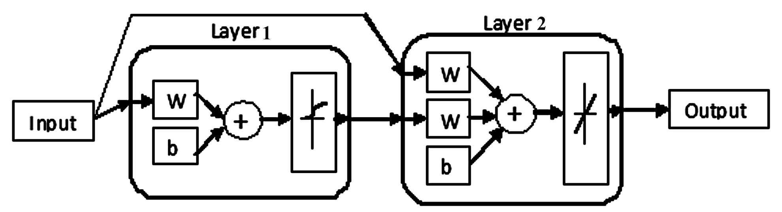
Figure 1. Cascade feed-forward ANN
Two transfer functions are associated with layers 1 and 2. The transfer function modifies the input to a layer such that the output can be easily classified into groups of similar data [7]. Each layer is initialized with a set of random weights and bias values. During the training process, these weights and biases are updated based on the training algorithm with error back-propagation. A learning algorithm is chosen to identify the patterns in the set of input data during training. Matlab software was used for the analysis. To control over-training, 20% of the data was used for validation and testing during the training process. Table 2 shows the different parameters associated with the ANN model developed during this study.
Table 2. Different parameters of the ANN model
Transfer function of layer 1 | Transfer function of layer 2 | Training function | Learning function | Error function
Log sigmoidal | Linear | Levenberg-Marquardt back-propagation | Gradient descent | Mean squared

Results and Discussion
Figure 2 shows the plot for the experimental vs. predicted values of bulk density. An R² value of 0.963 proves that the ANN model is capable of predicting the experimental results. Following this validation, the model was used to predict the effect of individual size fractions on the bulk density. Table 3 shows the granulometry used for these predictions, and the results are shown in Figure 3.
Figure 3 shows that with increase in size fractions of large and small particles, the bulk density increases initially then decreases. Increase in the size fraction of <1 mm particles up to 80 g increases the bulk density significantly. There is an optimum for each size fraction. On the other hand, the bulk density decreases with increase in the size fractions of 4-2 mm and 2-1 mm, especially with latter fraction.
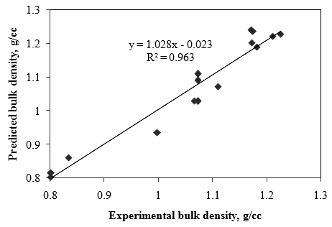
Figure 2. Experimental and predicted values of bulk density

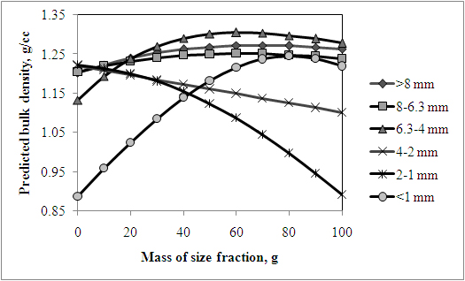
Figure 3. Effect of different size fractions on bulk density
The size fractions for the cases presented in Table 3 and Figure 3 were converted to percentage basis. The results are presented in Table 4 in a decreasing order of bulk density. This table shows how different fractions of the dry aggregates can be combined to obtain the desired bulk density using the ANN model. This can help industry formulate different recipes without performing experiments which, in turn, can save time and reduce cost for the industry.
Table 3. Granulometry used to study the effect of each size fraction
Effect of particle size | >8 mm particle, g | 8-6.3 mm particle, g | 6.3-4 mm particle, g | 4-2 mm particle, g | 2-1 mm particle, g | <1 mm particle, g
>8 mm | 0-100 | 5 | 14 | 6 | 11 | 59
8-6.3 mm | 5 | 0-100 | 14 | 6 | 11 | 59
6.3-4 mm | 5 | 5 | 0-100 | 6 | 11 | 59
4-2 mm | 5 | 5 | 14 | 0-100 | 11 | 59
2-1 mm | 5 | 5 | 14 | 6 | 0-100 | 59
< 1 mm | 5 | 5 | 14 | 6 | 11 | 0-100

Table 4. Bulk density of dry aggregates for different granulometry
>8 mm particle, % | 8-6.3 mm particle, % | 6.3-4 mm particle, % | 4-2 mm particle, % | 2-1 mm particle, % | <1 mm particle, % | Density, g/cc
3.42 | 3.42 | 41.10 | 4.11 | 7.53 | 40.41 | 1.305
3.21 | 3.21 | 44.87 | 3.85 | 7.05 | 37.82 | 1.303
3.68 | 3.68 | 36.76 | 4.41 | 8.09 | 43.38 | 1.301
3.01 | 3.01 | 48.19 | 3.61 | 6.63 | 35.54 | 1.298
3.97 | 3.97 | 31.75 | 4.76 | 8.73 | 46.83 | 1.290
2.84 | 2.84 | 51.14 | 3.41 | 6.25 | 33.52 | 1.289
2.69 | 2.69 | 53.76 | 3.23 | 5.91 | 31.72 | 1.278
42.42 | 3.03 | 8.48 | 3.64 | 6.67 | 35.76 | 1.273
38.71 | 3.23 | 9.03 | 3.87 | 7.10 | 38.06 | 1.272
45.71 | 2.86 | 8.00 | 3.43 | 6.29 | 33.71 | 1.271
4.31 | 4.31 | 25.86 | 5.17 | 9.48 | 50.86 | 1.270
34.48 | 3.45 | 9.66 | 4.14 | 7.59 | 40.69 | 1.269
48.65 | 2.70 | 7.57 | 3.24 | 5.95 | 31.89 | 1.268
51.28 | 2.56 | 7.18 | 3.08 | 5.64 | 30.26 | 1.263
29.63 | 3.70 | 10.37 | 4.44 | 8.15 | 43.70 | 1.263
24.00 | 4.00 | 11.20 | 4.80 | 8.80 | 47.20 | 1.253
3.23 | 38.71 | 9.03 | 3.87 | 7.10 | 38.06 | 1.252
3.03 | 42.42 | 8.48 | 3.64 | 6.67 | 35.76 | 1.251
3.45 | 34.48 | 9.66 | 4.14 | 7.59 | 40.69 | 1.251
2.86 | 45.71 | 8.00 | 3.43 | 6.29 | 33.71 | 1.248
3.70 | 29.63 | 10.37 | 4.44 | 8.15 | 43.70 | 1.247
4.13 | 4.13 | 11.57 | 4.96 | 9.09 | 66.12 | 1.245
2.70 | 48.65 | 7.57 | 3.24 | 5.95 | 31.89 | 1.244
4.00 | 24.00 | 11.20 | 4.80 | 8.80 | 47.20 | 1.241
17.39 | 4.35 | 12.17 | 5.22 | 9.57 | 51.30 | 1.240
4.72 | 4.72 | 18.87 | 5.66 | 10.38 | 55.66 | 1.239
3.82 | 3.82 | 10.69 | 4.58 | 8.40 | 68.70 | 1.238
2.56 | 51.28 | 7.18 | 3.08 | 5.64 | 30.26 | 1.238
4.50 | 4.50 | 12.61 | 5.41 | 9.91 | 63.06 | 1.237
4.35 | 17.39 | 12.17 | 5.22 | 9.57 | 51.30 | 1.232
9.52 | 4.76 | 13.33 | 5.71 | 10.48 | 56.19 | 1.223
5.62 | 5.62 | 15.73 | 6.74 | 0.00 | 66.29 | 1.223
4.76 | 9.52 | 13.33 | 5.71 | 10.48 | 56.19 | 1.220
5.32 | 5.32 | 14.89 | 0.00 | 11.70 | 62.77 | 1.220
3.55 | 3.55 | 9.93 | 4.26 | 7.80 | 70.92 | 1.219
4.95 | 4.95 | 13.86 | 5.94 | 10.89 | 59.41 | 1.216
5.05 | 5.05 | 14.14 | 6.06 | 10.10 | 59.60 | 1.214
4.81 | 4.81 | 13.46 | 9.62 | 10.58 | 56.73 | 1.209
5.26 | 0.00 | 14.74 | 6.32 | 11.58 | 62.11 | 1.205
0.00 | 5.26 | 14.74 | 6.32 | 11.58 | 62.11 | 1.202
4.59 | 4.59 | 12.84 | 5.50 | 18.35 | 54.13 | 1.200
4.39 | 4.39 | 12.28 | 17.54 | 9.65 | 51.75 | 1.197
5.21 | 5.21 | 10.42 | 6.25 | 11.46 | 61.46 | 1.194
4.03 | 4.03 | 11.29 | 24.19 | 8.87 | 47.58 | 1.185
5.49 | 5.49 | 15.38 | 6.59 | 12.09 | 54.95 | 1.183
4.20 | 4.20 | 11.76 | 5.04 | 25.21 | 49.58 | 1.181
3.73 | 3.73 | 10.45 | 29.85 | 8.21 | 44.03 | 1.173
3.47 | 3.47 | 9.72 | 34.72 | 7.64 | 40.97 | 1.161
3.88 | 3.88 | 10.85 | 4.65 | 31.01 | 45.74 | 1.156
3.25 | 3.25 | 9.09 | 38.96 | 7.14 | 38.31 | 1.149
6.17 | 6.17 | 17.28 | 7.41 | 13.58 | 49.38 | 1.139
3.05 | 3.05 | 8.54 | 42.68 | 6.71 | 35.98 | 1.138
5.81 | 5.81 | 0.00 | 6.98 | 12.79 | 68.60 | 1.133
2.87 | 2.87 | 8.05 | 45.98 | 6.32 | 33.91 | 1.126
3.60 | 3.60 | 10.07 | 4.32 | 35.97 | 42.45 | 1.124
2.72 | 2.72 | 7.61 | 48.91 | 5.98 | 32.07 | 1.114
2.58 | 2.58 | 7.22 | 51.55 | 5.67 | 30.41 | 1.102
3.36 | 3.36 | 9.40 | 4.03 | 40.27 | 39.60 | 1.087
7.04 | 7.04 | 19.72 | 8.45 | 15.49 | 42.25 | 1.086
3.14 | 3.14 | 8.81 | 3.77 | 44.03 | 37.11 | 1.045
8.20 | 8.20 | 22.95 | 9.84 | 18.03 | 32.79 | 1.025
2.96 | 2.96 | 8.28 | 3.55 | 47.34 | 34.91 | 0.998
9.80 | 9.80 | 27.45 | 11.76 | 21.57 | 19.61 | 0.959
2.79 | 2.79 | 7.82 | 3.35 | 50.28 | 32.96 | 0.946
2.65 | 2.65 | 7.41 | 3.17 | 52.91 | 31.22 | 0.892
12.20 | 12.20 | 34.15 | 14.63 | 26.83 | 0.00 | 0.888

Conclusions
A proper choice of an ANN model with appropriate learning and training algorithms can help predict the bulk density of dry aggregates for different granulometry. In this study, few data have been used for training. By increasing the amount of data used for training, the prediction efficiency of the ANN model can be further increased.
Acknowledgements
The technical and financial support of Aluminerie Alouette Inc. as well as the financial support of the National Science and Engineering Research Council of Canada (NSERC), Développement économique Sept-Îles, the University of Québec at Chicoutimi (UQAC), and the Foundation of the University of Québec at Chicoutimi (FUQAC) are greatly appreciated.
References
1. I. Berezin et al., “Improvement of Green Anodes Quality on the Basis of the Neural Network Model of the Carbon Plant Workshop,” Light Metals, 2002, 605-608.
2. Kirstine L. Hulse, “Anode Manufacture Raw Materials Formulation and Processing Parameters” (Sierre, Switzerland, R&D Carbon Ltd., 2000).
3. L. P. Lossius, B. Spencer and H. A. Øye, “Bulk Density- Overview of ASTM and ISO Methods with Examples of between Laboratory Comparisons”, Light Metals, 2011, 941-946.
4. T. Parthiban, R. Ravi and N. Kalaiselvi, “Exploration of Artiﬁcial Neural Network [ANN] to Predict the Electrochemical Characteristics of Lithium-ion Cells,” Electrochimica Acta, 53(4) (2007), 1877-1882.
5. H. White, “Artificial neural networks: Approximation and Learning Theory” (Cambridge, Blackwell, 1992).
6. J.K. Kruschke and J. R. Movellan. "Benefits of Gain: Speeding Learning and Minimal Hidden Layers in Back-Propagation Networks," IEEE Transactions on Systems, Man and Cybernetics, 21(1) (1991), 273 – 280.
7. D. Bhattacharyay et al., “Application of the Artificial Neural Network (ANN) in Predicting Anode Properties,” Light Metals, 2013, 1189-1194.

