QUANTITATIVE EVALUATION OF THE CRACKING OF CARBON ANODES BY IMAGE ANALYSIS FOR ALUMINUM INDUSTRY
Salah Amrani¹, Duygu Kocaefe¹, Yasar Kocaefe¹, Dipankar Bhattacharyay¹, Brigitte Morais², Gerry Blainey²
¹University of Québec at Chicoutimi, Department of Applied Sciences, 555, boul. de l’Université, Chicoutimi, Québec, Canada G7H 2B1

²Aluminerie Alouette Inc., 400, Chemin de la Pointe-Noire, C.P. 1650, Sept-Îles, Québec, Canada, G4R 5M9

Abstract
Quality of carbon anodes used in aluminum industry affects significantly the electrolytic cell performance including the energy consumption. One of the important factors that influence the anode quality is the cracking of anodes. Quantitative evaluation of this problem helps identify the causes and consequently allows the necessary corrective actions to be taken.

The characterization of the baked anode cracking was done by determining the sizes (width, length) of the cracks and their distribution on the anode surface. This work was carried out using the image analysis technique. Two types of cracking, horizontal and vertical, were investigated for industrial baked anodes. The results show the types of cracks encountered in industrial anodes and indicate the regions susceptible to the formation of cracks. In this article, the characterization method will be described, and the results on the anode crack formation will be presented.

Keywords: Carbon anodes, cracking, crack formation, crack analysis, image analysis.

Introduction

In aluminum industry, the challenge is the continuous improvement of product quality which has utmost importance for the global market. The quality of aluminum produced depends on several parameters including the quality of anodes. The stability of electrolysis cells is one of the important factors for this industry, and anode as a consumable electrode is one of the key elements for a reliable operation of the cell [1]. During the production of aluminum from alumina through the reduction reaction in the electrolytic cell, the energy requirement is directly related to the state of the anode used [2]. The quality of carbon anodes is defined by its properties (high density, low electrical resistivity, and low reactivities to air and CO2) [3]. The manufacture of dense carbon anodes involves several stages [4-6]. Coke and pitch along with the recycled anodes/butts are the main raw materials [7, 8]. Their mixture gives a paste which is transformed into a green anode using a vibro-compactor or a press. The properties of green anodes are improved during baking [9].

The conditions that the anodes are subjected to during their formation, baking or use in electrolysis may result in the appearance of cracks on their surfaces [10]. The existence of cracks in an anode increases its electrical resistivity, which, in turn, increases the energy consumption during electrolysis. The presence of cracks also increases the anode reactivity and results in subsequent release of greenhouse gas emissions [9].
The shapes of cracks observed in industrial anodes can be grouped in to several categories as cited in the literature by different researchers [11-13]. Characterization of cracking can be carried out using different investigative techniques at microscopic and macroscopic scales [14-16]. The objective of the current work is to evaluate qualitatively and quantitatively two types of cracks (horizontal and vertical) seen frequently in industrial anodes. The distribution of crack width along the crack length is determined for these two types of cracks, and the results are discussed.

Methodology

Analysis of the surface area and the width for vertical and horizontal cracks was carried out using an image analysis technique.
Evaluation of the width and the surface area of a horizontal crack
Figure 1a shows an image of a horizontal crack observed in a baked carbon anode. The image was taken by an ordinary camera. This study was conducted on a sample with dimensions of 150mm x 50mm.

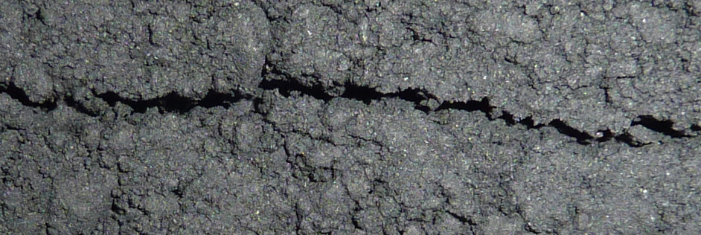 | 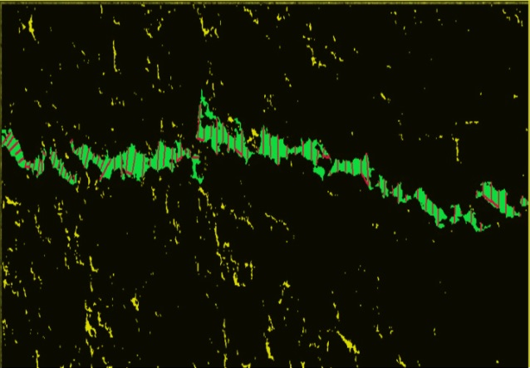
a) Original image (horizontal crack) | b) Processed image (horizontal crack)

Figure 1: Image of one horizontal continuous crack (in green) as well as discontinuous cracks or pores (in yellow) in a baked anode sample.
On the image processed using the image analysis software, green shows the continuous crack (Figure 1b) while the yellow color indicates the discontinuous cracks or pores. The crack area is determined by the measurement of the areas of the colored sections. The width of the crack is calculated only on the continuous crack by tracing the vertical segments along the crack (see Figure 1-b).

Evaluation of the width and the surface area of a vertical crack
A vertical crack present in an anode is shown in Figure 2a. The image analysis allows the quantification of the crack (green region) as shown in Figure 2b. The sample dimensions are 55mmx50mm.
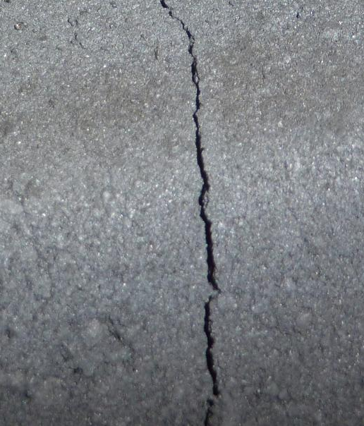 | 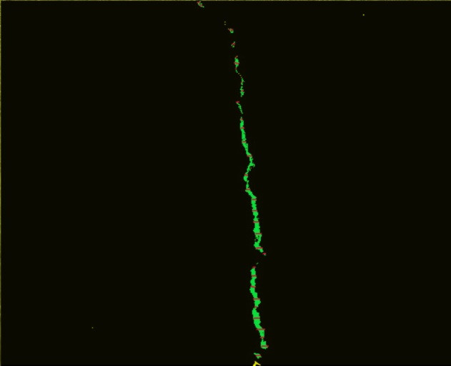
a) Original image | b) Processed image

Figure 2: Image of a continuous vertical crack in a baked anode.

Results and Discussion

Image analysis was used to determine and quantify the surface areas and the variation of the width along the crack length for two types of cracks (horizontal and vertical). The green color on the images shown in Figures 1b and 2b indicates continuous surface cracks, and yellow color indicates the discontinuous cracks. The crack area smaller than 0.76 mm² was defined as discontinuous cracks.

Evaluation of horizontal crack surface area
The distribution of the surface area of both continuous horizontal and discontinuous cracks present on the surface of the baked anode sample is shown in Figure 3.

Figure 3: Distribution of continuous and discontinuous cracks on the surface of a baked anode sample.
Figure 3 shows the distribution of two types of cracks: 4.8% of the surface was covered by continuous cracks and 0.5% was covered by discontinuous cracks. This indicates that 5.3% of a total surface area of the sample (150x50mm) was cracked.

Evaluation of the width of a horizontal crack
Visual inspection of baked industrial anodes with a horizontal crack showed that this type of crack has an irregular shape (change of direction) and the crack width varies along the crack length. It was observed that the crack width changes when the crack direction changes (see Figure 4).

Figure 4: Distribution of crack width along its length (red lines represent larger widths and blue ones represent narrower widths).

The distribution of crack width along the crack length shows the position where the crack width is greater. It can be seen from the results that the widths are larger in the middle of the crack (Figure 4). This illustrates that the crack formation starts in the middle and then propagates in both directions (from center towards both ends).

Influence of the distance of crack from the bottom of the anode on crack length
The distance between the anode bottom and the cracks were measured for 13 cracked industrial baked anodes (see Figure 5 for a schematic illustration).

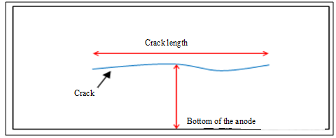
Figure 5: Illustration of the length of the crack as a function of the distance from the bottom of the anode

Figure 6 summarized the results of these measurements.

Figure 6: Variation of the length of cracks as a function of the distance between the crack and the bottom of the anode.

It was noted that the length of the crack was usually less than 40 cm when the crack is located at a distance less than 30 cm from the bottom of the anode. This can possibly be explained by the existence of slots in this region that help relieve the stress which, otherwise, could cause cracking during devolatilization at the baking stage. This figure also shows that if the distance between the crack and the bottom of the anode exceeds 30cm, the crack length is greater than 40 cm. In these regions, the slots do not exist, thus it is quite likely that the stress exerted on the anode during devolatilization is higher, resulting in longer cracks.

Evaluation of vertical crack surface area
Figure 7 shows the percent distribution of vertical cracks with respect to the total surface area considered (50mmx55mm).
Surface with cracks 0,622 %
Surface without cracks 99,377 %
Figure 7: Percentage of continuous vertical cracks on the surface of a baked anode sample

For vertical cracks (see Figure 2), the cracked surface area represents only 0.6% of the total surface area of the ​​55mm x 50mm sample (see Figure 7). This means that the percentage of surface covered by vertical cracks is less than that of horizontal cracks (5.328%). This seems to indicate that the horizontal cracks are relatively more common; and this is in general attributed to factors during the forming stage (compaction parameters).

Evaluation of the width of a vertical crack
The distribution of the variation of the width of a typical vertical crack along its length is shown for an industrial baked anode in Figure 8.

Figure 8: Distribution of crack width along its length (vertical crack; red lines represent larger widths and blue ones represent narrower widths).

It was observed that vertical cracks have larger widths at only one of the extremities (see Figure 8). Therefore, it can be stated that, after the creation of the crack, it propagates in a single direction.

The width of the horizontal cracks varied between 0.3 mm and 4.9 mm while that of the vertical crack ranged from 0.095 mm to 0.859 mm. The horizontal crack is much larger, which seems to indicate that probably the effect of forming during green anode production had a greater impact on the formation of cracks.

Conclusions

The qualitative and quantitative characterization of cracks (vertical and horizontal) of carbon anodes for the aluminum industry has been carried out. The results show that the width of the vertical crack is larger at one end and the crack propagates in a single direction. On the other hand, for the horizontal crack, the maximum width lies in the middle of the crack, which indicates its propagation in both directions. Vertical cracks are usually created at the baking stage whereas the horizontal cracks indicate issues during the forming stage (compaction). For the samples studied, the relatively higher presence of larger horizontal cracks probably shows that the compaction parameters are not optimized for the given anode paste.

Acknowledgements

The technical and financial contributions of Aluminerie Alouette Inc. and the financial support from the Natural Sciences and Engineering Research Council of Canada (NSERC), the Economic Development Sept-Iles, the University of Quebec at Chicoutimi (UQAC), and the Foundation of the University of Quebec at Chicoutimi (FUQAC) are greatly appreciated.

References
[1] N.. A. Ambenne, Vertical anode cracking - the valco experience, Light Metals, (1997), 577-583.
[2] N. E. Saue , J. O. Ystgaard , J-I. Johannessen , M. W. Meier, R. C. Perruchoud, Improvement of anode paste quality and performance of Alcoa Lista, Light Metals, (2012), 1159-1163.
[3] R. J. Akhtar , S. A. Rabba , M. W. Meier, Dynamic process optimization in paste plant, Light Metals, (2006), 571- 575.
[4] K. Azari, H. Alamdari, G. Aryanpour , D. Picard, Mixing variables for prebaked anodes used in aluminum production, Powder Technology 235, (2013) 341–348.
[5] M. Tkac, Porosity development in composite carbon materials during heat treatment, Thesis for the degree of philosophiae doctor, Norwegian University of Science and Technology, (2007), 27-37.
[6] O. E. Frosta, A. P. Ratvik, H. A. Øye, Properties and production conditions affecting crack formation and propagation in carbon anodes, Light Metals, (2012), 1293-1298.
[7] L. Edwards, N. Backhouse, H. Darmstadt, M-J. Dion, Evolution of anode grade coke quality, Light Metals, (2012), 1207-1212.
[8] V.M. Polovnikov, I.V. Cherskikh, E.A. Startsev, Effect of pitch quality on properties of baked anodes. The second international congress “non ferrous metals-2010, Aluminum reduction technology, Part VI, (2010), 333-335.
[9] A. Al Marzouqi, T. K. Sahu, S. A. Rabba, Baking Furnace Optimisation, Light Metals, (2008), 913-917.
[10] O. E. Frosta, T. Foosnæs*, H. A. Øye*, H. Linga, Modelling of anode thermal cracking behaviour, ), Light Metals, (2008), 923-927.
[11] M. W. Meier, K. Cracking, cracking behaviour of anode. R & d. Carbone. Ltd. chapitre 4, (1996), pp, 251-268.
[12] M. W. Meier, K. Fischer, R. C. Perrucoud, thermal shok of anodes-a solved problem, Light Metals, (1994), anode for the aluminum industry, R & D carbon, ltd, 4eme edition 2007, pp, 321-323.
[13] F. Keller, U. M, Weiler, R. C. perruchoud, Anode performance, the link between coke properties and aluminum production cost, RCD internal publication, anode for the aluminum industry, (1994), R & D carbon, ltd, 4eme edition 2007, 381-387.
[14] S. Rørvik, L, P. Lossius, H. A. øye, Classification of pores in prebake anodes using automated optical microscopy, Light Metals, ( 2003), 531-534.
[15] D. Picard, H. Alamdari, D. Ziegler, P-O. St-Arnaud, M. Fafard, Characterization of a full-scale prebaked carbon anode using x-ray computerized tomography, Light Metals, (2011), 973-975.
[16] D. Picard, H. Alamdari, D. Ziegler, B. Dumas, M. Fafard, Characterization of pre-baked carbon anode samples using x-ray computed tomography and porosity estimation, Light Metals, (2012), 1283-1288.

