**Acoustic emission techniques to measure the properties of coke particles – a first foray**

**Geoffroy Rouget1, Petre Manolescu1,2, Donald Picard1, Carl Duchesne1, Houshang Alamdari1, and Duygu Kocaefe3**

1. Aluminum Research Centre – REGAL, Université Laval, Québec (QC), Canada, G1V 0A6
2. Alcoa Corporation, Smelting Process Engineer, Fjardaal smelter, Hraun 1, 730 Reydarfjordur, Iceland

3. Aluminum Research Centre – REGAL, Université du Québec à Chicoutimi (UQAC), Chicoutimi (QC), Canada, G7H 2B1

Corresponding author: carl.duchesne@gch.ulaval.ca

**Abstract**

The performance of the Hall-Héroult aluminium reduction process is strongly influenced by fluctuations of the baked carbon anode properties. The currently decreasing quality and increasing variability of the anode raw materials, coke and pitch, combined with the frequent supplier changes by anode manufacturers to meet their specifications and reduce purchasing costs make it very challenging to produce anodes with consistent properties. Furthermore, the coke quality control scheme traditionally used by aluminium smelters involving infrequent coke sampling and characterization in the laboratory is inadequate for tracking coke variability when formulating the anode paste, and applying timely corrective actions when necessary. Developing new rapid and non-destructive sensors for measuring key coke properties such as density and porosity directly from the production line is highly desirable. This work investigates the possibility of using acoustic emission techniques for measuring physical and/or mechanical properties of coke particles. A set-up was developed for recording the sound made by coke particles dropped on a metal sheet. The potential of the approach was tested on coke samples having different physical properties (several sizes and suppliers). The acoustic signature of each type of coke particle was correlated with their physical properties using regression analysis.

1. **Introduction**

Carbon anodes are used in the aluminium industry for the electrolysis of alumina by transferring the electrical energy to the electrolytic bath, and providing the carbon necessary for the reaction. Prebaked anodes are made of petroleum coke aggregates, coal tar pitch and anode butts   
(recycled anode particles). The mix of these materials in certain proportions, called the anode paste, is formed in a mould and generally densified by vibro-compaction. The resulting block is called the green anode. The last step of anode fabrication is the baking in large furnaces, in which hundreds of anodes are baked for about two weeks. During all the above mentioned stages of anode production, materials are characterized, from the raw material, such as coke and butts, to the anode paste, the green anode, and then the baked anode. The different analyses are performed to characterize the product quality, as the anode efficiency is related to its physical properties, such as density and porosity [1-3], reactivity (air [4, 5], CO2 [6]), mechanical strength [7], and electrical resistivity [8]. In order to maintain consistent anode quality when facing changes in raw materials properties, adjustments to the anode paste formulation are implemented. This requires characterizing the raw materials as early as possible in the process. Coke particles are shipped to the plants by train and while unloading the shipment, coke particles flow from their container to specific storage bins in the plant. During the transfer of raw material from transport container to the bins, falling particles emit sound due to interaction with each other as well as falling on sieving grids. The sound emitted is expected to be an intrinsic characteristic of the material analysed. Acoustic chemometrics for fluid and solid media was used to perform either qualitative [9] or quantitative [10] measurement of flows. These methods allow a non-invasive and non-destructive analysis of the materials. Bruwer et al. [11], as well as Haltesen and Esbensen [12] performed sound analysis on materials such as particles having a wide size range, or snack foods in order to determine either the size distribution or the mechanical strength of the studied material, respectively. Based on these studies, it appears that using sound analysis would be a feasible approach to perform a preliminary characterization of coke particles conveyed to the anode plant. Samples could be collected at different locations in the green mill and submitted to sound analysis using the set-up described later in this paper, or emitted sound could potentially be collected directly from the line. The proposed approach could help estimate coke density and porosity before the anode formulation step, which could guide the operators in making feed forward adjustments when necessary. It is also believed that the method could detect changes in coke source, for instance due to a supplier change or when cokes from more than one source are stored in the same bin. The sound emitted by the particles may be used to distinguish coke sources, and estimate their proportions in the mix. To validate these assumptions, tests were performed on several cokes of similar size fractions that were previously investigated in detail [1]. Sound emission analysis of each source was carried out. Then, the cokes having the most different apparent densities were blended and their acoustic signatures were measured.

1. **Material and Method**
   1. **Acoustic emission measurement**

To perform the measurements, the same cokes as those used by Azari et al. [1] were investigated. These correspond to cokes labeled A, C, D, and E in [1]. To facilitate the analysis and the comparison between both works, cokes designation is the same. To perform the sound analysis, the anechoic chamber shown in Figure 1 was built using stainless steel tubes with a square cross-section. The internal surfaces were coated with convoluted acoustic foam. The bottom of the box was placed on a low density Styrofoam plate. A two-inch hole was drilled through the top of the box to allow the particles to flow from the feeder to the reception plate. The set-up was placed on a table separated from the feeder to avoid vibrations coming from the feeder motor. To reduce even more the influence of surrounding sound, a small box was placed onto the arm of the feeder, above the feeding hole. The feeder consists of a flat arm, vibrating at a certain frequency controlled by a variable frequency electrical motor. The reception plate, made of 0.01 inch thin steel, was placed at a specific height inside the anechoic chamber. It was installed on a solid and heavy steel foot, on which the microphone was also fixed in order to keep the same orientation and distance from the impact point of the thin steel plate. The impact sound made by the particles when dropping on the metal plate from a certain height is recorded by the microphone (signal of interest). After contacting the steel plate, the particles fall in a large plastic box, covered with a rubber mat to reduce the sound of the impact at reception.



**Figure 1. Schematic view of the sound acquisition set-up.**

The microphone wire was passed through an insulated hole in the chamber to avoid corruption of the signal by external noises. The microphone used was model GRAS 46AE (Sound & Vibration Solutions Canada Inc., Acton, ON, Canada), which is unidirectional, and has a high sensitivity in the frequency range between 3 Hz and 20 kHz. The wire connecting the microphone to the acquisition system was highly shielded against parasitic magnetic signals. The hardware used for the signal acquisition was a National Instrument cDAQ-9171 CompactDAQ, USB, connected to the NI 9250 BNC module. The signal was acquired using Matlab R2015b (Mathworks, Natick, MA, USA).

The sound data collected for a coke sample (i.e., a small lot of particles) was converted from the time domain to the frequency domain using the Fast Fourier Transform (FFT). Considering the high sampling rate of the acquisition system (102.4 kHz) and the frequency range studied, each power spectrum contains information about the presence of signals at 204545 frequencies. The power spectrum of the sample was then stored as a row vector in matrix **X** for subsequent statistical analysis. Each individual sample was run through the set-up at least five times and the sound was recorded. To quantify the surrounding noise, blank experiments were carried out without particles, but with the feeder motor turned on. Blank experiments were conducted on different days; each time a coke sample was tested, and was repeated at least five times. These measurements are labelled as “void” measurements. The different measurements performed are described in Table 1. In total, power spectrum of the sound emitted by 83 coke samples were collected in data matrix **X**, which dimensions are (83×204545). Multivariate analysis was then performed to compare the frequency peaks observed for each coke samples. The density and porosity of the materials (previously measured by Azari et al. [1]) were also stored in a second data matrix **Y**, and regressed on the power spectra (**X**) in order to assess whether these coke properties could be predicted using sound data.

**Table 1. Different experiments performed for each coke source.**

|  |  |
| --- | --- |
| Experiments | Coke used |
| Single coke, -8 +14 Mesh size fraction | A, C, D, E |
| Blend of cokes, -8 +14 Mesh size fraction | 25 % A, 75% C |
| Blend of cokes, -8 +14 Mesh size fraction | 50 % A, 550% C |
| Blend of cokes, -8 +14 Mesh size fraction | 75 % A, 25% C |
| Single coke, blended size fractions  50 % -8 +14 Mesh, 50 % -14 +28 Mesh | A, D |
| Single coke, blended size fractions  50 % -8 +14 Mesh, 50 % -28 +50 Mesh | A, D |
| Single coke, blended size fractions  50 % -14 +28Mesh, 50 % -28 +50 Mesh | A, D |

* 1. **Multivariate analysis**

The data was analysed using the EigenVector package [13] for Matlab. Multivariate analysis tools such as Principal component analysis (PCA), Partial Least Squares (PLS) and Partial Least Squares Discriminant Analysis (PLS-DA) were used to observe and interpret the clustering of the data collected. These tools project the data from a high dimensional space to a much lower dimensional latent variable subspace capturing the directions of greatest variance within the dataset. A model can be built on the initial values (for example, individual coke sources and sizes) while the others can be projected onto the model (for example, the mixture of coke sources or size blending). Thus, the clustering of the samples can be observed and interpreted.

The initial data matrix **X** is first centered and scaled to unit variance. In PCA, the variance-covariance matrix of **X** is decomposed as shown by Equation 1. The scores **T** correspond to the projection of each observation (row in **X**) onto the lower dimensional subspace. The latter is defined a set of linear combinations of the original variables (columns in **X**) explaining most of the variance in the data, and the weights are stored in the loadings matrix denoted by **P**. These linear combinations are also called principal components, and their number need to be selected by the user based on some criteria, such as the amount of variance explained by the PCA model of prediction performance. The scores are used to visualize the clustering patterns of the observations (i.e., coke samples), while the loadings could be used to interpret the differences between the samples based on their power spectra..

$X={TP}^{T}+E$ (1)

PLS is a regression technique based on a similar latent variable subspace concept as PCA but it requires two data matrices: the predictor matrix **X** and the response matrix **Y**. The objective for defining the latent variable subspace is to threefold namely, find the best explanation of the X-space, the best explanation of the Y-space and maximize the relationship between X- and Y-space. In this paper PLS is used to predict **Y** (measured density/porosity values) given **X** (acoustic spectrum of samples). The combinations of different sources/sizes are projected onto the model built to see where their respective predicted values would land. The PLS method could also be used to discriminate the samples based on pre-defined classes (e.g., coke sources). In this case, the **Y** data matrix is filled with binary numbers (0 or 1) assigning a class to each sample. This approach is referred to as PLS-DA in the literature. The interested reader can find detailed descriptions of these methods in the works of Wold et al. on PCA [14] and PLS [15], Gelaldi et al. [16], Hoskuldson [17] and Barker et al. [18] on PLS.

A preliminary PCA model, built on all the data available, revealed that the void measurements were clustered tightly together. Subsequently, they were averaged and removed from all coke signals to allow the easier differentiation between the clustering of different sources/sizes.

1. **Results**

Four different types of analysis were performed on the data. First a PLS-DA model was built on the single source and single size (8-14 mesh) data for cokes A, C, D and E, as shown in Figure 2. The mixtures of cokes A and C were then projected onto the model. Here, the aim was to discriminate to the coke samples according to their source, since coke from different suppliers are expected to have different properties. The single sources are connected by the coloured lines to ease their visibility. In the figure, the samples are labeled by their source, followed by their size and replicate number. For instance, sample C814\_5 refer to coke C in size class 8-14 mesh, and replicate #5. For mixtures of two cokes, their source and portions are used to identify them. For example, A25C75\_4 is the 4th replicate of the mixture made with 25% of coke A and 75% of coke C.

Notice that A is placed in the third quadrant, E is in the fourth, D is in the first and fourth and C is in the first and second quadrants. The score plot shows that the mixtures fall within the area established by the single source and single size measurements, but there is no clear trend with respect to their composition. One would expect that the sample would be closer to the source which constitutes 75% of its composition. This will be investigated further in future work. There is some variability within the measurements which can be attributed to the way the particles fall onto the metal sheet. Given that the samples are of sponge coke, their angle of impact on the metal sheet might influence the frequency spectrum. The homogeneity of the coke might add to its variability on the latent variable plane in addition to the angle of impact.

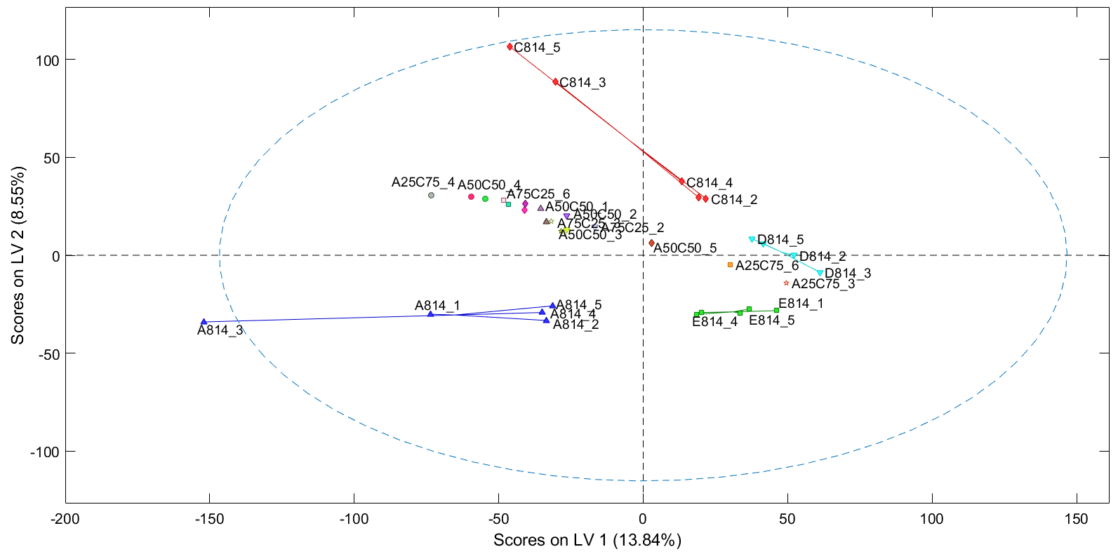

**Figure 2. Score plot of the PLS-DA model of single source and single size, and projections of source mixtures.**

The second analysis was performed with a PLS-DA model developed on the single source and different sizes measurements (i.e., all sources, three different sizes). The aim here is to discriminate the coke particles based on their size, which is expected to affect the impact sound. The size mixtures were used as projections onto the model. Three different classes of sizes in the model are connected by coloured lines to ease visibility. Here the coarser particles (8-14 red) are clustered to the left of the plot while the finer classes (14-28 green and 28-50 blue), are on the right. As expected the mixtures are gathered between the different individual sizes of their respective sources. Also, they move to the right as their size decreases.

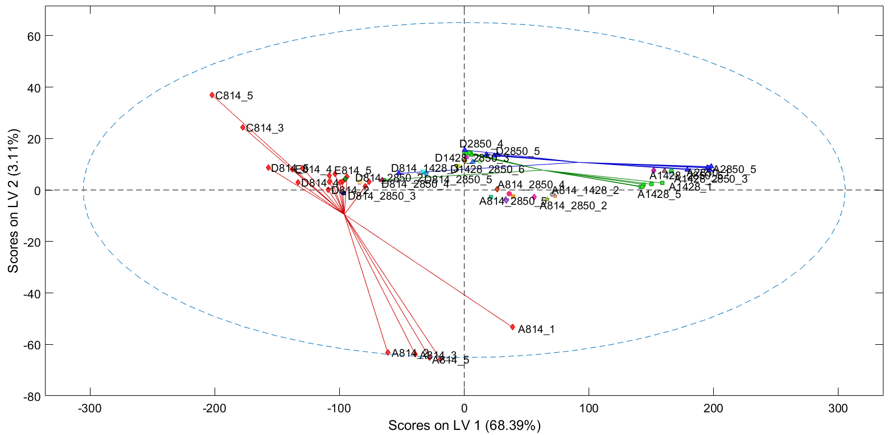

**Figure 3. Score plot of the PLS-DA model of single source and single size, and projections of size mixtures.**

The third analysis was performed using PLS analysis built on the different single sources, single sizes against their respective density. The aim was to find out how well the model can predict the density, illustrated in Figure 4. The green line represents perfect correlation while the red one represents the correlation between the predicted values against the measure ones. It is clear that the model is highly accurate, and that a linear relationship seems to exist between the power spectra of the particles and their density. The mixtures do not have a density measurement, and thus were left out. Instead, they were projected (Figure 5) onto the model to see if they would fall within the expected range, given by their respective individual sources and sizes. It is important to bear in mind that the density measurements were not taken on the specific samples used in this experiment. They were taken on a sample from the same batch of coke. The individual size sample densities increase as the particles become finer (both sources A and D). The density projections of size mixtures from source A fall within the limits established by the individual sizes, as seen in Figure 5. Coke source D shows a slight deviation, with the mixtures projected density falling slightly lower than the frame set by the single sizes. This deviation could be attributed to the uncertainty of measurements In Figure 5, the measured ad predicted coke density is presented as a function of sample number. Every predicted value appears as a specific point identified by the name of the sample; the measured value comes with the same shape and colour point with no label associated. For the case of mixtures, only the predicted value is presented, and those can be compared to measured density values of the associated single size samples used in the mixture.

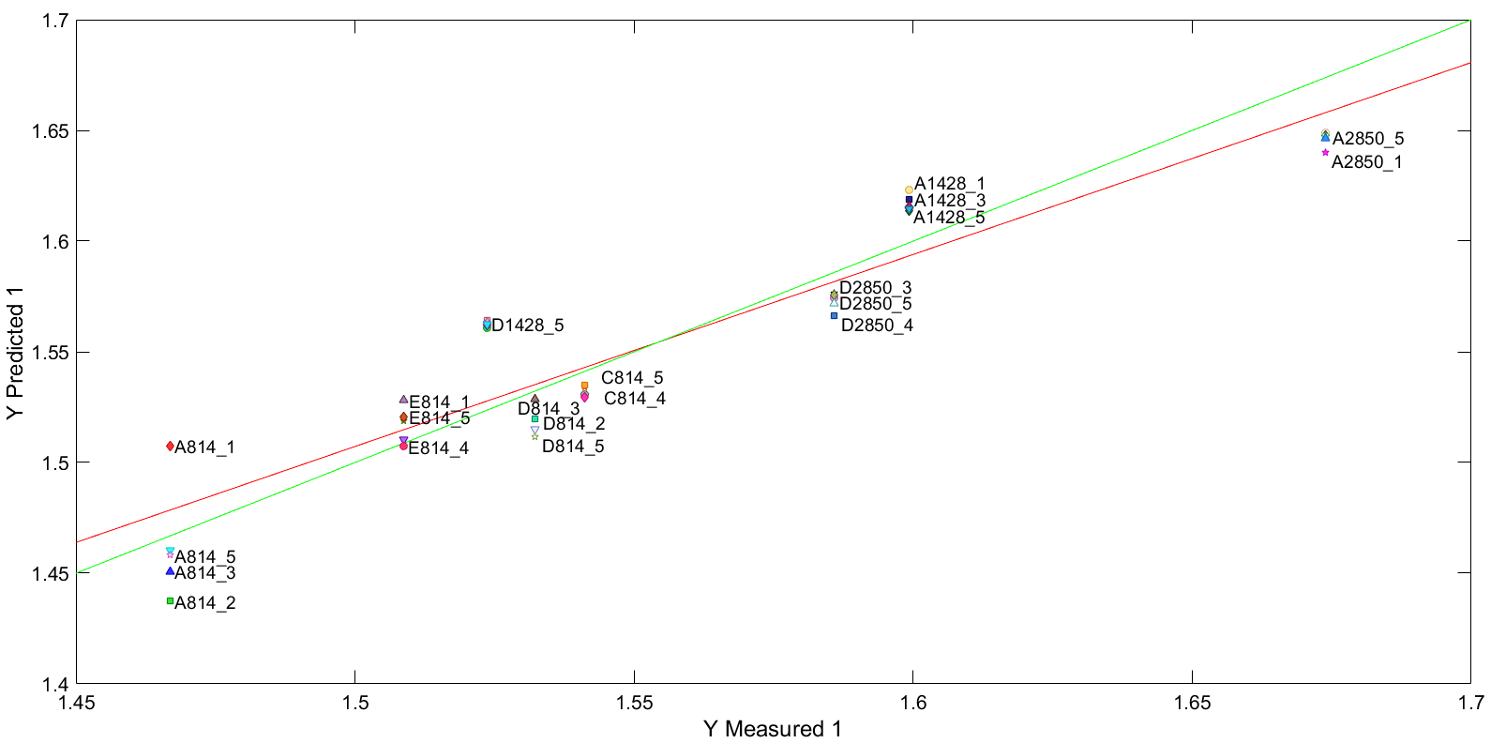

**Figure 4. Measured density values against predicted density given by the PLS model.**

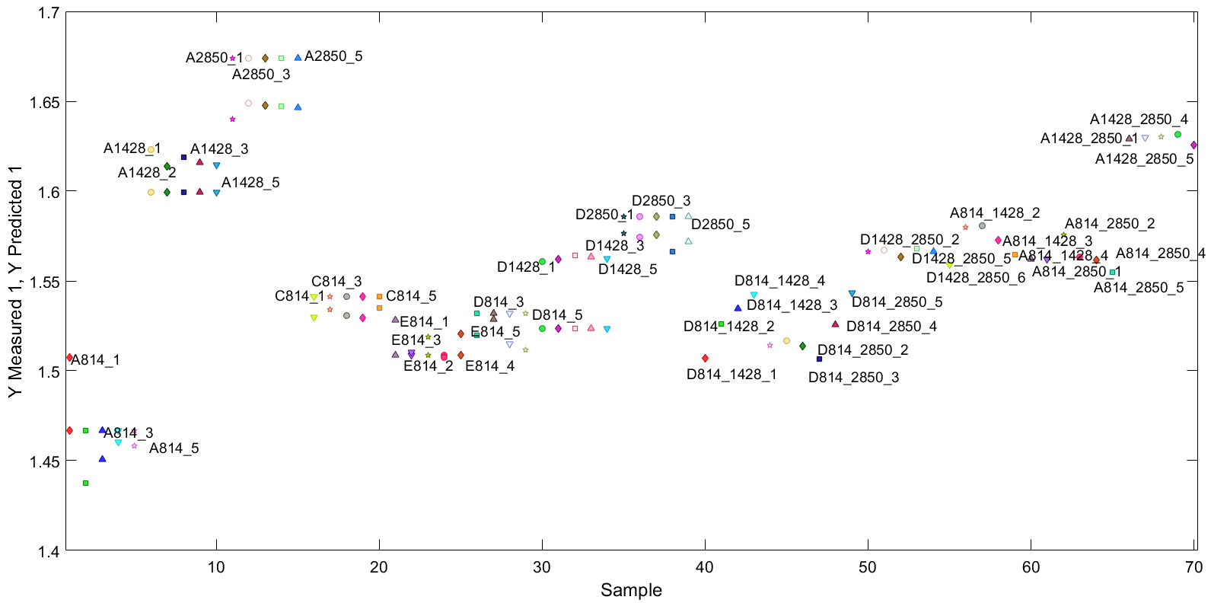

**Figure 5. PLS measured and predicted values of density for all samples.**

The fourth analysis was performed using PLS, this time predicting the porosity of the particles. The correlation between the predicted and measured values is shown in Figure 6. As with the density, the PLS model is highly accurate in predicting the porosity.

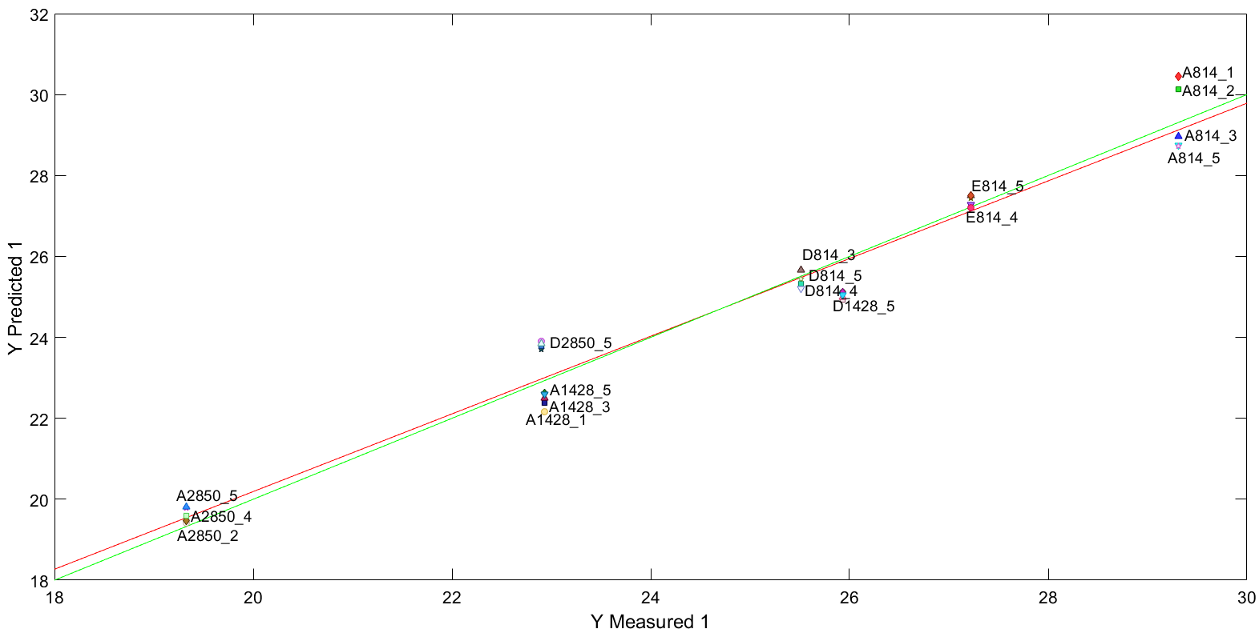

**Figure 6. Measured porosity values against the PLS model predictions.**

As with the density, the porosity measurements were taken on a sample from the same batch of coke and not the specific ones used in this experiment. This can be seen from the difference in the projections of the A coke and D coke in Figure 7.

C:\Users\peman7\AppData\Local\Microsoft\Windows\INetCache\Content.Word\Sample_MeasPred_Coded_Decluttered_Cropped.tif

**Figure 7 . Measured porosity values and PLS predictions for each sample.**

In Figure 7, it can be observed for samples of coke of source A that the coarser the particles, the higher the porosity. For smaller particles, the porosity decreases. Coke of source A shows more consistency since its porosity increases with the size of the particles in the sample. The same is shown for the mixtures of coke source A. The greater the size of the blend the higher its predicted porosity, all the while staying in the range provided by the lowest and highest measurements of single size samples. The source D does not follow along the same pattern. The coarsest particles show a lower porosity than the 14-28 mesh while the projections go above the measured porosities. This difference is corroborated by the measurement of porosity found by Azari et al. [1].

As the results show, the PLS-DA analysis can discern between the clustering of individual sources and mixtures (both size wise on single source and source mixing of one size). The PLS analysis gave promising results indicated by the strong correlation between measured values and projections of density and porosity, respectively. It is thus possible to estimate the density and porosity of mixtures.

1. **Conclusions**

The results of the study on acoustic emissions of coke particles to estimate their physical properties were presented in this article. After acoustic emission acquisition as well as PCA, PLS and PLS-DA modeling, the results show the clustering of different coke sources and sizes. Furthermore, PLS analysis shows that it is possible to predict density and porosity of different mixtures and sizes. The density model shows that the projections fall within the expected limits but the porosity shows an inconsistency with respect to source D while the other is within range. Further experimentation would be needed to explain better the phenomena and build a more robust model. In future work, a more sensitive and accurate model could be built by de-convoluting the acoustic signal and thus investigating single particles instead of a sample as a whole. Multivariate specification regions for each size fraction and source would be clearer.

**References**

[1] K. Azari, H. Alamdari, D. Ziegler, M. Fafard, Influence of coke particle characteristics on the compaction properties of carbon paste material, Powder Technology, 257, 2014, pp 132-140.

[2] B. Majidi, K. Azari, H. Alamdari, M. Fafard, D. Ziegler, Simulation of vibrated bulk density of anode-grade coke particles using discrete elemet method, Powder Technology, 2014, 261, pp 154-160.

[3] K. Azari, W. Bogoya-Forero, C. Duchesne, J. Tessier, Measurement of vibrated bulk density of coke particle blends using image texture analysis, Journal of the Minerals, metals, and Materials Society, 2017, pp 1-11.

[4] R. Ishak, D. Picard, G. Laroche, D.P. Ziegler, H. Alamdari, Application of Boron Oxide as a Protective Surface Treatment to Decrease the Air Reactivity of Carbon Anodes, Metals, 2017, 7, 3, pp 79.

[5] F. Chevarin, R. Ishak, D. Ziegler, M. Fafard, H. Alamdari, Evolution of Anode Porosity under Air Oxidation: The Unveiling of the Active Pore Size, Metals, 2017, 7, 3, pp 101.

[6] F. Chevarin, K. Azari, L. Lemieux, D. P. Ziegler, M. Fafard, H. Alamdari, Active pore sizes during the CO 2 gasification of carbon anode at 960 C, Fuel, 2016, 178, pp 93-102.

[7] S. Thibodeau, H. Alamdari, D.P. Ziegler, M. Fafard, New insight on the restructuring and breakage of particles during uniaxial confined compression tests on aggregates of petroleum coke, Powder Technology, 253, 2014, pp 757-768.

[8] G. Rouget, B. Majidi, D. Picard, G. Gauvin, D. Ziegler, j. Mashreghi, H. Alamdari, Electrical resistivity measurement of petroleum coke powder by means of four-probe method, Metallurgical and Materials Transactions B, 2017.

[9] M.-J. Bruwer, J. F. MacGregor, W. M. Bourg Jr, Fusion of sensory and mechanical testing data to define measures of snack food texture, Food Quality and Preference, 18, (2007), pp 890–900.

[10] K. H. Esbensen, B. Hope, T. T. Lied, M. Halstensen, T Gravermoen, K, Sundberg, Acoustic chemometrics for fluid flow quantifications—II: a small constriction will go a long way, Journal of Chemometrics 13, (1999), pp 209–236 .

[11] M.-J. Bruwer, J. F. MacGregor, W. M. Bourg Jr, Soft Sensor for snack food textural properties using on-line vibrational measurements, Ind. Eng. Chem. Res., 46, 2007, 864-870.

[12] M. Halstensen, K. Esbensen, New developments in acoustic chemometric prediction of particle size distribution, the problem is the solution, Journal of Chemometrics 2000; 14: 463–481.

[13] Eigenvector Research, Inc., eigenvector.com

[14] S. Wold, K. Esbensen, P. Geladi, Principal component analysis, Chemometrics and intelligent laboratory systems, 1987, Vol 2, pp 37-52.

[15] S. Wold, M. Sjöström, L. Eriksson, PLS-Regression: a basic tool of chemometrics, Chemometrics and Intelligent Laboratory Systems, 2001, Vol 58. Pp 109-130.

[16] P. Geladi, B.R. Kowalski, Partial least squares regression: A tutorial, Analytica Chimica Acta, 1986, Vol 186, pp.1-17.

[17] A. Höskuldsson, PLS regression methods, Journal of Chemometrics, 1988, vol 2. , pp. 211-228.

[18] M. Barker, W. Rayens, Partial least squares for discrimination, Journal of chemometrics 2003, Vol. 17, Nr. 3, pp. 166-173.