Advancements in rock block volume calculation by analytical method for geological engineering applications
Aboubacar Sidiki Koulibaly^{1*}, Alireza Shahbazi¹, Ali Saeidi¹, Alain Rouleau¹, Marco Quirion², Romain Chesnaux¹
¹Université du Québec à Chicoutimi, 555 Boulevard de l’Université, Chicoutimi, Québec G7H 2B1, Canada
²Hydro-Québec Production Unité Expertise en barrages, 75 Boulevard René-Lévesque Ouest, Montréal, Québec, H2Z 1A4, Canada
Aboubacar Sidiki Koulibaly, ORCID: 0000-0003-0307-928X
*Corresponding author: aboubacar-sidiki.koulibaly1@uqac.ca
Alireza Shahbazi: alireza.shahbazi1@uqac.ca, ORCID: 0000-0001-9595-8948
Ali Saeidi: ali_saeidi@uqac.ca ORCID: 0000-0001-6954-5453
Alain Rouleau: alain_rouleau@uqac.ca, ORCID: 0000-0003-1012-9898
Marco Quirion: quirion.marco@hydro.qc.ca, ORCID: 0000-0003-2568-6339
Romain Chesnaux: romain_chesnaux@uqac.ca, ORCID: 0000-0002-1722-9499

Abstract
The shape, the volume, and the distribution of the rock blocks represent important geomechanical factors of a rock mass behavior in engineering works. Several methods have been developed for estimating these parameters, including numerical models, as well as analytical and empirical methods. However, their determination in actual in-situ conditions can be quite challenging. The existing analytical methods show limitations in determining the in-situ rock blocks volume. Numerical models provide more reliable estimates of these parameters, but they are not accessible to all, and they require a good working knowledge. Increasing the accuracy of existing analytical methods, or developing more reliable and accessible methods, are more realistic approaches to obtain better estimates of rock block volumes. This paper presents a new method to obtain more accurate estimates of in-situ rock block volume. The method is developed for rock a mass consisting of three persistent joint sets, each set having constant spacing and orientation values. It is based on vector products to obtain exact block volumes, an improvement as compared to previous methods. The volumes of the rock blocks are calculated through the multiplication of the blocks’ edge vector. The results of the developed equation are validated with the output of numerical simulations using 3DEC version 7.0 software, and the results indicate that the developed method makes it possible to determine in-situ rock block volume more reliably than the existing methods.

Keywords
Block volume, Rock mass, Analytical method, Vector multiplication

Abbreviations
(.): The point is an inner product of a pair of vectors
(×): The multiplication sign is a cross product
A: The area of the observation zone (m²)
$\overset{⃑}{A},\overset{⃑}{B}, and \overset{⃑}{C}$: edge vectors of the intact block
a₁: longest dimension of the block (m)
a₃: shortest dimension of the block (m)
D₁, D₂, and D₃: dips of the joint sets 1, 2, and 3
DD₁, DD₂, and DD₃: dip directions of the joint sets 1, 2, and 3
E_{doa}: erosion, discontinuity orientation adjustment
J_{a}: joint alteration number
J_{n}: number of joint sets
J_{o}: joint aperture (m)
J_{r}: joint roughness number
J_{s}: relative block structure
J_{v}: number of joints intersecting a volume of 1m³ of rock (m⁻³)
L: characteristic length of the rock mass (m)
l_{i}: joint length (m)
N_{J1}, N_{J2}, and N_{J3}: normal vectors to joint sets J₁, J₂, and J₃ plane
N_{r}: number of random joints in the real location
P_{i}: joint persistence
RQD: rock quality designation
RMSE: root mean square error
S: average joint spacing measured along the drill core (m)
S_{a}: average joint spacing of all sets (m)
S_{i}: average spacing of joint set i (m)
$\overset{⃑}{u_{A}}$, $\overset{⃑}{u_{B}}$, and $\overset{⃑}{u_{C}}$: unit vectors of $\overset{⃑}{A},\overset{⃑}{B,} and \overset{⃑}{C}$
V_{b}: volume of blocks (m³)
V_{b}^{A}: the analytically calculated block volume (m³)
wJd: weighted joint density
γ₁, γ₂, and γ₃: angle between each pair of joint sets
β: form factor of the blocks

Introduction
The rock mass can be intact or fractured, jointed, in blocks or completely disintegrated. This aspect of rock masses greatly affects their behavior and is mainly controlled by the presence and frequency of the discontinuities (joints). A rock mass is generally composed of a mixture of small and large blocks, since individual intact rock element of different sizes, i.e., in-situ blocks, result from the mutual intersection of discontinuities with different spacing and orientation characteristics. As the interlocked rock elements surrounded by discontinuities, form a discontinuous and complex rock mass like a three-dimensional puzzle (Moomivand et al. 2021). This non-uniformity of the rock mass makes the design of engineering structures a challenging issue. Regarding the hydraulic erosion, rock masses consisting of small blocks are more susceptible to erosion than those consisting of large blocks. Unlike underground excavations, smaller blocks are often of less concern because they typically fail during blasting and excavation or can be held up with ground support. However, the larger blocks control the behavior of the rock mass and play the greatest role in controlling the stability of underground structures (Kalenchuk et al. 2006). On the other hand, an estimation of the volume of a unit block is also required in fluid flow problems (oil, gas, and water) in fractured rock mass (Gringarten 1984; Wang et al. 2018; Jia et al. 2019). The crucial important of this parameter is recognized by several authors (Barton et al. 1974; Hudson et Priest 1979; Palmstrom 1982; Annandale 1995; Palmström 1996; Kim et al. 2007; Hoek et al. 2013; Chen et Yin 2020; Ghaedi Ghalini et al. 2022). Several methods for the determination of this parameter have been developed in order to better characterize a jointed rock mass.
Determination of the size of the rock blocks requires the collection of characteristic measurements of the joints in the field, including dip, dip-direction, persistence, and the frequency of the joint set. Determination of the block volume has been performed using analytical methods, numerical modeling, and characterization of the rock blocks volume distribution in the rock mass, including image analysis techniques.
- For field data collection, several digital mapping techniques such as photogrammetry and laser scanning have been developed to improve the quality of data and minimize the time of data collection (Slob 2010; Assali et al. 2014; Elmo et al. 2014; Riquelme et al. 2014; Kim et al. 2015; Gaich et Pischinger 2016; Buyer et al. 2018; Vazaios et al. 2018; Li et al. 2019; Buyer et al. 2020; Azarafza et al. 2021). Based on these techniques, a number of general methods for determining the rock blocks volume, have been proposed (Lopes et Lana 2017).
- Regarding analytical methods, a number of equations are frequently used to determine rock blocks volume (Palmstrom 1982; Palmström 1996; Cai et al. 2004a; Palmstrom 2005; Latham et al. 2006). However, by comparing with real field cases, the accuracy of these equations appears limited to a number of specific cases (Kalenchuk et al. 2006; Elci et Turk 2014; Kluckner et al. 2015; Yarahmadi et al. 2018; Umili et al. 2020). These limitations are addressed later in this paper.
- The need for estimating block volume, has resulted in the development of in situ block volume distribution estimation methods (IBSD) (Lu et Latham 1999; Kalenchuk et al. 2006; Kalenchuk et al. 2008; Elmouttie et Poropat 2012; Stavropoulou 2014; Ma et al. 2018; Stavropoulou et Xiroudakis 2020; Umili et al. 2020; Ghaedi Ghalini et al. 2022).
The importance of defining rock block volume is indicated by the large number of references on this topic. It also emerges that the methods of characterizing this parameter have only evolved in one direction. That is, more discontinuities can be recorded in the field; indeed, more measurements can be made on rock outcrops and particularly, on the faces and walls of tunnels, providing the location, orientation, spacing and persistence of discontinuities in greater number and quality. As an example, an image analysis technique has been developed to determine the block size distribution in a rock mass in order to develop a rock fragmentation technique (Azizi et Moomivand 2021; Moomivand et al. 2021). Despite the availability of new methods in rock mass characterization (e.g., remote measurements), in-situ block volume estimate at the same level of sophistication is still not available. Furthermore, the joint set characteristics is introduced to 3DEC (The Itasca Consulting Group) to determine the size and shape distribution of the blocks at a very high level of accuracy. However, this type of software is not accessible to engineers during the field works (Umili et al. 2020).
Thus, it appears that a reliable and user-friendly analytical method, would represent a good option to facilitate and improve the characterization of the in-situ blocks in a rock mass. On the other hand, the existing analytical equations are not reliable in many field situations. The content of this article presents the development of a reliable and easy-to-use analytical method to characterize the volume of the in-situ blocks of a rock mass. This method is developed for a rock mass that includes three persistent joint sets, and the volume of the block that is created by the crossing of the joint sets is determined by the vector multiplication product of the block’s edge vectors. The block volume calculated with this equation is fully compatible with the results of numerical simulation. In the following sections, the existing analytical methods for calculating the block volume are reviewed, the development of a vectoral equation for block volume calculation is presented, followed by a discussion and a conclusion.

Review of analytical equations
Quantitative characterization of rock block size using drill core was first performed using RQD (Rock Quality Designation index) (Deere 1964). Subsequently, this parameter has undergone several extensions. Priest and Hudson (1976) extended this parameter to surface data using scanline mapping, and proposed an analytical relationship between RQD and joint frequency (Priest et Hudson 1976; Hudson et Priest 1979). To correct for the effect of the sampling direction, either along a borehole or a surface scanline on the estimated value of RQD, Kazi and Sen (1985) suggested the Volumetric Rock Quality Designation (V. RQD) (Kazi et Sen 1985). The RQD is also widely used in rock mass classification systems; combined with the Rock Mass Rating (RMR) (Bieniawski 1989) and the Q-system (Barton et al. 1974), the ratio of (RQD/J_{n}) represents the block size, were J_{n} is the number of joint set. However, the limitations of this ratio in estimating block size was demonstrated by Bieniawiski (Huang et al. 2013), Edelbro (Aksoy et al. 2012), Grenon and Hadjigeorgiou (Grenon et Hadjigeorgiou 2008), Palmström (Azarafza et al. 2020), and Pells (Gottron et Henk 2021). Thus, several methods for determining the average volume of rock blocks formed by orthogonal joint sets have been developed, using the average spacing between all joints in a rock mass, which is assumed equal to the product of the average spacing values of all the joint sets. However, these methods give very approximative estimates of rock blocks volume and they assume that rock blocks are formed only by orthogonal joint sets, which is not the cases for most rock mass.
A number of approaches to consider the non-orthogonality of joint sets have been proposed using analytical methods based on the average spacings and angles between joint sets (Table 1).
Table 1 Methods for calculating the average block volume of a fractured rock mass
 | Reference | Equation | Parameters
A | Global method for determining block size for orthogonal joint sets | $$V_{b}=S_{1}×S_{2}×S_{3}$$ | - $C_{i,p}$(i = 10, 20, …. 100): are respectively block sizes of percentage passing and calibrated empirical coefficients.  - P_{i}: Persistence of joint set i, $P_{i}=\frac{{\overline{l}}_{i}}{L}, if l_{i}<L$ or $P_{i}=1, if l_{i}≥L$, where l_{i} is the accumulated joint length of set $i$ in a sampling plan, and L is the characteristic length of the rock mass.  - T: transformation factor of the average joint persistence.  - β: block shape factor (  $β=\frac{{\left(α_{2}+α_{2}×α_{3}+α_{3}\right)}^{3}}{{\left(α_{2}×α_{3}\right)}^{2}}$), where α₂=S₂/S₁ and α₃=S₃/S₁; S₁ is the minimum spacing, whereas S₃ is the maximum spacing of joint sets.  - $θ$, $ϕ$ , and $α$: angles between the mean orientation of three joint sets.
B | (Palmström 1982) | $$V_{b}=\frac{β×J_{v}^{-3}}{\sin{γ_{1}}×\sin{γ_{2}}×\sin{γ_{3}}}$$
C | (Lu et Latham 1999) | $$V_{b}=\frac{C_{i,p}×\left(S_{pm1}×S_{pm2}×S_{pm3}\right)}{\operatorname{Cos}{θ}×\operatorname{Cos}{ϕ}×\operatorname{Cos}{α}}$$
D | (Palmström 1996) | $$V_{b}=\frac{S_{1}×S_{2}×S_{3}}{{\sin{γ}}_{1}×{\sin{γ}}_{2}×{\sin{γ}}_{3}}$$
E |  | $$V_{b}=\frac{β×{wJd}^{-3}}{\sin{γ_{1}}×\sin{γ_{2}}×\sin{γ_{3}}}$$
F | (Cai et al. 2004a) | $$V_{b}=\frac{S_{1}×S_{2}×S_{3}}{\sin{γ_{1}}\sin{γ_{2}}\sin{γ_{3}}\sqrt[3]{P_{1}P_{2}P_{3}}}$$
G | (Palmström 1982)  (Latham et al. 2006) | $$V_{b}=\frac{1}{\sin{γ_{1}}×\sin{γ_{2}}×\sin{γ_{3}}}×{\left({S_{a}}/2\right)}^{3}$$
H | (Kluckner et al. 2015) | $$V_{b}=\frac{S_{1}×S_{2}×S_{3}}{\sin{γ_{1}}\sin{γ_{2}}\sin{γ_{3}}}.T$$
Among the equations given in Table 1, that of Palmström 1996 is the most widely used. However, calculated values of block volume by these analytical methods, in most cases deviate from actual field values. It also appears that these methods are criticized in the literature, as their reliability is often not verified before their application, and there are no practical case studies confirming their acceptable reliability. For example, based on data from discontinuity survey from 11 limestone quarries in Karaburn Peninsula (Izmir in Turkey), Elci and Turk (Elci et Turk 2014; Yarahmadi et al. 2018) calculated the block volume (V_{b}) based on method D using the average spacing of the discontinuities (S_{a}), the real spacing (S), and the number of volumetric joints (J_{v} method B). The calculated V_{b} values showed significant differences with the actual values of the block volume. Furthermore, despite the fact that method D (which is identical to method B) is widely used for this purpose (Palmström 1995; Cai et al. 2004b; Palmström 2005), a noticeable difference can be found among the results of this model and those using real data.

Kluckner et al., argued that analytical methods should be calibrated with data from real values in order to better validate their practical relevance (Kluckner et al. 2015). So, for further investigation of these methods, the analytical equation A, B, C, D and G developed for persistent joint sets, were applied to a data base from more than 100 real case studies conducted on the rock mass of uncoated flow channels of spillways in Australia and South Africa (Fig 1). This database summarizes all the relevant geomechanical parameters, including dip, dip directions, and spacings of joints. For a better compatibility between this database and the methods mentioned above, the cases that include only three persistent joint sets and do not comprise columnar blocks, were selected in this study (the concept of columnar blocks is explained later in the text).
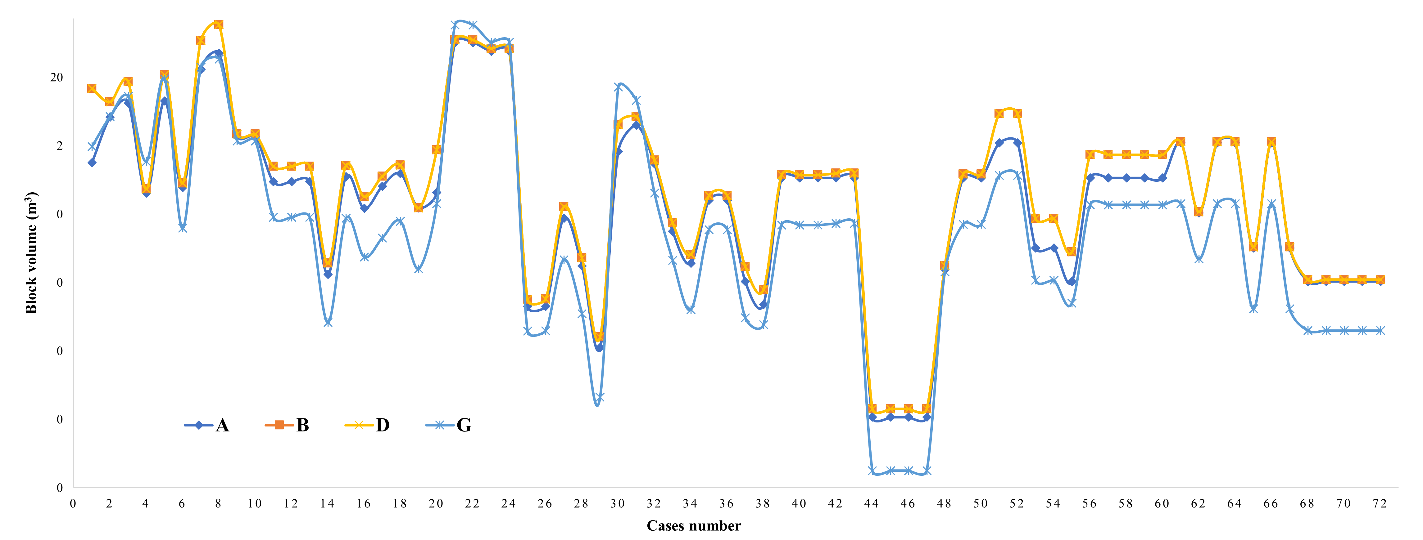
Fig 1. Graphical representation of the block volumes determined using methods A, B, D, and G
Method C is not considered in the graphical representation of Fig 1, as it gives unrealistically values for some joint set. In method C, the absolute value of the cosine of the angle between two joint sets is considered, in order to avoid negative values for the volumes, for angles greater than 90° (Umili et al. 2020). Methods B and D give the same values of the block volume, and in the 44% of cases (32 of 72 cases) the volumes calculated by these methods are different from the other methods A and G. These 32 cases either include low average angles between joint sets (γi <75°), or by wide average spacing values of some joint set (Si > 2m). On the other hand, the 40 cases where these methods give similar results are characterized by a value of Si ≤ 2m and of γi ≥ 75° (Appendix A). It shows that if the joint sets are deviating from orthogonality, block volume is either overestimated or underestimated. Methods A, B, D and G only show the same results for 4 cases (5%), and these 4 cases are characterized by Si < 0.5 m, which are equivalent to blocks whose orthogonality has little influence on their volume. Method A is only applicable for orthogonal joint sets, which does not reflect the majority of the rock mass cases. However, method B, D and G are general formulas for all rock mass cases. The block volumes calculated by method G can be influenced by the Sa value, because using and average spacing can lead to overestimation or underestimation of the rock block volume. By studying the effect of the smaller discontinuity spacing on the mean discontinuity spacing, in a study conducted by Moomivand et al. (2021) on the effect of the smaller values on the estimated mean discontinuity spacing, it has been observed that the standard deviation of spacing distribution has significantly high value, and it may be up to or greater than the mean discontinuity spacing. Therefore, estimating the block size by method G can give an unrealistic value (Moomivand et al. 2021). As methods B and D are equivalent, one of them can be illustrated as a representative. To evaluate the reliability of these methods, we compare the results of method D to that of 3DEC modeling on 28 cases of rock mass (Fig 2, Table 2).
3DEC is a numerical program whose accuracy and reliability are recognized by several authors to characterize the volume of the rock blocks (Kalenchuk et al. 2006; Kalenchuk et al. 2008; Buyer et al. 2020; Umili et al. 2020). This software is based on the distinct element method, and uses a mapping system by using coordinates identification to calculate surface and volume (Itasca Consulting Group 2021). A brief summary of this method is provided in Appendix B.
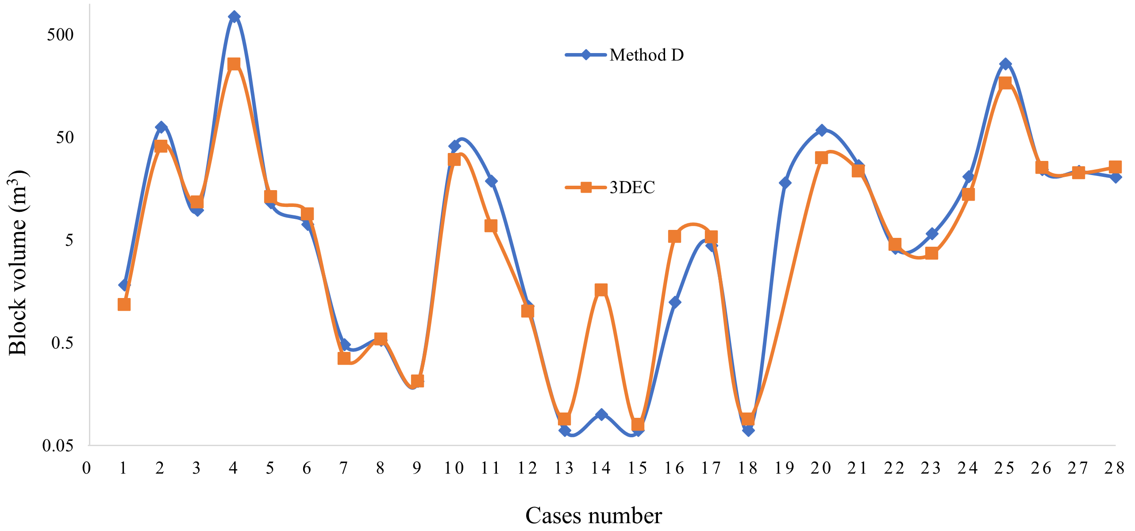
Fig 2. Block volume calculation for a rock mass that includes three joint sets using method D and 3DEC software
Table 2 Block volume calculation for a rock mass that includes three joint sets using method D (Table 1) and 3DEC software
 | Joint set 1 |  |  | Joint set 2 |  |  | Joint set 3 |  |  | Block volume (m³)
Case | DIP | DD | Spacing (m) | DIP | DD | Spacing (m) | DIP | DD | Spacing (m) | Method D | 3DEC
1 | 90 | 350 | 0.98 | 61.57 | 10 | 0.87 | 81.96 | 29 | 0.35 | 1.82 | 1.17
2 | 90 | 10 | 3.94 | 67.16 | 340 | 0.35 | 90 | 350 | 3.94 | 62.81 | 40.49
3 | 90 | 10 | 3.94 | 90 | 70 | 1.37 | 43.16 | 300 | 1.37 | 9.78 | 11.64
4 | 80 | 0 | 0.98 | 90 | 10 | 3.94 | 90 | 350 | 3.94 | 748.44 | 257.29
5 | 43.16 | 60 | 0.34 | 67.16 | 20 | 3.46 | 67.16 | 340 | 3.46 | 11.51 | 13.07
6 | 90 | 10 | 0.39 | 90 | 30 | 0.87 | 67.16 | 340 | 3.46 | 7.07 | 8.9
7 | 43.16 | 60 | 0.34 | 60 | 0 | 3.46 | 23.26 | 330 | 0.14 | 0.48 | 0.35
8 | 20.32 | 10 | 0.34 | 90 | 70 | 0.34 | 67.16 | 340 | 3.46 | 0.53 | 0.54
9 | 21.34 | 340 | 0.34 | 80 | 0 | 0.98 | 43.16 | 60 | 0.34 | 0.21 | 0.21
10 | 90 | 30 | 0.87 | 90 | 350 | 0.98 | 80 | 0 | 3.94 | 41.04 | 30.1
11 | 80 | 0 | 0.98 | 67.16 | 340 | 0.87 | 60 | 0 | 0.87 | 18.81 | 6.84
12 | 90 | 10 | 0.98 | 61.57 | 350 | 3.46 | 43.16 | 60 | 0.14 | 1.13 | 1.01
13 | 90 | 10 | 0.39 | 90 | 350 | 0.39 | 43.16 | 60 | 0.14 | 0.07 | 0.09
14 | 80 | 0 | 0.39 | 43.16 | 60 | 0.14 | 90 | 350 | 0.39 | 0.10 | 1.62
15 | 67.16 | 20 | 0.87 | 90 | 70 | 0.14 | 21.34 | 340 | 0.34 | 0.07 | 0.08
16 | 67.16 | 20 | 0.87 | 43.16 | 60 | 1.37 | 90 | 350 | 0.39 | 1.24 | 5.38
17 | 90 | 350 | 0.98 | 90 | 10 | 0.98 | 43.16 | 60 | 1.37 | 4.41 | 5.34
18 | 43.16 | 60 | 0.14 | 90 | 10 | 0.39 | 90 | 350 | 0.39 | 0.07 | 0.09
19 | 90 | 30 | 0.35 | 90 | 350 | 3.94 | 90 | 10 | 0.98 | 17.97 | N/A
20 | 90 | 10 | 3.94 | 90 | 350 | 3.94 | 60 | 0 | 0.35 | 58.29 | 31.44
21 | 20 | 0 | 2 | 20 | 120 | 1 | 10 | 300 | 3 | 26.55 | 23.39
22 | 30 | 20 | 4 | 10 | 100 | 1 | 80 | 300 | 0.5 | 4.14 | 4.52
23 | 39 | 44 | 1 | 10 | 130 | 2 | 20 | 340 | 0.5 | 5.74 | 3.70
24 | 0 | 10 | 1 | 30 | 45 | 2 | 40 | 340 | 2 | 20.71 | 13.73
25 | 0 | 0 | 2 | 30 | 130 | 2 | 20 | 27 | 7 | 259.28 | 167.64
26 | 70 | 20 | 2 | 45 | 70 | 3.5 | 40 | 240 | 2.5 | 24.14 | 25.30
27 | 0 | 10 | 1 | 60 | 100 | 3 | 70 | 20 | 6 | 23.28 | 22.46
28 | 55 | 60 | 2 | 20 | 95 | 3 | 90 | 180 | 2 | 20.57 | 25.47

Based on Fig 2 and Table 2, a considerable difference exists between the block volume calculated by method D and the output of numerical simulation using 3DEC. This comparison shows that the block volume calculated by method D deviates in 40 % of the cases (11/28) from 3DEC calculation. Overestimating or underestimating the size of the blocks induces an error in the characterization of the rock mass. Case number 19 (Table 2) presents a set of joints forming columnar blocks. For a better understanding of this concept, a 3D model of case 19 with different spacing values is illustrated in Fig 3. The spacing value used in Fig. 3 is slightly different from case number 19 for a better visualization of the formed block, as it does not affect the issue. Method D gives a value of block volume for cases 19 (Table 2), although the numerical modeling specifies these cases as not applicable (N/A). In addition to the findings that method D yields different block volume values from the real in-situ block volume (Elci et Turk 2014; Yarahmadi et al. 2018), its reliability is once again questioned, as these limitation or outliers mentioned above have never been specified regarding this method.
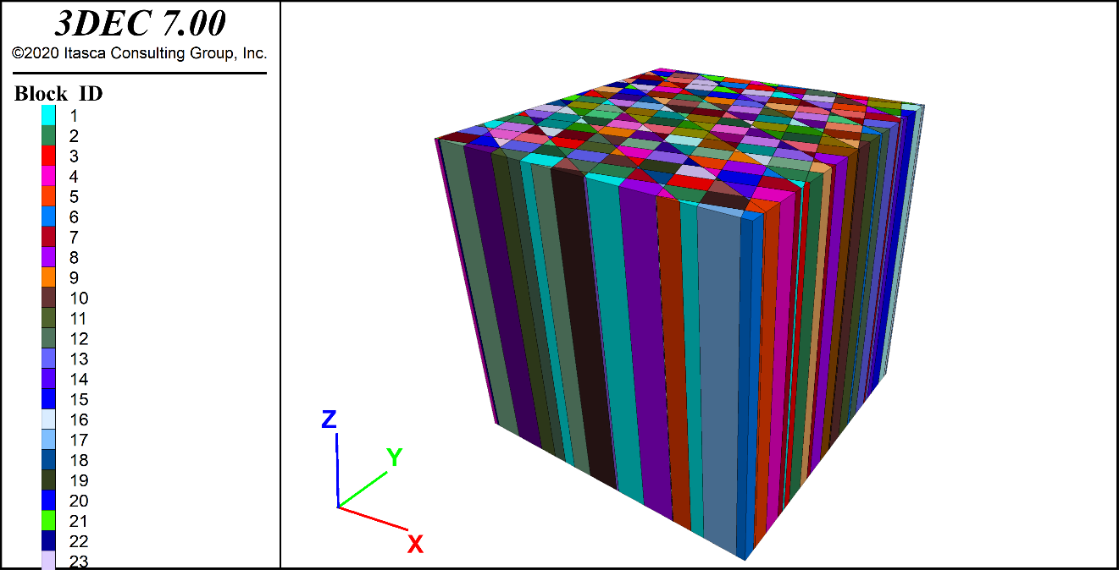
Fig 3. A 20 x 20 m rock mass that includes three joint sets with dip/dip direction according to case number 11 of Table 2, but with different spacings (2, 3, and 4 meters for joint sets 1, 2, and 3, respectively).
From the above information on analytical methods for determining in-situ block size of the rock mass, we can deduce the following points:
- Analytical methods for determining the volume of rock blocks are interesting. However these methods are not applicable for all cases of in-situ rock mass. For non-orthogonal joint sets, these methods overestimate or underestimate the size of the blocks.
- These methods must be modified in order to be able to be applied to different cases of in-situ rock mass. Therefore, in the next section, an analytical solution is proposed to overcome this problem.

Development of an analytical model for block volume calculation
The development of this method has required a review of the characteristic elements of a jointed rock mass, in order to determine those needed for block volume calculation. A vector model is developed to calculate the block volume in the case of three persistent joint sets. The method is also validated by 3D numerical modeling using 3DEC software (Itasca Consulting Group 2021).

Fractured system parameters for block volume calculation
Rock mass consists of intact rock bounded by a system of discontinuities (joint sets). In a fractured rock mass, a “joint set” refers to a family of parallel and evenly spaced planar discontinuities that are characterized by dip, dip direction, spacing, and other significant parameters, as shown in Fig 4. The mechanical properties of a rock mass depend largely on the characteristics of the system of discontinuities and the strength of the intact rock (Singh et Basu 2018).
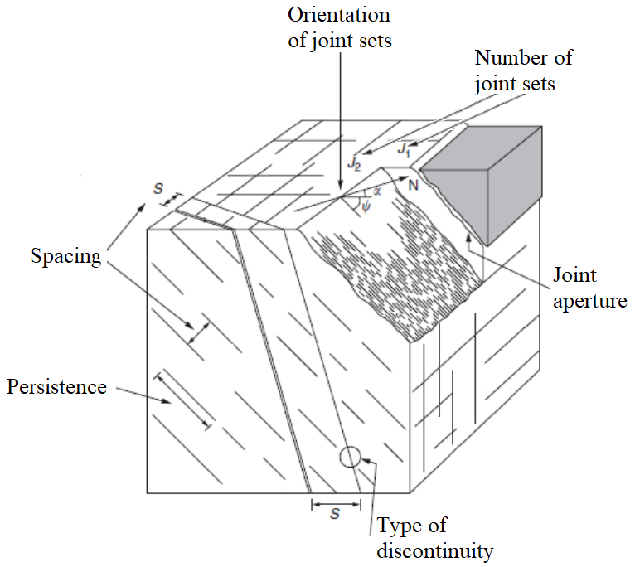
Fig 4. The structural characteristics of a rock mass
Based on Fig 4, a rock mass is an assembly of blocks everyone adjacent to others. Block shape and dimensions are defined by geometrical characteristics of joint sets (i.e. the number of joint sets, their spacing, and the dip, the dip direction, and the persistence of individual joints). However, other geometrical properties of the rock mass, such as aperture and surface profile, do not affect the block volume. For example, in a rock mass that is created by the intersection of three persistent joint sets (Fig 5), dip, dip-direction, and spacing are the only parameters that define block volume. In addition, according to Palmström (Palmström 1995), the random joints define the block volume for a rock mass that includes less than three joint sets. In the cases of more than three joint sets, the block volume could be determined by considering only the three dominant joint sets. Based on this statement, three non-parallel and non-vertical joint sets are needed to form a block (Shahbazi et al. 2021a; Shahbazi et al. 2021b).
However, by creating a numerical model, most of the blocks located along a boundary are also cut by the boundaries of the model; only inner blocks remain intact, as shown in Fig 5b and c, respectively. The outcomes of all previously developed and current models are used to calculate the volume of the intact blocks (Fig 5c).
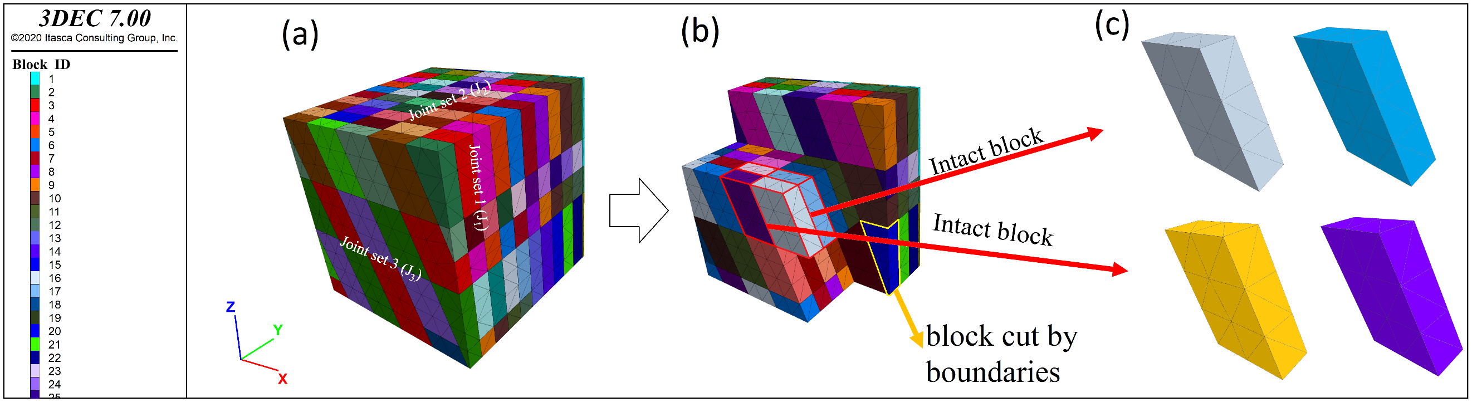
Fig 5. The methodology used for the analytical calculation of the block volume; (a) a model comprising three persistent joint sets, each set having a single value for dip, dip-direction, and spacing; (b) blocks that are not cut by the boundaries of the model and boundary blocks; (c) intact blocks that are all identical in dimension and volume.
Except for the boundary blocks, the geometries of all other blocks are identical, as illustrated in Fig 5c. One of the intact blocks in Fig 5c is selected and analyzed in detail in Fig 6, showing the geometric and trigonometric elements that characterise one block.
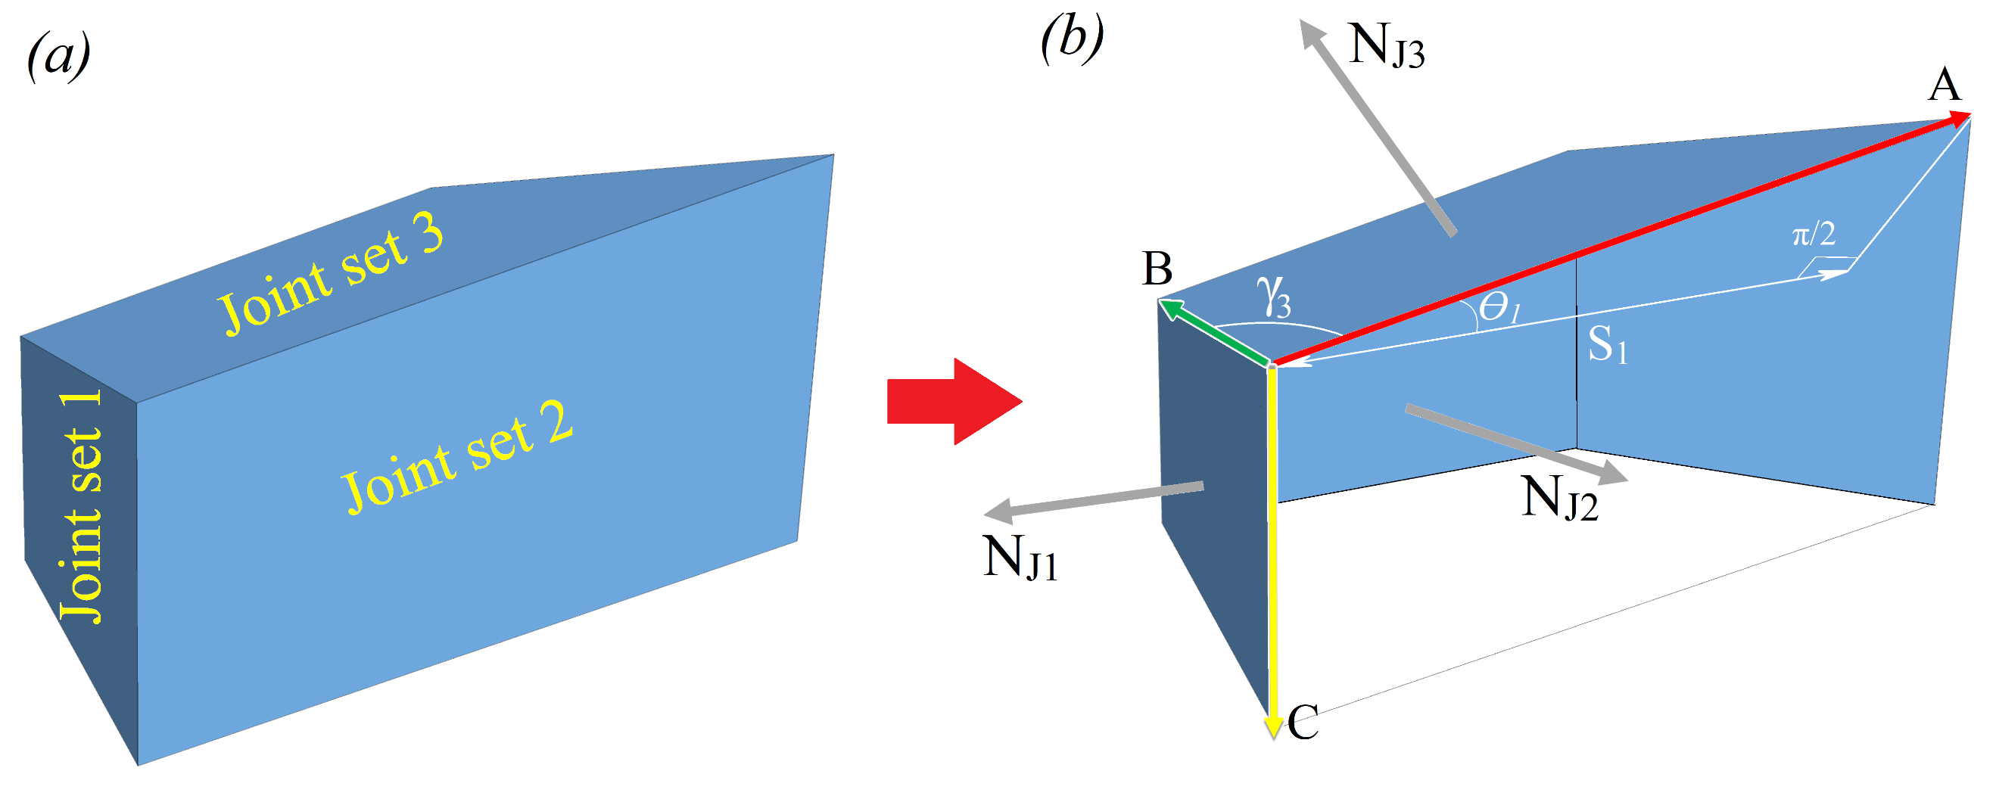
Fig 6. Block volume calculation method: (a) an intact block produced by three joint sets. (b) Illustration of the following parameters: the normal to joint set (N_{J1}, N_{J2} and N_{J3}), the edge vectors (A, B, and C), the true spacing of joint set 1 (S₁), the angle between edge vector A and S₁ (θ₁), the angle between joint sets 1 and 2 ($γ_{3}$)
The existing methods, for example method D (Table 1), preferentially use the spacing and the angle between the faces of the block, to calculate the volume of the block. These parameters are the spacing (Si) and the angle ($γ_{i}$) between joint sets in the rock mass. The equations used by these methods comprises three parts of S_{i}/$\sin{γ_{i}}$ ≈ Sp_{i}, where Sp_{i} is the apparent spacing of joint set i. Thus, the volume of the block as calculated by Eq. D is the result of the multiplication of three apparent spacing values. However, the results presented in section 2 show that this method for determining the spacing does generate over or under-estimation in the case of non-orthogonal joint sets. The errors in the estimate related to factor S_{i}/$\sin{γ_{i}}$ ≈ Sp_{i}, is illustrated by a basic geometrical representation (Fig 7).
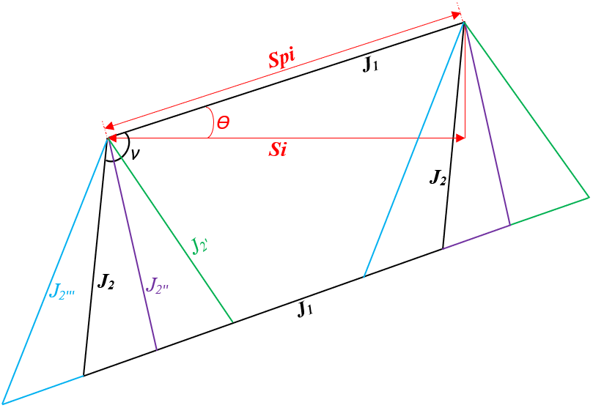
Fig 7. 2D representation of one face of a block delimited by the two non-orthogonal joint sets (J₁ and J₂). Different Dip are attributed to J₂ represented by J_{2’}, J_{2’’} and J_{2’’’}, allowing to have several shapes for a constant area.
In Fig 7, one face of the block is delimited by two non-orthogonal joint sets (J₁ and J₂). We notice that J₂ can have a constant value of Si, but with different values of angle $γ_{i}$ with J₁. Thus, this possibility to have several $γ_{i}$ to calculate the same Spi clearly leads to overestimation (Table 3). As illustrated in Fig 7, random values of $γ_{i}$ were used to calculate Spi for Si = 2 m.
In Table 3, calculation of the apparent spacing between J₁ an J₂ with different values of $γ_{i}$ is performed, as illustrated in Fig 7.
Table 3 Calculation of the apparent spacing different values of $γ_{i}$.
Joint sets | $γ_{1-2}$ (°) | Si (m) spacing of J₂ | Spi (m) | Formula
J₁ vs J₂ | 100 | 2 | 2.03 | S_{i}/$\sin{γ_{1-2}}$ ≈ Sp_{i}
J₁ vs J_{2’} | 60 |  | 2.30
J₁ vs J_{2’’} | 90 |  | 2.00
J₁ vs J_{2’’’} | 130 |  | 2.61
From Table 3, it can be deduced that the over-estimation of the block volume shown in Figs 1, and 2, are due to the errors related to the method of calculation. Using the angles between joint sets to calculate the block volume is not an optimal choice, as it overestimates the volume. In Fig 7, different inclination of two parallel joints can take place by keeping a constant spacing. This aspect influences more the angle that these joints form with respect to other sets of which intersect them. Hence, the error associated with the existing analytical equations for calculation of the volume of the blocks, arises from this issue.
However, the angle (θ) formed between the true spacing and the apparent spacing (normal to joint sets and the direction of the edge vectors (Fig 6b) remains constant with the multiple cases of disposition of the joint sets 2 (J₂) (Fig 7). This issue shows the relevance of this angle for determining the block volume. Surprisingly, this is not the first time that this parameter has been identified as being relevant for determining block volume. Hudson and Priest (1979) mentioned the relevance of this angle in their method of estimating the volume of the blocks on borehole data (Hudson et Priest 1979; Stavropoulou et Xiroudakis 2020). However, no reliable information exists regarding the determination of this parameter for the outcrop or underground excavations. It is probably due to the complexity of determining this angle, that would be as a result of the absence of a reliable method to determine it. Very recently, Stavropoulou and al., used Hudson and al., 1979 method to develop IBSD method, despite determining the volume of the intact blocks was not considered in their work (Stavropoulou 2014; Stavropoulou et Xiroudakis 2020).
In the next section, a vector method for determining the block volume has been developed based on vectoral multiplication.

Analytical method for bloc volume calculation
The shape of the blocks in a rock mass depends directly on the geometry of the joint sets, their intersection forming parallelepipeds (Fig 5). The following is a review of trigonometric rules (Andreescu et Gelca 2008; Proulx et Pimm 2008; Kattan 2009) that are relevant to the determination of block shape.
- The volume of a parallelepiped can be found by calculating the absolute value of the mixed product of the three edge vectors A, B and C (Fig 6b).
- Each edge vector A, B and C is a product of its unit vector and its magnitude.
- And each face of the parallelepiped is characterized by a unit normal vector N_{J1}, N_{J2}, and N_{J3} (Fig 6b), which designates the normal vectors to joint sets planes in the context of the rock mass.
Thus, the block volume (V_{b}^{A}) can be calculated using Eq 1.
$$V_{b}^{A}=\left|\left(\overset{⃑}{A}×\overset{⃑}{B}\right).\overset{⃑}{C}\right|$$ | 1
In this equation, the multiplication sign (×) demonstrates the cross product, and the point (.) shows the inner product of a pair of vectors. The magnitude of the edge vectors A, B, and C in Eq. 1 can be determined by Eq. 2.
$$\left|\overset{⃑}{A}\right|= \frac{S_{1}}{\cos{θ_{1}}}$$  $$\left|\overset{⃑}{B}\right|= \frac{S_{2}}{\cos{θ_{2}}}$$  $$\left|\overset{⃑}{C}\right|= \frac{S_{3}}{\cos{θ_{3}}}$$ | 2
where ǀAǀ, ǀBǀ, and ǀCǀ are the magnitudes of each edge vector, S₁, S₂, and S₃ are the true spacings of joint sets 1, 2, and 3, respectively, and Ɵ₁, Ɵ₂, and Ɵ₃ are the angles between normal to joint sets and the direction of the edge vectors (Fig 6b). Thus, each edge vectors in the Eq. 1 can be determined by multiplying its magnitude by its unit vector (Eq. 3).
$$\overset{⃑}{A}=\left|\overset{⃑}{A}\right|×\overset{⃑}{u_{A}}= \frac{S_{1}}{\cos{θ_{1}}}×\overset{⃑}{u_{A}}$$  $$\overset{⃑}{B}=\left|\overset{⃑}{B}\right|× \overset{⃑}{u_{B}}=\frac{S_{2}}{\cos{θ_{2}}}×\overset{⃑}{u_{B}}$$  $$\overset{⃑}{C}=\left|\overset{⃑}{C}\right|×\overset{⃑}{u_{C}}= \frac{S_{3}}{\cos{θ_{3}}}×\overset{⃑}{u_{C}}$$ | 3
Where $\overset{⃑}{u_{A}}$, $\overset{⃑}{u_{B}}$, and $\overset{⃑}{u_{C}}$ are the unit vectors of each edge vectors A, B, and C, respectively, which directions could be defined by Eq. 4.
$$\overset{⃑}{u_{A}}=\frac{\overset{⃑}{N_{J2}}×\overset{⃑}{N_{J3}}}{\left|\overset{⃑}{N_{J2}}×\overset{⃑}{N_{J3}}\right|}$$  $$\overset{⃑}{u_{B}}=\frac{\overset{⃑}{N_{J1}}×\overset{⃑}{N_{J3}}}{\left|\overset{⃑}{N_{J1}}×\overset{⃑}{N_{J3}}\right|}$$  $$\overset{⃑}{u_{C}}=\frac{\overset{⃑}{N_{J1}}×\overset{⃑}{N_{J2}}}{\left|\overset{⃑}{N_{J1}}×\overset{⃑}{N_{J2}}\right|}$$ | 4
where N_{J1}, N_{J2}, and N_{J3} are the normal vectors to joint set J₁, J₂, and J₃, respectively. According to Fig 6b, the angle Ɵ in Eq 4 could be defined by considering the inner product of the normal to joint set vectors (N_{J}) and the unit edge vectors (u) according to Eq. 5, as follows:
$$\overset{⃑}{u_{A}}.\overset{⃑}{N_{J1}}=\left|\overset{⃑}{u_{A}}\right|×\left|\overset{⃑}{N_{J1}}\right|×\cos{θ_{1}}$$  $$\overset{⃑}{u_{B}}.\overset{⃑}{N_{J2}}=\left|\overset{⃑}{u_{B}}\right|×\left|\overset{⃑}{N_{J2}}\right|×\cos{θ_{2}}$$  $$\overset{⃑}{u_{C}}.\overset{⃑}{N_{J3}}=\left|\overset{⃑}{u_{C}}\right|×\left|\overset{⃑}{N_{J3}}\right|×\cos{θ_{3}}$$ | 5
Given that u_{A}, u_{B}, and u_{C} and N_{J1}, N_{J2}, and N_{J3} are unit vectors, their absolute values are all equal to 1. Then, by combining Eq. 4 and Eq. 5 we have:
$$\cos{θ_{1}}= \left(\frac{\overset{⃑}{N_{J2}}×\overset{⃑}{N_{J3}}}{\left|\overset{⃑}{N_{J2}}×\overset{⃑}{N_{J3}}\right|}\right). \overset{⃑}{N_{J1}}$$  $$\cos{θ_{2}}= \left(\frac{\overset{⃑}{N_{J1}}×\overset{⃑}{N_{J3}}}{\left|\overset{⃑}{N_{J1}}×\overset{⃑}{N_{J3}}\right|}\right). \overset{⃑}{N_{J2}}$$  $$\cos{θ_{3}}= \left(\frac{\overset{⃑}{N_{J1}}×\overset{⃑}{N_{J2}}}{\left|\overset{⃑}{N_{J1}}×\overset{⃑}{N_{J2}}\right|}\right). \overset{⃑}{N_{J3}}$$ | 6
Considering Eqs. 3, 4, and 6, the vectors A, B, and C could be respectively determined by Eq. 7, as follows:
$$\overset{⃑}{A}= \left|\overset{⃑}{A}\right|×\overset{⃑}{u_{A}}=\frac{S_{1}}{\left(\overset{⃑}{N_{J2}}×\overset{⃑}{N_{J3}}\right). \overset{⃑}{N_{J1}}}×\left(\overset{⃑}{N_{J2}}×\overset{⃑}{N_{J3}}\right)$$  $$\overset{⃑}{B}= \left|\overset{⃑}{B}\right|×\overset{⃑}{u_{B}}=\frac{S_{2}}{\left(\overset{⃑}{N_{J1}}×\overset{⃑}{N_{J3}}\right). \overset{⃑}{N_{J2}}}×\left(\overset{⃑}{N_{J1}}×\overset{⃑}{N_{J3}}\right)$$  $$\overset{⃑}{C}= \left|\overset{⃑}{C}\right|×\overset{⃑}{u_{C}}=\frac{S_{3}}{\left(\overset{⃑}{N_{J1}}×\overset{⃑}{N_{J2}}\right). \overset{⃑}{N_{J3}}}×\left(\overset{⃑}{N_{J1}}×\overset{⃑}{N_{J2}}\right)$$ | 7
Thus, in the context of an in-situ rock mass, the normal vector to joint sets (N_{J1}, N_{J2}, and N_{J3}) could be respectively defined by Eq. 8, as follows:
$$\overset{⃑}{N_{J1}}= \left(\sin{{DD}_{1}}.\sin{D_{1}}\right)\overset{⃑}{i}, \left(\cos{{DD}_{1}}.\sin{D_{1}}\right)\overset{⃑}{j}, \left(-\cos{D_{1}}\right)\overset{⃑}{k}$$  $$\overset{⃑}{N_{J2}}= \left(\sin{{DD}_{2}}.\sin{D_{2}}\right)\overset{⃑}{i}, \left(\cos{{DD}_{2}}.\sin{D_{2}}\right)\overset{⃑}{j}, \left(-\cos{D_{2}}\right)\overset{⃑}{k}$$  $$\overset{⃑}{N_{J3}}= \left(\sin{{DD}_{3}}.\sin{D_{3}}\right)\overset{⃑}{i}, \left(\cos{{DD}_{3}}.\sin{D_{3}}\right)\overset{⃑}{j}, \left(-\cos{D_{3}}\right)\overset{⃑}{k}$$ | 8
where DD₁, DD₂, and DD₃ are the dip directions, and D₁, D₂, and D₃ are the dip of the joint sets 1, 2, and 3, respectively. Finally, block volume could be specified through the incorporation of Eqs. 7 and 8 into Eq. 1. By obtaining information on the values of the dip, the dip direction, and the true spacing of the three joint sets, the volume of the intact blocks could be determined by Eq. 1.

Model validation
The data of Table 2 are used to compare the results of method D (Table 1) with the developed equation 1, and the output of the numerical simulations using 3DEC version 7 software (Itasca Consulting Group 2021) (Fig 8, Table 4).
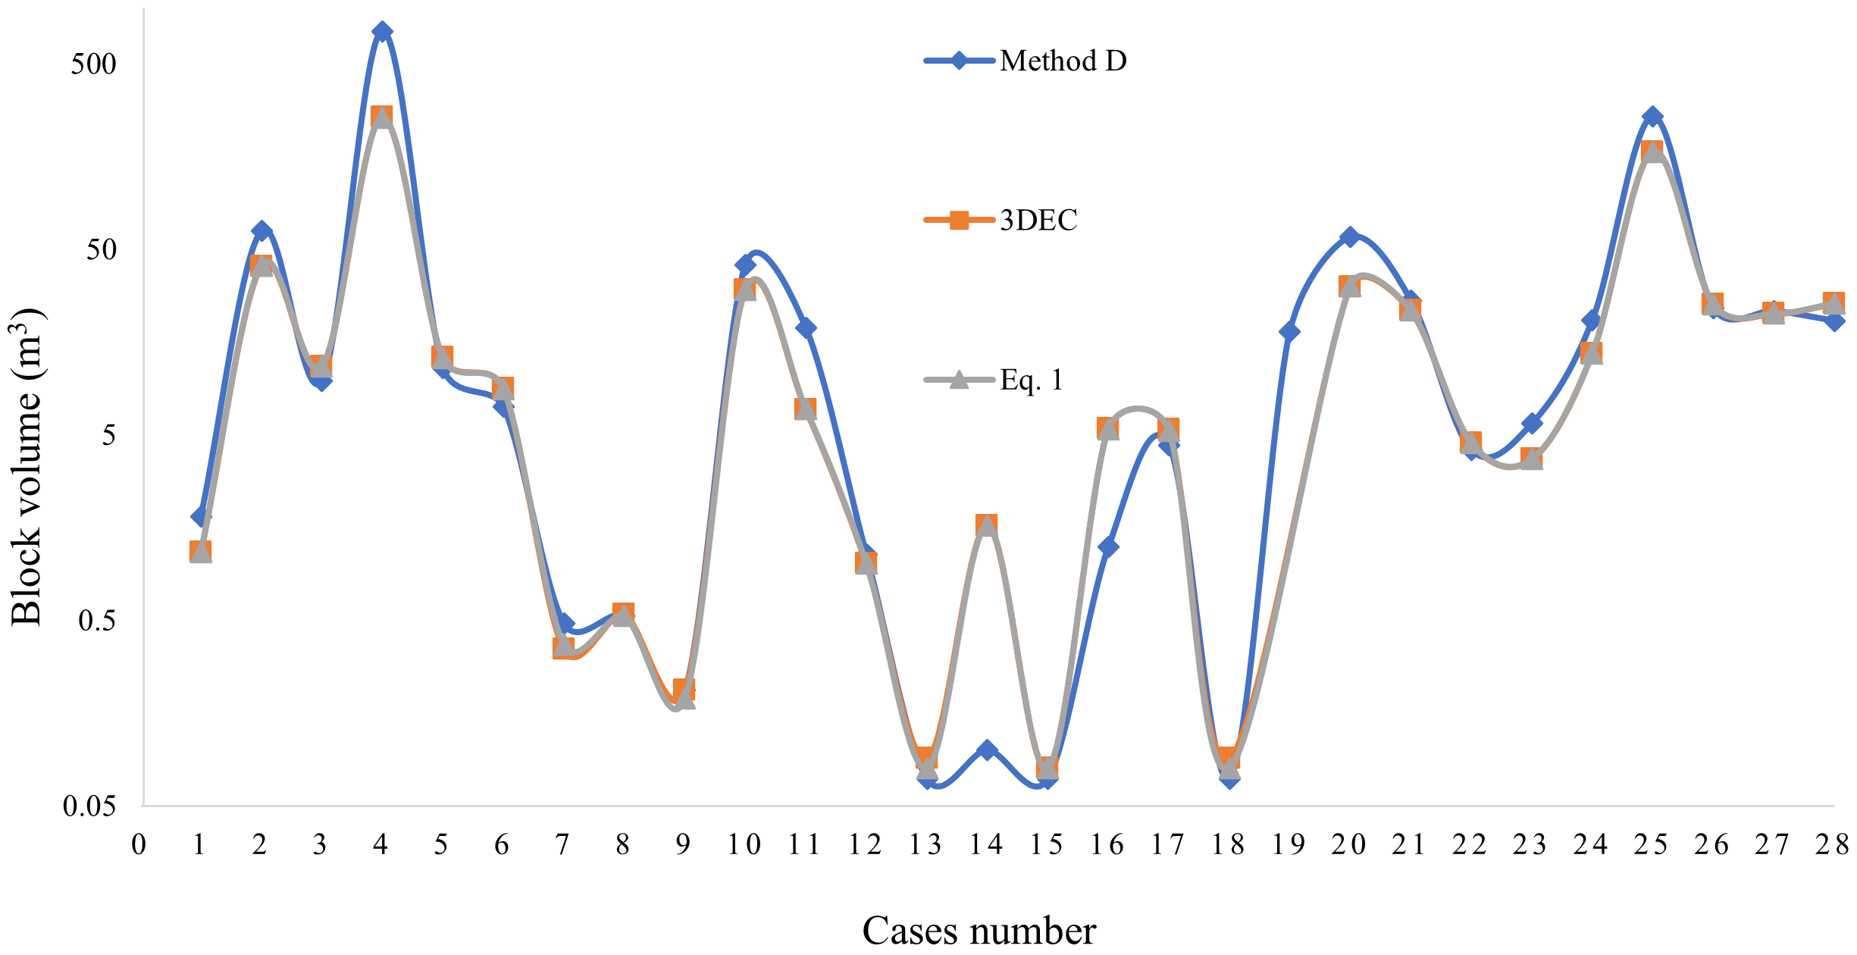
Fig 8. Block volume calculation for a rock mass that includes three joint sets using different analytical methods and 3DEC software
Table 4 Lists of the block volume calculation for a rock mass that includes three joint sets using analytical method D, Eq. 1, and 3DEC software
Case | Block volume (m3)
 | Method D | 3DEC | Eq. 1
1 | 1.82 | 1.17 | 1.17
2 | 62.81 | 40.49 | 40.92
3 | 9.78 | 11.64 | 11.71
4 | 748.44 | 257.29 | 256.44
5 | 11.51 | 13.07 | 12.94
6 | 7.07 | 8.9 | 8.84
7 | 0.48 | 0.35 | 0.37
8 | 0.53 | 0.54 | 0.53
9 | 0.21 | 0.21 | 0.19
10 | 41.04 | 30.1 | 30.09
11 | 18.81 | 6.84 | 6.88
12 | 1.13 | 1.01 | 1.01
13 | 0.07 | 0.09 | 0.08
14 | 0.10 | 1.62 | 1.62
15 | 0.07 | 0.08 | 0.08
16 | 1.24 | 5.38 | 5.36
17 | 4.41 | 5.34 | 5.27
18 | 0.07 | 0.09 | 0.08
19 | 17.97 | N/A | N/A
20 | 58.29 | 31.44 | 31.77
21 | 26.55 | 23.39 | 23.39
22 | 4.14 | 4.52 | 4.52
23 | 5.74 | 3.70 | 3.70
24 | 20.71 | 13.73 | 13.73
25 | 259.28 | 167.64 | 168.03
26 | 24.14 | 25.30 | 25.30
27 | 23.28 | 22.46 | 22.45
28 | 20.57 | 25.47 | 25.47

According to Fig 8 and Table 4, a major difference exists in most of the cases between the results of the previously developed model (method D) and the output of the numerical simulations. However, the block volume calculation with the developed model in this article is completely in accordance with the results of 3DEC. The curves of the block volumes obtained from 3DEC, and Eq. 1 are exactly the same.
Based on Eq. 1, the block volume is defined by the inner and cross products of parallelepiped edge vectors. If all edge vectors (A, B, and C) are perpendicular to each other, the volume of the formed block is equal to the product of the edge’s values. This case is correctly calculated by considering Ɵ₁ = Ɵ₂ = Ɵ₃ = π/2 in Eqs. 6 and 7. Accordingly, the block volume is defined by V_{b}^{A} = ǀAǀ×ǀBǀ×ǀCǀ. However, the volume of the case number 19 (Table 4) is estimated at 17.97 m³ by method D, despite the fact that Eqs. 1 and the numerical model estimate an infinite block volume for this case. As shown in Fig 3, case number 19 corresponds to blocks that are elongated vertically, and by increasing the size of the simulation domain, the blocks expand in an unlimited manner. The output obtained using the developed analytical model (Eq. 1) is in accordance with the results of the numerical simulations, and both are in conflict with the results obtained from the previously developed analytical equations.

Discussion
The geomechanical and geometrical characteristics of joints have an indisputable impact on the mechanical properties of rock mass. In this regard, block volume is a geometrical parameter that has a significant impact on the mechanical properties of a fractured rock mass. The commonly used methods for calculating block size in a fractured rock mass have been developed based on measurements of spacings and the orientation of the joint sets. Palmstrom’s equation (method D, Table 1) is one of the most widely used method, based on the spacings of three persistence joint sets and the angle between them.
A very similar logic has been used in the development of the other equations for the calculation of block volume. However, there are two major criticisms in utilization of these methods. First, the approximation of the volume of a parallelepiped block by multiplication of the apparent spacings is by itself is subjected to errors. Secondly, the apparent spacings is used instead of the true spacing and the angle between joint sets. It is apparent from Fig 8, that for the same spacing, several angles between two joint sets can form, thus leading to errors in the determination of the volume of the blocks. Figures 1, 2 and 8 show differences and errors produced by different methods of block volume calculation. The magnitude of these errors varies from one method to another, and it is more important when the joint sets deviate from orthogonality; this constitutes a significant limitation in the application of existing methods. As presented above, the developed equation (Eq. 1) gives reliable estimates of block volume and is applicable to all disposition cases of joint sets (orthogonal and non-orthogonal), with the exception of vertical joint sets (case 19 of Table 2). The reliability of these equations is also validated by the results of numerical simulations using 3DEC software.
Equations 6 and 8 set up in this article on the basis of vectoral multiplication, resembles that of Hudson and Priest (Hudson et Priest 1979), and this can lead to misinterpretation. However, these equations differ in terms of method of determination and results obtained. Regarding the determination of Ɵ, Hudson and Priest used the followings equations.
$$n.m=\left|n\right|∙\left|m\right|∙\cos{θ}$$ | 11
$$n=\left[\sin{α_{i}}\sin{β_{i}}\sin{α_{i}}\cos{β_{i}}\cos{α_{i}}\right]$$ | 12
$$m=\left[-\sin{β}\cos{α} -cos{β}\cos{α}\sin{α}\right]$$ | 13
In these equations, $θ$ is the acute angle between the normal to the joint planes and the borehole axis, determined by using the scalar product of the unit vector n normal to the joint planes of a set and of the vector m parallel to the borehole (Eq. 11). This equation represents the case where the borehole is vertical, and wherein bold small case letters (n, m) denote vectors and $\left|∙\right|$ denotes the length of the vector it encloses. The unit normal vector of a plane of the i-th joint set with dip angle $α_{i}$ and dip direction angle $β_{i}$ was calculated using Eq. 12. The unit vector of the borehole axis with trend $β$ and plunge $α$ is defined by Eq. 13. So, the angle $θ$ is obtained by substituting Eqs 11, 12 and 13 as follow.
$$\cos{θ}=\cos{α_{i}}\sin{α}-\sin{α_{i}}cos{α}\cos\left(β_{i}-β\right)$$ | 14
Equation 14 is then used to calculate the volume of a block created from three persistent joint sets along the borehole as follow.
$$V=cfA_{3}d_{3}=cf\left(\frac{d_{1}{\cos{θ}}_{1}}{\cos{γ_{23}}}\frac{d_{2}\cos{θ_{2}}}{\cos{γ_{13}}}\sin{γ_{12}}\right)d_{3}$$ | 15
Where $d_{3}$ is the true distance or spacing between consecutive joints of the set 3, $A_{3}$ is the area of the face of the block given by the term between in the parenthesis of Eq. 15, in which ${ d}_{1}$ and ${ d}_{2}$ are the apparent spacing of joint of sets 1 and 2 respectively, measured along the borehole, $θ_{1}$ and $θ_{2}$ are the angles between the normal vectors to the joint planes 1, 2, respectively and the borehole axis. $γ_{i-i}$ is the angle formed between joint planes i-i, founded from vector product of the vectors of the edges (n_{i-i}) formed by the intersection of planes 1 and 3 and of planes 2 and 3 the following manner.
$$n_{13}×n_{13}=\left|n_{13}\right|∙\left|n_{23}\right|∙{\sin{γ}}_{12}∙n_{3}$$ | 16
Where the edges vector n_{i-i} = n_{i} × n_{i} and the normal unit vectors on the joint planes (n_{i}) are founded by using Eq 12. The last term in Eq. 15, is an orientation correction factor ($cf$), which can be determined as follows.
$$cf=\frac{{\cos{θ}}_{1}\cos{θ_{2}}\cos{θ_{3}{\sin{γ}}_{12}}}{\cos{γ_{23}}\cos{γ_{13}}}$$ | 17
Thus, this review clearly shows the differences between the equations developed in this article and those presented by Hudson and Priest (Hudson et Priest 1979). A summary of notable differences is given in Table 5.
Table 5 Differences between the current method and that of Hudson (Hudson et Priest 1979)
 | Hudson (Hudson et Priest 1979) | Current method
Context of methods development and application | Borehole | Outcrop
Angle $θ$ | Cute angle subtended between the normal to the joint planes and the borehole axis. | Angles between normal to joint sets and the direction of the edge vector.
Unitor vector of the joint set planes | $$n=\left[\sin{α_{i}}\sin{β_{i}}\sin{α_{i}}\cos{β_{i}}\cos{α_{i}}\right]$$ | $$N_{Ji}= \left(\sin{{DD}_{i}}.\sin{D_{i}}\right) \left(\cos{{DD}_{i}}.\sin{D_{i}}\right) \left(-\cos{D_{i}}\right)$$
Borehole vector | $$m=\left[-\sin{β}\cos{α} -cos{β}\cos{α}\sin{α}\right]$$ | N/A
Borehole correction factor | $$cf=\frac{{\cos{θ}}_{1}\cos{θ_{2}}\cos{θ_{3}{\sin{γ}}_{12}}}{\cos{γ_{23}}\cos{γ_{13}}}$$ | N/A
Where: $n$ = unit normal vector to the joint set, $m$ = unit vector of the borehole axis, $α_{i}$ = dip angle of the joint set i, $α$ = plunge of the borehole, $β_{i}$ = dip direction of the joint set i, $β$ = trend of the borehole, $cf$ = orientation correction factor, $θ_{i}$= cute angle between the normal to the joint planes i and the borehole axis, $γ_{i-i}$= angle between two joints set, $N_{Ji}$ = normal vector to joint set i, ${DD}_{i}$ = dip direction of the joint set i, and $D_{i}$ = dip of the joint set i.
Apart from the differences summarized in Table 5, the method of Hudson and Priest are relatively empirical in nature and are not applicable to surface data. These aspects justify why this method has not been further upgraded. In addition, Eq. 12 used in the Hudson and Priest method, could provide erroneous values, because it is different from Eq. 8 obtained according to the trigonometric rules for determining the volume of a parallelepiped. However, it must be recognized that the information presented by Hudson and Priest (Hudson et Priest 1979) is very remarkable. Part of the content of this article could be considered as an extension of this method.
The analytical solution presented in this article comes from an analysis of the existing methods (Table 1). Using trigonometric rules, a solution was developed to solve problems in the methods used to determine the volume of rock blocks (Table 1). Using the trigonometric definitions for determining the volume of a parallelepiped, reliable formulas have been developed to calculate the volume of a block of rock. To facilitate the use of Eq. 1, an Excel spreadsheet for calculating the block volume is attached to this article.

Conclusion
An analytical model based on a vector product has been developed to calculate the block volume for the case of three persistent joint sets with constant spacing and orientation values. The accuracy of the model is validated using numerical simulation. Thus, the proposed method could be applied based on the vector product (an Excel spreadsheet is attached to this article) using the values of dip, dip direction, and spacing of joint sets. This method is easily applicable in the in-situ characterization of the volume of the blocks in a rock mass because it gives a reliable result for all the cases of rock mass, excepted vertical joint sets (case 19 of Table 2). This method is applicable for both blocks formed by orthogonal joint sets, as well as those formed by non-orthogonal joint sets. A limitation of this method though, is that it does not consider the cases of non-persistent joint sets.

CRediT authorship contribution
A.S.K: Formal analysis, Conceptualization, Resources, Investigation, Data curation, Writing - Original draft.
Alireza.S: Conceptualization, Resources, Data curation, Software, validation, Methodology, Writing-Original draft.
A.S: Conceptualization, Supervision, Investigation, Methodology, Project administration, Writing - Review and editing.
A.R: Conceptualization, Supervision, Writing - Review and editing.
M.Q: Funding acquisition, Writing - Review and editing.
R.C: Supervision, Writing - Review and editing.

Declaration of Competing Interests
The authors declare that there is no conflict of interest associated with this publication.

Acknowledgment
The authors would like to thank the Natural Sciences and Engineering Research Council of Canada (NSERC) and Hydro-Québec for the funding provided through the RDC (RDC 537350) Program. Furthermore, the authors wish to convey their deep gratitude to the Itasca Consulting Group in Minneapolis for the IEP Research Program, especially Jim Hazzard, for his valuable technical support and advice.

References
Aksoy CO, Geniş M, Uyar Aldaş G, Özacar V, Özer SC et Yılmaz Ö. 2012. A comparative study of the determination of rock mass deformation modulus by using different empirical approaches. Engineering Geology, 131-132 : 19-28.
Andreescu T et Gelca R. 2008. Mathematical olympiad challenges. Springer Science & Business Media.
Annandale G. 1995. Erodibility. Journal Of Hydraulic Research, 33 : 471-494.
Assali P, Grussenmeyer P, Villemin T, Pollet N et Viguier F. 2014. Surveying and modeling of rock discontinuities by terrestrial laser scanning and photogrammetry: Semi-automatic approaches for linear outcrop inspection. Journal of Structural Geology, 66 : 102-114.
Azarafza M, Koçkar MK et Faramarzi L. 2021. Spacing and block volume estimation in discontinuous rock masses using image processing technique: a case study. Environmental Earth Sciences, 80 : 1-13.
Azarafza M, Nanehkaran YA, Rajabion L, Akgün H, Rahnamarad J, Derakhshani R et Raoof A. 2020. Application of the modified Q-slope classification system for sedimentary rock slope stability assessment in Iran. Engineering Geology, 264 : 105349.
Azizi A et Moomivand H. 2021. A new approach to represent impact of discontinuity spacing and rock mass description on the median fragment size of blasted rocks using image analysis of rock mass. Rock mechanics and rock engineering, 54 : 2013-2038.
Barton N, Lien R et Lunde J. 1974. Engineering classification of rock masses for the design of tunnel support. Rock mechanics, 6 : 189-236.
Bieniawski ZT. 1989. Engineering rock mass classifications: a complete manual for engineers and geologists in mining, civil, and petroleum engineering. John Wiley & Sons.
Buyer A, Pischinger G et Schubert W. 2018. Image‐based discontinuity identification: Bildgestützte Trennflächenidentifikation. Geomechanics and Tunnelling, 11 : 693-700.
Buyer A, Aichinger S et Schubert W. 2020. Applying photogrammetry and semi-automated joint mapping for rock mass characterization. Engineering Geology, 264 : 105332.
Cai M, Kaiser P, Uno H, Tasaka Y et Minami M. 2004a. Estimation of rock mass deformation modulus and strength of jointed hard rock masses using the GSI system. International Journal of Rock Mechanics and Mining Sciences, 41 : 3-19.
Cai M, Kaiser PK, Uno H, Tasaka Y et Minami M. 2004b. Estimation of rock mass deformation modulus and strength of jointed hard rock masses using the GSI system. International Journal of Rock Mechanics and Mining Sciences, 41 : 3-19.
Chen Q et Yin T. 2020. Modification of the rock mass rating system (RMR mbi) considering three-dimensional rock block size. Bulletin of Engineering Geology and the Environment, 79 : 789-810.
Deere DU. 1964. Technical description of rock cores for engineering purpose. Rock Mechanics and Enginee-ring Geology, 1 : 17-22.
Elci H et Turk N. 2014. Block Volume Estimation from the Discontinuity Spacing Measurements of Mesozoic Limestone Quarries, Karaburun Peninsula, Turkey. The Scientific World Journal, 2014 : 363572.
Elmo D, Rogers S, Stead D et Eberhardt E. 2014. Discrete Fracture Network approach to characterise rock mass fragmentation and implications for geomechanical upscaling. Mining Technology, 123 : 149-161.
Elmouttie M et Poropat G. 2012. A Method to Estimate In Situ Block Size Distribution. Rock Mechanics and Rock Engineering - ROCK MECH ROCK ENG, 45.
Gaich A et Pischinger G. 2016. 3D images for digital geological mapping: Focussing on conventional tunnelling. Geomechanics and Tunnelling, 9 : 45-51.
Ghaedi Ghalini M, Bahaaddini M et Amiri Hossaini M. 2022. Estimation of In-Situ Block Size Distribution in Jointed Rock Masses using Combined Photogrammetry and Discrete Fracture Network. Journal of Mining and Environment, 13 : 175-184.
Gottron D et Henk A. 2021. Upscaling of fractured rock mass properties – An example comparing Discrete Fracture Network (DFN) modeling and empirical relations based on engineering rock mass classifications. Engineering Geology : 106382.

Grenon M et Hadjigeorgiou J. 2008. A design methodology for rock slopes susceptible to wedge failure using fracture system modelling. Engineering Geology, 96 : 78-93.
Gringarten AC. 1984. Interpretation of tests in fissured and multilayered reservoirs with double-porosity behavior: theory and practice. Journal of petroleum technology, 36 : 549-564.
Hoek E, Carter T et Diederichs M. Quantification of the geological strength index chart. Dans : 47th US rock mechanics/geomechanics symposium, 2013. OnePetro.
Huang R, Huang J, Ju N et Li Y. 2013. Automated tunnel rock classification using rock engineering systems. Engineering Geology, 156 : 20-27.
Hudson JA et Priest SD. 1979. Discontinuities and rock mass geometry. International Journal of Rock Mechanics and Mining Sciences & Geomechanics Abstracts, 16 : 339-362.
Itasca Consulting Group I. 2021. 3DEC — Three-Dimensional Distinct Element Code. Itasca, Minneapolis.
Jia B, Tsau J-S et Barati R. 2019. A review of the current progress of CO2 injection EOR and carbon storage in shale oil reservoirs. Fuel, 236 : 404-427.
Kalenchuk KS, Diederichs MS et McKinnon S. 2006. Characterizing block geometry in jointed rockmasses. International Journal of Rock Mechanics and Mining Sciences, 43 : 1212-1225.
Kalenchuk KS, McKinnon S et Diederichs MS. 2008. Block geometry and rockmass characterization for prediction of dilution potential into sub-level cave mine voids. International Journal of Rock Mechanics and Mining Sciences, 45 : 929-940.
Kattan P. 2009. Math Notebook for Students: 350 Essential Mathematical Formulas and Equations. Petra Books.
Kazi A et Sen Z. Volumetric RQD: An index of rock quality. Dans : International symposium on fundamentals of rock joints, 1985. p. 95-102.
Kim B, Cai M, Kaiser P et Yang H. 2007. Estimation of Block Sizes for Rock Masses with Nonpersistent Joints. Rock Mechanics and Rock Engineering - ROCK MECH ROCK ENG, 40 : 169-192.
Kim BH, Peterson RL, Katsaga T et Pierce ME. 2015. Estimation of rock block size distribution for determination of Geological Strength Index (GSI) using discrete fracture networks (DFNs). Mining Technology, 124 : 203-211.
Kluckner A, Söllner P, Schubert W et Pötsch M. Estimation of the in situ block size in jointed rock masses using three-dimensional block simulations and discontinuity measurements. Dans : 13th ISRM International Congress of Rock Mechanics, 2015. OnePetro.
Latham J-P, Van Meulen J et Dupray S. 2006. Prediction of in-situ block size distributions with reference to armourstone for breakwaters. Engineering Geology, 86 : 18-36.
Li X, Chen Z, Chen J et Zhu H. 2019. Automatic characterization of rock mass discontinuities using 3D point clouds. Engineering Geology, 259 : 105131.
Lopes P et Lana M. 2017. Analytical method for calculating the volume of rock blocks using available mapping data field. Mathematical Geosciences, 49 : 217-229.
Lu P et Latham J-P. 1999. Developments in the assessment of in-situ block size distributions of rock masses. Rock mechanics and rock engineering, 32 : 29-49.
Ma C, Yao W, Yao Y et Li J. 2018. Simulating Strength Parameters and Size Effect of Stochastic Jointed Rock Mass using DEM Method. KSCE Journal of Civil Engineering, 22 : 4872-4881.
Moomivand H, Seadati S et Allahverdizadeh H. 2021. A new approach to improve the assessment of rock mass discontinuity spacing using image analysis technique. International Journal of Rock Mechanics and Mining Sciences, 143 : 104760.
Palmstrom A. The volumetric joint count―a useful and simple measure of the degree of rock mass jointing. Dans : International Association of Engineering Geology International congress 4, 1982. p. 221-228.
Palmstrom A. 2005. Measurements of and correlations between block size and rock quality designation (RQD). Tunnelling and Underground Space Technology, 20 : 362-377.
Palmström A. The volumetric joint count―a useful and simple measure of the degree of rock mass jointing. Dans : International Association of Engineering Geology International congress, India / Netherlands, 1982. A.A. Balkema, p. 221-228.
Palmström A. 1995. RMi-a rock mass characterization system for rock engineering purposes. University of Oslo.
Palmström A. 1996. The Rock Mass index (RMÐ applied in rock mechanics and rock engineering.
Palmström A. 2005. Measurements of and correlations between block size and rock quality designation (RQD). Tunnelling and Underground Space Technology, 20 : 362-377.
Pells S. 2016. Erosion of rock in spillways. University of New South Wales, Australia, 1982 p.
Priest SD et Hudson J. Discontinuity spacings in rock. Dans : International Journal of Rock Mechanics and Mining Sciences & Geomechanics Abstracts, 1976. Elsevier, p. 135-148.
Proulx J et Pimm D. 2008. Algebraic Formulas, Geometric Awareness and Cavalieri's Principle. For the Learning of Mathematics, 28 : 17-24.
Riquelme AJ, Abellán A, Tomás R et Jaboyedoff M. 2014. A new approach for semi-automatic rock mass joints recognition from 3D point clouds. Computers & Geosciences, 68 : 38-52.
Shahbazi A, Saeidi A et Chesnaux R. 2021a. Dependency of the average inflow rate to the tunnel excavated in a fractured rock mass to its length and direction. GeoNiagara, Septermber 2021, Niagara Falls, ON, CA.
Shahbazi A, Saeidi A, Chesnaux R et Rouleau A. 2021b. The Specific Length of an Underground Tunnel and the Effects of Rock Block Characteristics on the Inflow Rate. Geosciences, 11.
Singh HK et Basu A. 2018. Evaluation of existing criteria in estimating shear strength of natural rock discontinuities. Engineering Geology, 232 : 171-181.
Slob S. 2010. Automated rock mass characterisation using 3-D terrestrial laser scanning.
Stavropoulou M. 2014. Discontinuity frequency and block volume distribution in rock masses. International Journal of Rock Mechanics and Mining Sciences, 65 : 62-74.
Stavropoulou M et Xiroudakis G. 2020. Fracture Frequency and Block Volume Distribution in Rock Masses. Rock mechanics and rock engineering : 1-17.
Umili G, Bonetto SMR, Mosca P, Vagnon F et Ferrero AM. 2020. In situ block size distribution aimed at the choice of the design block for rockfall barriers design: A case study along gardesana road. Geosciences, 10 : 223.
Vazaios I, Farahmand K, Vlachopoulos N et Diederichs MS. 2018. Effects of confinement on rock mass modulus: A synthetic rock mass modelling (SRM) study. Journal of Rock Mechanics and Geotechnical Engineering, 10 : 436-456.
Wang X, Ding W, Cui L, Wang R, He J, Li A, Gu Y, Liu J, Xiao Z et Fu F. 2018. The developmental characteristics of natural fractures and their significance for reservoirs in the Cambrian Niutitang marine shale of the Sangzhi block, southern China. Journal of Petroleum Science and Engineering, 165 : 831-841.
Yarahmadi R, Bagherpour R, Taherian S-G et Sousa LMO. 2018. Discontinuity modelling and rock block geometry identification to optimize production in dimension stone quarries. Engineering Geology, 232 : 22-33.

Appendix A
Table 1.A. Characteristic data of the database summarizing the case studies of Pells (Pells 2016)
 | Dip/Dip direction |  |  | Joint spacing (m) |  |  |  | Angle between joint sets (°) |  |  |  |  | Dip/Dip direction |  |  | Joint spacing (m) |  |  |  | Angle between joint sets (°)
 | Joint Set 1 | Joint Set 2 | Joint Set 3 | Joint Set 1 | Joint Set 2 | Joint Set 3 | Average (S_{a}) | Angle 1-2 | Angle 1-3 | Angle 2-3 | Average |  | Joint Set 1 | Joint Set 2 | Joint Set 3 | Joint Set 1 | Joint Set 2 | Joint Set 3 | Average (S_{a}) | Angle 1-2 | Angle 1-3 | Angle 2-3 | Average
1 | 25/110 | 30/230 | 20/220 | 0.75 | 1 | 1.5 | 1.08 | 47 | 36 | 11 | 31 | 37 | 65/250 | 85/190 | 55/350 | 0.4 | 0.13 | 0.4 | 0.31 | 60 | 83 | 135 | 93
2 | 10/50 | 90/192 | 90/50 | 0.35 | 2.5 | 6 | 2.95 | 97 | 80 | 142 | 106 | 38 | 65/250 | 85/190 | 55/350 | 0.4 | 0.06 | 0.4 | 0.29 | 60 | 83 | 135 | 93
3 | 05/50 | 35/50 | 90/120 | 0.35 | 6 | 4 | 3.45 | 30 | 88 | 78 | 65 | 39 | 25/110 | 90/90 | 90/0 | 0.4 | 1.3 | 1.3 | 1.00 | 66 | 98 | 90 | 85
4 | 10/50 | 80/130 | 90/65 | 1.5 | 4.5 | 0.06 | 2.02 | 78 | 80 | 65 | 74 | 40 | 25/110 | 90/90 | 90/0 | 0.4 | 1.3 | 1.3 | 1.00 | 66 | 98 | 90 | 85
5 | 10/50 | 30/350 | 90/50 | 1.2 | 0.75 | 10 | 3.98 | 26 | 80 | 75 | 60 | 41 | 25/110 | 90/90 | 90/0 | 0.4 | 1.3 | 1.3 | 1.00 | 66 | 98 | 90 | 85
6 | 05/50 | 90/140 | 90/80 | 1.75 | 0.4 | 0.7 | 0.95 | 90 | 85 | 60 | 78 | 42 | 25/110 | 90/90 | 60/0 | 0.4 | 1.3 | 1.3 | 1.00 | 66 | 70 | 90 | 75
7 | 5/200 | 80/250 | 80/225 | 1.5 | 1.75 | 10 | 4.42 | 76 | 75 | 24 | 58 | 43 | 25/110 | 90/90 | 60/0 | 0.4 | 1.3 | 1.3 | 1.00 | 66 | 70 | 90 | 75
8 | 5/200 | 80/250 | 80/225 | 1.5 | 3 | 10 | 4.83 | 76 | 75 | 24 | 58 | 44 | 45/55 | 57/235 | 75/0 | 0.06 | 0.06 | 0.06 | 0.06 | 102 | 55 | 109 | 89
9 | 5/200 | 80/225 | 80/140 | 0.65 | 6.5 | 0.65 | 2.60 | 75 | 77 | 83 | 78 | 45 | 45/55 | 57/235 | 75/0 | 0.06 | 0.06 | 0.06 | 0.06 | 102 | 55 | 109 | 89
10 | 5/200 | 80/225 | 80/140 | 0.65 | 6.5 | 0.65 | 2.60 | 75 | 77 | 83 | 78 | 46 | 45/55 | 57/235 | 75/0 | 0.06 | 0.06 | 0.06 | 0.06 | 102 | 55 | 109 | 89
11 | 57/150 | 80/243 | 19/165 | 0.4 | 1.1 | 1.35 | 0.95 | 87 | 38 | 76 | 67 | 47 | 45/55 | 57/235 | 75/0 | 0.06 | 0.06 | 0.06 | 0.06 | 102 | 55 | 109 | 89
12 | 57/150 | 80/243 | 19/165 | 0.4 | 1.1 | 1.35 | 0.95 | 87 | 38 | 76 | 67 | 48 | 25/0 | 60/220 | 63/145 | 0.4 | 0.06 | 1.3 | 0.59 | 80 | 84 | 64 | 76
13 | 57/150 | 80/243 | 19/165 | 0.4 | 1.1 | 1.35 | 0.95 | 87 | 38 | 76 | 67 | 49 | 25/0 | 60/220 | 63/145 | 0.4 | 1.3 | 1.3 | 1.00 | 80 | 84 | 64 | 76
14 | 70/77 | 80/335 | 35/335 | 0.22 | 0.3 | 0.4 | 0.31 | 97 | 80 | 45 | 74 | 50 | 25/0 | 60/220 | 63/145 | 0.4 | 1.3 | 1.3 | 1.00 | 80 | 84 | 64 | 76
15 | 20/74 | 80/335 | 80/290 | 0.8 | 0.55 | 1.6 | 0.98 | 83 | 96 | 44 | 74 | 51 | 20/270 | 72/180 | 85/0 | 1.3 | 1.3 | 1.3 | 1.30 | 73 | 85 | 157 | 105
16 | 20/63 | 80/316 | 75/5 | 0.8 | 0.55 | 0.55 | 0.63 | 86 | 65 | 48 | 66 | 52 | 20/270 | 72/180 | 85/0 | 1.3 | 1.3 | 1.3 | 1.30 | 73 | 85 | 157 | 105
17 | 41/193 | 72/244 | 80/337 | 0.8 | 0.8 | 0.8 | 0.80 | 51 | 113 | 89 | 84 | 53 | 20/270 | 72/180 | 85/0 | 0.4 | 0.4 | 0.4 | 0.40 | 73 | 85 | 157 | 105
18 | 85/280 | 76/51 | 27/208 | 0.65 | 1.5 | 0.8 | 0.98 | 128 | 77 | 101 | 102 | 54 | 20/270 | 72/180 | 85/0 | 0.4 | 0.4 | 0.4 | 0.40 | 73 | 85 | 157 | 105
19 | 90/98 | 90/192 | 0/100 | 0.7 | 0.7 | 0.5 | 0.63 | 94 | 90 | 90 | 91 | 55 | 20/270 | 72/180 | 85/0 | 0.4 | 0.13 | 0.4 | 0.31 | 73 | 85 | 157 | 105
20 | 50/160 | 90/255 | 35/155 | 0.9 | 0.4 | 1.15 | 0.82 | 71 | 15 | 79 | 55 | 56 | 15/150 | 80/250 | 80/90 | 1.3 | 1.3 | 0.4 | 1.00 | 82 | 72 | 151 | 102
21 | 9/105 | 90/237 | 90/170 | 0.4 | 8 | 20 | 9.47 | 96 | 86 | 67 | 83 | 57 | 15/150 | 80/250 | 80/90 | 1.3 | 1.3 | 0.4 | 1.00 | 82 | 72 | 151 | 102
22 | 9/105 | 90/237 | 90/170 | 0.4 | 8 | 20 | 9.47 | 96 | 86 | 67 | 83 | 58 | 15/150 | 80/250 | 80/90 | 1.3 | 1.3 | 0.4 | 1.00 | 82 | 72 | 151 | 102
23 | 9/105 | 90/237 | 90/170 | 0.4 | 8 | 15 | 7.80 | 96 | 86 | 67 | 83 | 59 | 15/150 | 80/250 | 80/90 | 1.3 | 1.3 | 0.4 | 1.00 | 82 | 72 | 151 | 102
24 | 9/105 | 90/237 | 90/170 | 0.4 | 8 | 15 | 7.80 | 96 | 86 | 67 | 83 | 60 | 15/150 | 80/250 | 80/90 | 1.3 | 1.3 | 0.4 | 1.00 | 82 | 72 | 151 | 102
25 | 0/150 | 90/75 | 90/202 | 0.6 | 0.075 | 0.2 | 0.29 | 90 | 90 | 127 | 102 | 61 | 0/0 | 90/10 | 80/290 | 1.3 | 1.3 | 1.3 | 1.30 | 90 | 80 | 80 | 83
26 | 12/150 | 90/75 | 90/202 | 0.6 | 0.075 | 0.2 | 0.29 | 87 | 82 | 127 | 99 | 62 | 0/0 | 90/10 | 80/290 | 0.4 | 1.3 | 0.4 | 0.70 | 90 | 80 | 80 | 83
27 | 10/65 | 62/75 | 90/310 | 0.35 | 1 | 0.5 | 0.62 | 52 | 94 | 120 | 89 | 63 | 0/0 | 90/10 | 80/290 | 1.3 | 1.3 | 1.3 | 1.30 | 90 | 80 | 80 | 83
28 | 35/200 | 90/202 | 90/310 | 0.35 | 0.2 | 0.5 | 0.35 | 55 | 101 | 108 | 88 | 64 | 0/0 | 90/10 | 80/290 | 1.3 | 1.3 | 1.3 | 1.30 | 90 | 80 | 80 | 83
29 | 22/228 | 75/172 | 77/246 | 0.15 | 0.1 | 0.15 | 0.13 | 64 | 56 | 71 | 64 | 65 | 0/0 | 90/10 | 80/290 | 0.4 | 0.4 | 0.4 | 0.40 | 90 | 80 | 80 | 83
30 | 80/278 | 80/130 | 35/280 | 10 | 0.3 | 0.55 | 3.62 | 142 | 45 | 110 | 99 | 66 | 0/0 | 90/10 | 80/290 | 1.3 | 1.3 | 1.3 | 1.30 | 90 | 80 | 80 | 83
31 | 75/278 | 80/130 | 58/200 | 10 | 1 | 0.4 | 3.80 | 101 | 56 | 67 | 75 | 67 | 0/0 | 90/10 | 80/290 | 0.4 | 0.4 | 0.4 | 0.40 | 90 | 80 | 80 | 83
32 | 90/220 | 86/103 | 9/133 | 0.8 | 3 | 0.45 | 1.42 | 116 | 89 | 78 | 94 | 68 | 30/12 | 90/105 | 80/195 | 0.4 | 0.4 | 0.13 | 0.31 | 91 | 110 | 90 | 97
33 | 80/231 | 65/162 | 15/250 | 1.25 | 0.2 | 0.45 | 0.63 | 66 | 65 | 65 | 65 | 69 | 30/12 | 90/105 | 80/195 | 0.4 | 0.4 | 0.13 | 0.31 | 91 | 110 | 90 | 97
34 | 62/243 | 83/144 | 34/130 | 0.19 | 0.45 | 0.45 | 0.36 | 94 | 78 | 50 | 74 | 70 | 30/12 | 90/105 | 80/195 | 0.4 | 0.4 | 0.13 | 0.31 | 91 | 110 | 90 | 97
35 | 25/150 | 35/340 | 85/250 | 0.4 | 2 | 0.4 | 0.93 | 59 | 89 | 86 | 78 | 71 | 30/12 | 90/105 | 80/195 | 0.4 | 0.4 | 0.13 | 0.31 | 91 | 110 | 90 | 97
36 | 25/150 | 35/340 | 85/250 | 0.4 | 2 | 0.4 | 0.93 | 59 | 89 | 86 | 78 | 72 | 30/12 | 90/105 | 80/195 | 0.4 | 0.4 | 0.13 | 0.31 | 91 | 110 | 90 | 97

Appendix B
*** This information is taken from: Itasca Consulting Group Inc, 2016. 3DEC: 3 Dimensional Distinct Element Code. Online Manual
(http://docs.itascacg.com/3dec700/3dec/docproject/source/theory/3dectheory/theory_background.html?node2134)
«The space containing the system of blocks is divided into rectangular 3D cells. Each block is mapped into the cell or cells that its “envelope space” occupies. A block’s envelope space is defined as the smallest three-dimensional box with sides parallel to the coordinate axes that can contain the block. Each cell stores, in linked-list form, the addresses of all blocks that map into it. Following Figure illustrates the mapping logic for a two-dimensional space (as it is difficult to illustrate the concept in three dimensions). Once all blocks have been mapped into the cell space, it is an easy matter to identify the neighbors to a given block: the cells that correspond to its envelope space contain entries for all blocks that are near. Normally, this “search space” is increased in all directions by a tolerance, so that all blocks within the given tolerance are found. Note that the computer time necessary to perform the map and search functions for each block depends on the size and shape of the block, but not on the number of blocks in the system. The overall computer time for neighbor detection is consequently directly proportional to the number of blocks, provided that cell volume is proportional to average block volume. Il est difficile de fournir une formule pour une taille de cellule optimale en raison de la variété des formes de blocs qui peuvent être rencontrées. À la limite, si une seule cellule est utilisée, tous les blocs y seront mappés et le temps de recherche sera quadratique. Au fur et à mesure que la densité de cellules augmente, le nombre de blocs non voisins récupérés pour un bloc donné diminue. A un certain point, il n'y a aucun avantage à augmenter la densité de cellules, car tous les blocs récupérés seront voisins. Cependant, en augmentant encore la densité cellulaire, le temps associé à la cartographie et à la recherche augmente. La densité cellulaire optimale doit donc être de l'ordre d'une cellule par bloc, afin de réduire les deux sources de perte de temps».
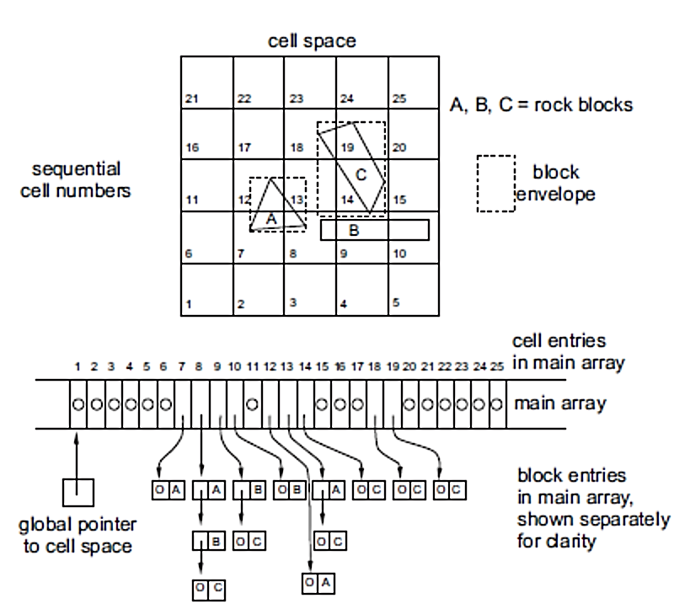
Fig. 1.B. Examples of block mapping to cell space, in to dimensions.

