Prediction of post-peak stress-strain behavior for sensitive clays
Zinan Ara Urmi¹, Ali Saeidi¹, Alba Yerro², Rama Vara Prasad Chavali¹
1 Department of Applied Science – University of Quebec at Chicoutimi, Saguenay, Quebec, Canada
2 Department of Civil and Environmental Engineering – Virginia Tech, Blacksburg, Virginia, USA
Abstract
Unlike typical soils, sensitive clays undergo extensive post-peak strength degradation with increasing strain and finally disintegrate into a remolded liquid state. Realization of post-peak stress-strain behavior of sensitive clay up to large strains is vital in assessing large deformation problems such as landslides and mud flows. The conventional experimental approaches are uncertain about accurately determining the post-peak stress curve up to large strains (>100%) owing to rapidly increasing testing problems at increasing strains. This necessitates the exploration of an alternative scientific approach to predict the complete stress-strain curve for sensitive clays, which is addressed in this paper. Post-peak stress-strain curves of sensitive clays for different sites are obtained by converting remolding index vs. strain energy curves. Using site-specific data from eastern Canada sites, a mathematical expression is proposed to predict the complete stress-strain curve. Subsequently, an equation is developed for predicting remolding energy based on the stress-strain curve. Finally, it is observed that the post-peak stress-strain behavior is highly site-specific and can be mathematically expressed with a combination of exponential and linear strain-softening curves. Overall, the knowledge of the complete stress-strain behavior contributes greatly to the prediction of post-failure movements closer to reality.
Key Words: Strain-softening, Stress-strain behavior, Sensitive clays, Large deformation, Remoulding energy, Retrogression distance

Introduction

General background
The post-failure behavior of sensitive clays is attributed to the reduction in strength after reaching peak strength under shear loading, which is also known as strain softening (Pusch, 1966). Sensitive clays generally have high intact shear strength, but the shear strength reduces to a significantly low value (remolded shear strength) when subjected to disturbance in undrained condition (Crawford, 1968; Skempton, 1964). The strength reduction reaches a point where the clay completely loses its intact structure and disintegrates to a liquid-like mass (remolded clay) that can flow (Rosenqvist, 1953, 1966). Thus, the soil is referred to as "sensitive" because its post-peak strength is sensitive to disturbance. The sensitivity ($S_{t}$) of soil is quantified by the ratio between the peak ($s_{up}$) and remolded ($s_{ur}$) shear strength (Skempton and Northey, 1952). In analyzing landslides in sensitive clays, understanding how material sensitivity controls soil behavior is of utmost importance. Once the failure starts in sensitive clay slopes, the clay layer gets remolded and keeps moving away from its original position. The drag of this liquified soil results in subsequent failures (progressive or retrogressive) until the flow of this liquified clay stops or is unable to initiate another failure (Bjerrum, 1955). Thus, the extent of the failure of sensitive clay slopes is enormous compared to slope failure in non-sensitive soil. For example, the recently occurred Gjerdrum landslide (2020) in the highly sensitive clays of Norway spanned a flow-off area of 210,000 m² and additionally affected 90,000 m² by debris flow (Liu et al., 2021).
The devastating aftermath of landslides in sensitive clays intrigued researchers to extensively investigate the behavior of these materials that leads to the initiation and progress of extremely large landslides under different loading conditions. Due to strain-softening behavior, the mobilized strength along a potential failure surface varies from the peak to the remolded shear strength, unlike a constant value used in limit equilibrium (LE) methods (Bishop, 1971; Bjerrum, 1967; Locat et al., 2013, 2011; Skempton, 1964). Therefore, analysis of sensitive clay slopes requires peak shear strength and detailed information about the strain-softening behavior, which fundamentally cannot be incorporated into conventional LE analysis (Gylland et al., 2014). Recent studies suggest that the stability analysis of sensitive clay slopes requires advanced numerical modeling tools to capture the retrogressive nature of these landslides (Dey et al., 2015; Islam et al., 2019; Tran and Sołowski, 2019; Wang et al., 2020; Zhang et al., 2018). Numerical modeling of sensitive clay slopes offers valuable insights into failure mechanisms and post-failure runout, which are crucial for landslide hazard mapping in such areas. The constitutive soil model, which represents the stress-strain behavior of the soil, is the most critical component for modeling sensitive clay slopes. The capability to reproduce realistic strain-softening characteristics in the material model is necessary for more accurate numerical analyses of large deformation problems in such materials (Rødvand et al., 2022). Additionally, for retrogressive failure to occur, the soil must be capable of being wholly remolded and flowing out of the crater (Bjerrum, 1955; Carson, 1977; Mollard and Hughes, 1973; Tavenas et al., 1983). The energy required for the remolding process is termed “remolding energy” and can be quantified from the area under the post-peak stress-strain curve with the principle of fracture mechanics (Quinn et al., 2011; Thakur et al., 2017). If the available potential energy of the slope is greater than the remolding energy of the clays, the slope is then considered susceptible to retrogressive failure (Lebuis et al., 1983; Tavenas et al., 1983). Hence , it is possible to evaluate the likelihood of a location being prone to retrogressive landslides by using post-peak stress-strain behavior up to the point of remolding.

Relevant works on large deformation behavior of sensitive clays
Ideally, the strain value required to reach the remolded shear stress is extremely large. Stark and Contreras (1996) suggested that a completely remolded state may occur when the specimen is sheared to several hundred millimeters, corresponding to several hundred percent of the shear strain in soil specimens subjected to conventional laboratory tests. Stress-strain curves obtained from triaxial compression tests are limited to only 10-20% strain (Thakur et al., 2014). Generally, ring shear tests, reversal shear box tests, or direct simple shear tests are used to study the large deformation behavior, but these laboratory-scale shear tests could only achieve strains up to 30%-45% (Durand, 2016; Locat, 2007; Locat et al., 2017, 2015, 2013). Thakur et al. (2015) examined the stress-strain behavior of sensitive clays using field vane shear testing. However, the residual torque at 90˚ rotation could not reach the remolded level even after multiple manual turns due to factors associated with the drainage in the failure zone around the vane (Gylland et al., 2016). Thus, predicting post-peak stress-strain behavior is one of the major challenges in analyzing sensitive clay landslides where large deformation is involved.
Stress-strain data close to the remolded state of sensitive clays can only be found in Tavenas et al. (1983)’s work. They determined the strain energy required to remold the clay with four innovative test methods, including impact on a rigid surface, impact from falling objects, extrusion through a narrowing tube, and shearing through oscillating simple shear in a large shear box. They considered the reduction of shear strength from its peak strength to the remolded strength as 100% remolding. They defined a parameter called the remolding index, which represents the amount of strength reduction as a percentage of the total strength reduction from the peak to the remolded state as follows,
$$I_{r}=\frac{s_{up}-s_{u}}{s_{up}-s_{ur}}×100\%$$ | 1
where $s_{up}$,$s_{u}$, and $s_{ur}$ are the undrained shear strength at the peak, at any point after the peak, and at the remolded state. Additionally, the normalized strain energy ($w_{N}$) corresponding to a particular $I_{r}$ is defined as
$$w_{N}=\frac{W_{x}}{w_{Ls}}×100\%$$ | 2
where $W_{x}$ is the energy per unit volume (kN-m/m³) to reduce the strength from $s_{up}$ to $s_{u}$ and $w_{Ls}$ is the energy per unit volume (kN-m/m³) required to reach the peak strength, i.e. the limit state energy. As per Tavenas et al. (1979), the energy needed to reach the peak stress (limit state energy) for Champlain Sea clay can be expressed as,
$$w_{LS}=0.013σ_{p}́$$ | 3
where $σ_{p}́$ is the pre-consolidation pressure.
Finally, they generated the remolding index ($I_{r}$) vs. normalized strain energy ($w_{N}$) curves for different locations of eastern Canadian sensitive clays. The soil properties and the $I_{r}$ vs. $w_{N}$ curves of Tavenas et al.'s (1983) work are presented in Table 1 and Figure 1, respectively. Quinn et al. (2011) converted those remolding-index vs. strain-energy curves to stress-displacement curves (Figure 2).
As per the author’s knowledge, the very first equation to represent the strain-softening behavior of sensitive clay for measuring the resistance of soil around a cone penetrometer was proposed by Einav and Randolph (2005) as follows,
$$s_{u}=s_{ur}+\left(s_{up}-s_{ur}\right)e^{-\frac{3γ}{γ_{95}}}$$ | 4
where $s_{up}$ is the peak shear strength, $s_{u}$ is the degraded shear strength after the peak, $s_{ur}$ is the remolded shear strength, $γ$ is the strain corresponding to $s_{u}$, and $γ_{95}$ is the strain when the strength is reduced by 95% of the supposed total reduction ($s_{up}-s_{ur}$). Dey et al. (2016) calibrated Equation 4 using Quinn et al.’s (2011) interpreted curves (Figure 2) for its application in the landslide analysis of sensitive marine clay. However, the authors acknowledged the uncertainty in evaluating the large deformation parameter ($γ_{95}$) used in the softening equation.
Table 1: Soil properties of each location of Tavenas et al.'s (1983) work
Name of the site | Sample depth (m) | Peak shear strength $s_{up}$ (kPa) | Remolded shear strength $s_{ur}$ (kPa) | Pre-consolidation pressure, $σ_{p}́$ (kPa)
Saint-Léon (SLE) | 4.8 | 30 | 1.10 | 100
Saint-Léon (SLE) | 9.3 | 49.5 | 2.10 | 180
Louiseville (LOU) | 6 | 39 | 1.30 | 125
Saint-Hilaire (HIL) | 5.6 | 35 | 0.80 | 115
Saint-Thuribe (THU) | 6 | 55 | 0.40 | 175
Saint-Thuribe (THU) | 12 | 42 | 0.07 | 195
Mascouche (MAS) | 9 | 135 | 1.30 | 400
Saint-Alban (SAL) | 6.6 | 21 | 0.20 | 85
Saint-Jean-Vianney (SJV) | 30 | 320 | 1.20 | 1000

Figure 1: Relationship between normalized energy and remolding index for Champlain clay samples (replotted from Tavenas et al., 1983).

Figure 2: Stress-strain curves interpreted by Quinn et al. (2011) from the remolding index vs. normalized strain energy curves of Tavenas et al. (1983)
Some researchers used the linear strength degradation equation for simplicity (Locat et al., 2017, 2015, 2013; Mohammadi and Taiebat, 2013; Thakur, 2011), but strain softening in sensitive clays can be highly non-linear (Durand, 2016; Locat, 2007; Locat et al., 2017, 2015, 2013). Most of the recent studies on the simulation of sensitive clay landslides (Tran and Sołowski, 2019; Wang et al., 2021, 2020; Yuan et al., 2020; Zhang et al., 2018) used Einav and Randolph's strain-softening equation (Equation 4). Generalized application of this equation without site-specific verification and without an accurate estimation of the large-deformation parameter, $γ_{95}$, might result in erroneous outcomes. Site-specific applicability of this equation has been discussed in detail in section 3.1.

Study outline
In a nutshell, even though post-peak stress-strain behavior is crucial in the analysis of post-failure behavior of sensitive clay landslides, existing work related to the prediction of the stress-strain curve of sensitive clays is limited. This study aims to provide a methodology to obtain a complete post-peak stress-strain curve up to the point of remolding based on site-specific geotechnical investigation results and a suitable strain-softening equation. To achieve this objective, firstly, the remolding index-strain energy curves (Tavenas et al., 1983) are converted to stress-strain curves. Then, focusing on the shortcomings of the existing strain-softening equation, a new site-specific strain-softening criterion is established to predict the post-failure behavior and determine the remolding energy of sensitive clays. Next, the criterion is applied to predict the complete stress-strain curves of five different locations. Finally, an equation is proposed to determine the distance of retrogression of spreading kind of failure based on the calculated remolding energies from the predicted curves of those five locations.

Development of shear stress-strain curve from remolding index-strain energy curve
Quinn et al. (2011) first interpreted the energy curves from Tavenas et al.’s (1983) data as stress-strain and stress-displacement curves considering basic assumptions. In particular, they assumed that the strain was linear-elastic up to the peak strength; therefore, the energy required to reach the peak strength (w_{LS}) was defined as,
$$w_{LS}=\frac{1}{2}{×γ}_{p}{×s}_{up}$$ | 5
Additionally, they assumed that, $γ_{p}=1\%$ and $w_{N}=W_{x}$, that is, $w_{LS}=1$ as per Equation 2. However, the assumption that both $γ_{p}$ and $w_{LS}$ equal to 1 is unrealistic because it results in a constant peak strength value for all sites as per Equation 5. The authors of this present paper re-interpreted those curves, and the reasons will be clarified further in this section.
In this work, a stress-strain curve has been considered for sensitive clays, as shown in Figure 3. The soil is assumed to be perfectly elastic up to the peak (i.e., no energy dissipation during this part of the curve).

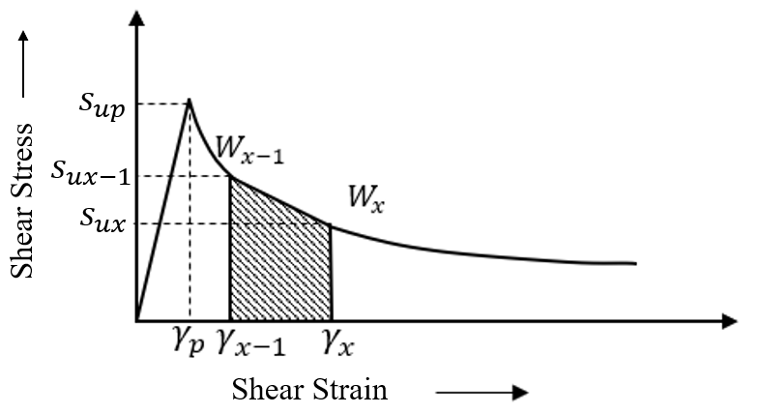
Figure 3: Stress-strain curve of a sensitive clay
Consider two points in the curve after the peak at a stress $s_{ux-1}$ and $s_{ux}$ having strains $γ_{x-1 }$ and $γ_{x}$, respectively. Therefore, the strain energy required for the reduction of the stress from $s_{ux-1}$ to $s_{ux}$ is the shaded area under the stress-strain curve in Figure 3. This energy is the difference between the energies at these two points (i.e., $W_{x-1}$and $W_{x}$), and it can be approximated as such,
$$\frac{1}{2}\left(s_{ux-1}+s_{ux}\right)\left( γ_{x}-γ_{x-1}\right)=W_{x}-W_{x-1} → γ_{x}=\frac{2\left(W_{x}-W_{x-1}\right)}{\left(s_{ux-1}+s_{ux}\right)}+γ_{x-1}$$ | 6
To evaluate the $γ_{x}$ for the first point of the post-peak stress-strain curve, the value of $s_{ux-1}$,$γ_{x-1}$, and $w_{x-1}$ would be the peak shear stress ($s_{up}$), peak strain ($γ_{p}$), and the energy required to reach the peak stress ($w_{LS}$). That is, for the current step, the value of $s_{ux-1}$,$γ_{x-1}$, and $w_{x-1}$ would be the stress, strain, and energy value of the previous incremental step. While $s_{ux}$ can be determined by rearranging Equation 1
$$s_{ux}=s_{up}-I_{rx}\left(s_{up}-s_{ur}\right)$$ | 7
where, $I_{rx}$ is the remolding index corresponding to stress $s_{ux}$.
Using the data from Table 1 and Equations 2, 3, 5, 6, and 7, $I_{r}$ vs. $w_{N}$ curves can be converted to stress-strain curves for each site. Figure 4 shows the stress-strain curves produced from the data of Tavenas et al.'s (1983) $I_{r}$ vs. $w_{N}$ curves (Figure 1).

Figure 4: Stress-strain curves produced from Tavenas et al.’s (1983) data.
For the evaluation of strains ($γ_{x}$) from Tavenas et al.'s (1983) data, Quinn et al. (2011) proposed the following equation,
$$γ_{x}=\frac{2w_{N}}{\left(s_{ux-1}+s_{ux}\right)}+γ_{x-1}$$ | 8
It can be noted that instead of using the difference of energies between two incremental stresses, $W_{x}-W_{x-1}$, Equation 8 considers the normalized strain energy of the current step ($w_{N}$), that is, the energy required for the strain accumulation from $γ_{x-1}$ to $γ_{x}$ has been taken as $\frac{W_{x}}{w_{Ls}}$ which represents what fraction of the limit state energy is required to reach $γ_{x}$ from $γ=0$. Therefore, the inconsistency in Equation 8 is that even though the strains are incremental, the energy is not. By comparing the stress-strain curve produced by Quinn et al. (2011) (Figure 2) and the curves produced by this study (Figure 4), we can see that the strain values in Quinn et al.'s (2011) interpretation are considerably higher, for example, in Saint-Alban, the strain value corresponding to a normalized strain energy value =190 corresponds to a strain value of 45485% by Quinn et al., (2011). In contrast, the same strain energy corresponds to a strain value of 3970% as per this study. The difference between the interpreted strain values of Figure 2 (Quinn et al. 2011) and Figure 4 (this study) is evident in Figure 5, where stress-strain curves produced by both the studies are plotted together (dashed lines represent this study, solid lines represent Quinn et al. (2011), and the locations are color coded). To determine which interpretation is more consistent with Tavenas et al.'s (1983) data, the experimental setup for evaluating the strain energy values in Tavenas et al.'s (1983) work has been analyzed. The description of these experiments can be found in Flon et al. (1982). Tavenas et al. (1983) determined the strain energy from four methods, one of which was simple shearing. For the determination of strain energy by simple shearing, the sample size was 12x12x10cm, and each half cycle of simple shearing was equivalent to a displacement of 8cm. The highest number of cycles for each sample varied between 60 to 90. Therefore, the highest strain for each sample could be in the range of 8000-12000%. From this study, the highest values of interpreted strains for the maximum values of strain energies are in the range of 3200-12000%, which is comparable with Tavenas et al.'s (1983) test methods. In comparison, the maximum strain values for different locations by Quinn et al. (2011) are in the range of 14000-55000%, which is inconsistent with Tavenas et al.'s (1983) experimental setup. That is why the re-interpretation of the strains was considered important in this study.

Figure 5: Comparison of the stress-strain curves interpreted by this study with Quinn et al. (2011)

Development of strain-softening equation for sensitive clay

Applicability of existing equation
It is evident from the stress-strain curves (Figure 4) that the post-peak strength decreases with increasing strain is non-linear. Einav and Randolph's (2005) strength degradation equation (Equation 4) was the very first equation describing the non-linear strain softening behavior of sensitive clays in large deformation problems and had become increasingly popular for its application in the numerical simulations of sensitive clay landslides (Dey et al., 2015; Islam et al., 2019; Tran and Sołowski, 2019; Wang et al., 2020; Zhang et al., 2018). To assess the applicability of Equation 4 for predicting the post-peak behavior of the sensitive clays of Tavenas et al.’s (1983) studied locations, stress-strain curves produced from Tavenas et al. (1983) 's data (these curves would be referred to as "SST curves" from here on) and stress-strain curves predicted by Einav & Randolph's (2005) strain softening equation (these curves would be referred as "SSER" curves from here on) have been plotted for comparison in Figure 6.
(b)
(a)
(d)
(c)
Figure 6: Comparison of the stress-strain curves produced from Tavenas et al.'s (1983) experimental data with Einav and Randolph's (2005) strain softening equation for four sensitive clays from different sites.
As per the definition of $γ_{95}$, it is the value of strain corresponding to an $I_{R}=95\%$. From Tavenas et al. 's (1983) experimental results, samples from only four sites could reach up to 95% of remolding, that is, $γ_{95}$ was obtainable only for four sites. Despite the reduced amount of data, these four locations have a wide range of peak shear stress (40-320kPa), plasticity index (13-46%), sensitivity (24-260), and pre-consolidation pressure (25-1000kPa); therefore, it is reasonable to assume that the soils from these sites are a good representation of sensitive clays with varying soil properties. It is observed from Figure 6 that in all cases, Equation 4 overpredicts the stress-strain curves produced from the experimental data to a significant extent. The rate of strength decrease is slower in SSER curves compared to SST curves. Additionally, the SSER curves have a uniform exponential decrease, whereas the rate of strength decrease in the SST curves is higher in the initial parts at smaller strains compared to the final parts at larger strains. For example, in the Saint-Jean-Vianney (SJV) SST curve, 80% of the strength decrease happens within 125% strain value, but it takes another 800% of strain to reach 95% of strength reduction. It can be concluded that for a more accurate prediction of the stress-strain curves, modification is required in the exponent part of the strain-softening equation ($e^{-\frac{3γ}{γ_{95}}}$) which controls the rate of strength decrease. For a more precise understanding, developing a strain softening equation compatible with laboratory-obtained shear test results from a specific site requires two essential parameters. First, a parameter is needed to initiate the curve at the correct peak stress, and second, a parameter is necessary to regulate the curve's exponent, preventing over- or underestimation. For example, in Figure 7, the stress-strain curves from two sites, a and b, can be re-presented with a strain-softening equation if the starting point and exponent of the softening equation can be calibrated based on the site-specific results. The development process is further clarified in the next section.
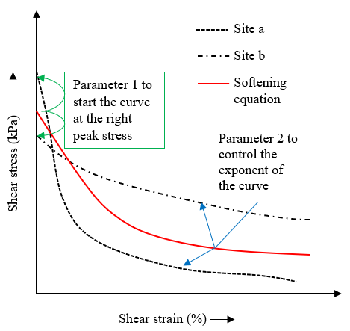
Figure 7: Development of a site-specific strain softening equation

Development of a new strain-softening equation
The exponential term in Equation 4 represents the fraction of the total shear strength reduction required to reach the remolded strength. To understand this term more clearly, at the peak strength, the fraction of total reduction required to reach the remolded strength is 1 (100%), so the equation gives $s_{u}=s_{up}$. Again, at remolded shear strength, the fraction of total reduction required to reach the remolded shear strength is 0; thus the equation gives $s_{u}=s_{ur}$. By rearranging Equation 4 we get,
$$e^{-\frac{3γ}{γ_{95}}}=\frac{s_{u}-s_{ur}}{s_{up}-s_{ur}}$$ | 9
As per Equation 9, plotting the $\frac{s_{u}-s_{ur}}{s_{up}-s_{ur}}$ against strain ($γ$), the exponential nature of the curves can be analysed better. After examining the trend of the curve, it is observed that even though the change in the fraction of total reduction required to reach the remolded strength is exponential up to a certain strength ($s_{uR}$) but does not exactly follow the equation $e^{-\frac{3γ}{γ_{95}}}$, rather it follows $αe^{-βγ},$ where $α$ and $β$ are site-specific strength reduction constants (Figure 8). It is essential to understand how these site-specific constants play an important role in capturing the particular stress-strain behavior of the site. In a physical sense, $α$ controls the starting point of the curve, and $β$ controls the rate of exponential strength reduction. For example, let us consider a particular site, Louiseville (LOU), for different α values keeping the β value fixed. It can be observed from Figure 9(a) that a precise α value helps in initiating the curve at the correct peak strength. To understand how β controls the stress-strain curve, we have performed a sensitivity analysis considering different values of β while keeping α constant for the Louiseville site (LOU). Figure 9(b) shows that β represents the rate of strength reduction to its final remolded shear strength.

Figure 8: $\frac{s_{u}-s_{uR}}{s_{up}-s_{uR}}$ vs. $γ$ curves, along with their exponential trend color-coded by location.

(a)
(b)
Figure 9: (a) Effect of α on the stress-strain curve; (b) effect of β on the stress-strain curve

Figure 10: $\frac{s_{u}-s_{uR}}{s_{up}-s_{uR}}$ vs $γ$ curve for Saint-Leon 9.3m
From the $\frac{s_{u}-s_{ur}}{s_{up}-s_{ur}}$ vs. $γ$ curves, it is also evident that the shear strength reduces exponentially up to a certain percentage of the total reduction, and the remaining can be considered a linear decrease. For example, for Saint-Leon (SLE) 9.3m sample, a combination of an initial exponential reduction (up to 93% of the total reduction) and final linear reduction gives an R²=0.9. In contrast, it reduces to R²=0.7 if the whole softening is considered exponential (Figure 10). Therefore, the strain-softening equation can be divided into two parts, an exponential initial part, and a final linear part, as
$$s_{u}=\left\{\begin{aligned}s_{uR}+\left(s_{up}-s_{uR}\right)αe^{-βγ}, &s_{u}≥s_{uR} \\ s_{uR}-\left(s_{uR}-s_{ur}\right)\frac{γ-γ_{R}}{γ_{r}-γ_{R}}, &s_{uR}{>s}_{u}≥s_{ur}\end{aligned}\right.$$ | 10
Where, $s_{uR}$ is the degraded strength up to which the strength reduction is exponential and $γ_{R}$ is the corresponding strain. It is found that the value $s_{uR}$ is dependent on the peak shear strength ($s_{up}$) by the following correlation (Figure 11),
$$s_{uR} =0.095s_{up}$$ | 11

Figure 11: Correlation between $s_{up}$ and $s_{uR}$
All the parameters required in Equation 10 for the prediction of stress-strain curves in all the considered sites are presented in Table 2. It can be seen that the value of α varies from 0.64 to 1.04, whereas Einav and Randolph (2005) (Equation 4) considered a constant value of 1. Additionally, the strain softening is not exponential up to 95% of strength decrease for every site as assumed in Equation 4. The value of $γ_{R}β$ varies from 3.84 to 5.79, unlike a constant value of $γ_{95}β=3$ as taken in Einav and Randolph's (2005) equation. An extremely small change in the exponent (i. e. $γ_{R}β$) of the strain softening equation significantly changes the post-failure retrogression and runout in sensitive clay landslides (Urmi et al., 2023). Another concern in applying Equation 4 in real-case scenarios is the uncertainty in the prediction of $γ_{95}$ when the complete stress-strain curve is unknown. On the other hand, in the solution presented here, $γ_{R}$ can be determined by calibrating the values of α, β, and $s_{uR}$. In particular, the site-specific constants α and β can be determined from the $\frac{s_{u}-s_{ur}}{s_{up}-s_{ur}}$ vs. $γ$ plot of a partial stress-strain curve (up to 30-40% of strain) obtained from conventional laboratory test results.
To complete the stress-strain curve up to the point of remolding, the strain at remolded shear stress $γ_{r}$ is required. As mentioned earlier, the I_{R} vs. $w_{N}$ curves could not attain 100% of remolding. The last point of those curves represents a point in between $s_{uR}$ and $s_{ur}$; therefore, the strain value ($γ_{r}$) corresponding to the remolded strength ($s_{ur}$) cannot directly be determined from those curves. Considering the assumption of this study that the strain softening is linear after $s_{uR}$, it is possible to determine $γ_{r}$ by rearranging the linear part of Equation 10 as follows
$$γ_{r}=\frac{\left(γ-γ_{R}\right)\left(s_{uR}-s_{ur}\right)}{s_{uR}-s_{u}}+γ_{R}$$ | 12
Where, $s_{u}$ and $γ$ are the stress and strain values of any points in between $s_{uR}$ and $s_{ur}$.
With conventional laboratory testing, however, a point in between $s_{uR}$ and $s_{ur}$ might not be available. Therefore, it was thoroughly assessed whether $γ_{r}$ can be determined from a reliable empirical equation. From the peak strength vs. $\frac{γ_{r}}{γ_{R}}$ relationship, a linear correlation (Figure 12) between these two parameters can be determined as per the following equation,
$$\frac{γ_{r}}{γ_{R}} =0.13s_{up}$$ | 13

Figure 12: Correlation between $s_{up}$ and $\frac{γ_{r}}{γ_{R}}$
Table 2: Parameters for prediction of stress-strain behavior of sensitive clays
Sites | SLE 4.8m | SLE 9.3m | LOU | HIL | SAL | MAS | THU 6m | THU 12m | SJV
Parameters
$s_{up}$ (kPa) | 31 | 49.5 | 39 | 32 | 21 | 135 | 55 | 42 | 320
$s_{uR}$(kPa) | 8.85 | 5.42 | 6.20 | 7.34 | 3.11 | 16.68 | 11.32 | 6.97 | 25.75
$γ_{R}$ (%) | 1501 | 3114 | 1944 | 2129 | 3614 | 1298 | 646 | 978 | 549
$$α$$ | 0.98 | 0.816 | 0.917 | 0.766 | 0.638 | 0.813 | 0.875 | 1.04 | 0.679
$$β$$ | 0.00287 | 0.00186 | 0.00217 | 0.00185 | 0.00134 | 0.00313 | 0.00595 | 0.00542 | 0.00905
% Reduction up to $s_{uR}$ | 74 | 93 | 87 | 79 | 86 | 89 | 80 | 84 | 92
$$γ_{R}β$$ | 4.31 | 5.79 | 4.22 | 3.94 | 4.84 | 4.06 | 3.84 | 5.30 | 4.97
$s_{ur}$ (kPa) | 1.1 | 2.1 | 1.3 | 0.8 | 0.2 | 1.3 | 0.4 | 0.07 | 1.2
$γ_{r}$(%) | 7503 | 22767 | 6399 | 10600 | 13071 | 16485 | 5793 | 9542 | 22781

Using all the parameters determined in Table 2, stress-strain curves are predicted with the new strain softening equation (Equation 10). It is observed that the proposed new softening equation immensely improves the accuracy of the prediction (Figure 13). For the evaluation of the site-specific strain softening parameters, α and β mentioned in Table 2, $\frac{s_{u}-s_{uR}}{s_{up}-s_{uR}}$ vs. $γ$ curves had all the strain values up to $γ_{R}$ (Figure 8), but with conventional laboratory testing, the maximum available strain ($γ$) is very low (at most up to 50% of the total strength reduction, $γ_{50}$). Therefore, it was important to assess the reliability of α and β values determined from partial stress-strain curves where strain value is available up to $γ_{50}$. Figure 14 illustrates the change of the predicted curves if α and β are obtained from a partial stress-strain curve. It can be observed that the prediction from the new strain-softening equation suits well with the SST curves even if α and β are determined from partial stress-strain curves.
(a)
(b)
(c)
(d)
(e)
(f)
(g)
(h)
(i)
Figure 13: Comparison of the SST curves with the stress-strain curves predicted with the new strain softening equation (Equation 10) for different sites
(a)
(b)
(c)
(d)
Figure 14 (a-d): Comparison of the SST curves, prediction by new equation and updated prediction when the site-specific parameters are obtained from a partial stress-strain curve.

Methodology for the prediction of post-peak stress-strain behavior of sensitive clays using the established strain-softening criterion
The site-specific data required for the prediction of the post-peak stress-strain behavior of a particular site using Equation 10 are the peak shear strength, the remolded shear strength, and a partial post-peak stress-strain curve. The following steps need to be followed:
- From the partial stress-strain curve, plot $\frac{s_{u}-s_{uR}}{s_{up}-s_{uR}}$ vs. $γ$ to evaluate the value of α and β from the exponential trend of the plot, as shown in Figure 15.
Here, $s_{uR}$ is obtained from Equation 11.

Figure 15: Estimation of α and β from the partial stress-strain curve
- With the values of $s_{up}$, $s_{uR}$ , α and β plot the exponential part of Equation 10 as shown in the first blue rectangle of Figure 16.
- Estimate the strain value ($γ_{R}$) corresponding to the stress $s_{uR}$ from the plotted curve and estimate $γ_{r}$ from Equation 12.
- With the values of $s_{uR}$, $s_{ur}$, $γ_{R}$ and $γ_{r}$ complete the linear part of the curve as shown in the second blue rectangle of Figure 16.
Figure 16 shows the complete stress-strain curve for a particular site where the curve up to the peak comes from laboratory experiment and the post-peak curve comes from the methodology described above.
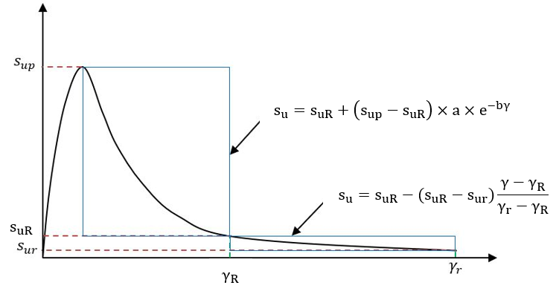
$$αe^{-βγ}$$
Figure 16: Prediction of post-failure stress-strain behavior of sensitive clays

Analytical framework for the estimation of remolding energy based on the post-peak stress-strain curves
During a sensitive clay slide, the initial potential energy (E^{P}) is divided into the energy required to remold the clay (remolding energy E^{R}) and the movement of the slide (kinetic and frictional energy, E^{KF}).
$$E^{P} =E^{R}+E^{KF}$$ | 14
The movement of the slide, thus, entirely depends on how much energy is required to remold the soil and whether there is enough energy left for the remolded debris to flow (Lebuis et al., 1983; Tavenas et al., 1983; Thakur and Degago, 2012). Remolding energy is generally defined as the strain energy dissipated in the process of remolding. Tavenas et al. (1983) illustrated the effect of the remolding energy on initiating retrogressive failure. They measured the total strain energy required to remold the clay and normalized it with respect to the limit state energy ($w_{LS}$) as the remolding process started after the peak. They showed that retrogression happens only when enough energy is available to remold the clay to a certain percentage. The concept of remolding energy to evaluate the susceptibility of landslides to retrogressive failure surfaced as a result of the observation that several landslide locations did not adhere to the evaluation criteria based on sensitivity, liquidity index, and remolded shear strength for predicting the occurrence of retrogressive failure (Lebuis et al., 1983; Tavenas et al., 1983). Building upon the data presented by Tavenas et al. (1983), Leroueil et al. (1996) identified a correlation between remolding energy and the multiple of plasticity index ($I_{p}$) and peak shear strength ($s_{up}$) as follows,
$$E^{R}=16 s_{up}I_{p}$$ | 15
Using this formula, Locat et al. (2008) estimated the remolding energies of 22 Canadian sensitive clay landslide locations and defined a parameter destruction index ($I_{D}=\frac{E^{P}}{E^{R}}$) to evaluate the effect of remolding energy on the landslide runout (D) (Figure 17).
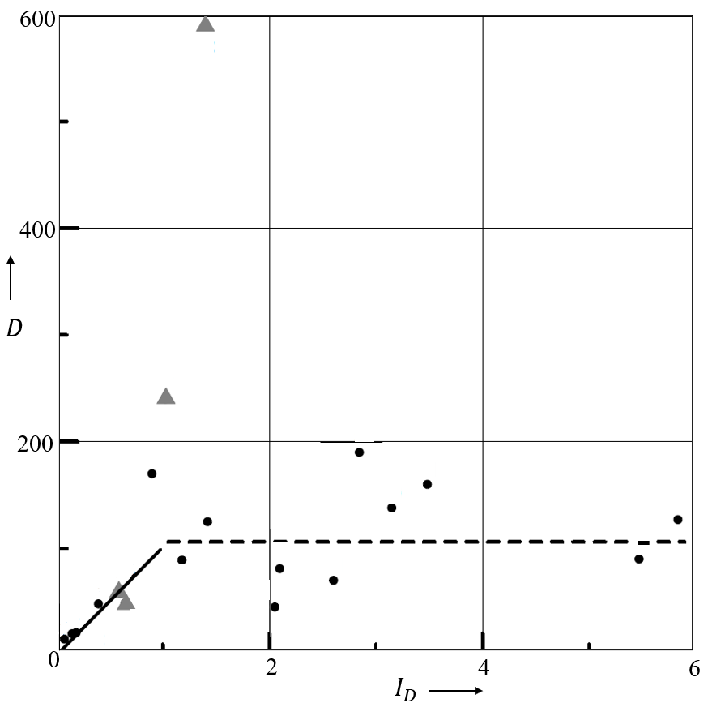
Figure 17: Relationship between run out of debris ($D$) and destruction index ($I_{D}$) (after Locat et al., 2008)
In their observations, a notable finding was the existence of a linear relationship between debris run-out and the destruction index when $I_{D}<1$. When the destruction index is below one, it indicates that the remolding energy surpasses the available potential energy, leading to insufficient potential energy for effectively remolding the soil. This inadequate energy availability ultimately results in minimal run-out, as depicted in the figure. This observation aligns with the argument put forth by Tavenas et al. (1983). However, for thirteen out of the twenty-two sites examined, no such relationship between the destruction index and run-out was discovered. Locat et al.’s (2008) reasoning behind this discrepancy suggests that the significant depthwise variation in the plasticity index of a specific site poses a challenge in determining the appropriate index to utilize for accurately estimating remolding energy from Equation 15. Additionally, the discrepancy may stem from the fact that the concept of the destruction index does not consider the frictional resistance exhibited by the moving debris, which plays a substantial role in influencing the magnitude of run-out.
Later on, Thakur et al. (2017) employed an analytical approach to determine energy dissipated in the process of remolding by calculating the area under the post-peak stress-strain curve up to remolded shear strength. They assumed an idealized stress-strain behavior, considering that strain softening is linear from the peak to the remolded shear strength (Figure 18). However, strain softening is highly non-linear. Determination of the area under the stress-strain curve with a linear assumption may only work if the underpredicted area and the over-predicted area are almost equal, as in the case marked by a red dashed line in Figure 18.
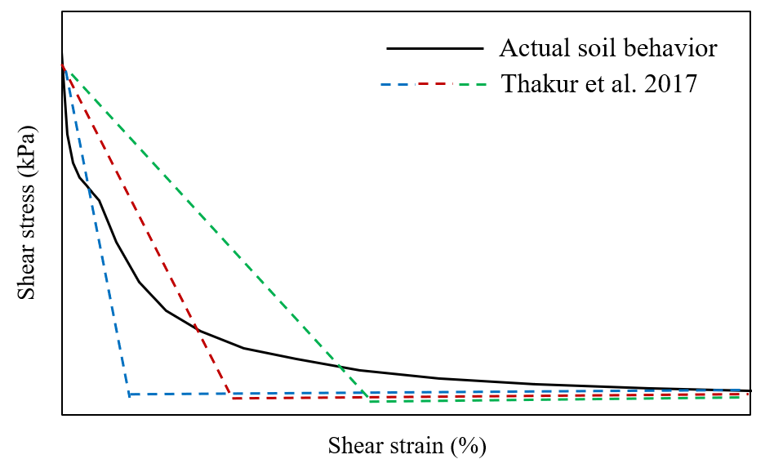
Figure 18: Stress-strain behavior of sensitive clays compared with the assumption of Thakur et al. (2017)
However, without the knowledge of the actual stress-strain curve, a linear assumption may result in a highly overpredicted or underpredicted area under the stress-strain curve, as illustrated in Figure 18 with green and blue dashed lines, respectively. The limitations of this approach become more evident when examining the determination of remolding energy for Klett clay, which was one of the cases studied by Thakur et al. (2017). This site had a peak shear strength ($s_{up}$) of 17 kPa, and remolded shear strength ($s_{ur}$) of 0.1 kPa. The vane shear test results indicated that strength reduction was only achieved up to 7 kPa at the maximum vane rotation. In their analysis, Thakur et al. (2017) extended the initial linear portion of the stress-strain curve up to the remolded strength and determined the area under the stress-strain curve as an estimate for the remolding energy (Figure 19a). However, based on the findings of this study regarding the post-peak stress-strain behavior of sensitive clays, it was established that the strength reduction follows an exponential decay pattern up to $s_{uR}$, followed by a linear decrease up to $s_{ur}$. Consequently, the partial stress-strain curve is extended exponentially up to 1.6 kPa (as per Equation 11) and then linearly up to 0.1 kPa (Figure 19b). It is observed that the linear approximation based on the partial stress-strain curve used by Thakur et al. (2017) for Klett clay substantially underestimates the actual remolding energy.

Figure 19: (a) Determination of remolding energy with linear approximation from a partial softening curve (after (Thakur et al., 2017) (b) Comparison between the remolding energy estimation by linear approximation vs. actual non-linear stress-strain behavior.
The viability of linear estimation relies on a balanced offset between over-prediction and under-prediction, as exemplified by the red line in Figure 19b. However, it is essential to note that such assumptions cannot be made without access to the complete stress-strain curve. Furthermore, if the complete curve is already obtainable, the necessity for a linear approximation becomes redundant.
This study proposes a methodology for obtaining the complete post-peak stress-strain curve, which enables the straightforward estimation of remolding energy by calculating the area beneath the stress-strain curve. The area under the non-linear stress-strain curve i.e. the remolding energy (Figure 20a), can be mathematically represented as,
$$E^{R}=\int_{γ=γ_{p}}^{γ=γ_{r}}{s_{u}}dγ$$ | 16
where $s_{u}$ is the shear strength that varies from the peak to the remolded state.
It is possible to estimate the remolding energy by integrating the degrading shear strength ($s_{u}$) in Equation 10 with respect to strain ($γ$) from $γ=γ_{p}$ to $γ=γ_{r}$ as illustrated in Figure 20b. Therefore, the analytical expression for the remolding energy would be,
$$E^{R}=\int_{γ_{p}}^{γ_{R}}{\left[s_{uR}+\left(s_{up}-s_{uR}\right)αe^{-βγ}\right]}dγ+\left[\frac{1}{2}(s_{uR}+s_{ur})(γ_{r}-γ_{R})\right]$$ | 17
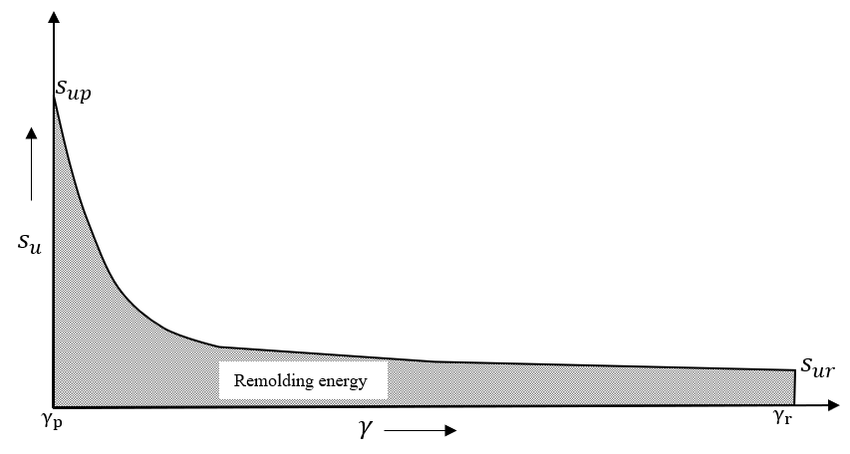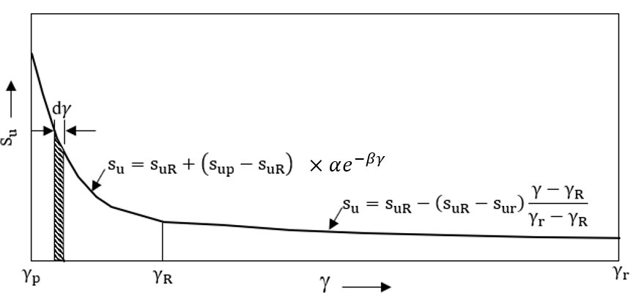
(a)
(b)
Figure 20 (a-b): Determination of area under the post-peak curve by integration

Application to real cases

Prediction of the stress-strain curve
The methodology described in section 3.3 has been applied to seven different landslide locations (6 eastern Canadian and 1 Norwegian) to predict the post-peak stress-strain behavior of sensitive clays. The landslides presented here are all identified as a spread retrogressive/progressive failure. The geotechnical properties of these sites are well described in the literature (Bjerrum and Landva, 1966; Burn, 1968; Durand, 2016; Eide and Bjerrum, 1955; Locat, 2007; Locat et al., 2017, 2015, 2013; Mitchell, 1969). One of the major challenges in working with laboratory test data of sensitive clays involves the effect of sample disturbances. The quality of soil samples is a critical consideration in laboratory-based soil testing methods, particularly in the case of sensitive clays where sampling disturbance can significantly impact the mechanical properties of the clay (Lefebvre and Poulin, 1979; Leroueil et al., 1983; Rochelle et al., 1981). If soil properties are taken from bad quality samples, the finite element numerical analysis of a sensitive clay slope may have a 25% lower safety factor compared to a high-quality sample (D’Ignazio et al., 2017). Lunne et al. (2006) have proposed criteria for assessing sample disturbance in marine clays with OCR between 1 and 2. These criteria involve categorizing sample quality based on the normalized change in the void ratio (Δe/e0) resulting from sample consolidation to assumed in situ effective stresses. These guidelines can be employed to ensure the quality of anisotropically consolidated samples compressed under undrained conditions (CAU) using the triaxial apparatus. The laboratory test data used in this study for most of the sites had geotechnical investigation reports verifying sample quality (Durand, 2016; Locat, 2007; Locat et al., 2019, 2017, 2015, 2013). It is crucial to obtain laboratory test results from high-quality samples to estimate post-peak stress-strain behavior accurately.
The geotechnical properties of each site are described in Table 3, the partial stress-strain curves from direct shear test results are illustrated in Figure 21, evaluation of $α$ and $β$ for each site from $\frac{s_{u}-s_{uR}}{s_{up}-s_{uR}}$ vs. $γ$ curves are illustrated in Figure 22 (a-g), with estimated values of α, β, $γ_{R}$ and $γ_{r}$ for all locations are presented in Table 4. Finally, the complete stress-strain curves are constructed in Figure 23 (a-b).
Table 3: Geotechnical properties for the sensitive clays of different landslide locations
Sites | Cassel-man | Saint-Barnabé-Nord | Saint-Jude | Saint-Luc-de-Vincennes | Saint-Monique | Rockcliffe | Bekkelaget
Parameters
Unit weight ($m$) kN/m³ | 17 | 16 | 16.5 | 16 | 16 | 17 | 18.9
Plasticity Index ($P_{I}$) % | 15 | 15 | 24 | 15 | 28 | 36 | 10
Liquidity Index ( I_{L}) % | 2 | 1.1 | 1.2 | 1.5 | 1 | 2 | 2.4
Slope Height (H) m | 44 | 70 | 30 | 35 | 45 | 12.2 | 16
Sensitivity (S_{t}) | 58 | 50 | 60 | 40 | 55 | 55 | 80
Peak strength (s_{up}) kPa | 87.0 | 79.5 | 55.2 | 55.0 | 40.5 | 54.9 | 16.2
Remolded strength (s_{ur}) kPa | 1.50 | 1.59 | 0.92 | 1.38 | 0.74 | 1.0 | 0.2
Peak strain $γ_{p}$ % | 6.5 | 4.0 | 3.2 | 2.4 | 2.4 | 3.0 | 6.6
s_{uR} (from eq 11) kPa | 8.27 | 7.55 | 5.24 | 5.22 | 3.85 | 5.22 | 1.54

Figure 21: Partial stress-strain curve from DSS test results for different sensitive clay landslide locations
(a)
(b)
(c)
(d)
(f)
(e)
(g)
Figure 22 (a-g): Estimation of $α$and β for different sensitive clay landslide locations
Table 4: Additional parameters required for the prediction of the complete stress-strain curves
Sites | Casselman | Saint-Barnabé-Nord | Saint-Jude | Saint-Luc-de-Vincennes | Saint-Monique | Rockcliffe | Bekkelaget
Parameters
$$α$$ | 1.157 | 1.091 | 1.049 | 0.945 | 0.952 | 1.208 | 1.526
$$β$$ | -0.024 | -0.026 | -0.025 | -0.029 | -0.028 | -0.060 | -0.048
$γ_{R}$ (%) | 250 | 230 | 240 | 195 | 180 | 95 | 120
$γ_{r}$(%) | 2828 | 2377 | 1722 | 1394 | 948 | 678 | 253

From the final prediction of the stress-strain curves (Figure 23), it can be observed that the rate of strain softening is extremely low for larger strain values (>100%). Beyond the exponential softening, the rate of strength reduction is so low that the linear parts of the softening curves seem almost horizontal, indicating that the strain value at the remolded strength is extremely high. To assess whether the post-peak stress-strain behavior is consistent with the observed landslide movement, remolding energies using these stress-strain curves were determined as per Equation 17 (Table 5). In all the cases, the available potential energy of the slope was greater than the estimated remolding energies required for the remolding of the clay, which suggests that the slopes were susceptible to retrogressive failure.
(a)
(b)
Figure 23: (a) Comparison between the predicted stress-strain curves and curves from DSS results. (b) Stress-strain curves plotted on a semi-logarithmic scale to illustrate the entire post-peak behavior
Table 5: Determination of remolding energies for the prediction of retrogressive failure occurrence
Locations | Cassleman | Saint-Barnabé-Nord | Saint-Jude | Saint-Luc-de-Vincennes | Saint-Monique | Rockcliffe | Bekkelaget
Potential energy  E^{P} (2mH/3) kN-m/m³ | 498.7 | 746.7 | 330.0 | 373.3 | 480.0 | 138.3 | 201.6
Remolding energy  E^{R} (kN-m/m³) | 374.8 | 298.1 | 186.0 | 142.9 | 88.0 | 79.8 | 29.05
Occurrence of large retrogressive failure  E^{P} >E^{R} | Yes | Yes | Yes | Yes | Yes | Yes | Yes

Interestingly, for three sites, the estimated remolding energy from the empirical equation proposed by Leroueil et al. (1996) closely matched the calculated remolding energies of this study. However, for other sites, overestimation or underestimation of remolding energy was observed, as depicted in Figure 24. In particular, at the Rockliffe site, Leroueil et al.'s (1996) equation yielded higher remolding energy than the available potential energy, suggesting that the occurrence of large retrogressive failure may not align precisely with Tavenas et al.'s (1983) remolding energy criterion. It is worth noting that the plasticity index for this site was significantly higher than the other sites.

Figure 24: Comparison between the remolding energy estimation by Leroueil et al. (1996) with this study

Prediction of the movement of remolded clay from the estimated remolding energies using the stress-strain curves
There are several empirical methods available for the estimation of retrogression distances. Mitchell and Markle (1974) correlated the stability number ($N_{s}=mH/s_{up}$) with retrogression distance assuming that retrogression will not occur for $N_{s}<6$. Later, other researchers linked retrogression distance with geometrical constraints like slope height and angle (Carson and Lajoie, 1981; Quinn et al., 2011). However, Demers et al. (2014) concluded that these correlations do not work well for Eastern Canadian landslides, especially for the Quebec region. The Norwegian Water Resources and Energy Directorate uses a simple method for mapping hazard zones that involves drawing a $1V:15H$ line from the toe of the slope to represent the maximum retrogression distance of potential flow slides in sensitive clay. But recent data shows that some landslides in Norway have exceeded this distance (L’heureux, 2012). Turmel et al. (2018) showed that in the Quebec region, observed retrogression distances for historical cases may vary between 2 to 50 times the height of the slope ($H$). Quebec Ministry of Transport, Sustainable Mobility and Transport Electrification (MTMDET) uses a statistical approach based on retrogression distances of historical landslides and ancient scars. Suppose a potential site satisfies the geotechnical and geomorphological requirements. In that case, the retrogression distance is assessed by applying a third-order moving average to the retrogression distance of previous scars in the vicinity. This method provides better results for regions where previously recorded landslide data is available (Turmel et al., 2018). Recently, numerical analysis of sensitive clay landslides has been used to predict post-failure retrogression (Locat et al., 2013; Tran and Sołowski, 2019; Wang et al., 2020; Zhang et al., 2018). For an accurate estimation of retrogression distance through numerical simulation, a site-specific strain-softening constitutive model for sensitive clays is required. The main aim of this paper was to produce an accurate strain-softening behavior model for sensitive clays designed explicitly for site-specific application, which can then be used to simulate sensitive clay landslides. It is worth noting that the post-peak stress-strain behavior model proposed in this study has a broader range of applications. Specifically, using the remolding energies estimated from these curves, an equation for calculating the retrogression distance may be developed using only laboratory test data of these locations.
As discussed in section 3.4, when remolded clay moves down a slope, the distance it travels (in retrogression and run out) depends on the available potential energy ($E^{P}$), the remolding energy ($E^{R}$), and the kinetic energy ($E^{KF}$) that develops during the movement of the slide. In spread failures, retrogression (the backward movement of the landslide toe) contributes to the lateral spreading of the slide mass. As the remolded clay spreads laterally within the slope, rather than flowing out of the crater as a cohesive mass, run-out distance (i.e., the distance the material travels downslope) is typically relatively low in spreads compared to earth flows. It can be assumed that most of the kinetic and frictional energy ($E^{KF}$) contributes to the retrogression distance.
By rearranging Equation 14, we get,
$$E^{KF} =E^{P}-E^{R}$$ | 18
By expanding the potential and remolding energies, we get,
$$E^{KF} =\frac{2}{3}mH-\int_{γ_{p}}^{γ_{R}}{\left[s_{uR}+\left(s_{up}-s_{uR}\right)αe^{-βγ}\right]}dγ+\left[\frac{1}{2}(s_{uR}+s_{ur})(γ_{r}-γ_{R})\right]$$ | 19
where m is the unit weight of the soil, and H is the average height of the slope.
The amount of energy left for the movement of the remolded clay vastly depends on the frictional resistance i.e. the viscosity and unit weight of the liquified clay. If the retrogression distance of the landslide is represented with "$RD$", Equation 19 can be rewritten as follows,
$$ω×RD=\frac{2}{3}mH-\int_{γ_{p}}^{γ_{R}}{\left[s_{uR}+\left(s_{up}-s_{uR}\right)×a×e^{-bγ}\right]}dγ-\left[\frac{1}{2}(s_{uR}+s_{ur})×(γ_{r}-γ_{R})\right]$$ | 20
where $ω$ is a proportional constant for the movement of the remolded clay, which is dependent on the viscosity and unit weight of the liquified clay. $ω$ can be determined using the potential and remolding energy of previously occurred landslide locations with known retrogression distances (Table 6).
Table 6: Determination of $ω$ for previously occurred landslide locations.
Locations | Cassleman | Saint-Barnabé-Nord | Saint-Jude | Saint-Luc-de-Vincennes | Saint-Monique | Rockcliffe | Bekkelaget
E^{KF} (kN-m/m³) | 182.53 | 448.57 | 144.00 | 230.43 | 391.97 | 58.5 | 172.55
RD (m) | 450 | 180 | 80 | 110 | 142 | 76 | 145
$ω$=$\frac{E^{KF}}{RD}$ | 0.41 | 2.49 | 1.80 | 2.09 | 2.76 | 0.77 | 1.19

Again, the viscosity of the remolded clay depends on the liquidity index of the clay (Locat and Demers, 1988). Therefore, $ω$ was calibrated against the unit weight and liquidity index of the clay using five out of the seven available landslide locations, while the remaining two sites will be reserved for validation purposes. It should be noted that the range for liquidity index ($I_{L}$) for the calibration of the proportional constant $ω$ was extremely narrow. A linear correlation (Figure 25) between the product of $I_{L}$ and $m$, and $ω$ was obtained as follows,
$$ω=4.2-0.1I_{L}m$$ | 21

Figure 25: Determination of the dependency of $ω$ on the clay unit weight ($m$) and the liquidity index ($I_{L}$)
Replacing $ω$ in Equation 20, the equation to determine retrogression distance is,
$$RD=\frac{\frac{2}{3}mH-\int_{γ_{p}}^{γ_{R}}{\left[s_{uR}+\left(s_{up}-s_{uR}\right)×α×e^{-βγ}\right]dγ-\left[\frac{1}{2}(s_{uR}+s_{ur})×(γ_{r}-γ_{R})\right]}}{4.2-0.1×I_{L}×m}$$ | 22
This equation is now applied to the two remaining locations for validation. For the eastern Canadian site, Rockcliffe equation 22 gives a retrogression distance very close to what was observed in the field. But for Bekkelaget, equation 21 provides a negative value of $ω$ because the unit weight and liquidity index value for this Norweigian site are higher than the Canadian sites with which the 𝜔 value has been calibrated. Due to the difference in overall soil properties in Norweigian quick clays to Eastern Canadian sensitive clays, it is suggested that $ω$ should be separately calibrated for Norweigian and Canadian sites. Other empirical methods for estimating the retrogression distance have been compared with the results of Equation 22 (Table 7). Unlike the previous empirical equations, the proposed equation considers geotechnical and geometrical parameters for the prediction. This equation has the potential for a closer approximation of the observed field data if calibrated against a large data set.
Table 7: Comparison of retrogression distances measured from Equation 22 with other empirical methods.
Locations | Observed retrogression distance on the field | $RD$ (m) from Equation 22 | Average Slope Angle | $RD$ (m) from Quinn et al. (2011)  $$RD=H/6sinA$$($A=$slope angle) | RD (m) from  Carson and Lajoie (1981)  $$RD=$$  $$4H \sim 27H$$ | RD (m) from  Mitchell and Markell (1974)  $$RD=$$  $$100 (Ns-4)$$ | RD (m) from  NVE  $$RD=15H$$
Cassleman | 450 | 456 | 20º | 21 | 176~ 1188 | 560 | 660
Saint-Barnabé-Nord | 180 | 184 | 37º | 19 | 140 ~1890 | 1009 | 1050
Saint-Jude | 80 | 65 | 16º | 18 | 60 ~ 810 | 497 | 450
Saint-Luc-de-Vincennes | 110 | 128 | 4.5º | 74 | 70 ~ 945 | 618 | 525
Sainte-Monique | 142 | 150 | 24º | 18 | 90 ~ 1215 | 1377 | 675
Rockcliffe | 76 | 73 | 16º | 7.37 | 48.8 ~ 329 | N/A | 183
Bekkelaget | 145 | N/A | 3º | 49 | 64 ~ 432 | 1566 | 240

Conclusions
- A new strain-softening equation for sensitive clays was proposed, which effectively reproduces the non-linear behavior observed in post-peak stress-strain curves (Equation 10). The equation comprises two distinct segments: an initial exponential strength reduction characterized by a higher rate of strain softening, followed by a final linear strength reduction where the rate of softening is minimal.
- The newly proposed strain-softening equation effectively addresses the challenge of accommodating the large deformation stress-strain behavior of sensitive clays, surpassing the limitations associated with conventional laboratory shear tests. Formulating the equation based on the actual behavior of sensitive clays under large deformations enables accurate prediction of post-peak stress-strain curves for up to the remolded shear stress. This constitutive equation thus may serve as a valuable tool in simulating large deformation problems specific to sensitive clays, enhancing its practicality and utility in such scenarios.
- The comprehensive stress-strain curves generated by the new equation facilitate accurate calculation of the remolding energy in sensitive clay slopes, thereby enabling the prediction of landslide susceptibility to retrogressive failure based on the remolding energy criterion.
- The estimated remolding energies hold the potential for predicting post-failure landslide movements, as exemplified by the formulation of Equation 22, which enables the estimation of post-failure retrogression in six eastern Canadian sites. To further advance the understanding and applicability of the proposed approach, additional studies should be conducted to encompass multiple landslides and explore their suitability in broader contexts. Moreover, undertaking calibration against a larger dataset could significantly improve the equation's capability to closely approximate observed field data.

Bishop, A.W., 1971. The Influence of Progressive Failure on the Choice of the Method of Stability Analysis. Géotechnique 21, 168–172. https://doi.org/10.1680/geot.1971.21.2.168
Bjerrum, L., 1967. The Third Terzaghi Lectures; Progressive Failure in Slopes of Overconsolidated Plastic Clay and Clay Shales. Journal of the Soil Mechanics and Foundations Division 93, 1–49. https://doi.org/10.1061/JSFEAQ.0001017
Bjerrum, L., 1955. Stability of Natural Slopes in Quick Clay. Géotechnique 5, 101–119. https://doi.org/10.1680/geot.1955.5.1.101
Bjerrum, L., Landva, A., 1966. Direct Simple-Shear Tests on a Norwegian Quick Clay. Géotechnique 16, 1–20. https://doi.org/10.1680/geot.1966.16.1.1
Bjrrum, L., 1955. Stability of Natural Slopes in Quick Clay. Géotechnique 5, 101–119. https://doi.org/10.1680/geot.1955.5.1.101
Burn, K.N., 1968. Direct simple shear tests on Leda clay. Internal Report 363, Division of Building Research, National Research Council of Canada, Ottawa. https://doi.org/https://doi.org/10.4224/20338301
Carson, M.A., 1977. On the retrogression of landslides in sensitive muddy sediments. Canadian Geotechnical Journal 14, 582–602. https://doi.org/10.1139/t77-059
Carson, M.A., Lajoie, G., 1981. Some constraints on the severity of landslide penetration in sensitive deposits. Géographie physique et Quaternaire 35, 301–316. https://doi.org/10.7202/1000541ar
Crawford, C.B., 1968. Quick clays of eastern Canada. Eng Geol 2, 239–265. https://doi.org/10.1016/0013-7952(68)90002-1
Demers, D., Robitaille, D., Locat, P., Potvin, J., 2014. Inventory of large landslides in sensitive clay in the province of Québec, Canada: Preliminary analysis, in: Advances in Natural and Technological Hazards Research. Springer Netherlands, pp. 77–89. https://doi.org/10.1007/978-94-007-7079-9_7
Dey, R., Hawlader, B., Phillips, R., Soga, K., 2016. Modeling of large-deformation behaviour of marine sensitive clays and its application to submarine slope stability analysis. Canadian Geotechnical Journal 53, 1138–1155. https://doi.org/10.1139/cgj-2015-0176
Dey, R., Hawlader, B., Phillips, R., Soga, K., 2015. Large deformation finite-element modelling of progressive failure leading to spread in sensitive clay slopes. Geotechnique 65, 657–668. https://doi.org/10.1680/geot.14.P.193
D’Ignazio, M., Jostad, H.P., Länsivaara, T., Lehtonen, V., Mansikkamäki, J., Meehan, C., 2017. Effects of Sample Disturbance in the Determination of Soil Parameters for Advanced Finite Element Modelling of Sensitive Clays. pp. 145–154. https://doi.org/10.1007/978-3-319-56487-6_13
Durand, A., 2016. Contribution à l’étude des étalements dans les argiles sensibles de la mer de Champlain (MSc Thesis). Département de Génie Civil, Faculté des Sciences et de Génie, Université Laval, Québec.
Eide, O., Bjerrum, L., 1955. The Slide at Bekkelaget. Géotechnique 5, 88–100. https://doi.org/10.1680/geot.1955.5.1.88
Einav, I., Randolph, M.F., 2005. Combining upper bound and strain path methods for evaluating penetration resistance. Int J Numer Methods Eng 63, 1991–2016. https://doi.org/10.1002/nme.1350
Flon, P., Tavenas, F., Leroueil, S., 1982. Energy de Remaniement et Regression des Coulees D’argile. Rapport GCT -82-01, Département de Génie Civil, Faculté des Sciences et de Génie, Université Laval, Québec.
Gylland, A.S., Jostad, H.P., Nordal, S., 2014. Experimental study of strain localization in sensitive clays. Acta Geotech 9, 227–240. https://doi.org/10.1007/s11440-013-0217-8
Gylland, A.S., Thakur, V., Emdal, A., 2016. Extended interpretation basis for the vane shear test, in: NGM 2016 Reykjavik, Proceedings of the 17th Nordic Geotechnical Meeting Challenges in Nordic Geotechnic . pp. 233–240.
Islam, N., Hawlader, B., Wang, C., Soga, K., 2019. Large-deformation finite-element modelling of earthquake-induced landslides considering strain-softening behaviour of sensitive clay. Canadian Geotechnical Journal 56, 1003–1018. https://doi.org/10.1139/cgj-2018-0250
Lebuis, J., Robert, J.M., Rissman, P., 1983. Regional Mapping of Landslide Hazard in Quebec, in: Proceedings of the Symposium on Slopes on Soft Clays. Swedish Geotechnical Institute, Report No.17. pp. 205–262.
Lefebvre, G., Poulin, C., 1979. A new method of sampling in sensitive clay. Canadian Geotechnical Journal 16, 226–233. https://doi.org/10.1139/t79-019
Leroueil, S., Tavenas, F., Bihan, J.-P. Le, 1983. Propriétés caractéristiques des argiles de l’est du Canada. Canadian Geotechnical Journal 20, 681–705. https://doi.org/10.1139/t83-076
Leroueil, S., Vaunat, J., Picarelli, L., Locat, J., Faure, R., Lee, H., 1996. A geotechnical characterisation of slope movements, in: Proceedings of the 7th Symposium on Landslides. Trondheim, pp. 53–74.
L’heureux, J.-S., 2012. A study of the retrogressive behavior and mobility of Norwegian quick clay landslides, in: Proceedings of the 11th International & 2nd North American Symposium on Landslides, Banff, Canada.
Liu, Z., L’Heureux, J.S., Glimsdal, S., Lacasse, S., 2021. Modelling of mobility of Rissa landslide and following tsunami. Comput Geotech 140. https://doi.org/10.1016/j.compgeo.2021.104388
Locat, A., 2007. Étude d’un Étalement Latéral dans Les Argiles de L’est du Canada et de la Rupture Progressive le Cas du Glissement de Saint-Barnabé-Nord (MSc Thesis). Département de Génie Civil, Faculté des Sciences et de Génie,Université Laval, Québec.
Locat, A., Jostad, H.P., Leroueil, S., 2013. Numerical modeling of progressive failure and its implications for spreads in sensitive clays. Canadian Geotechnical Journal 50, 961–978. https://doi.org/10.1139/cgj-2012-0390
Locat, A., Leroueil, S., Bernander, S., Demers, D., Jostad, H.P., Ouehb, L., 2011. Progressive failures in eastern canadian and scandinavian sensitive clays. Canadian Geotechnical Journal 48, 1696–1712. https://doi.org/10.1139/t11-059
Locat, A., Leroueil, S., Fortin, A., Demers, D., Jostad, H.P., 2015. The 1994 landslide at Sainte-Monique, Quebec: Geotechnical investigation and application of progressive failure analysis. Canadian Geotechnical Journal 52, 490–504. https://doi.org/10.1139/cgj-2013-0344
Locat, A., Locat, P., Demers, D., Leroueil, S., Robitaille, D., Lefebvre, G., 2017. The saint-jude landslide of 10 May 2010, Quebec, Canada: Investigation and characterization of the landslide and its failure mechanism. Canadian Geotechnical Journal 54, 1357–1374. https://doi.org/10.1139/cgj-2017-0085
Locat, A., Locat, P., Michaud, H., Hébert, K., Leroueil, S., Demers, D., 2019. Geotechnical characterization of the Saint-Jude clay, Quebec, Canada. AIMS Geosci 5, 273–302. https://doi.org/10.3934/geosci.2019.2.273
Locat, P., Leroueil, S., Locat, J., 2008. Remaniement et mobilité des débris de glissements de terrain dans les argiles sensibles de l’est du Canada, in: Proceedings of the 4th Canadian Conference on Geohazards : From Causes to Management. Presse de l’Université Laval, Québec, p. 594.
Lunne, T., Berre, T., Andersen, K.H., Strandvik, S., Sjursen, M., 2006. Effects of sample disturbance and consolidation procedures on measured shear strength of soft marine Norwegian clays. Canadian Geotechnical Journal 43, 726–750. https://doi.org/10.1139/t06-040
Mitchell, R.J., 1969. Landslides at Breckenridge, Pineview Golf Club, and Rockcliffe. Internal Report, National Research Council of Canada, Division of Building Research, Ottawa. https://doi.org/https://doi.org/10.4224/20338133
Mitchell, R.J., Markell, A.R., 1974. Flowsliding in Sensitive Soils. Canadian Geotechnical Journal 11, 11–31.
Mohammadi, S., Taiebat, H.A., 2013. A large deformation analysis for the assessment of failure induced deformations of slopes in strain softening materials. Comput Geotech 49, 279–288. https://doi.org/10.1016/j.compgeo.2012.08.006
Mollard, J.D., Hughes, G.T., 1973. Earthflows in the Grondines and Trois Rivikres Areas, Quebec: Discussion. Canadian Geotechnical Journal 10, 324–326. https://doi.org/10.1139/e73-029
Pusch, R., 1966. Recent quick-clay studies, an introduction. Eng Geol 1, 413–414. https://doi.org/10.1016/0013-7952(66)90017-2
Quinn, P.E., Diederichs, M.S., Rowe, R.K., Hutchinson, D.J., 2011. A new model for large landslides in sensitive clay using a fracture mechanics approach. Canadian Geotechnical Journal 48, 1151–1162. https://doi.org/10.1139/t11-025
Rochelle, P. La, Sarrailh, J., Tavenas, F., Roy, M., Leroueil, S., 1981. Causes of sampling disturbance and design of a new sampler for sensitive soils. Canadian Geotechnical Journal 18, 52–66. https://doi.org/10.1139/t81-006
Rødvand, L.A., Jostad, H.P., Grimstad, G., Andresen, L., 2022. Strain localisation in sensitive clays: can rate dependency provide mesh independent results? Comput Geotech 145, 104678. https://doi.org/10.1016/j.compgeo.2022.104678
Rosenqvist, I.T., 1953. Considerations on the sensitivity of norwegian quick-clays. Géotechnique 3, 195–200.
Rosenqvist, I.Th., 1966. Norwegian research into the properties of quick clay—a review. Eng Geol 1, 445–450. https://doi.org/10.1016/0013-7952(66)90020-2
Skempton, A.W., 1964. Long-term stability of clay slopes. Géotechnique 14, 77–102.
Skempton, A.W., Northey, R.D., 1952. The sensitivity of clays. Géotechnique 3, 30–52. https://doi.org/10.1680/geot.1952.3.1.30
Stark, T.D., Contreras, I.A., 1996. Constant volume ring shear apparatus. Geotechnical Testing Journal 19, 3–11. https://doi.org/10.1520/gtj11402j
Tavenas, F., Flon, P., Leroueil, S., Lebuis, J., 1983. Remolding energy and risk of retrogression in sensitive clays, in: Proceedings of the Symposium on Slopes on Soft Clays. Linköping, Sweden, SGI Report No. 17, pp. 423–454.
Thakur, V., 2011. Numerically observed shear bands in soft sensitive clays. Geomechanics and Geoengineering 6, 131–146. https://doi.org/10.1080/17486025.2010.546434
Thakur, V., Degago, S., Gylland, A.S., Sandven, R., 2015. In-situ determination of disintegration energy for soft sensitive clays, in: GEOQuebec 2015, 68th Annual Canadian Geotechnical Conference. Québec.
Thakur, V., Degago, S.A., 2012. Quickness of sensitive clays. Geotechnique Letters 2, 87–95. https://doi.org/10.1680/geolett.12.0008
Thakur, V., Degago, S.A., Selänpää, J., Länsivaara, T., 2017. Determination of Remoulding Energy of Sensitive Clays. pp. 97–107. https://doi.org/10.1007/978-3-319-56487-6_9
Thakur, V., Jostad, H.P., Kornbrekke, H.A., Degago, S.A., 2014. How well do we understand the undrained strain softening response in soft sensitive clays?, in: Advances in Natural and Technological Hazards Research. Springer Netherlands, pp. 291–303. https://doi.org/10.1007/978-94-007-7079-9_23
Tran, Q.A., Sołowski, W., 2019. Generalized Interpolation Material Point Method modelling of large deformation problems including strain-rate effects – Application to penetration and progressive failure problems. Comput Geotech 106, 249–265. https://doi.org/10.1016/j.compgeo.2018.10.020
Turmel, D., Potvin, J., Demers, D., Locat, P., Locat, A., Locat, J., Leroueil, S., 2018. Empirical estimation of the retrogression and the runout distance of sensitive clay flowslides, in: 7th Canadian Geohazards Conference – Geohazards 7. Canmore, Alberta.
Urmi, Z.A., Saeidi, A., Yerro, A., Chavali, R.V.P., 2023. Effect of strain softening on the prediction of post-failure runout in sensitive clay landslide , in: NUMGE 2023: 10th European Conference on Numerical Methods in Geotechnical Engineering . London.
Wang, C., Hawlader, B., Perret, D., Soga, K., 2020. Effects of geometry and soil properties on type and retrogression of landslides in sensitive clays. Géotechnique 1–15. https://doi.org/10.1680/jgeot.20.p.046
Wang, C., Hawlader, B., Perret, D., Soga, K., Chen, J., 2021. Modeling of Initial Stresses and Seepage for Large Deformation Finite-Element Simulation of Sensitive Clay Landslides. Journal of Geotechnical and Geoenvironmental Engineering 147, 04021111. https://doi.org/10.1061/(asce)gt.1943-5606.0002626
Yuan, W.H., Liu, K., Zhang, W., Dai, B., Wang, Y., 2020. Dynamic modeling of large deformation slope failure using smoothed particle finite element method. Landslides 17, 1591–1603. https://doi.org/10.1007/s10346-020-01375-w
Zhang, X., Sloan, S.W., Oñate, E., 2018. Dynamic modelling of retrogressive landslides with emphasis on the role of clay sensitivity. Int J Numer Anal Methods Geomech 42, 1806–1822. https://doi.org/10.1002/nag.2815

